# Homework Set 4

|  |  |
| --- | --- |
| General Solution | Why I Chose the Method |
| a.  integration by parts step: | I chose to use the reverse product rule since y and t could not be split up and put on opposite sides and still have something multiplied to dy/dt which is needed to use separation of variables. |
| b. | I chose to use the reverse product rule since y and t could not be split up and put on opposite sides and still have something multiplied to dy/dt which is needed to use separation of variables. |
| c. | I chose to use separation of variables because I was easily able to divide y from both sides and have a term times dy/dt on the left, which meant I could separate dy/dt and multiply dt to both sides. |
| d. | I chose to use separation of variables since we were only working with a term that had t so I could multiply the dt from dy/dt to the other side and integrate. |



|  |  |
| --- | --- |
| Separation of Variables | Reverse Product Rule |
|  |  |

1. A. Numerically and graphically, we can use Euler’s method and slope fields so approximate the general solution. Using analytic techniques, we can use the reverse product rule. We can’t use separation of variables since there’s no way to split up y and t and put them on separate sides, but still have something be multiplied to dy/dt.

B. Numerically and graphically, we can use Euler’s method and slope fields so approximate the general solution. Using analytic techniques, we can use separation of variables (the shortcut method and the method that preserves meaning) and the reverse product rule.

C. Numerically and graphically, we can use Euler’s method and slope fields so approximate the general solution. Using analytic techniques, we can use separation of variables (the shortcut method and the method that preserves meaning). We can’t use the reverse product rule since this isn’t a liner first order equation because of the squared.

D. Numerically and graphically, we can use Euler’s method and slope fields so approximate the general solution. Using analytic techniques, we can use the reverse product rule. We can’t use separation of variables since there’s no way to split up y and t and put them on separate sides, but still have something be multiplied to dy/dt.

1. A. dy/dt=y3 can only be solved with separation of variables since there is a cubed on the y so we can’t use the reverse product rule since it’s not in the correct form. The y term can only be raised to the first power to use the reverse product rule.

B. dy/dt=(y/(3t+1))+5 can only be solved using the reverse product rule. We can’t use separation by parts since there’s no way to separate y and t to get it into the correct form.

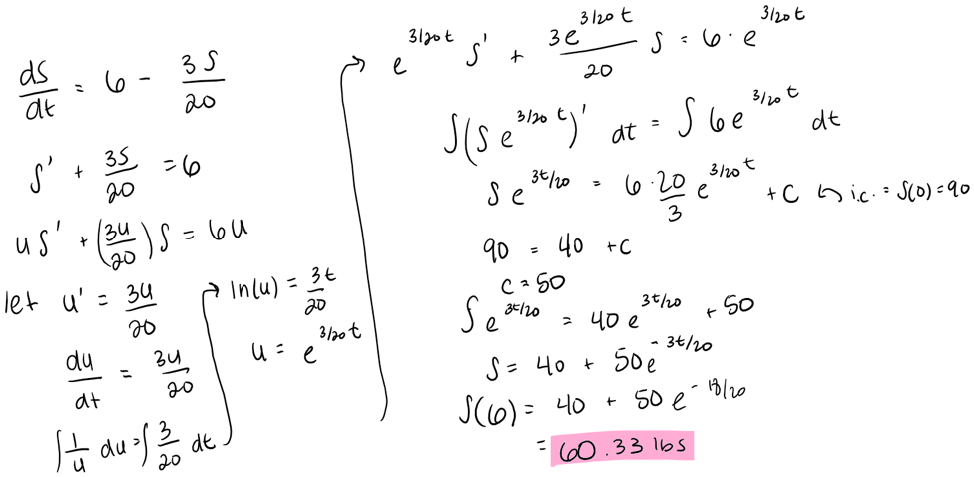C. dy/dt=3y+10 can be solved using either method since it can be put in the correct form for the reverse product rule and you can put the y variable with the dy and have the dt separate.

1. A.

|  |
| --- |
|  |

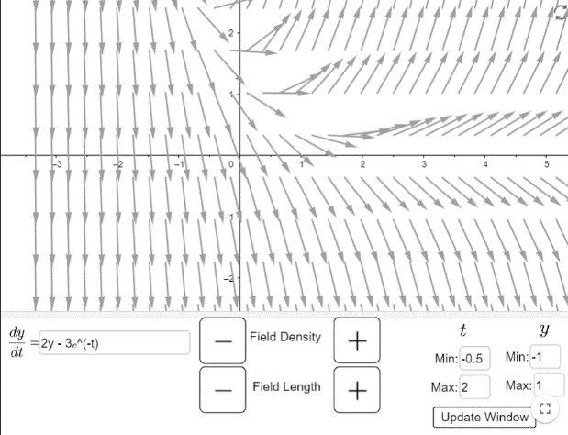

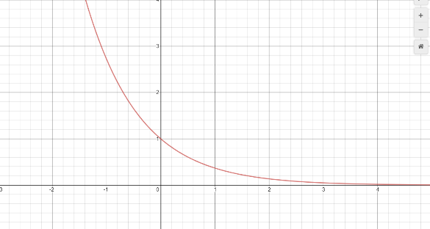B.

Solution Function

Slope Field

The long-term behavior of the solution function (in red) approaches zero at t increases whereas the Euler’s method approximation with step size of 0.5 (in blue) starts to approach zero but then approaches negative infinity very quickly. Since Euler’s method works from left to right, there is no way to get information about the solution function to the left of the initial condition of y(0)=1. This accounts for the left side of the red graph showing exponential decay. Since the solution function is concave up, this means that Euler’s method will give us an underestimate. Looking at the slope field above the Euler’s method solution graph, it looks like it is approaching zero for a little bit, but then since the approximated y values are less than the actual y values of the function, the slope field would push those values down toward negative infinity resulting in the blue graph. The solution function separates vectors that go to positive infinity and vectors that go to negative infinity, so any deviation away from the function as a result from the approximations in Euler’s method would result in the approximated solution function approaching either positive or negative infinity rather than zero.

Euler’s Method Approximation

C. To use the Runge Kutta method, we need to pick a step size h>0 and have yn+1=yn+(1/6)h(k1+2k2+2k3+k4) and tn+1=tn+h. We also have k1=f(tn, yn), k2=f(tn+h/2, yn+hk1/2), k3=f(tn+h/2, yn+hk2/2), and k4=f(tn+h, yn+hk3). Essentially tn+1=tn+h, is the same as Euler’s method. We are taking our t that we are at now and adding the step size to get to the next t. To find the y coordinate, Runge Kutta computes this a bit differently. It uses a weighted average of four increments rather than one slope over the entire step size. k1 is the slope at the beginning of the interval, which is what we use for Euler’s Method, k2 is the slope at the midpoint of the interval using y and k1, k3 is the slope at the midpoint using y and k2 and k4 is the slope at the end of the interval using y and k3. Using a weighted average allows us to give a greater weight to the midpoints (hence the 2 times k1 k3 in the formula for yn+1) where the slope of the step size is the most accurate to the actual equation. This method is better than Euler’s Method because it allows us to capture more information about the slopes to get a better approximation for yn+1. Euler’s method only uses the initial condition to calculate the slope and new y but this leaves a large gap in information and uses less accurate numbers for the entirety of the step size. By Runge Kutta using the weighted average at different points within the step size, we are able to get a more accurate slope which gives us a more accurate yn+1.

D.

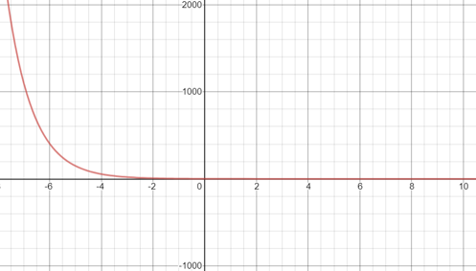Both the Euler’s Method and Runge Kutta graphs with a step size of 0.1 approach negative infinity as time increases. Neither exactly fit the path of the solution function. However, the Runge Kutta graph approximates the graph of the solution function longer than the Euler’s method graph does. As can be seen, the Runge Kutta graph approaches zero until about when t=9, when it exponentially decays towards negative infinity. This is in contrast to the Euler’s method graph where it only approaches zero until about t=6 and then decays towards negative infinity. If the approximations were perfect, both should approach zero as t goes towards infinity, but as stated in part B, the solution function y=e^(-t) separates vectors approaching negative and positive infinity meaning that any deviation (i.e. what happens in approximations) means that the approximated function will drastically stray away from the actual solution. Runge Kutta is able to give a more accurate approximation for longer since it takes the average rate of change over the 0.1 step size for each iteration so there is less of an error from iteration to iteration. Eventually, though, the error becomes large enough to push the approximation underneath the solution function so that it will pick up the vectors that point towards negative infinity.

1. To analytically analyze solutions to a differential equation means to use algebraic procedures to find the solution functions. This can include separation of variables, which involves integration techniques. We can also use the reverse chain rule, which is similar to separation of variables, but preserves meaning. Lastly, we can use the reverse product rule which involves both differentiation and integration techniques. To numerically analyze a solution means to use techniques, such as Euler’s method, to approximate a solution function. We are not finding the actual function, but we are able to get very close. To graphically analyze solutions to a differential equation would involve using a slope field to sketch the solution function. Again, we are not finding a numeric answer for the solution function, but we can use the sketch to glean information. We know that a function is a solution to a differential equation if its slope matches the slope field at every point at all possible initial conditions. In general, you would want to use the analytic approach when you want to find the actual solution function. However, there are not always ways to analytically find the solution. Graphical and numeric approaches always work but are not always the most accurate or may not give you the information you need. However, there are ways to make them more accurate, such as decreasing the step size in Euler’s method.
2. The integrating factors method is similar to the reverse product rule in that it requires the same format of the differential equation. It must be in the form dy/dx+p(x)*y=q(x). We then need to find the integrating factor which is found by taking e to the power of the integral of p(x). This is similar to the step when we need to solve for the function u with the reverse product rule. It is pretty much just a shortcut to use rather than thinking about how to find u using u’ and separation of variables. The next step with integrating factors is to write the equation d/dx(IF y)= IF q(x) where IF is the integrating factor. This is similar to when we rewrite uy’+u’y as (yu)’ on the left side of our equation with the reverse product rule. From there, we can integrate both sides with respect to x and solve for y to find an explicit solution just as we do with the reverse product rule. The reverse product rule is more conceptual and meaning base where as the integrating factor method uses ideas from the reverse product rule method but condenses them with a few shortcuts. Both methods will give you the same solution.
3. A.

|  |  |
| --- | --- |
| Tank B |  |
| Tank C |  |
| Tank D |  |

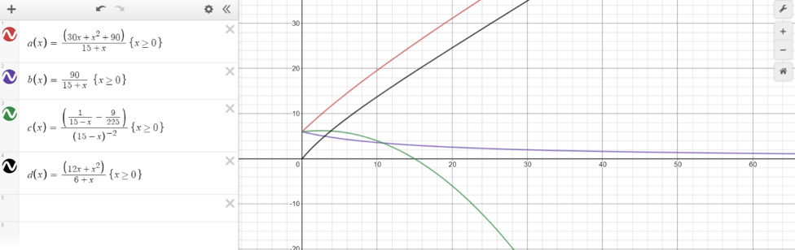B.

The red curve represents Tank A. As discussed in class, the concentration will become saltier but will eventually become linear. Tank D (black) is very similar to tank A as expected. It has the same kind of growth, but will be lower since we are starting out with pure water instead of salt water. This makes sense since adding the same amount of salt to Tank A vs Tank D will result in Tank A being saltier since there is already salt in in. Tank C (green) makes sense since more water is leaving each minute than coming in. Eventually, there will be no more water in the tank so the concentration would be 0. Tank B (purple) makes sense since it’s decreasing. Since we are pumping pure water into the tank, it makes sense that the concentration of salt would become more diluted. Eventually, there will be very little, if any, salt in the tank since it’s being “flushed out” by the pure water.

1. 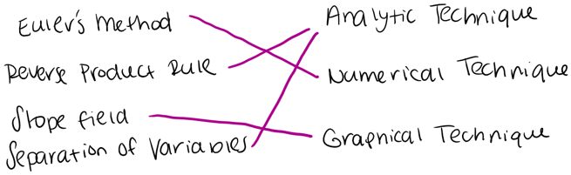
2. A. analytic approach, differential equation, Euler’s method, slope field, equilibrium solution, initial condition, initial value problem, integrating factor, numerical approach, graphical approach, reverse product rule, Runge Kutta method, separation of variables, separable differential equation, general solution, particular solution, exact solution

B. none