# Homework Set 5

1. The planes will never have a midair collision and the initially higher one will never get below the initially lower one. Taking the partial derivative with respect to h of dh/dt=-h^1/3 yields df/dh=-1/3h^(-2/3). The partial derivative of the rate of change function has a discontinuity at h=0 meaning that if this is in the rectangle, we cannot apply the Uniqueness Theorem. However, we don’t want to include h=0 in the rectangle since we are concerned about a midair collision. If we place our rectangle just above 0, there are no discontinuities in the partial derivative of the rate of change function, so the solution functions are unique. This means that the two planes will never collide and the higher one can’t be below the lower one since they would have to collide to do so. A second argument would be that since the differential equation is autonomous, we know that all solutions are horizontal translations of each other. This means that the solution functions will never cross since we are translating each h value over. The only case where it would overlap is at h=0, but we are not concerned about this since it is when the planes are on the ground.
2. Considering the differential equation dP/dt=0.3P(1-P/12.5), we can take the partial derivative of dP/dt with respect to P and get *df/dP*=0.3-0.6P/12.5. This partial derivative represents the equation for a line which is continuous everywhere no matter where the rectangle is in the P vs t plane, so the conditions of the theorem are met. This means that we can apply the uniqueness theorem and conclude that each solution function is unique. This means that the population will never reach 12.5 since that would mean that we would have a solution function intersecting the equilibrium solution which would mean that the functions are not unique. The population will approach 12.5 but will never actually reach it.
3. A. Considering the differential equation dL/dt=.5(1-L), we can take the partial derivative of dL/dt with respect to L since dL/dt is continuous. This gives df/dL=-0.5 which is a constant function which is continuous everywhere so no matter what our rectangle is in the L vs t plane, our partial derivative will be “nice”. This means that the uniqueness theorem applies, meaning that all solution functions are unique to one another. In other words, this means that graphs of solution functions will never touch the equilibrium solution at L=1.

B. Considering the differential equation dy/dt=.3y(1-y/10), we can take the partial derivative of dy/dt with respect to y since dy/dt is continuous. This gives df/dy=.3-.6y/10. The partial derivative represents the equation of a line which is continuous everywhere so no matter what our rectangle is in the y vs t plane, our partial derivative will be “nice”. So, for both positive and negative values of t, this means that the uniqueness theorem applies, meaning that all solution functions are unique to one another. In other words, this means that graphs of solution functions will never touch the equilibrium solution at y=10 or at y=0.

C. There are no equilibrium solutions for the solution functions to touch since dy/dt is only in terms in t. We know that all solution functions are unique though since taking the derivative with respect to y of dy/dt yields a constant function of 0 which is continuous everywhere so no matter what our rectangle is, the partial derivative is continuous meaning that the Uniqueness Theorem applies.

D. Considering the differential equation dy/dt=y^1/2, we can take the partial derivative of dy/dt with respect to y since dy/dt is continuous. We get df/dy= $\frac{1}{2\sqrt{y}}$. The partial derivative has a discontinuity at y=0 meaning that df/dt is not continuous so if we have a rectangle around 0 in the y vs t plane, our partial derivative is not “nice”. Because of this, we cannot apply the uniqueness theorem, so the theorem does not tell us if the solution functions are or are not unique. Knowing this, it could be possible for solution functions to touch the equilibrium solution of y=0. We need to use separation of variables to figure out if it touches the equilibrium solution. Now we need to ask ourselves, does the general solution function with any constant ever touch the equilibrium solution at y=0. For example, choosing C=2 gives the equation 0=(1/2t+1)^2. We get that y(t)={0 for t<=-2 and (1/2t+1)^2 for t>-2} based on the slope field. This means that the solution function will touch the equilibrium solution of y=0. Other C values would produce similar results.

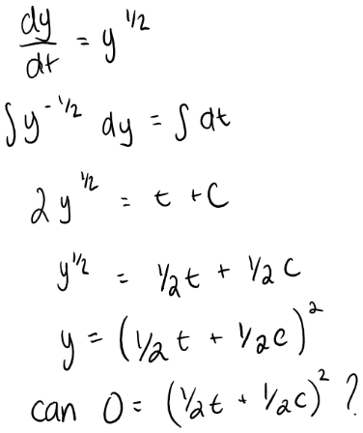

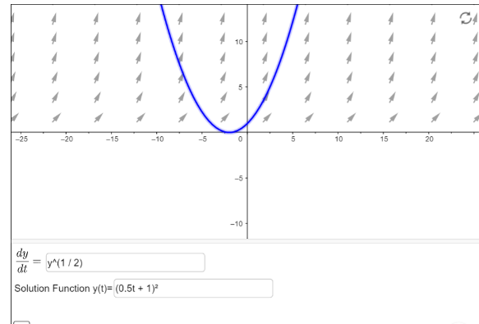

1. The first step to this problem would be to consider if the uniqueness theorem applies. This was done in question 3A and I found that we can apply the uniqueness theorem meaning that all solution functions will never cross one another at any point. This means that the student who starts out knowing none of the list will never catch up to the student who knows 1/3 of the list. Since the student who knows none of the list’s solution function starts out below the student who knows 1/3 of the list’s solution function, in order for them to catch up the two solution functions would need to cross at some point which is impossible based on the uniqueness theorem. Both functions will approach the equilibrium solution at L=1 but will never touch. The solution function of the student who starts off knowing nothing will always be slightly below the solution function of the student who starts off knowing 1/3 of the list as t increases.
2. 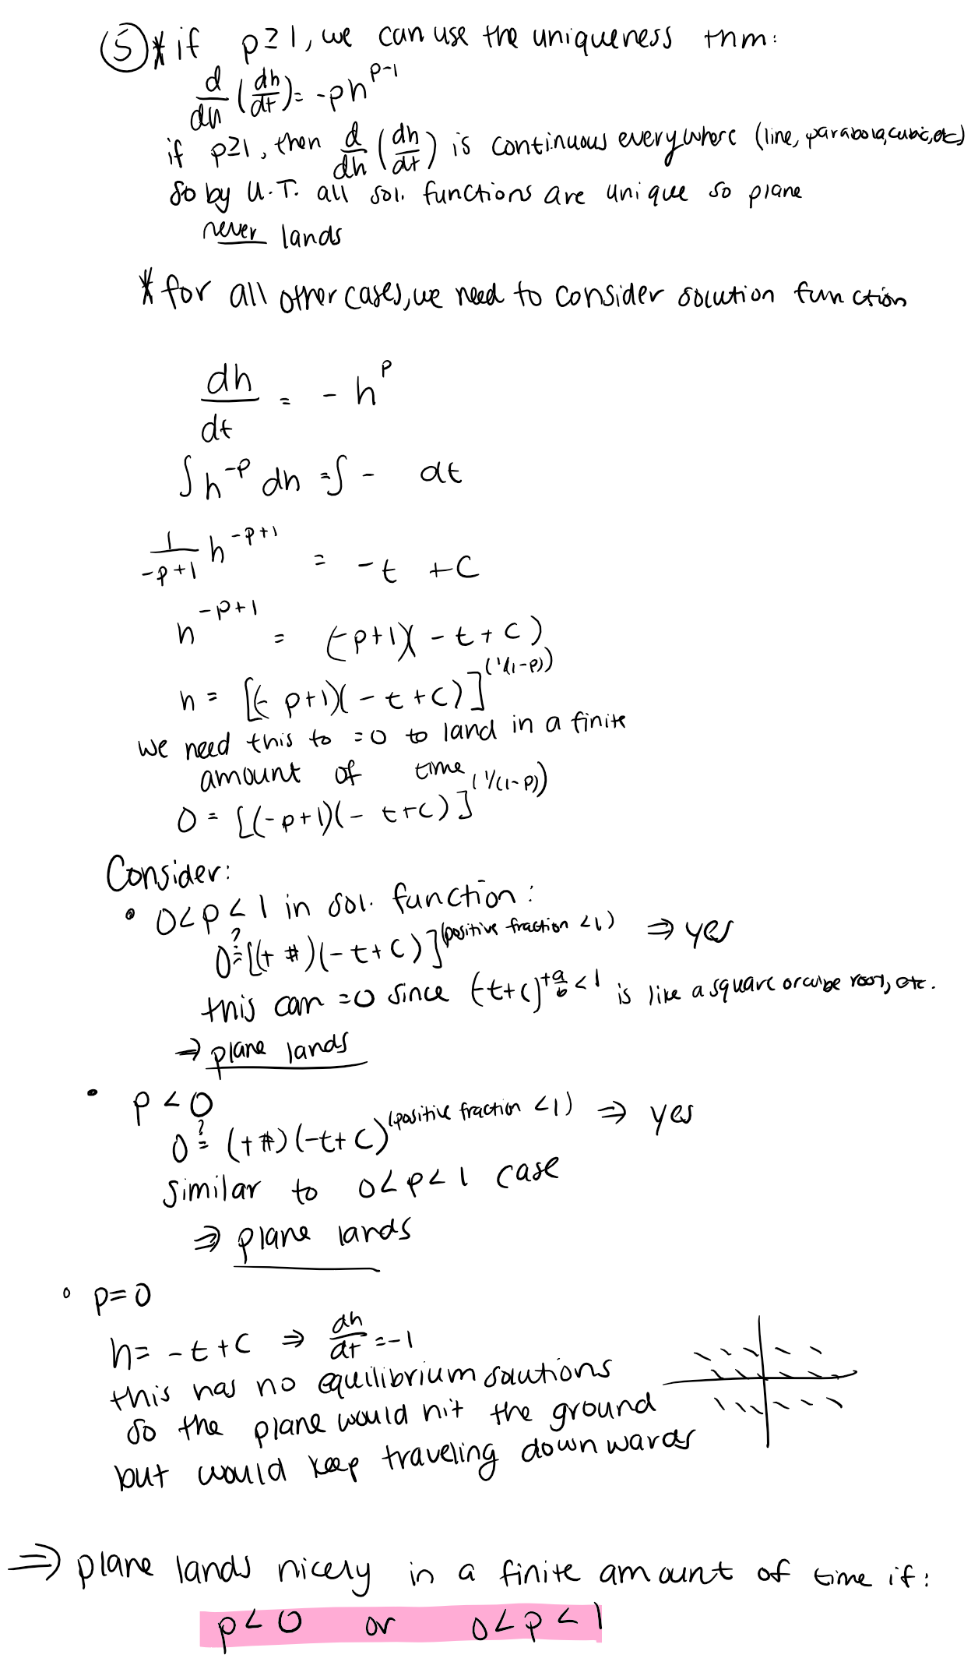
3. 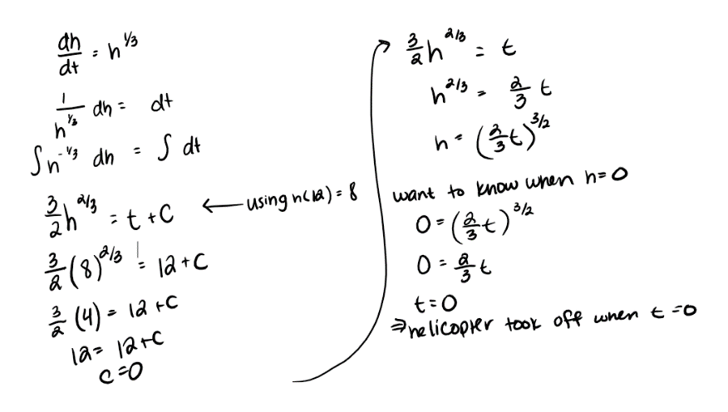h(12)=8 means when time is equal to 12 units (seconds, minutes, hours…), the helicopter is 8 units (feet, miles, etc.) above the ground. According to the math below, the helicopter took off when time is equal to 0. We needed to know that h(12)=8 to determine when the helicopter took off because if we were only given the initial condition of h(0)=0, we would not know if it ever took off since h=0 is an equilibrium solution. Since we knew that h(12)=8, we knew that the helicopter had to lift off from the ground rather than staying grounded for all t.

***NOTE: In the student’s exemplar work there is a computation error. The correct value of c is -6. Continuing onward with this one would find that the helicopter took off at t=6 (not t=0).***

1. A. Since the partial derivative of the rate of change function is undefined at y=0, the Uniqueness Theorem tells us nothing since it can not be applied. It does not tell us whether or not the solution functions ever cross the equilibrium solution at y(t)=0.

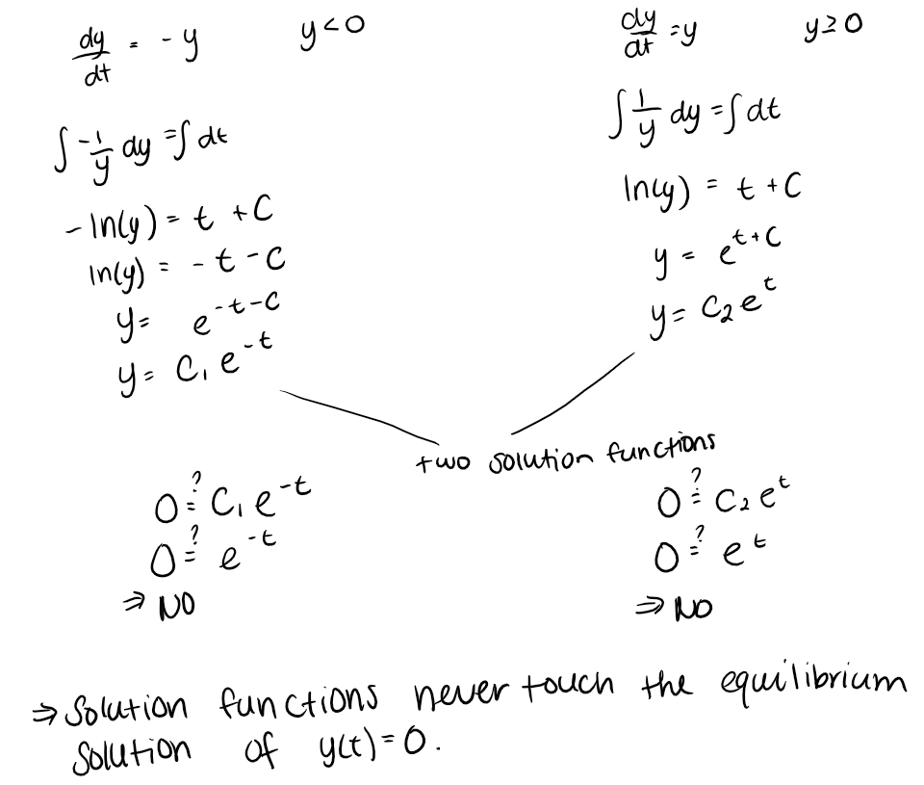B.

1. A. analytic approach, differential equation, equilibrium solution, initial condition, initial value problem, separable differential equation, separation of variables, particular solution, uniqueness theorem

B. none