# Homework Set 6

|  |  |
| --- | --- |
| i.  This graph can be interpreted in terms of prototypical solutions since there are two branches separated by the equilibrium solution at y=0. I found the equilibrium solution of y=0 by setting dy/dt equal to zero. I then found the other branches of solution functions by plugging in numbers just above zero and just below zero into the differential equation. I found that above zero, dy/dt is negative so the function is decreasing and below zero, dy/dt is positive so the function is increasing. All prototypical graphs are just horizontal translations of each other depending on the value of C due to different initial conditions. All graphs will look the same and have the same shape; they are just horizontal shifts. | ii.  This graph can be interpreted in terms of prototypical solutions since there are three branches separated by two equilibrium solutions at y=0 and y=2. I found the equilibrium solutions of y=0 and y=2 by setting dy/dt equal to zero. I then found the other branches of solution functions by plugging in numbers just above zero and below two, above 2, and just below zero into the differential equation and seeing if the rate of change function was positive or negative indicating an increasing or decreasing solution function respectively. All prototypical graphs are just horizontal translations of each other depending on the value of C due to different initial conditions. All graphs will look the same and have the same shape; they are just horizontal shifts. |
| iii.  This graph can be interpreted in terms of prototypical solutions since there are three branches separated by two equilibrium solutions at y=-1 and y=3 I found the equilibrium solutions of y=-1 and y=3 by setting dy/dt equal to zero. I then found the other branches of solution functions by plugging in numbers just above -1 and below 3, above 3, and just below -1 into the differential equation and seeing if the rate of change function was positive or negative indicating an increasing or decreasing solution function respectively. All prototypical graphs are just horizontal translations of each other depending on the value of C due to different initial conditions. All graphs will look the same and have the same shape; they are just horizontal shifts. | iv.    This graph can be interpreted in terms of prototypical solutions since there are two branches separated by the equilibrium solution at y=0. I found the equilibrium solution of y=0 by setting dy/dt equal to zero. I then found the other branches of solution functions by plugging in numbers just above zero and just below zero into the differential equation. I found that above zero, dy/dt is positive so the function is increasing and below zero, dy/dt is positive so the function is also increasing resulting in a node at y=0. All prototypical graphs are just horizontal translations of each other depending on the value of C due to different initial conditions. All graphs will look the same and have the same shape; they are just horizontal shifts. |

|  |  |  |
| --- | --- | --- |
| Part | Differential Equation | Explanation |
| A | dy/dt=(y-4)(y-2) | I noticed that since the slopes are the same horizontally, then the differential equation must be autonomous. There are also two equilibrium solutions, one at 4 and the other at 2. I knew that above 4 the slopes must be positive according to the slope field, so plugging in a number greater than 4 confirms this. Between 2 and 4 the slopes are negative and below 2, the slopes are again positive. 2 would be an attractor and 4 would be a repeller. |
| B | dy/dt=(t+1)(t-2) | I noticed that slopes are the same vertically, so the differential equation should only depend on t, thus there are no equilibrium solutions. To follow the general shape of the slope field, the solution function looks to be cubic so the differential equation needs to be a quadratic. I also noticed that the slope equaled zero when t=-1 and t=2 which is why I chose factors that would give me this. |
| C | dy/dt=t-y | I noticed that slopes are not the same horizontally or vertically, so there needs to be a y and a t in the differential equation. The slope is zero when y=t so we either want y-t or t-y. Since the slopes are negative when y>t and positive when t>y, then we wanted to choose t-y. |
| D | dy/dt=y-t^2 | I noticed that slopes are not the same horizontally or vertically, so there needs to be a y and a t in the differential equation. There are also no equilibrium solutions. Since it looks like y=t^2 is a solution and the slope is zero when t=y=0 I could either choose y-t^2 or t^2-y. Based on the slopes, I chose the first one since when y is bigger than a value of t squared, the slopes are still positive. |

|  |  |  |
| --- | --- | --- |
| Part | Differential Equation | Explanation |
| A | dy/dt=(t-2)(t-4)(t-6) | At first, I thought about how the attractors and repellers could be laid out. Originally, I thought about  putting the repeller in the middle, but then this would result in two attractors if we only had three constant solution functions. This led me to put the one attractor in the middle. I then chose 3 random numbers, (2,4,6) and played around with the sign of them to see if plugging in numbers just above and below each equilibrium solution resulted in the correct sign the corresponds to the direction of the arrow in the phase line. This can be seen with the check marks. This took a couple of tries changing around the plusses to minuses, but eventually I got it to work. |
| B | dy/dt=(t-2)(t-4)^2 | The first thing I did was draw what I wanted the prototypical solution function graph to look like. I made the equilibrium solution y=4 a node by making the top branch increase away from y=4 and the middle branch increase towards y=4. To make y=2 a repeller, making the middle branch increase took care of half of it and then I made the bottom branch go away from y=2. Then I plotted the behavior of these on a dy/dt vs y graph. I noticed that above 4, the solution function was increasing, so dy/dt has to be positive. I plotted a turning point at 4 since dy/dt=0 at y=4, but still needs to be positive on either side. Below 2 on the solution function, the function is decreasing so dy/dt is negative. This produced a cubic looking function on the dy/dt graph so I used this to create dy/dt=(t-2)(t-4)^2. |
| C | Not possible | This case is not possible. I started out by making the branches above y=4 and below y=2. To be an attractor, these two branches needed to approach the equilibrium solution. For the middle branch there are two possibilities: one increasing and one decreasing. This produces one attractor and one node in both cases. To get two attractors, the middle branch would need to look like a sideways u but this is not possible because it wouldn’t be a function so this whole case is not possible. |

1. 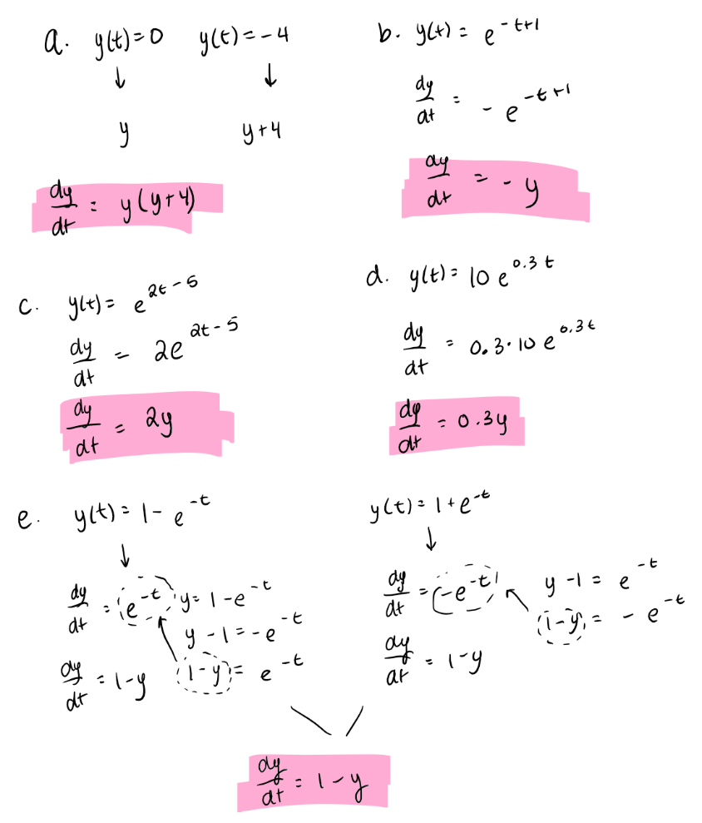
2. It is essential for the differential equation to be autonomous because the phase line only accounts for changes of values of y in dy/dt. If t is changing, we would not be able to account for this on the phase line. In addition, if it is not autonomous then all of the solution functions would not be horizontal shifts of each other so we could not account for an infinite amount of prototypical solutions in one 1-D model.
3. [Answers will vary]
4. A. autonomous derivative graph, autonomous differential equation, differential equation, equilibrium solution, graphical approach, slope field, general solution,

B. prototypical solution, phase line