# Homework Set 7

1. 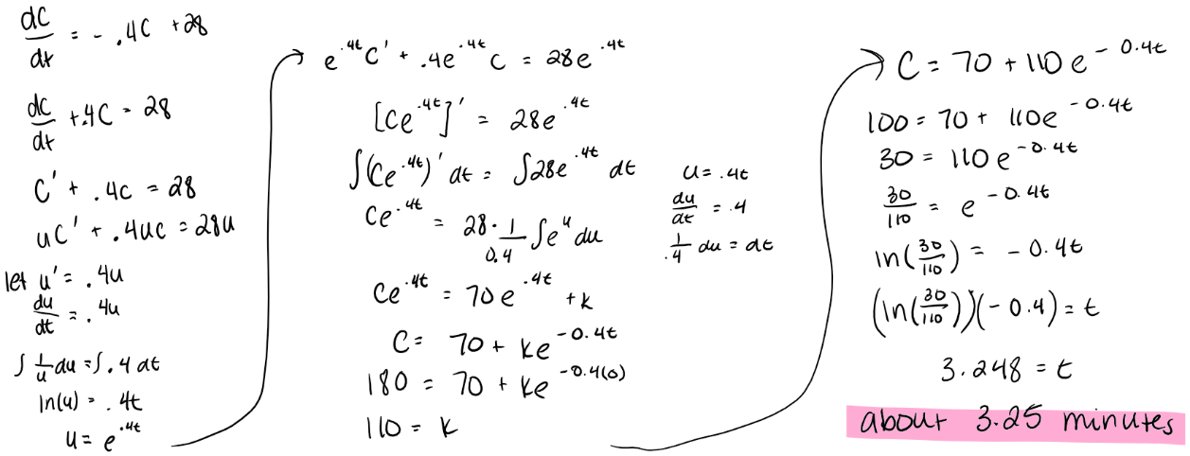A. Considering the rate of change equation for the cup of coffee, we want to find out if the cups of coffee will ever reach the same temperature. We can take the rate of change of the rate of change with respect to C and get d/dy(d/dt) =-0.4. This is a constant function which is continuous everywhere. This means that no matter where we place our rectangle on the C vs t plane, our partial derivative will behave “nicely.” Since the rate of change of the rate of change is continuous everywhere, we are able to apply the Uniqueness theorem to conclude that all solution functions are unique. This means that the two cups of coffee will never be the exact same temperature. This also means that the functions will never hit the equilibrium solution at C=70 meaning that the two cups will never truly reach room temperature but will only be infinitesimally close. The cups of coffee that began at 160 will always be slightly cooler than the one that started at 180. In reality, this doesn’t really hold long term. There is nothing stopping the cup of coffee from hitting room temperature, so our model isn’t an accurate prediction as t gets bigger.



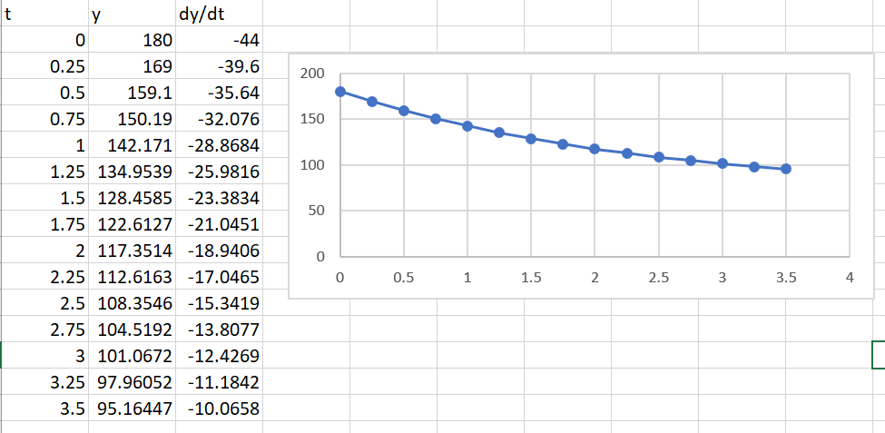

Through the reverse product rule, I found that it will take approximately 3.25 minutes for the coffee to reach 100 degrees. In Euler’s method, I found that it would take somewhere between 3 and 3.25 minutes. This is very close to the other answer. It makes sense that the answer for Euler’s method would be slightly less since the solution function is concave up so it would produce and underestimate. This means at the time =3.25, the reverse product rule gave 100 degrees whereas Euler’s method gave 97.9 degrees.

|  |  |
| --- | --- |
| If initial condition is above 3, the long-term behavior will tend towards infinity. If the initial condition is between 2 and 3, the long term behavior will decrease towards y=2. If the initial condition is between -3 and 2, the long-term behavior will increase towards y=2. If the initial condition is below -3, then the long-term behavior will decrease to negative infinity. If the initial condition is -3, 2 or 3 then the long-term behavior will remain constant at that value. | If the initial condition is above 3 then the long-term behavior will decrease towards y=3. If the initial condition is between 0 and 3, then the long-term behavior will increase towards y=3. If the initial condition is between -2 and 0 then the long-term behavior will increase towards y=0. If the initial condition is below -2 then the long-term behavior will decrease towards negative infinity. If the initial condition is 3, 0 or -2 then the long-term behavior will remain constant at that value. |

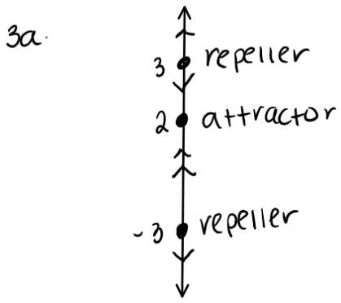

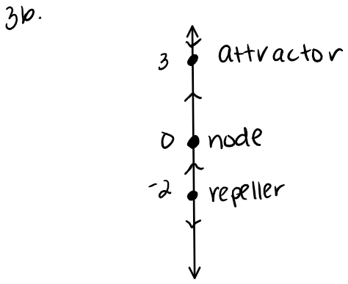

2. Taking the partial derivative with respect to y of the rate of change function dy/dt will yield a cubic function with negative end behavior. Since polynomials are defined to be continuous everywhere and a cubic function is a polynomial, then the partial derivative is continuous everywhere. This means that no matter where we choose our rectangle, the partial derivative with respect to y will always be continuous. So, by the uniqueness theorem, all solution functions are unique meaning that none of the nonconstant solution functions will ever reach the equilibrium solution, y=0 in a finite amount of time.
3. First you should find where the equilibrium solution functions. These occur when the autonomous derivative graph crosses the horizontal axis. Plot these values as constant functions on the solution function graphs. Next, figure out where the autonomous derivative graph is above the horizontal axis. This translates into the solution function increasing between two equilibrium solutions. Next, find where the autonomous derivative graph is below the horizontal axis. This translates into the solution function decreasing between the two equilibrium solutions. Lastly, remember that the autonomous derivative graph represents an infinite amount of solution functions since they’re all horizontal translations of each other.
4. 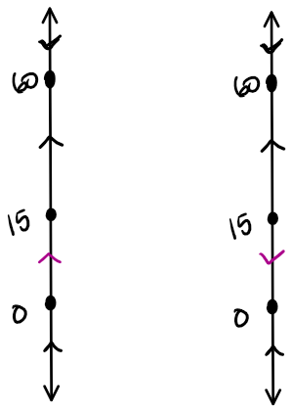A.

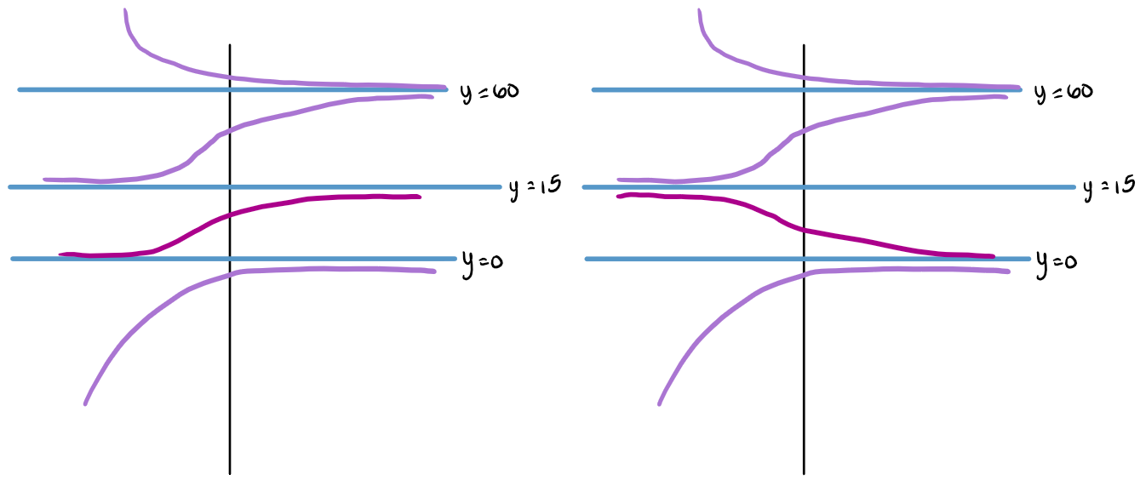 B.

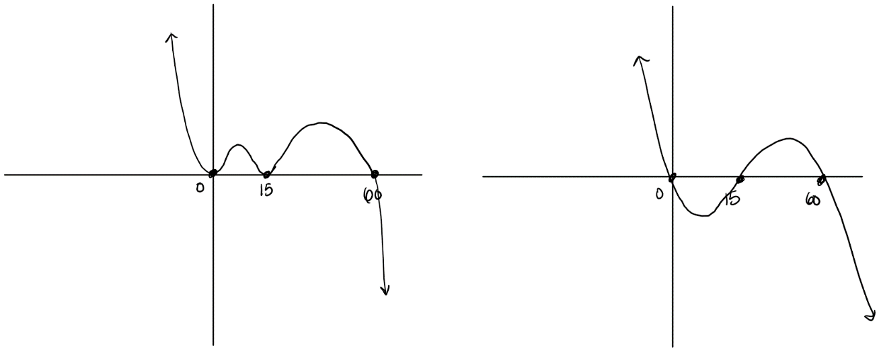 C. Left: dy/dt=-y^2(y-60)(y-15)^2

Right: dy/dt=-y(y-60)(y-15)

1. The letter y is like a variable since you can plug in a specific value and get out a unique dy/dt. The letter y is like a function since it represents a solution function to the differential equation. We just write y rather than y(t). dy/dt is like a function since it becomes the dependent variable based upon values of y. It shows that you can plug in any y and get a dy/dt value.
2. The cooling coffee problem reflects Newton’s Law of Cooling since we can consider the object in Newton’s Law of Cooling to be the cup of coffee and it is immersed in a room with a constant room temperature. In the cooling coffee problem, we created an equation which models how the cup of coffee cools at a rate proportional to the difference in its temperature and the room temperature. The proportional aspect of this shows up in Newton’s law of cooling as the k, or the coefficient being multiplied outside of the parentheses, and the difference between the temperature of the coffee and the room shows up as C-70 where C is the temperature of the coffee and 70 is room temperature.
3. We can apply Newton’s Law of Cooling to this situation which gives us dB/dt=k(B-R) where B is the temperature of the body, R is the room temperature and k is a constant reflects that the rate is proportional to the difference in temperatures between the body and room. Knowing the room temperature allows us to replace the R parameter with the actual room temperature. From there, we can find solutions to the differential equation which will give us a solution that looks like B-R=Ce^(kt). We now need to solve for k and C since these are the only two parameters we don’t know yet. We can use the temperature of the body at two different times to do so. If we plug these values in for B and t in two separate equations, we can figure out k and C by setting up a system of equations and solving for one variable at a time. Since we now know all of the parameters, R, C, and k, we can set B=98.6 in the equation and solve for t to estimate the time of death.
4. A. False. If the autonomous derivative graph has a vertical tangent at a point, this means that the rate of change of the rate of change is not defined at that point, which means that the uniqueness theorem does not apply. We cannot determine or guarantee that solutions will touch or cross at this point by using the uniqueness theorem.

B. True. Since the uniqueness theorem requires that we take the rate of change of the rate of change, this will result in another polynomial function (could be constant or of a higher degree) which is always continuous. This means that we can apply the uniqueness theorem and conclude that all solutions to the differential equation are unique everywhere.

1. A. analytic approach, autonomous derivative graph, autonomous derivative equation, differential equation, equilibrium solution, initial condition, initial value problem, qualitative approach, separable differential equation, separation of variables, explicit solution, particular solution, general solution, exact solution, uniqueness theorem

B. Newton’s Law of Cooling, phase line