# Homework Set 8

1. A. When k = 12 there are two equilibria, P=10 and P=15. 15 is a stable equilibrium and 10 is unstable. So for an initial population of 25 the population will decrease towards 15.

B. No matter what initial population they have, the population of fish will decrease until there are no fish left.

C. No. This is because if we consider the population levels in part A, the population of 5 is not in the range of values that would lead to a positive dy/dt meaning that the population cannot increase any more past 5. In fact, it will actually decrease until the population is equal to zero.

1. 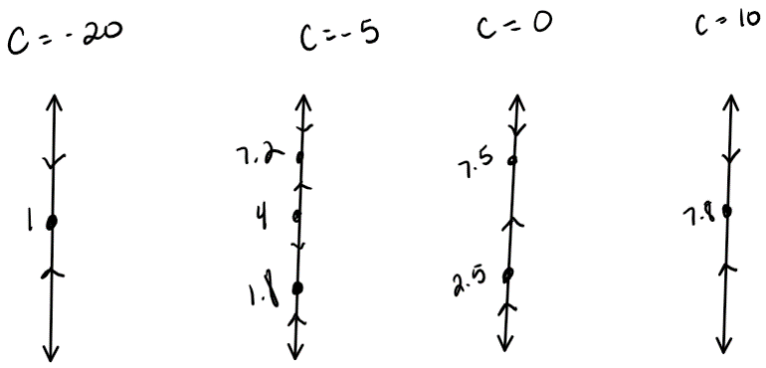A.

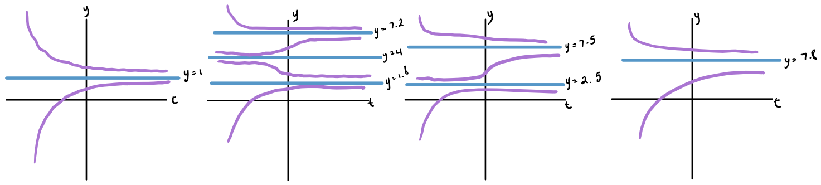B.

C. There are two attractors when -15<c<0.

D. It would not be possible for the whole curve to be stable since that would mean that it would have to approach two equilibrium solutions at once which isn’t possible; it can only choose one. It would have to move to two values at once which would imply that we have a repeller in between.

E. We should choose c=-3

F. i. It would approach 1.5.

ii. It would approach 7.8.

iii. No, it wouldn’t since it would approach 6.8 rather than 1.5. In other words, it is approaching a different equilibrium solution than in 2fi.

1. 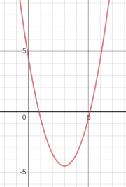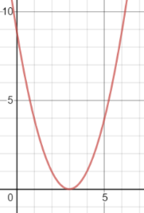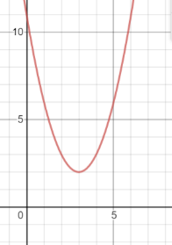 A.

When r is positive, there are no equilibrium solutions. All parts of the solution function are increasing When r=0 there is one equilibrium solution at 3, and other than this point all parts are increasing. This equilibrium solution is a node. When r is negative there are two equilibriums. The left one is stable, whereas the right one is unstable. To the left of the left equilibrium solution and to the right of the right equilibrium solution, the solution function is increasing. Between the two equilibrium solutions, the solution function is decreasing. The equilibrium solutions get farther apart the lower r becomes. The precise value of r that affects the equilibrium solutions is r=0.

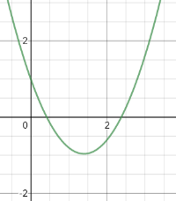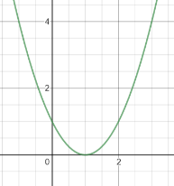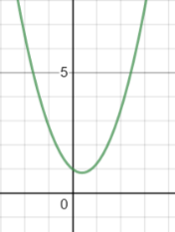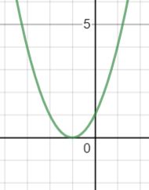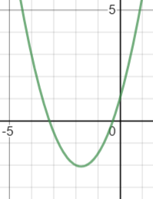B.

When r<-2 we have two equilibrium solutions (one stable, one unstable) and the solution function is increasing on either side of the equilibrium solutions and decreasing for values between them. When r=-2, we have one equilibrium solution (node) and the solution function is increasing everywhere but -2. When -2<r<2, we have no equilibrium solutions and the solution function is increasing everywhere. When r=2, we have a node and the solution function is increasing everywhere but -2, and when r>2, we have two equilibrium solutions (one stable, one unstable) and the solution function is increasing on either side of the equilibrium solutions and decreasing for values between them. The bifurcation values are r=2 and r=-2.

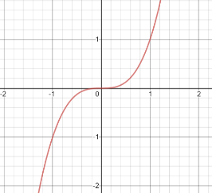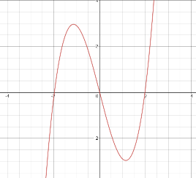

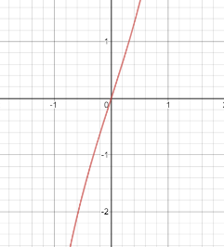C.

When r>0, we have one equilibrium solution at y=0. This equilibrium solution is unstable. When r=0, we have one equilibrium solution at y=0 and is also unstable. The solution function is decreasing to the left of y=0 and increasing to the right of y=0 for both of these values of r. When r<0, we have three equilibrium solutions. We have one at y=0 that will always occur no matter what the value of r is. This equilibrium solution is stable unlike when r>0 or r=0. We also have two other equilibrium solutions that vary depending on the value of r. The one on the left is unstable and so is the one on the right. The solution function is decreasing to the left of the left equilibrium solution, increasing between the left equilibrium solution and y=0, decreasing between y=0 and the right equilibrium solution, and increasing to the right of the right equilibrium solution.

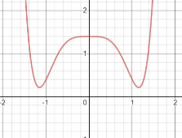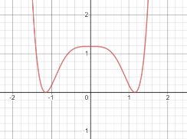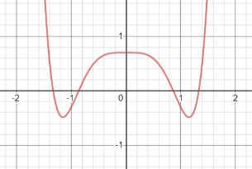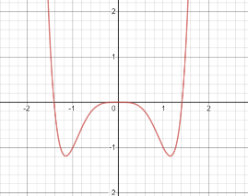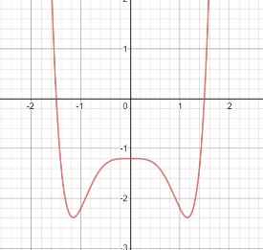D.

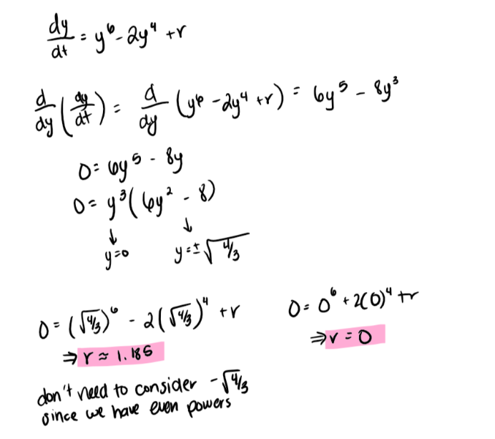When r<0 we have two equilibrium solutions. The one on the left is stable, whereas the one on the right is unstable. When r=0, we go from having two equilibrium solutions to having three. The left equilibrium is stable and the right is unstable. The middle equilibrium solution at y=0 is a node. When 0<r<1.185, we have four equilibrium solutions. The far left one is stable, the second from left is unstable, the second from right is stable, and the far right is unstable. When r=1.185, we go from having four equilibrium solutions to two. Both equilibrium solutions are nodes. When r>1.185, there are no equilibrium solutions and the solution function is increasing everywhere. The two bifurcation values are 0 and 1.185.

1. 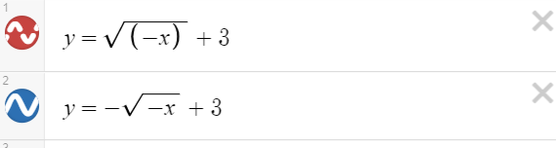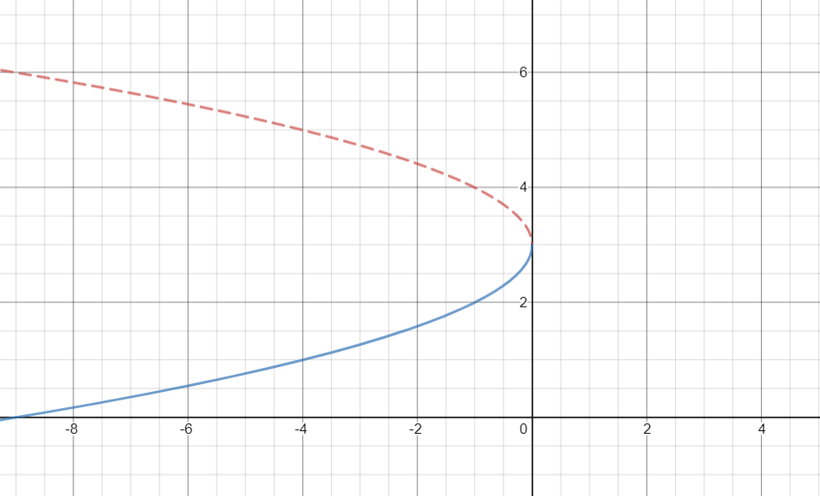

The bifurcation value would be at r=0 since that is where we go from 2 to 1 to no equilibrium solutions.

1. 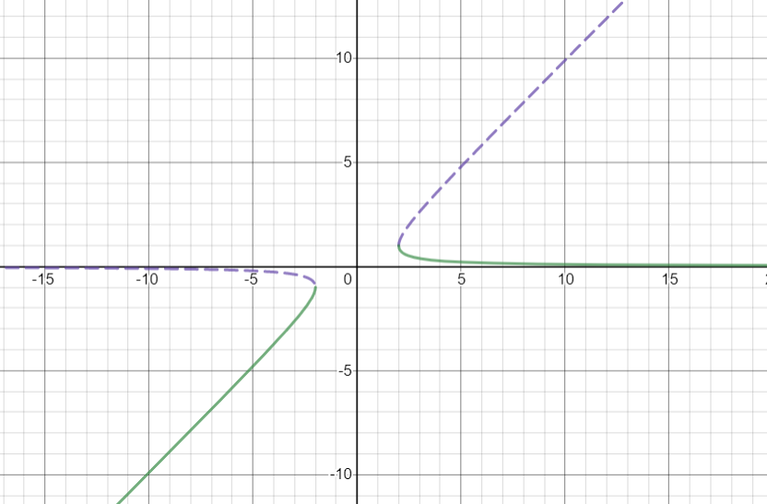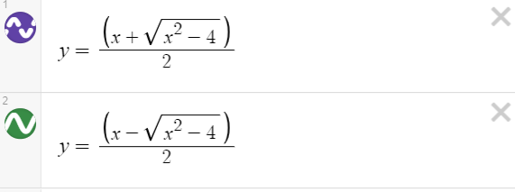

The bifurcation values are at r=2 and r=-2.

1. 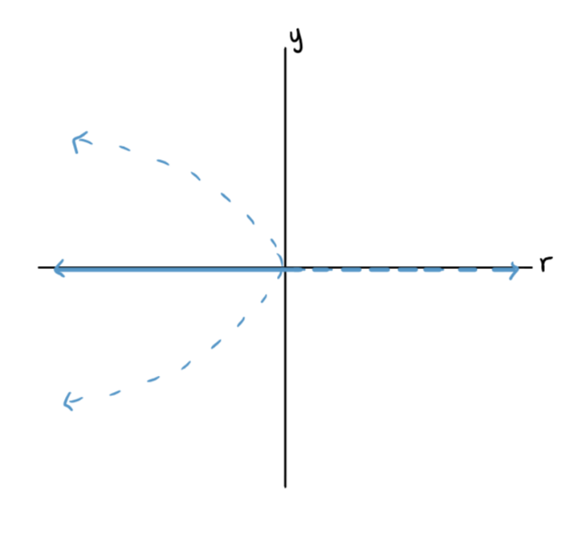

The bifurcation value is r=0. This might be called a pitchfork bifurcation because r branches off from unstable to unstable and stable when r goes from positive to negative. This looks like a pitchfork from right to left.

1. A. autonomous derivative graph, autonomous differential equation, bifurcation diagram, bifurcation value, differential equation, equilibrium solution, initial condition

B. stable, unstable, node, phase line