# Homework Set 9

1. A. 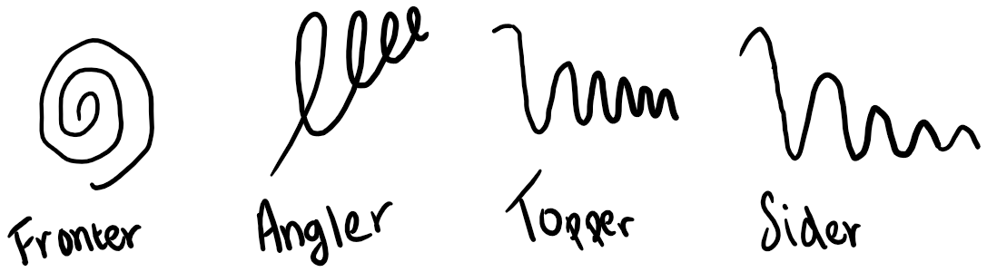

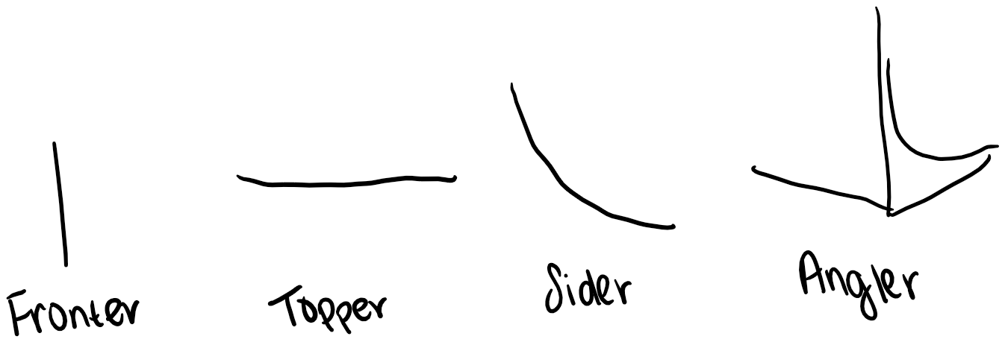

B.

1. 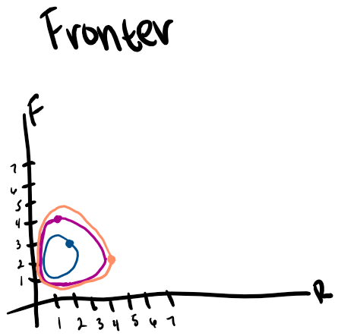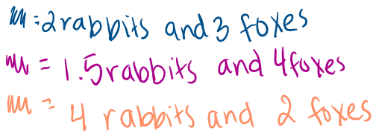

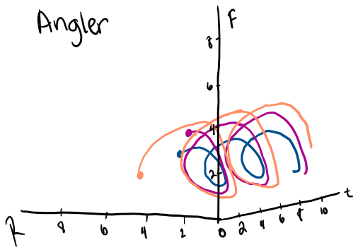

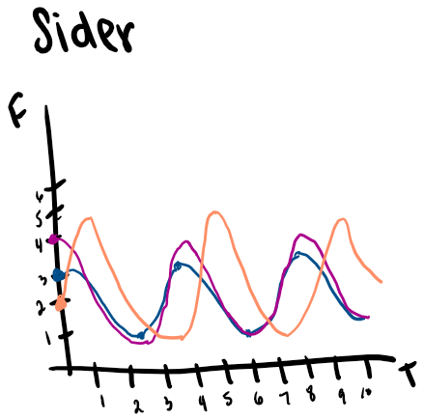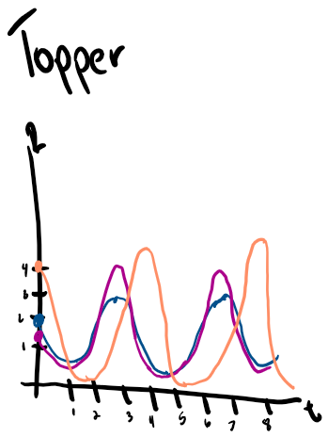

1. A. The future number of foxes will decay exponentially, and the future number of rabbits will remain zero. This is because if we plug in the initial condition into dR/dt we will get dR/dt=0. This means that there is no change over time, so the rabbit population is unable to change from the initial condition. Since the initial condition of rabbits was 0, a rate of change of 0 means that the rabbit population will stay at 0. For the foxes, plugging in R=0 to dF/dt gives dF/dt=-F. This represents exponential decay as a solution function, so the fox population will begin at 2 then decay exponentially and will eventually approach zero.

B.

|  |  |
| --- | --- |
| Angler    The right part of the graph shows that the fox population is declining exponentially with an initial population of 2. The left portion of the graph shows that the rabbit population remains at 0 since there is no curve showing any sort of growth over time. | Sider    This graph compares the population of foxes over time. It shows an initial population of 2, and then exponential decay after. This makes sense since dF/dt=-F which represents exponential decay for a solution function. |
| Topper    This graph represents the population of rabbits over time. We can see that as time increases the number of rabbits remain at 0. This makes sense since dR/dt=0 so the rate of change is 0 meaning that whatever the initial condition is (in this case 0) stays the same regardless of time. | Fronter    This graph shows the population of foxes versus the population of rabbits with both curves implicitly being dependent on time. Looking at the behavior of the red line and the vertical axis, we can see that from the initial condition of 2, the population of foxes approaches 0 which was what we predicted. Looking at the horizontal axis there is no growth or decay of the rabbit population; it simply remains at 0 since there is no line along the horizontal axis showing any growth or decay. |

C. The system of equations predicts that the population of rabbits remains at 0 and the population of foxes decays exponentially from 6. The reasoning is very similar to part A. This is because the initial population of rabbits in this case is still zero resulting in the same differential equations as in part A. They are dR/dt=0 and dF/dt=-F. This means that the population of rabbits will remain extinct and the population of foxes will decay exponentially. The only difference between this scenario and part A is that since we are starting with an initial population of 6 here, it will take a little bit longer for the fox population to decay to 0.

1. A. I chose iii for part a since there is only one equilibrium solution at (0,0). This narrows down the choices to i, ii, or iv but I am choosing iv for part b, so it is narrowed down to i or ii. If we look at the graph, it appears that there are y nullclines along the line y=-x. This would happen when dy/dt=x+y which appears in choice iii. In addition, I tested a few other points with iii and their slopes and direction matched up.

B. I chose iv for part b since if we consider dy/dx=(2x+2y)/(x+y), this reduces to 2. This means at every point, the slope is 2 which is true for graph b. The only variation in the vectors is the direction, but this can be calculated by looking at the signs of dy/dt and dx/dt at each point. For example, at (1,1) dx/dt=2, dy/dt=4 so dy/dx=2 and the vector points up and to the right since dy/dt and dx/dt are positive. For (-1,-1), dx/dt=-2, dy/dt=-4, dy/dx=2 but since dy/dt and dx/dt are negative the vector points down and to the left.

C. I chose ii for part c since on the graph it appears that there are two equilibrium solutions. There is a saddle at (0,0) and a center at approximately (11,9). Choice ii is the only possibility that will produce two equilibrium solutions since it is the only one that has an “xy” term. This will give two solutions to the system of equations when dx/dt=dy/dt=0 since you would factor out an x or y depending on the equation and then you would set each factor equal to zero.

1. A. System A describes a cooperative species since the interaction terms are both positive. This means as y increases, it has a positive effect on dx/dt and as x increases, it has a positive effect on dy/dt. Conversely, system B is competitive since the interaction terms are negative. This means as one population increases, it has a negative impact on the rate of change of the other population, so their population decreases.

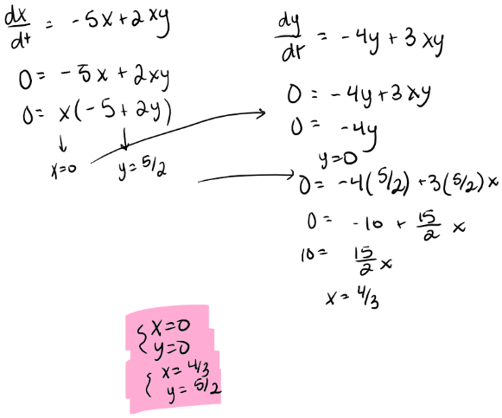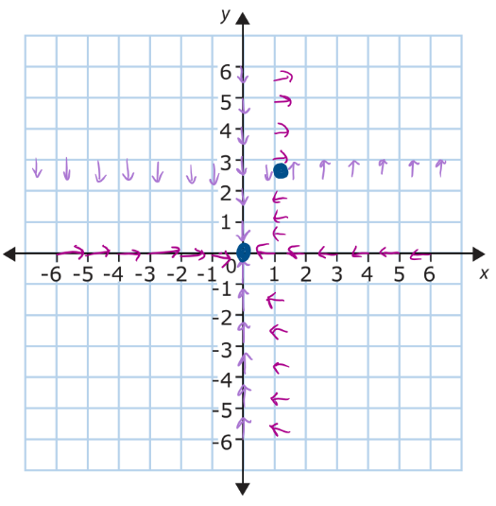B.

C. If we break the first quadrant up into four sub quadrants based on where the nullclines intersect, the behavior of the system depends on where the initial condition is placed in the four quadrants. If the initial condition is in the bottom left quadrant, both populations will approach 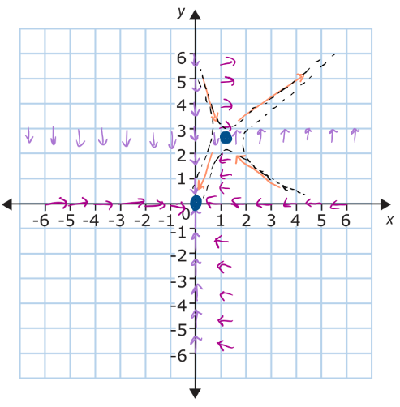the equilibrium solution at (0,0) meaning that both populations go extinct. If the initial condition is in the upper right quadrant, both populations tend away from the equilibrium solution at (4/3, 5/2) and grow indefinitely. If the initial condition is in the upper left quadrant, there are two possibilities. In both, the populations will approach the equilibrium solution but then one will turn away and continue to grow whereas the other will continue to decrease towards extinction. This is similar to what will happen if the initial condition is in the bottom right quadrant. They will both approach the equilibrium, but then one scenario is that both populations will turn away and decrease towards extinction and the other scenario is that they turn away from equilibrium and continue to grow.

1. A. In both of the systems, x represents the prey. This is because if we look at the interaction terms in both systems of dx/dt, as y increases it will have a negative impact on the x population. This means that y is the predator so as there are more and more predators, they are able to eat more prey which would lead to a decrease in the x population. Looking at dy/dt, if we increase x, this will have a positive impact on the y population. If x is the prey, this means that if there are more prey available the predators can eat more and will have more resources, so their population will increase.

B. System A represents predator and prey that are relatively the same size. This is because the interaction terms both have a factor of 1/20. This means that any interaction the two populations have is scaled down by the same amount. This is in contrast to system B where in dx/dt the interaction term has a factor of 1/100 and in dy/dt the interaction term has a factor of 25 meaning that any interaction they have has a big difference for one population but a small 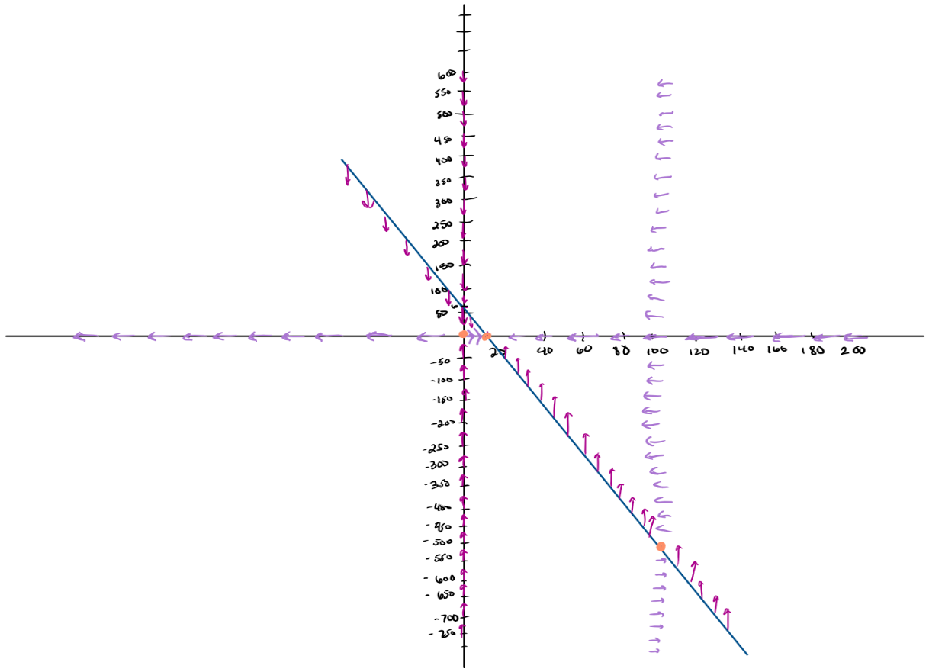difference in the other meaning that one is large and the other is small.

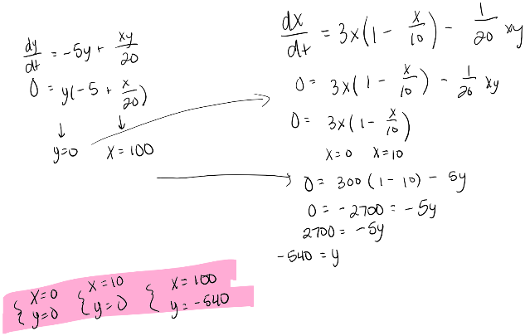C.

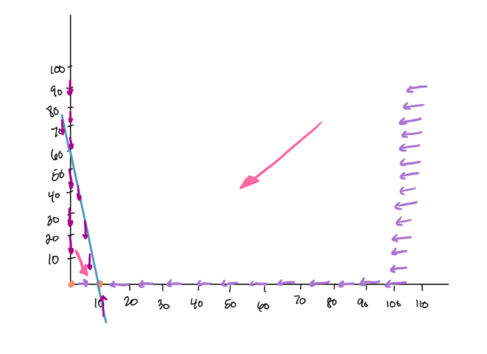D. No matter where the initial condition is in quadrant 1, the y population will go extinct and the x population will go to 10. This is because if we choose initial conditions to the right of the slanted line, the y nullclines at x=100 will push the population to the left and the x nullclines at x=0 will push the population down into the region between the slanted line and the x and y axes. In this region, the populations will be pushed to the right and down towards the nonzero equilibrium. This makes sense looking at the differential equations because as x gets lower dy/dt will decrease meaning that its only food supply is the x species so it will die out. But for dx/dt, the x population still has some other food source when y is zero since it will look like a logistic curve so it makes sense that it would approach its carrying capacity at x=10.

1. 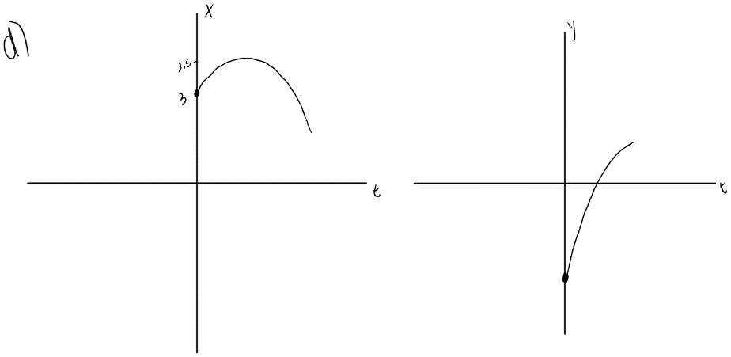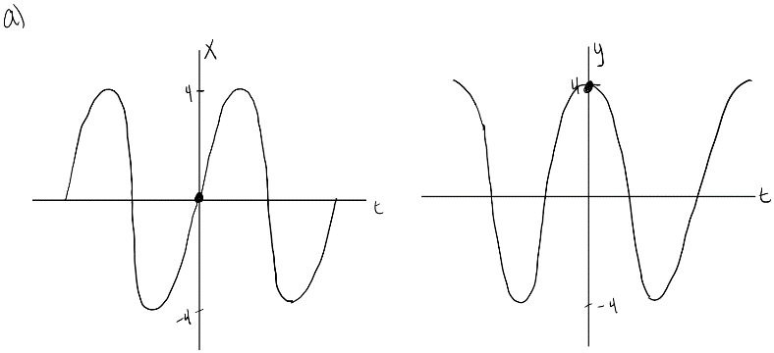

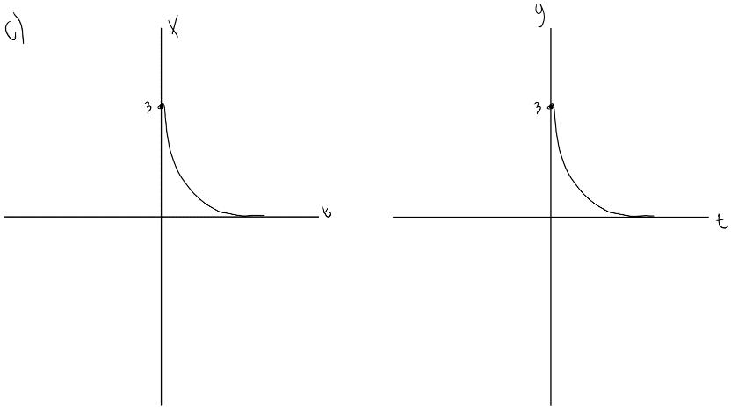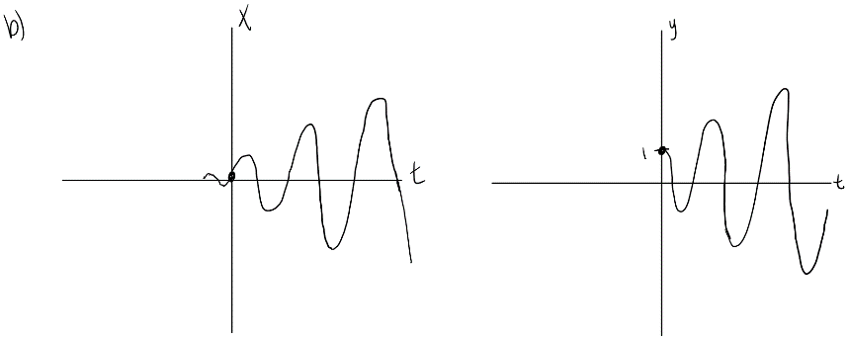

1. A. differential equation, linear system of differential equations, phase plane, phase portrait, vector field, nullcline, isocline

B. system of rate of change equations, Euler’s method, equilibrium solutions, solution curves