# Homework Set 10

1. 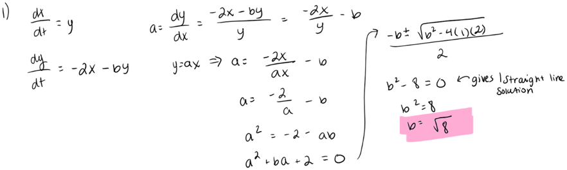

|  |  |  |  |  |
| --- | --- | --- | --- | --- |
|  |  |  |  |  |
| How many equilibrium solutions are there and what are they? |  |  |  |  |
| Are there solutions that, when viewed in the phase plane, lie along a straight line? If so, algebraically figure out the slope of the straight line(s). |  |  |  |  |
| For those systems that do have solutions that, when viewed in the phase plane, lie along a straight line, figure out the exact x(t) and y(t) equations for any solution with initial condition on the straight line(s). |  | n/a |  |  |
| For those systems with straight line solutions, write down the general solution. |  | n/a |  |  |
| How would you classify the equilibrium solution? Create terms if needed to classify any new types of equilibrium solutions and explain the meaning of your terms. | I would call the equilibrium solution at (0,0) a saddle because it has the straight line solution going into it, but then vectors at points not on the straight line get repelled away. | I would call the equilibrium solution a spiral center since it is the center of a spiral on the phase plane. It is similar to a center equilibrium in that it is in the middle and has vectors rotating around it, but I think center is supposed to only be used for circle or ellipse type shapes. | I would call the equilibrium solution an attractor since all on the phase plane, all of the solution functions and vectors seem to be getting pulled in by the equilibrium solution. | I would call the equilibrium solution a repeller since all on the phase plane, all of the solution functions and vectors seem to be getting pushed out by the equilibrium solution. |
| For those systems of differential equations that do have solutions that lie along straight lines, what do these straight lines look like in 3D? |  | n/a |  |  |

1. 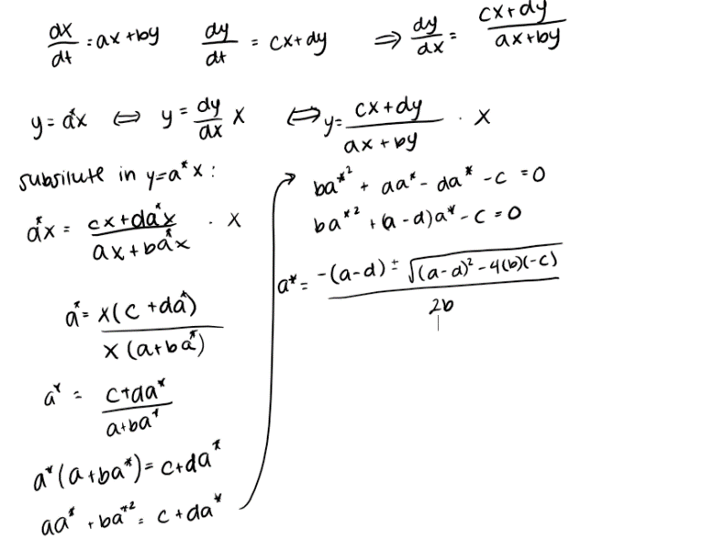A. We are able to set a=dy/dx which is the same as a=(dy/dt)/(dx/dt). Since a represents the slope in y=ax, we are able to set a =dy/dx which also represents the slope. From here, we can plug in the dx/dt and dy/dt we were given to find dy/dx. Then we can substitute ax in for all of the y’s since we know y=ax. Then we just need to solve for a. If we are able to solve for a with real numbers, then there are straight line solutions with slopes equal to what we found a to equal, but if we need to use complex numbers, there are no straight line solutions.

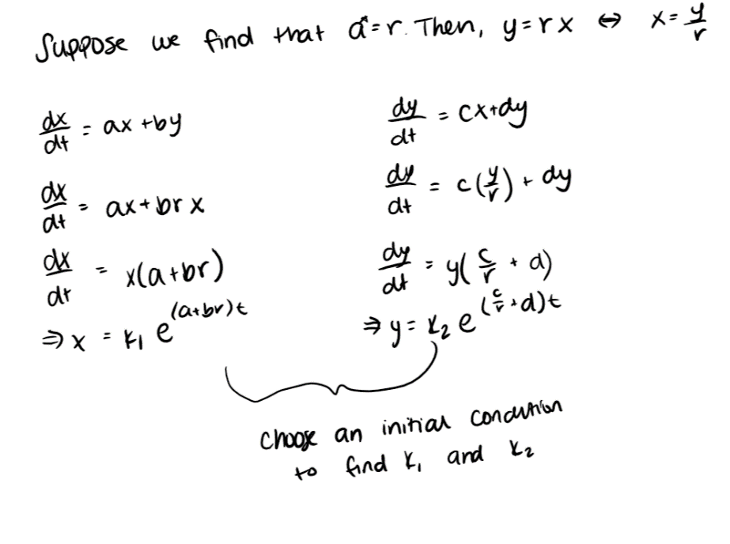B. In order to figure out the x(t) and y(t) equations, we can plug in the a that we found into y=ax to get an equation for a straight line solution. From there, we can solve y=ax for y and x. In our dx/dt equation, we can substitute y for ax and then use separation of variables to solve the differential equation to get x(t). In our dy/dt equation, we can substitute x for y/a and then use separation of variables to get y(t). We can choose an initial condition that works for y=ax to solve for the constants in y(t) and x(t). We repeat this process for every slope that we found.

C. If we have two different straight line solutions, we are able to create a linear combination of the two in order to find the equations for any initial condition, even if it does not fall on one of the straight lines. This allows us to find the equations at any point we want.

1. A. Since both points are along a y nullcline, y(t) will remain at zero as time progresses, whereas x(t) will experience exponential growth with both initial conditions of x(0)=1 and x(0)=3. The only difference is that x(0)=3 will grow faster since it’s a higher initial condition.

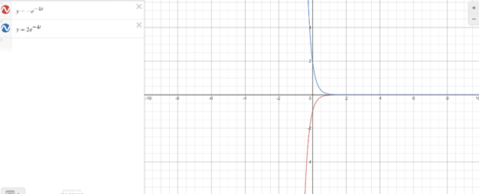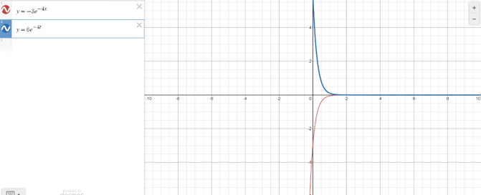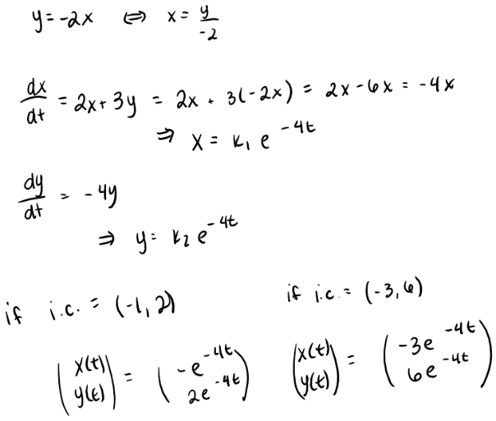B. Both graphs will experience similar behavior as time progresses since they both lie along the same straight-line solution. As shown in the work below, both solution functions will tend toward zero over time.

1. 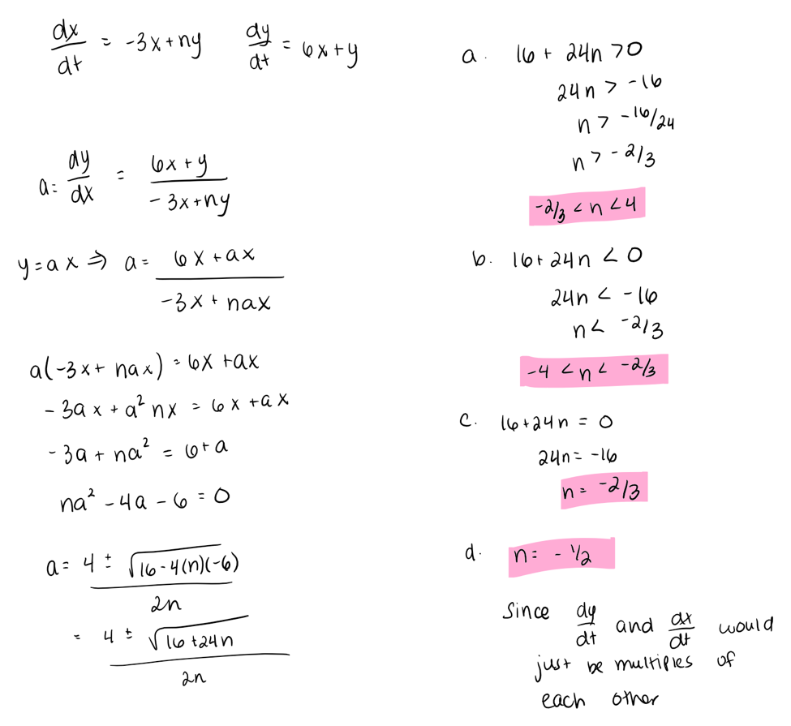
2. 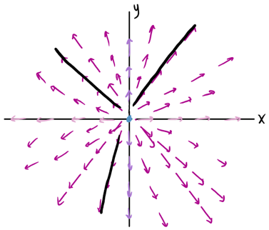A.

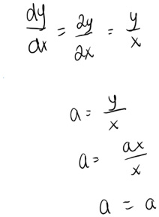I began by figuring out the equilibrium solution which occurred at (0,0). From this, I found the x and y nullclines and used the signs of dx/dt and dy/dt to figure out the direction of the vectors. After this, I tried to find the straight-line solutions. I got that a=a which means that I can choose any slope that is y/x and that will be a straight-line solution at any point (x,y). This means that this entire phase plane has straight line solutions. I figured out the direction of the vectors by plugging in the points into dy/dt and dx/dt and looking at the signs and their ratio. Lastly, in black, I outlined several straight-line solutions. They never touch the equilibrium solution so I left a small gap (in reality, this gap would be way smaller, but I wanted to be able to tell that they didn’t touch the equilibrium).

B. This system is different because dx/dt only depends on x and dy/dt only depends on y. This allows us to use techniques used with one dimensional systems since each differential equation is a 1 dimensional differential equation. Essentially, this is a system of 1 dimensional differential equations.

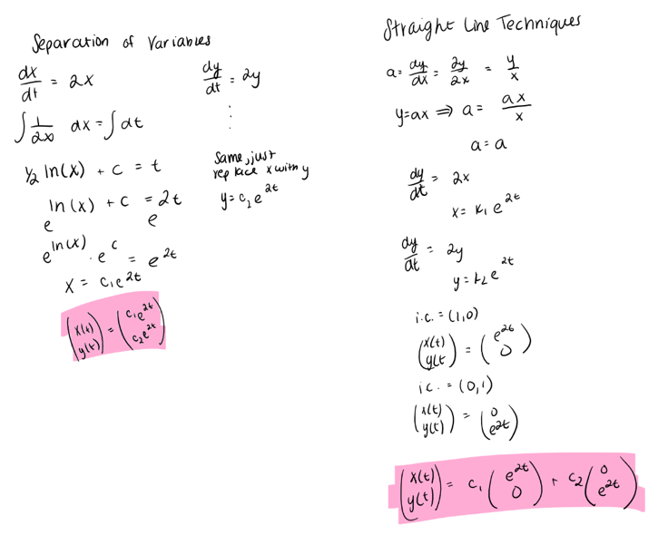C.

D. The general solution can help make sense of the solution graphs in the phase plane since you are able to plug in any point on the graph into the general solution and it will give you a specific solution that you can graph to see the solution function’s behavior over time. In addition, the solution function can help you determine if the solution functions are straight lines in the phase plane since the exponent would have to be the same so that when you calculate dy/dx, it would cancel and we would be left with a constant slope.

1. 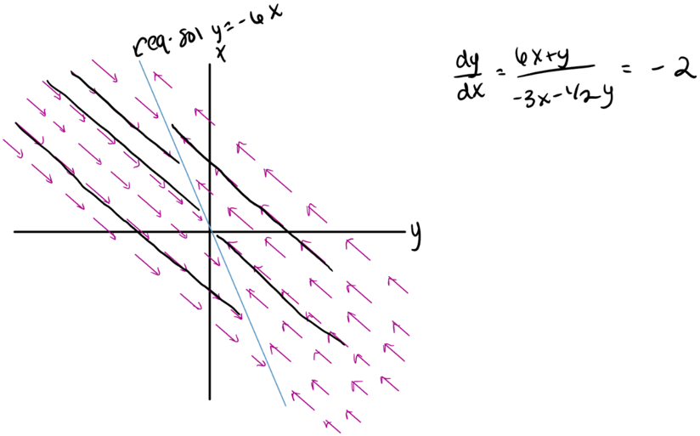I began by finding my equilibrium solutions and noticed that there were infinitely many all along y=-6x. This is because the two differential equations are multiples of each other. Then I wanted to calculate my straight-line solutions and noticed that since the differential equations are just multiples of each other, that dy/dx=-2 everywhere. This means that at any point, the slope is -2. Then I plugged in a couple points to the differential equations so that I could figure out the vectors. Then I outlined several solution functions in black. They are all being attracted towards the equilibrium solution line.
2. A. There are three equilibrium solutions. We have one at (0,0) which is a spiral attractor and two saddle points at (1,0) and (-1,0). The equilibrium solution at (0,0) means that small displacements away from (0,0) will result in the skyscraper swaying but will eventually return back to its equilibrium position, meaning that the building is still standing. The two saddle points show regions where the larger the displacement away from the equilibrium the larger the values of x become, so the building will fall down since the distance from the building being vertical is growing.

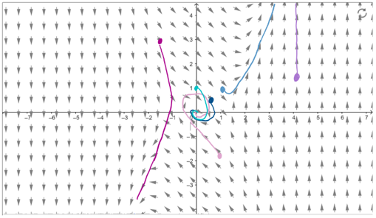B. If the x coordinate of the initial condition is greater than 1 or smaller than -1, the building will follow the path of the saddle which means that the building will fall over. If the x coordinate of the initial condition is between -1 and 1, the building will follow the path of the spiral attractor and will return to equilibrium at (0,0) meaning that the building will remain standing. In addition, if the initial y value is very big or very small, the building will be more likely to fall over. This occurs around when y>1.5 and y<-1.5.

1. A. dependent, differential equation, isocline, nullcline, linear system of differential equations, phase plane, phase portrait, solution, vector field

B. none