# Homework Set 11

1. The sines and cosines account for the fact that the differential equations predict that the mass will oscillate about the zero position. The e-t corresponds the decreased amplitudes over time since as time increases e-t will decrease and when distributed to the sines and cosines, this e-t is the amplitude.
2. If we switched e-t and et then the solution functions would spiral out instead of in. This just means that it would be the same spiral shape, but the direction of the vectors would switch directions.
3. 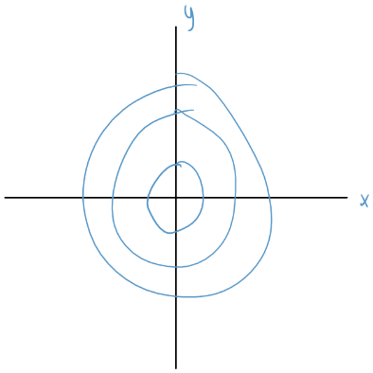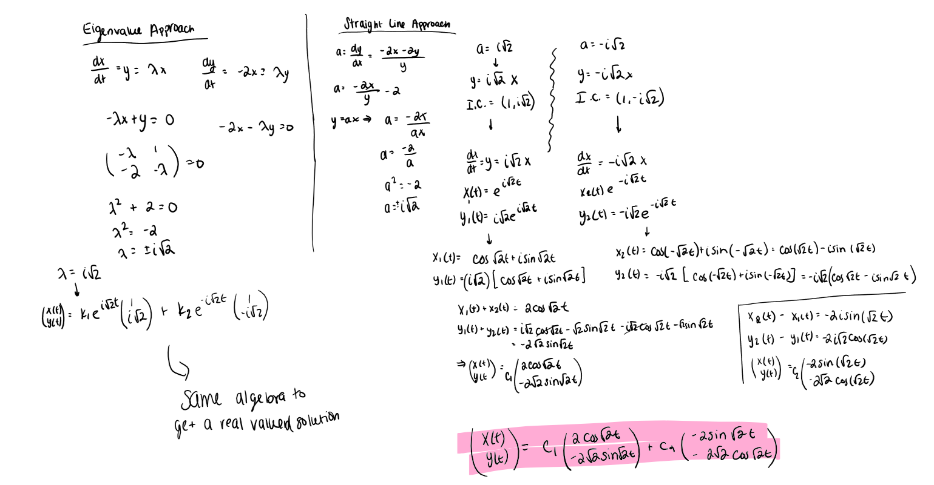

This general solution fits with my expectation of the behavior since there is no friction. Since the part that controls friction is the et part is missing, this means that there is no friction which means that the amplitude does not decrease over time. This means that we have sines and cosines which have a consistent oscillation and oscillate forever, we will get solutions that look like circles.

1. 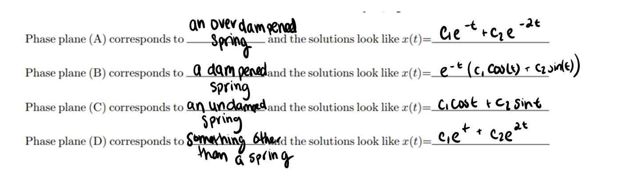
2. A. A car that bounces every time it hits a bump corresponds to an undamped system since it is able to go up and down and there is not enough friction to make it stop. This means that the spring will keep moving every time it hits a bump since there is nothing to make it stop moving.

B. A pendulum immersed in a vat of honey is an example of an over damped system. This is because there would be so much friction from the honey that the pendulum would probably not be able to make one full oscillation before it stops.

C. a bungee jumper would correspond to a damped system. This is because he would be able to swing back and forth several times before slowly coming to a stop. Each time he swings back and forth he wouldn’t go out as far as the time before which indicated dampening.

1. A. dx/dt=y, dy/dt=-2x

B. dx/dt=y, dy/dt=-2x-2y

C. dx/dt=y, dy/dt=-2x-3y



|  |
| --- |
|  |
|  |