# Homework Set 12

1. 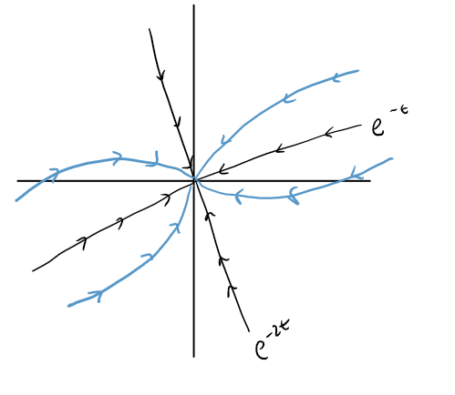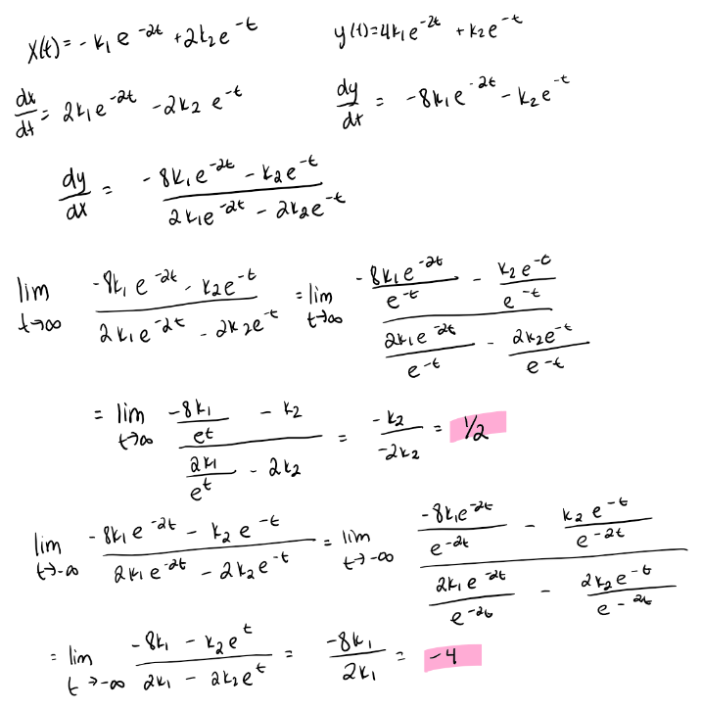Non straight line solutions will be parallel to y=1/2x as t goes to infinity and parallel to y=-4x as t goes to negative infinity. This is because y=1/2x corresponds with e-t and since e-2t goes to zero quicker as time goes on than e-t, the non straight line solutions will be parallel to the slope associated with e-t‑ since it will have more pull over time. As time goes to negative infinity, e-2t will have more pull than e-t so the non straight line solutions will start to become parallel to y=-4x since this is the straight line solution associated with e-2t. We can also see this using the limit of dy/dx. We can also think about this using limits.
2. Solutions that are not straight lines will tend towards the line that represents e3t over time. This is because as time goes to infinity e3t will have more pull since e-t will go to zero. However, if time is going towards negative infinity, then the solutions will curve towards e-t since e-3t would go to zero quicker if time is negative. In addition, when time goes to infinity, since one solution going in towards zero, and one solution going out from zero, this creates a saddle equilibrium solution, so curves will be forced to turn around once they get close to the equilibrium and then follow the path of the solution going out which is the e3t solution.

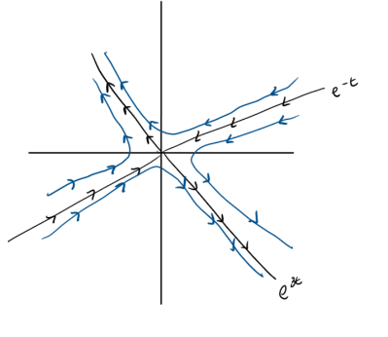

1. 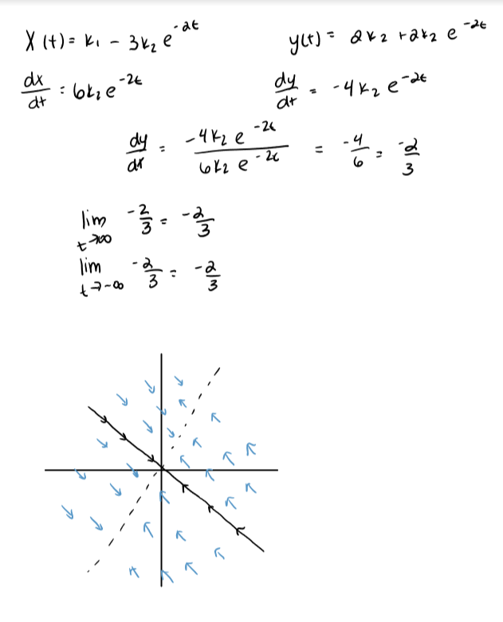Solutions will look like the line y=-2/3x shifted around. This is because the first term is just k1(1 2) so this represents a shift of the straight line solution k2e-2t(-3 2) since the first part of the equation has no “pull”. It only changes the starting point. In addition, looking at this in terms of limits, I got that time cancelled out so no matter if t goes to infinity or negative infinity, the limit will always be -2/3 meaning that the slope of the vectors anywhere is always -2/3.

4.

|  |
| --- |
| A. |
| B. |
| C. |
| D. |
| E.  . |
| F. |
| G. |
| H. NOTE: There is a multiplication error in the students work here. The correct values for are 0 and -2. This changes the second term in the answer to . |

1. 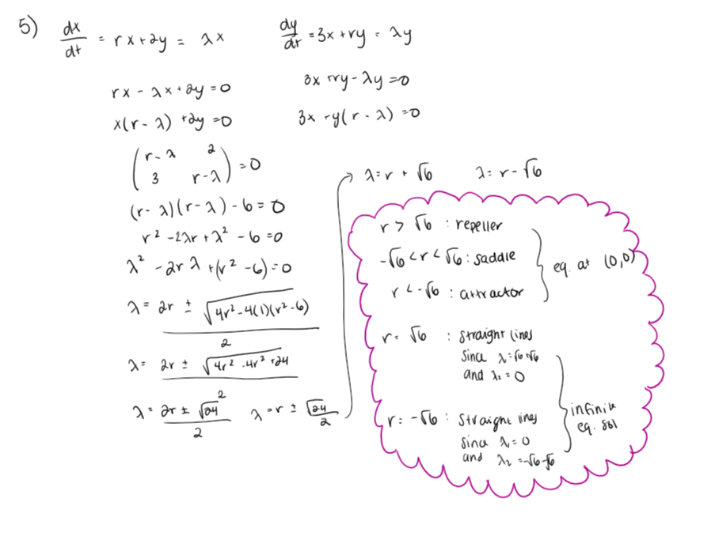
2. 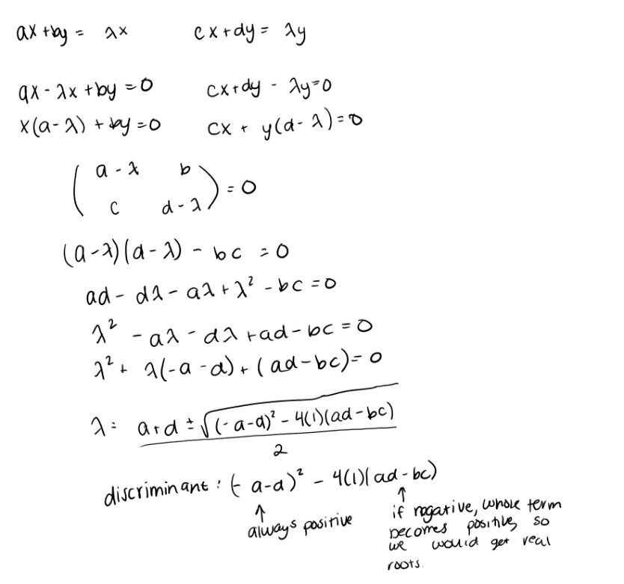 I disagree with Denise. Looking at the algebra needed to find the eigenvalues, I found that if (ad-bc) is negative, then the discriminant becomes positive, meaning that we get real valued solutions for lambda. In order to get solutions that spiral, we need to have complex roots, which would only happen if ad-bc is positive.
3. A. If the eigenvalues are distinct real numbers, we can write the general solution that way since the eigenvalue represents the slope of the straight-line solution. Since e^at represents the general form of a straight-line solution, we can write this times a constant to take care of any multiples of the original form. The eigenvector represents the initial condition found along the straight line and the eigenvalue tells us the slope of the line. We have two add the two terms so that we can use any initial condition, even if it does not lie along a straight line.

B. We can write the general solution this way for many of the same reasons as in part A. The difference here is that we want to “get rid of” the complex part so we can use Euler’s Formula to write the complex part in terms of sines and cosines which appears in the eigenvalue in the exponent as well as in the initial condition.

|  |  |  |
| --- | --- | --- |
| Eigenvalues | Typical Phase Plane | Basic format of general solution |
| Two distinct positive real numbers |  |  |
| One positive and one negative real number |  |  |
| Two distinct negative real numbers |  |  |
| Two identical (repeated) positive real numbers |  |  |
| A complex conjugate pair with negative real part |  |  |
| A complex conjugate pair with positive real part |  |  |
| A complex conjugate pair with no real part |  |  |

1. A. dependent, differential equation, eigensolution, eigenvalue, linear system, phase plane, phase portrait, solution, vector field

B. eigenvector