**Unit 1: Qualitative and Graphical Approaches**

Goals/Rationale

The mathematical goals of Unit 1 are to introduce students to: (1) qualitative ways of reasoning about differential equations (aka rate of change equations), (2) the fundamental concept of what DEs are and what solutions to DEs are, and (3) slope fields. Qualitative and graphical approaches will feature prominently throughout the course and hence the problems are designed to both challenge students and promote the value of such approaches. By the end of the unit students should have a basic understanding that differential equations give information about the rate of change of some quantity that changes over time and that solutions to differential equations are functions. There will be several instances later in the materials that students need to think about whether the rate of change should depend explicitly on time or not (and why) and the problem on page 1.2 will be the first of several problems that require them to think about this issue. By page 1.4 students should also be able to produce slope fields by hand and realize that slope fields are a graphical way to represent both the rate of change of a quantity and provide a means to see how a quantity changes over time.

The open-ended nature of the problems (in this unit and throughout the materials) are also intended to promote the following:

* Explaining one’s reasoning in small group and the whole class, however tentative
* Listening to and trying to make sense of other students’ reasoning
* Indicating agreement or disagreement with other students’ reasoning and explaining why

**Page 1.1 – Bees and Flowers**

Implementation Notes and Student Thinking

To introduce this problem, begin by asking students to brainstorm two species whose presence is helpful or somehow beneficial for the other species (cooperative) and two species for which the presence of one species is somehow detrimental to the other species (competitive). Ask students *why* Bees and Flowers are cooperative, what other examples of cooperative species can they think of and what examples of competitive species can they think of. Students can then work on problem 1 without further instructions or hints.

Even after working for 15-20 minutes students will most likely not have solved the problem. Don’t let students go too much beyond this. Instead, convene a whole class discussion of the different approaches being used. Doing so reinforces the expectation that students explain their reasoning, even if not finished or uncertain about their approach.

Possible discussion questions:

* How do you interpret what *x* and *y* are? Are they numbers, variables, functions?
* What does a positive value of *dx/dt* mean for the species represented by *x*?
* What does a negative value of *y* mean for the *x*-species?

Most common student approaches:

* Integrate one or more equations, treating *x* as a variable and *y* as constant (for example). This is a good opportunity to get students talking about whether they think of *x* and *y* as numbers, as variables, as unknown functions, as both variables and functions. It is conceptually challenging for students to think of *x* and *y* as representing unknown functions on the one hand, but then also as independent variables on which *dx/dt* and *dy/dt* depend.
* Plug in different values for *x* and *y* (rarely do they plug in *0* for *x* or *y*) into the rate equations and compute values of *dx/dt* and *dy/dt*. Students are not usually very systematic about varying values for *x* and *y* and often uncertain on how to interpret the values they get.

Building off the plugging in values approach, one can ask students to figure out what happens to the *x*-species if they plug in *0* for the *y*-species (meaning the *y*-species is extinct). Similarly, what happens to the *y*-species if the *x*-species is extinct? Students can usually solve the problem with this suggestion.

Another line of investigation is to hold *x* constant and systematically increase the value *y* to see what effect this has on *dx/dt* and what this then means for the *x*-species. This can lead to introducing the terminology of the *2xy* term (for example) as the “interaction term” and ask follow up questions such as:

* Suppose the *x*-species and the *y*-species are both present (non-zero), what effect does the -*xy* term have on *dy/dt* and what does that mean for the *y*-species?

**Page 1.2 – A Simplified Situation**

Implementation Notes and Student Thinking

*Problem 2* – In addition to giving students some experience with modeling, this problem is specifically designed to enable the instructor to record student thinking with what an expert would recognize as the beginning of a slope field. Slope fields will be formally introduced on page 1.4 and student work here sets the stage for this.

Typical student response to is something like this 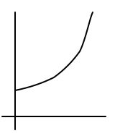 which is perfectly fine, but often students do not make explicit why the graph should have this shape in relation to the given assumptions, the instructor might ask:

* Why not something like this? Or this?”

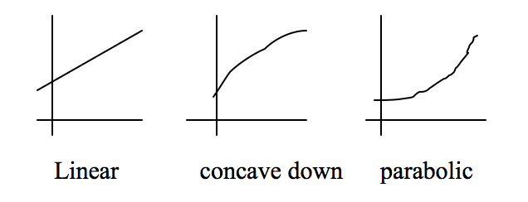

In addition to helping students make explicit their intuitive ideas to the assumptions, student responses to the parabolic alternative in particular will provide an opportunity for the instructor to record student reasons with a tangent vector at time zero.

* Should this initial vector be flat? Why or why not? This question typically elicits a discussion about the given assumption that there are fish in the lake before recordings of the population began, and hence growth is already happening. Record student thinking with the lower vector like in figure A.
* The conversation can move to how the rate of change at this initial point compares to the rate of change at a later time. Again, student reasoning can allow the instructor to record this reasoning, ending up with something like that in A.
* What if the initial population at *t=0* was the same value as that at this second vector in Figure A? What would the slope be and why? [This can develop into B and C with a second graph and similar questions can lead to something like D.]

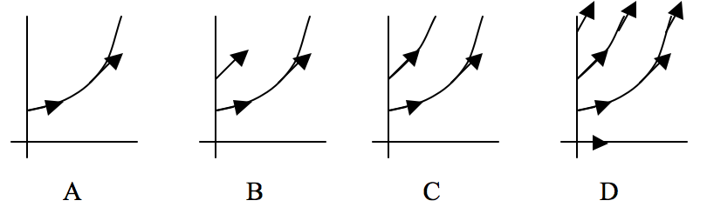

The intention is to develop imagery and rationale that suggests graphs and/or tangent vectors are shifts along *t*-axis. In other words, the rate of change function does not depend explicitly *t*. Also, the instructor notating of student thinking about the slope is intended to give rise to the start of a slope field.

Note that the population situation can provide a rationale for why the graphs are shifts (doesn’t matter if you initially take data on Tuesday or Saturday, it is the same lake of fish).

*Problem 3* - This problem is intended to provide an opportunity for students to first think about whether the rate of change of the population should depend on time, on just the population, or both. While students might have said this in the previous problem, this reasoning often does not readily transfer to writing down a rate of change equation.

It is likely that students will come up with a variety of response, none of which are correct. One way to handle this is to provide a list of possibilities and ask students to comment on each one whether it does or does not make sense (and importantly why they think so). Some choices to offer are:

$\frac{dP}{dt}=(t+1)^{2}$ $\frac{dP}{dt}=2P$ $\frac{dP}{dt}=P_{0}e^{t}$ $\frac{dP}{dt}=2t$ $\frac{dP}{dt}=P^{2}+1$

Ideas that can serve as resources for student reasoning and/or questions for whole class discussion that will allow students to reject many of these options:

* It doesn’t matter if you initially take data on Tuesday or Saturday, it is the same lake of fish, and so the rate of change doesn’t depend on time, just the number of fish.
* The rate of change should be larger for larger values of *P* (greater opportunity for species to interact and hence reproduce).
* The record of student reasoning that led to Figures A-C says that the rate should depend only on population, that is, *dP/dt = f(P)*.
* What should the rate of change be if the population is initially *0*? [If there are no fish in the lake then there will be no reproduction and hence *dP/dt* should be *0*]
* Another connection the instructor can make for students is the fact that their initial imagery of the Pop versus time graph is exponential, something like $P=e^{kt}$. Given this, then $dP/dt=ke^{kt}=kP$.

**Page 1.3 – What Exactly is a Differential Equation and What is a Solution?**

This problem provides students with some basic terminology and definitions and gives students a foundation for what it means to solve a differential equation before any formal analytic techniques. It also introduces the practice of reading a differential with meaning. This practice will be revisited several times later in the material.

Implementation Notes

In problem 4, discuss how to read the differential equation *dy/dt = y+2t* with meaning. By reading with meaning we mean verbalizes the fact that y is actually a function, *y(t)*. So for example, one way to read this differential equation with meaning is to say, “the derivative of some unknown function *y* (or *y(t)*) is equal to the function plus 2 times *t*.” Another way is “*y(t)* is a function whose first derivative is the function itself plus *2t*.”

Reading with meaning will enable students to solve problems 5 and 6 in an intuitive way. Formal techniques like separation of variables should not be introduced. This comes later. Problem 4b provides another opportunity to discuss that the letter y in the differential equation actually an unknown function and so while there is surface resemblance between the derivative of t^3 +2t to the differential equation, the two are very different.

For problem 7 students should be able to solve this using techniques from calculus.

P**ages 1.4-1.5 – Slope Fields**

Slope fields, which appeared informally on page 1.2 are now formally defined. We intentionally use tangent vectors to help promote imagery of movement and flow, which will be foundational for a late problem where students reinvent Euler’s method.

Student Thinking

When completing the table for problem 8 some students will build on earlier reasoning that the slopes of the tangent vectors for this differential equation do not depend explicitly on time and thus one can replicate tangent vectors horizontally for a fixed *P* value.

In problem 8 students typically employ one or more of the following strategies:

* Notice either horizontal or vertical invariance in the slope field and thus eliminate several differentials because they depend explicitly on *y* or on *t*.
* Plug in values for *y* and *t* and determine if the slope of the tangent vector more or less matches.
* Look at what the slope of tangent vectors are if you set *y=0* and vary *t* (and vice versa).
* Integrate (i) and (vi) to determine which one fits (c).

Implementation Notes

Problem 9 page 1. 5 - Because there are so many different ways to arrive at correct matches, this is an ideal problem to have student share their different approaches.

**Homework Problems**

Problem 3 is inspired by an actual student solution, who created the graph shown and correctly solved the problem, but when discussing the solution in class she realized that she didn’t really know what this was a graph of. Graphs of *dy/dt* vs. *y* for autonomous differential equations will play an important role in later units and so it is worth going over student solutions to this problem.

Problem 4c is intended to foreshadow the uniqueness theorem in Unit 5. Some students will argue in ways that anticipate uniqueness and others will not. Discussing their reasoning in class can be worthwhile for later work with the uniqueness theorem. At this point, students do not really have solid reasoning for one way or the other, so credit should be given for explaining their thinking rather than the correct solution based on the uniqueness theorem. This same problem is revisited in the homework for Unit 5.

**Notes for Personal Reflections on Unit 1**