**Molecular Dynamics simulations**

Initial coordinates for the molecular dynamics based free energy calculations were taken from the lipidic-sponge phase X-ray structure *(1).* Missing residues and co-factor segments were retrieved from the refined model of the *Blastochloris viridis* reaction centre by Deisenhofer *et al*. *(14)*. Protonation states of titrating residues were chosen based on their reference *pK*a values and structural criteria, such as hydrogen bond networks. Simulations were performed using a periodic rectangular box of approximately 10 x 10 x 15 nm. The reaction centre was embedded in a DOPC (dioleoylphosphatidylcholine) membrane system *(15)* (Fig. S8A) and crystal waters were retained. After adding 32627 TIP3P water molecules *(16),* and 7 (or 3) potassium ions to neutralize the box, the total system consisted of about 160,000 atoms. The AMBER03 force field was used to describe the interactions between the atoms in this system *(17, 18).* The atomic charges of the four hemes in the cytochrome subunit corresponded to the reduced state (*i.e.* heme(II)) in the first series of simulations, and to the oxidized state ((*i.e.* heme(III)) in second *(19)*. Atomic charges on the special pair of bacteriochlorophylls after the electron transfer event were obtained by fitting atomic charges to the electrostatic potential generated by the electron density of the oxidized special pair, which was computed at the B3LYP/6-31G* level of theory *(20, 21).* Protein atoms were included as point charges in this calculation. After the fitting, charges on chemically identical protons were made equal. The same approach was applied to obtain the partial charges of the reduced menaquinone co-factor. The quantum chemistry calculations were performed with the Gaussian03 program *(22).*

Prior to the free energy calculations, the system was equilibrated for 30 ns, with the Cα root mean square deviation (RMSD) of the protein with respect to the X-ray structure leveling off at approximately 0.13 nm after 4 ns, essentially identical to that observed in previous simulations of reaction centers using the Amber force field (*23*). The equilibrations were run at a constant pressure and temperature by coupling to an external bath *(24),* with time constants of 0.1 ps and 1.0 ps for the temperature and semi-isotropic pressure coupling, respectively. The LINCS algorithm was used to constrain bond lengths *(25),* allowing a time step of 2 fs in the classical simulations. SETTLE was applied to constrain the internal degrees of freedom of the water molecules *(26).* A twin-range cut-off method was used for non-bonded Van der Waals interactions, which were modeled by a twin-range Lennard-Jones potential: interactions within 1.0 nm were calculated at every time step, whereas interactions between 1.0 and 1.6 nm were calculated every ten steps. Coulomb interactions were computed with the smooth particle mesh Ewald method *(27)*, using a 1.0 nm real-space cut-off and a grid spacing of 0.12 nm. The relative tolerance at the real-space cut-off was set to 10-5. Equilibration was carried out both before and after an electron is transferred from the special pair to menaquinone, using the different atomic charge sets for the special pair and menaquinone. All simulations were performed with the GROMACS-4.0 *(28)* molecular dynamics program.

**Free energy calculations**

The change in the free energy upon photo-activation for transferring the hydroxyl proton from TyrL162 to the carboxylate moiety of GluC254, was determined by thermodynamic integration with a coupling parameter *λ (29):*

,



where is the free energy difference between the deprotonated state A (λ = 0) and the protonated state B (λ = 1). The (classical) Hamiltonian H is interpolated between these two states:



,



where, p and q are the positions and momenta of all atoms in the system. Thus at *λ* = 0, the system’s topology corresponds to a protonated tyrosine and deprotonated glutamate (Fig. S8B), while at *λ* = 1, tyrosine is deprotonated and glutamic acid is protonated (Fig. S8C).

Classical molecular dynamics trajectories of 500 ps each were generated at 21 equidistant points along this interval and the ensemble average was computed, using the last 300 ps of the simulations. The ensembles were generated with a stochastic dynamics integrator running at 300 K with a friction coefficient of 1.0 ps-1. Numerical integration of over *λ* yields the free energy difference between the two states at *λ* = 0 and *λ* = 1. Error estimates for the computed free energies were determined by fitting an analytic function to the block average of as a function of block size for each of the *λ* points and integrating these errors over *λ* *(30).* The free energy calculations were repeated three times for both the resting and photoactivated states with a reduced and oxidized cytochrome subunit, respectively. Thus, in total twelve such simulations were performed. The free energies were averaged to obtain the final proton transer free energies in each of the four situations.



We note that the above free energy differences between protonated and deprotonated states only includes the electrostatic interaction of the proton with its environment, but neither the enthalpy, the covalent bond, nor electronic polarization effects of the chromophore. Accordingly, comparison of the calculated free energy differences will differ from the experimental ones by these missing contributions. Assuming the offset to be similar both for the dark (P960:QA) and photo-activated (P960+:QA-) state, however, allows one to calculate the change in free energy of proton transfer upon photo-induced charge transfer

,



using the thermodynamic cycle shown in Scheme S1.Since we make the same systematic errors in both branches of the cycle, these errors cancel out. The *difference* in free energy , therefore, is a meaningful quantity which can be compared to the experiment.



Fig. S8D shows as a function of *λ*. The integrated curves show the free energy (within the force field approximation) of this transfer process before (black) and after (red) electron transfer from P960 to QA. The free energies of each run and their averages are listed in Table S3. After electron transfer, the free energy associated with the simultaneous deprotonation of TyrL162 and the protonation of GluC254 is lowered by 47 ± 6 kJ/mol when the four hemes of the cytochrome subunit are reduced. For comparison, the difference in free energy was also evaluated with all hemes in the cytochrome subunit. In this situation, which corresponds to the experiment, the free energy is lowered by 46 ± 3 kJ/mol). As is shown in Fig. S8B and C, the buried water molecules that are part of the hydrogen bonding network adapt to the new protonation state.



The stability of the co-factor arrangement was evaluated by monitoring the distances between their centers of mass (with the tails of the bacteriochlorophyls excluded). Histograms of the distance between the two bacteriochlorophylls that form the special pair and the nearest heme moiety in the cytochrome subunit (c559) are plotted in Fig. S9. The average displacement has increased by approximately 0.06 nm relative to the crystallographic structure. Although small displacements may have a significant effect concerning the electronic coupling between the chromophores, the impact on proton transfer free energies is probably negligible.

**pKa estimations**

In our approach the free energy associated with a proton transfer process was computed, rather than the free energy associated with the direct deprotonation of the tyrosine. Due to the use of peridiodic boundary conditions in combination with the Ewald summation, the free energy of a process in which the overall charge changes is notoriously hard to compute accurately (*31*). Instead, we used GluC254 as a probe to measure the shift in pKa of TyrL162 upon activation, assuming that the pKa of GluC254 is not much affected by the photo-oxidation of the special pair.

By comparing the free energy to transfer a proton between TyrL162 and GluC254 in the reactioncenter to the free energy to transfer a proton between tyrosine and glutamate in water, we obtain a crude estimate of the pKa of TyrL162. However, since coupling to other titrating sites is not included, we are actually estimating a microscopic pKa. The free energy in water is -51 ± 1 kJ/mol (Table S3), and corresponds to a pKa difference of 5.5 units. Thus, under the additional assumption that the pKa of GluC254 is 4.0 both in water and the reactioncenter, photo-activation shifts the pKa of TyrL162 from 23 to 4 if the cytochrome subunit is reduced, and from 17 to 9 if the cytochrome subunit is oxidized.

**Table S3:** Free energy to transfer a proton from TyrL162 to GluC254 in four different states of the reactioncenter and in water. The roman numerals between parentheses indicate the oxidation state of the hemes in the cytochrome subunit.

|  |  |  |  |  |
| --- | --- | --- | --- | --- |
|  | **(kJ/mol)**  **run 1** | **(kJ/mol)**  **run 2** | **(kJ/mol)**  **run 3** |  |
| **C559(II),P9600** | 21.1 ± 2.9 | 23.1 ± 2.2 | 27.0 ± 2.0 | 24 ± 3 |
| **C559(II),P960+** | -20.0 ± 2.2 | -24.9 ± 2.3 | -24.8 ± 3.5 | -23 ± 5 |
| **C559(III),P9600** | -4.9 ± 3.5 | -1.8 ± 2.3 | -9.8 ± 3.2 | -6 ± 2 |
| **C559(III),P960+** | -48.1 ± 2.0 | -52.3 ± 2.2 | -54.2 ± 2.1 | -52 ± 2 |
| **water** | -50.4 ± 0.5 | -48.8 ± 1.0 | -52.3 ± 1.5 | -51 ± 1 |

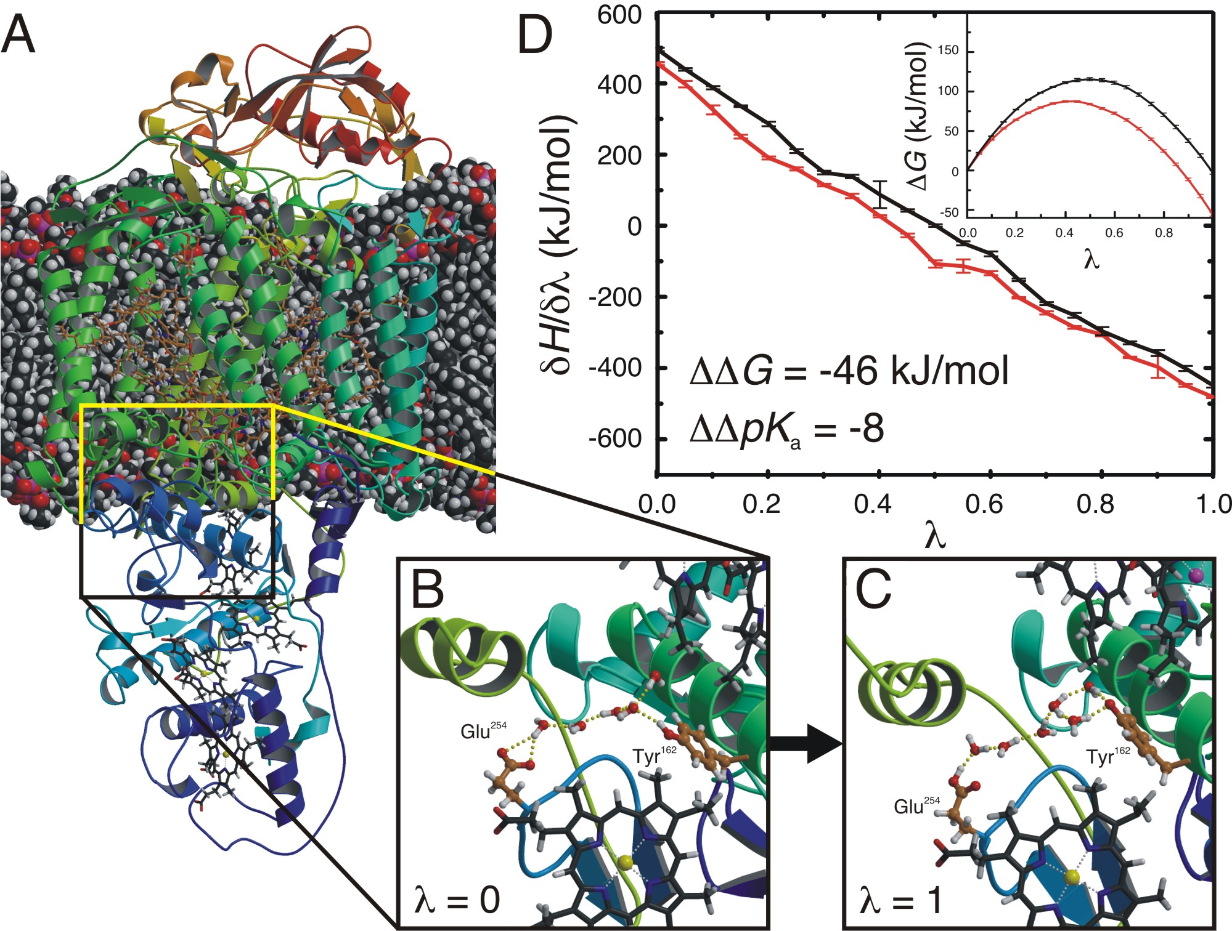

**Figure S8:** Molecular dynamics simulations used to calculate the change in the free energy (G) upon photo-activation for transferring the hydroxyl proton from TyrL162 to the carboxylate moiety of GluC254. **(A)** Snapshot from the MD simulation showing the reaction centre embedded in a DOPC membrane (bulk water not shown). Snapshot of the simulation before **(B)** (*λ* = 0) and after **(C)** (*λ* = 1) the proton is transferred from TyrL162 to GluC254. **(D)** Free energy calculations showing associated with the proton transfer before (black) and after (red) electron transfer from the special pair to menaquinone, as a function of *λ*. The inset shows the integrated free energy (G) versus *λ*. If the four hemes in c559 are oxidized, the photo-activated electron transfer reduces the free energy of proton transfer (G) by approximately 46 kJ/mol, which corresponds to a decrease of the *pK*a difference of about 8 units.



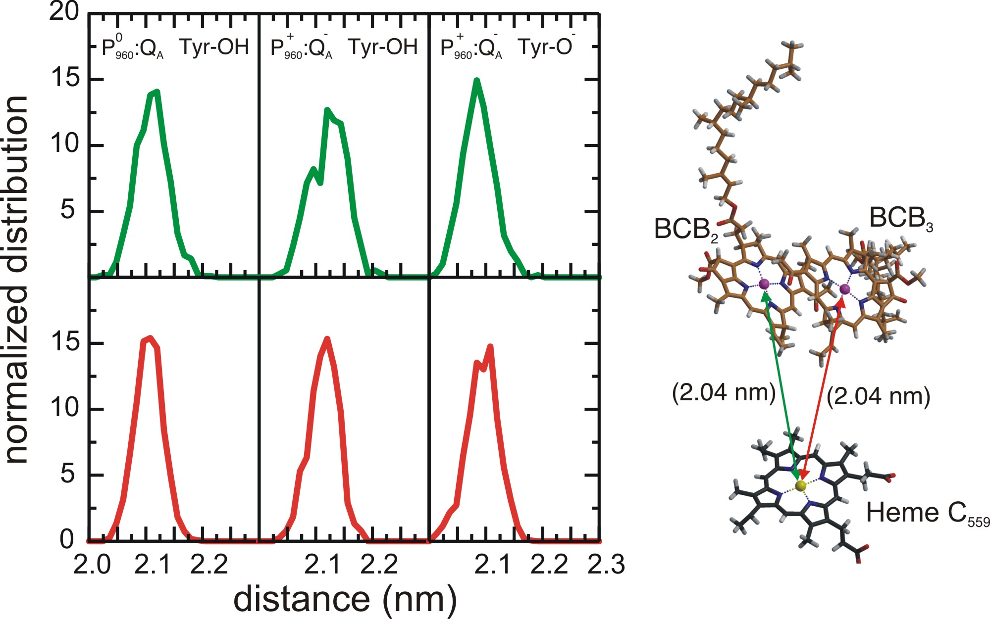

**Figure S9:** Histograms of the distances between the centers of mass of the two special pair bacteriochlorophyll B’s and the Heme moiety of the cytochrome subunit during a 30 ns MD simulation of the resting state (left panels), of the photoactivated state with TyrL162 protonated (middle panels), and of the photoactivated state, with TyrL162 deprotonated (right panels). The distances in the starting structure are shown between parentheses in the graphical representation of the co-factors.

**Figures**

Figures were generated with PYMOL ([DeLano Scientific LLC](http://www.delanoscientific.com)), Molscript *(32)* and Raster3D *(33)*.

**REFERENCES**

**1. A. B. Wöhri, W. Y. Wahlgren, E. Malmerberg, R. Neutze, G. Katona, *Biochemistry* under review, (2009).**

**2. A. B. Wöhri *et al.*, *Structure* 16, 1003 (Jul, 2008).**

**3. P. Wadsten *et al.*, *J Mol Biol* 364, 44 (Nov 17, 2006).**

**4. Y. Kalinin *et al.*, *J Appl Cryst* 38, 333 (2005).**

**5. G. N. Murshudov, A. A. Vagin, E. J. Dodson, *Acta Crystallogr D Biol Crystallogr* 53, 240 (May 1, 1997).**

**6. P. Emsley, K. Cowtan, *Acta Crystallogr D Biol Crystallogr* 60, 2126 (Dec, 2004).**

**7. R. Henderson, J. K. Moffat, *Acta Cryst B* 27, 1414 (1971).**

**8. L. Howell, D. Smith, *J. Appl. Crystallogr.* 25, 81 (1992).**

**9. R. J. Read, *Acta Crystallogr.* A 42, 140 (1986 ).**

**10. Collaborative computational project number 4, *Acta Crystallogr D* 50, 760 (Sep 1, 1994).**

**11. G. Katona *et al.*, *Nat Struct Mol Biol* 12, 630 (Jul, 2005).**

**12. A. Hadfield, J. Hajdu, *J Appl Cryst* 26, 839 (1993).**

**13. P. Gourdon *et al.*, *Protein Expr Purif* 58, 103 (Mar, 2008).**

**14. J. Deisenhofer, O. Epp, I. Sinning, H. Michel, *J Mol Biol* 246, 429 (Feb 24, 1995).**

**15. S. W. Siu, R. Vacha, P. Jungwirth, R. A. Bockmann, *J Chem Phys* 128, 125103 (Mar 28, 2008).**

**16. W. L. Jorgensen, J. Chandrasekhar, J. D. Madura, R. W. Impey, M. L. Klein, *J. Chem. Phys.* 79, 926 (1983).**

**17. Y. Duan *et al.*, *J Comput Chem* 24, 1999 (Dec, 2003).**

**18. M. Ceccarelli, P. Procacci, M. Marchi, *J Comput Chem* 24, 129 (Jan 30, 2003).**

**19 F. Autenrieth, E. Tajkorsid, J. Baudry, Z. Luthey-Schulten, *J. Comput. Chem.* 25, 1613-1622 (2004):**

**20. A. D. Becke, *J. Chem. Phys.* 98, 1372 (1993).**

**21. C. T. Lee, Y. W.T., R. G. Parr, *Phys. Rev. B.* 37, 785 (1988).**

**22. M. J. Frisch *et al.* (Gaussian, Inc., Wallingford CT, 2004).**

**23. M. Ceccarelli, M. Marchi, *J. Phys. Chem. B.* 107, 1423 (2003).**

**24. H. J. C. Berendsen, J. P. M. Postma, W. F. Van Gunsteren, A. Dinola, J. R. Haak, *J. Chem. Phys.* 81, 3684 (1984).**

**25. B. Hess, H. Bekker, H. J. C. Berendsen, J. G. E. M. Fraaije, *J. Comp. Chem.* 18, 1463 (1997).**

**26. S. Miyamoto, P. A. Kollman, *J. Comp. Chem.* 13, 952 (1993).**

**27. U. Essmann *et al.*, *J. Chem. Phys.* 103, 8577 (1995 ).**

**28. B. Hess, C. Kutzner, D. Van der Spoel, E. Lindahl, *J. Chem. Theo. Comp.* 4, 435 (2007).**

**29. J. G. Kirkwood, *J. Chem. Phys.* 3, 300 (1935).**

**30. B. Hess, *J. Chem. Phys.* 116, 209 (2002 ).**

**31. S. Bogusz, T. E. Cheatham, B. R. Brooks, *J. Chem. Phys.* 108, 7070 (1998).**

**31. P. J. Kraulis, *J. Appl. Cryst.* 24, 946 (1991).**

**33. E. A. Merritt, D. J. Bacon, *Methods Enzym.* 277, 505 (1997).**

**34. V. Srajer *et al.*, *J Synchrotron Radiat* 7, 236 (Jul 1, 2000).**