UPPERMOST®

Commerce V1
Architecture & Implementation Blueprint

Framer-first commerce · Razorpay variable recurring mandates · Shiprocket logistics · Supabase source of truth

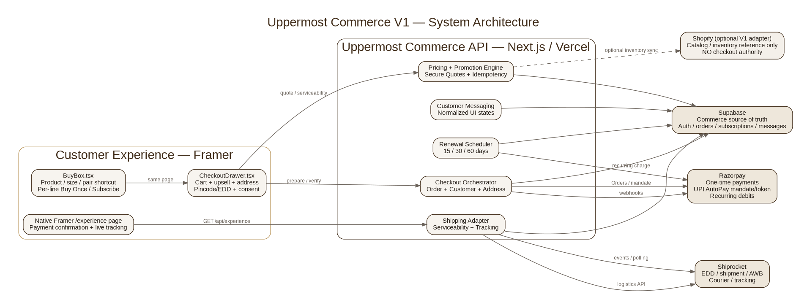

Document | Value
Status | FROZEN V1 BASELINE
Version | 1.0
Date | 24 September 2026
Audience | CXO · Product · Engineering · Framer · Operations · Growth
Canonical repo path | docs/UPPERMOST_COMMERCE_ARCHITECTURE.md

Executive Summary
Uppermost will preserve a single, premium customer journey inside Framer while moving every security-sensitive and financially authoritative decision into a thin commerce backend.
- Framer owns what the customer sees: product selection, cart/checkout drawer, address, pincode/EDD, consent, Razorpay launch, inline payment status and the native post-purchase /experience page.
- The Next.js/Vercel commerce layer owns authoritative pricing, promotions, secure quotes, checkout orchestration, variable renewals, Razorpay/Shiprocket secrets, idempotency and webhook reconciliation.
- Supabase is the system of record for customers, addresses, orders, subscriptions, recurring mandates, messages, shipment state and audit snapshots.
- Razorpay is the payment rail rather than the subscription brain: one-time payments, first authorization payment, UPI AutoPay mandate/token and later recurring debits.
- Shiprocket is the logistics rail: serviceability, EDD, shipment, courier/AWB and tracking.
- Shopify Checkout exits the new path. Shopify can remain an optional catalog/inventory reference during migration.
- fastrr is excluded from V1 to avoid competing pricing authorities and to preserve the Framer-first experience.

The business model in one minute
- Purchase mode is per line item. A single first order can contain Gir as Subscription and Murrah as Buy Once.
- The customer pays the complete first-order amount immediately while the recurring mandate is authorized in the same subscription checkout flow.
- Future renewal carts contain subscription lines only. One-time lines automatically disappear.
- Every renewal is re-priced from current product pricing plus only promotions and entitlements valid for that subscriber, stage and cycle.
- New promotions are not automatically granted to existing subscribers.
- A mandate maximum gives pricing flexibility without repeated authorisation. If the required renewal amount exceeds the cap, Uppermost stops and asks for re-authorisation.

CXO decision summary
Decision | Frozen V1
Customer journey | Framer-first; no traditional multi-page cart/checkout
Checkout UX | Same-page right-side drawer; Razorpay modal; one navigation after payment
Subscription billing | Uppermost scheduler + Razorpay recurring mandate/token
Recurring amount | Dynamic every renewal
Mixed cart | Supported: subscription + buy-once in one first order
Payments | Razorpay managed QR/UPI Intent; no custom QR generator
Address | Collected once in Framer
Tracking | Native Framer /experience page
Promotions | General rule engine, not hard-coded discounts
Logistics | Shiprocket
Customer identity | Guest checkout first; Supabase Auth roadmap
fastrr | Excluded from V1

Executive System View
The principle is simple: Framer owns experience, Uppermost backend owns truth, Razorpay owns money movement, Shiprocket owns physical delivery.

Premium customer journey

Critical Mixed-Cart Use Case
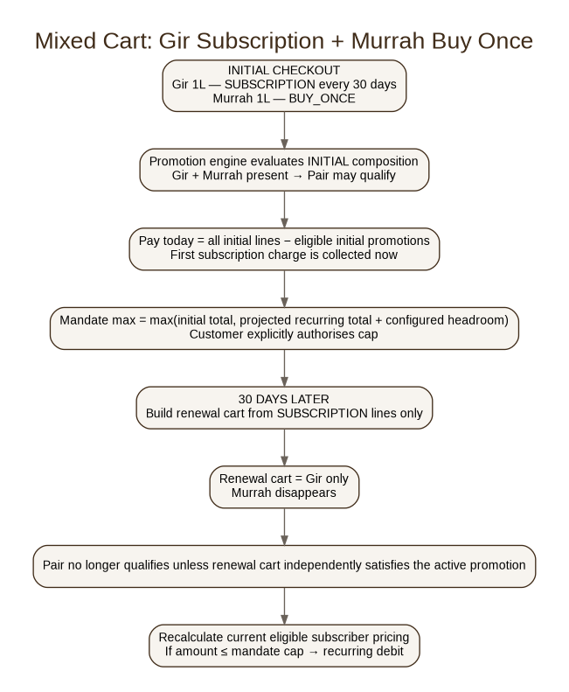
This scenario is a mandatory test case. It is the reason the architecture models purchase mode per cart line rather than one global Buy Once/Subscribe state.

Current live commercial baseline
Offer | Current rule | Lifecycle interpretation
Gir 1 L Early Bird | ₹7,500 standard → ₹7,000 through 4 Oct 2026 | Initial/eligible orders while promotion is active
Murrah 1 L Early Bird | ₹5,500 standard → ₹5,000 through 4 Oct 2026 | Initial/eligible orders while promotion is active
The Pair | Configured benefit for qualifying Gir + Murrah; mixed sizes allowed | Global one-year promotion window; re-evaluate each priced cart
Subscription benefit | ₹500 from shipment/cycle #2 onward | Renewal-only from cycle >= 2
Shipping | Free across India currently | Configuration, not permanent code assumption

Future promotion examples already supported
- Minimum cart value discount
- Fixed bundle price
- Buy X Get Y
- Free shipping threshold
- Father’s Day complimentary gift wrapping
- Free gift product
- Founding subscriber grandfathered benefit
- Customer/subscription cohort offer
- One-use or limited-use entitlement

1. Platform Architecture & Ownership
Platform | Owns | Must not own
Framer | All visible commerce UI; line selection; checkout drawer; address; EDD display; consent; payment launcher; /experience page | Secrets, authoritative prices, mandate token
Next.js / Vercel | Pricing, promotion evaluation, quote security, checkout, renewals, integrations, webhooks, normalized states | Long-term visual presentation
Supabase | Commerce source of truth; customers, addresses, orders, subscriptions, messages, tracking; Auth/RLS | Client-trusted price calculations
Razorpay | Payment Orders; UPI AutoPay authorisation/token; subsequent recurring debit | Cart, offers, subscription schedule
Shiprocket | Serviceability, EDD, shipment, courier/AWB, tracking | Checkout price logic
Shopify | Optional catalog/inventory sync/reference | Payment authority / new checkout

2. Framer Component Architecture
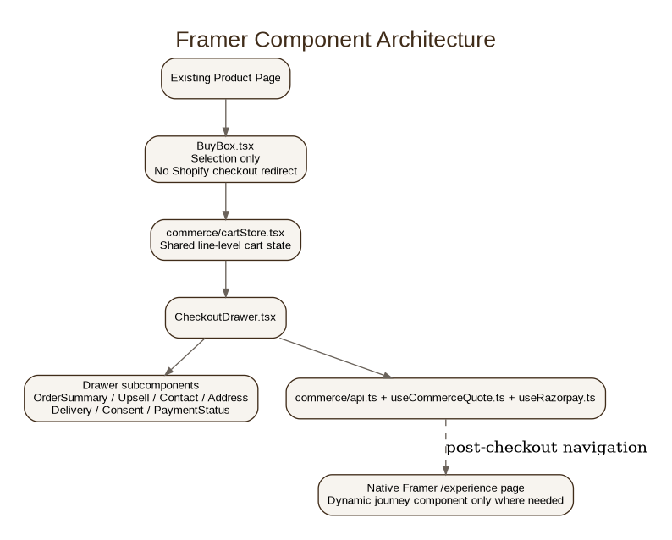
The existing BuyBox remains the premium product configurator. It stops being the checkout engine. A separate CheckoutDrawer owns cart review, upsell, customer/address, serviceability, consent and payment state.

Existing BuyBox migration facts
- Current purchase frequency is a single global once/sub state; this must become per cart line.
- The 15/30/60 controls already exist visually and should be preserved.
- Current Pair/subscription pricing is calculated client-side; server quote becomes authoritative.
- Current one-time runCheckout creates a Shopify Storefront cart and redirects to Shopify checkout; this path is retired.
- Current subscription CTA is still a reservation/waitlist flow; it becomes a real checkout path.

3. Cart & Subscription Model
There is cart state, but no dedicated cart page.
V1 cart line contract:
line_id · sku · qty · purchase_mode = BUY_ONCE | SUBSCRIPTION · interval_days = 15 | 30 | 60 when subscribed

V1 recurring-group constraint
All subscription lines in one checkout use one shared interval. The storage/API shape remains extensible to multiple recurring groups later.

Initial vs renewal
Stage | Lines priced | Bundle/Pair behavior
INITIAL | All BUY_ONCE + SUBSCRIPTION lines | Evaluate against first-order composition
RENEWAL | SUBSCRIPTION lines only | Re-evaluate current renewal composition; do not inherit Pair merely from first order

4. Promotion Engine
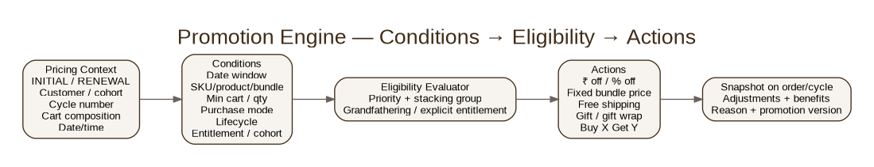

Conditions supported
- valid_from / valid_until
- SKU / product / variant targeting
- required product combination / bundle
- minimum cart value
- minimum quantity
- BUY_ONCE / SUBSCRIPTION / MIXED
- INITIAL_ONLY / RENEWAL_ONLY / INITIAL_AND_RENEWAL
- minimum/maximum subscription cycle
- new or existing subscriber
- customer/subscription cohort
- explicit entitlement
- first or returning order
- usage limits
- priority, stackability and exclusivity group

Actions supported
- AMOUNT_OFF
- PERCENT_OFF
- FIXED_BUNDLE_PRICE
- FREE_SHIPPING
- SHIPPING_DISCOUNT
- FREE_GIFT
- FREE_GIFT_WRAP
- BUY_X_GET_Y
- informational/non-monetary benefit

Why promotion_entitlements is a table
A boolean cannot represent multiple concurrent benefits, expiry, remaining uses, grandfathering, revocation or grant reason. Use a dedicated promotion_entitlements table with starts_at, ends_at, remaining_uses, status, is_grandfathered, grant_reason and audit timestamps.

5. Razorpay Payment & Variable Recurring Architecture
Uppermost still sells “subscriptions” to customers, but V1 does not use Razorpay Plans or Razorpay Subscriptions. Uppermost owns the subscription business state; Razorpay owns financial authorisation and debit.

Initial subscription / mixed checkout
- Resolve/create Razorpay Customer.
- Create recurring UPI authorisation Order.
- Initial Order amount = complete first checkout total, including buy-once items.
- Projected recurring amount = subscribed lines only.
- Mandate max = max(initial total, projected recurring amount + configurable headroom).
- Display mandate max clearly before customer authorises.
- Customer completes first payment and mandate authorisation in Razorpay-managed UPI QR/Intent flow.
- Store returned recurring token/mandate server-side only.
Current business preference is roughly ₹2,000–₹3,000 headroom, but the exact policy is server-configured and should stay close enough to expected debit to preserve trust.

Desktop and mobile payment UX
Device | Preferred experience
Desktop subscription registration | Razorpay-managed UPI QR where Intent is unavailable; no Uppermost QR generator
Mobile subscription registration | Supported UPI Intent flow
Desktop one-time | UPI/QR made prominent where Razorpay Checkout configuration supports it; other enabled methods remain available
Mobile one-time | Razorpay supported UPI Intent / other enabled methods

6. Variable Renewal Engine
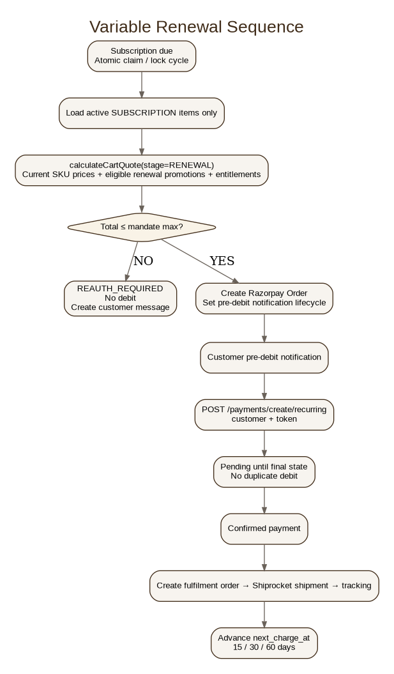

Renewal pricing rule
“Current pricing” does not mean “apply every currently active offer.” Each rule is evaluated against renewal lifecycle, subscriber cohort, cycle number and explicit/grandfathered entitlements.

No silent over-cap debit
If renewal total exceeds mandate maximum, set REAUTH_REQUIRED, create a customer message and do not attempt a debit.

7. Payment State Machine & Customer Messaging
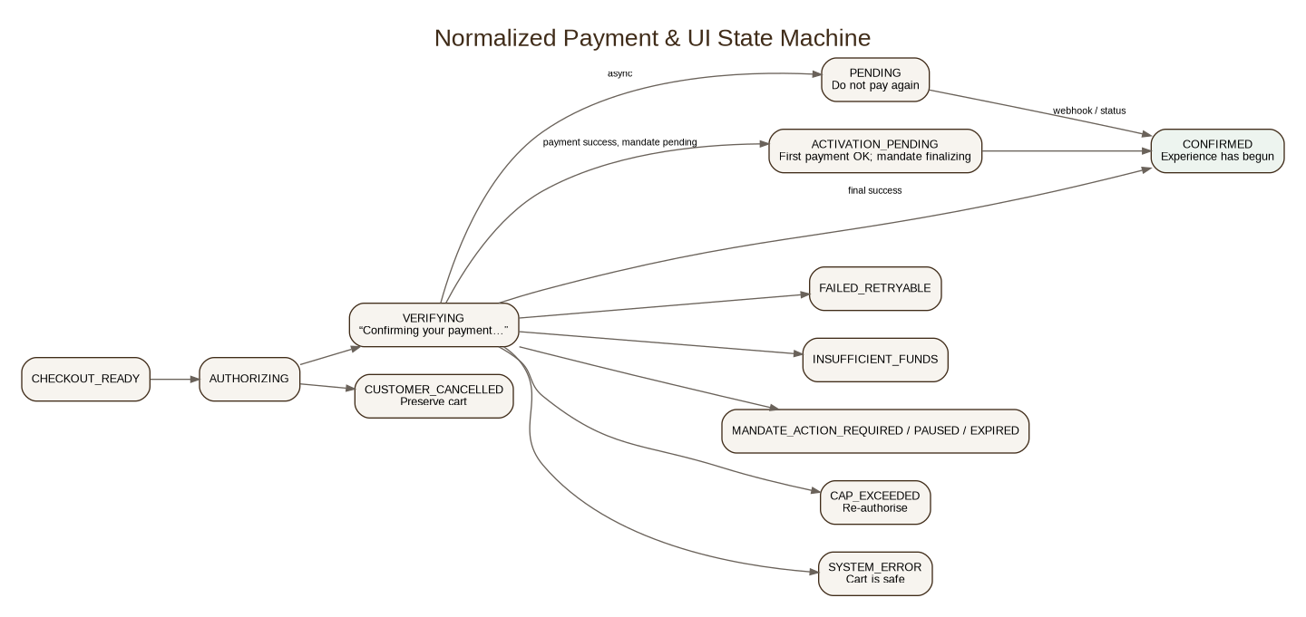

Customer-facing mapping
Normalized state | Customer UI
VERIFYING | Confirming your payment…
CONFIRMED | Your Uppermost experience has begun.
ACTIVATION_PENDING | Your payment is confirmed. We’re completing your recurring authorisation.
PENDING | We’re confirming your payment. Please don’t make another payment yet.
FAILED_RETRYABLE | We couldn’t complete the payment. Please try again.
INSUFFICIENT_FUNDS | This account couldn’t complete the payment. You can retry using another account.
MANDATE_ACTION_REQUIRED | Your recurring authorisation needs to be renewed.
MANDATE_PAUSED | Your recurring authorisation is paused.
CAP_EXCEEDED | Your updated recurring order exceeds your authorised limit. Review and re-authorise to continue.
CUSTOMER_CANCELLED | Return to checkout quietly; preserve cart.
SYSTEM_ERROR | We couldn’t complete this request right now. Your cart is safe.

Message storage
Use message_templates + customer_messages + message_deliveries, with lib/commerce/messages.ts as a safe code fallback. DB copy overrides the fallback so CXO/ops-approved copy can be changed without a frontend redeploy.

8. API Connectivity
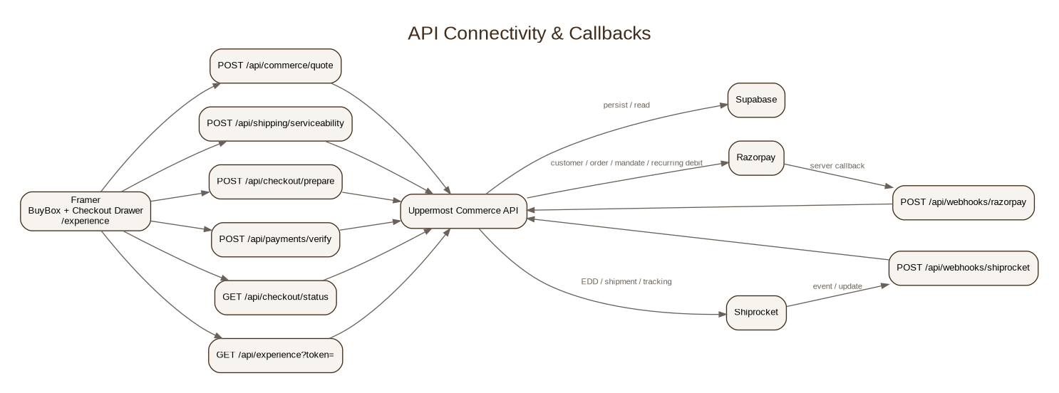
Endpoint | Caller | Purpose
POST /api/commerce/quote | Framer | Authoritative pricing, promotions, recurring projection
POST /api/shipping/serviceability | Framer | Pincode eligibility, EDD, shipping amount
POST /api/checkout/prepare | Framer | Unified one-time/subscription/mixed preparation
POST /api/payments/verify | Framer after Razorpay | Signature/payment verification
GET /api/checkout/status | Framer | Pending/late state reconciliation
POST /api/webhooks/razorpay | Razorpay | Signed server callback
POST /api/webhooks/shiprocket | Shiprocket / adapter | Shipment/tracking update ingestion
GET /api/experience?token= | Framer /experience | Safe order + shipment + subscription view
GET/POST /api/customer/addresses | Framer account/drawer | Saved Uppermost addresses
Protected renewal runner | Scheduler | Due subscription cycles

9. Secure Quote & Idempotency
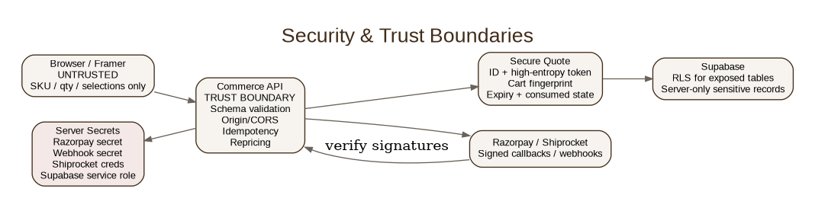

Quote binding
- guest session or authenticated customer
- normalized cart fingerprint
- exact SKUs/qty/purchase mode/interval
- currency
- pricing version
- promotion version
- server price snapshot
- shipping context when relevant
- created_at / valid_until
- OPEN / CONSUMED / EXPIRED / REVOKED state

Required responses
Condition | Response
Unknown/forged quote | INVALID_QUOTE
Wrong token | INVALID_QUOTE
Expired | QUOTE_EXPIRED
Consumed by same idempotent request | Return prior checkout session
Replay/mismatch | Reject / conflict
Price changed before prepare | QUOTE_CHANGED + fresh quote; never silently charge

Idempotency
Every money-changing endpoint requires Idempotency-Key. Same key + same request returns the original result. Same key + different request returns 409 IDEMPOTENCY_CONFLICT. Webhook event ids, renewal cycles and shipment creation also use unique/idempotent guards.

10. Unified Checkout Preparation
- Validate quote id + quote token + session/customer binding + expiry.
- Recalculate authoritative quote and compare to snapshot.
- Resolve/create Uppermost customer.
- Save delivery address and immutable checkout-time address snapshot.
- Create checkout_session.
- Create internal Uppermost order in PAYMENT_PENDING.
- Snapshot items, purchase modes, prices, promotions, benefits, shipping and consent.
- Choose normal Razorpay Order when there are zero subscription lines.
- Choose recurring authorisation Order when at least one line is subscription.
- Return only public checkout fields; never send secrets.

Internal correlation
Every Razorpay Order maps to an internal Uppermost order, checkout_session and customer. Use safe receipt/notes for reconciliation; never place full address or secrets in Razorpay notes.

11. Address, Pincode & Delivery
Address is entered once in the Checkout Drawer. Uppermost owns the address UX; Razorpay is not used as the shipping-address system.
- Name
- Phone
- Email
- Address line 1
- Address line 2
- Landmark optional
- City
- State
- Pincode
- Country = IN
Use browser autocomplete semantics and later saved Uppermost addresses. Do not make V1 dependent on a Razorpay global address API. Shiprocket serviceability receives only server-derived origin, weight, dimensions, value and payment mode; frontend cannot submit trusted parcel metrics.

12. Native Framer /experience Page
After verified payment there is one navigation to /experience?t=<high-entropy-token>. This page is the thank-you page and live tracking experience combined.
- “Your Uppermost Experience Has Begun” hero and normalized status message.
- Order reference and placed date.
- Expected delivery window — never falsely “guaranteed”.
- Elegant timeline: Confirmed → Preparing → Handed to carrier → In transit → Out for delivery → Delivered.
- Latest safe scan/location and timestamp when available.
- This shipment items, including clear Buy Once vs Subscription labels.
- Paid pricing snapshot and applied benefits.
- Subscription-only next order: subscribed items, interval, next charge date, projected amount, mandate max.
- Action-required CTA for mandate/re-auth issues.
- Safe destination summary; avoid unnecessary full address exposure in public-token view.

Polling behavior
Fetch on load. While shipment is non-final, poll conservatively (about 30–60 seconds), only while the page is visible; stop on final states. Keep last valid state visible during temporary API failure.

13. Data Model
Domain | Tables / records
Catalog | products, product_variants
Promotion | promotions, promotion_entitlements
Cart/Quote | carts, cart_items, commerce_quotes
Customer | customers, customer_addresses
Checkout | checkout_sessions, idempotency_records
Order | orders, order_items, order_adjustments, order_benefits
Subscription | subscriptions, subscription_items, subscription_cycles, recurring_mandates
Payment | payment_attempts, payment_events
Shipping | shipments, tracking_events
Messaging | message_templates, customer_messages, message_deliveries

Store money as integer paise wherever practical. Snapshot commercial terms on orders/cycles so future promotion edits do not rewrite history.

14. Security & Compliance Engineering
- Never trust frontend price, discount, shipping, parcel weight/dimensions or quote id alone.
- Never expose Razorpay key secret, webhook secret, recurring token, Shiprocket credentials or Supabase service role.
- Production CORS only for Uppermost domains and explicitly configured Framer preview origins; no wildcard.
- Validate Razorpay payment/webhook signatures and process events idempotently.
- Use high-entropy public experience token; sequential order number is display-only.
- Use RLS on exposed Supabase tables; sensitive payment/mandate records remain server-only.
- Keep explicit subscription consent version, consent text/snapshot, mandate max, interval and consent timestamp for auditability.

15. Authentication Roadmap
Login must not become a purchase blocker. Guest checkout remains first-class. Supabase Auth is the preferred account layer for Google, email OTP/magic link and later phone OTP. Phone OTP in India is enabled only after the SMS provider and DLT requirements are ready.

16. Failure & Recovery Principles
- A browser timeout is not automatically a failed payment. Show PENDING and reconcile server/webhook state before permitting retry.
- Never start a second debit while the prior attempt is unresolved.
- Razorpay modal dismissal preserves cart and contact/address state.
- Shiprocket failure after successful payment does not alter paid state; shipment creation is retried idempotently.
- Quote changes are shown to the customer before payment; no silent amount changes.
- Renewal amount above mandate cap never gets clipped or partially charged; re-authorisation is required.

17. Rollout & Ownership
Phase | Engineering outcome | Owner surface
1 | DB migrations, products, promotions, secure quote | Backend/Supabase
2 | Pricing engine + idempotency tests | Backend
3 | Shiprocket serviceability/EDD | Backend
4 | Normal Razorpay one-time checkout | Backend + Framer
5 | Recurring authorization + token persistence | Backend + Framer
6 | Payment webhooks + messaging states | Backend
7 | BuyBox refactor + cart store + CheckoutDrawer | Framer
8 | Native /experience page + experience API | Framer + Backend
9 | Renewal scheduler + recurring debit + shipment | Backend
10 | Test-mode matrix, operational runbook, production cutover | Engineering + Ops

18. Must-Pass Test Matrix
- Gir buy-once
- Gir subscription
- Gir subscription + Murrah buy-once
- Gir + Murrah both subscribed
- Initial mixed Pair qualification
- Renewal Gir-only no Pair
- Pair one-year expiry
- Early-bird expiry
- Subscription benefit absent cycle 1 / present cycle 2
- New-subscriber-only promotion does not leak to existing subscriber
- Minimum cart offer
- Free gift wrap benefit
- Forged quote id
- Wrong quote token
- Expired quote
- Consumed/replayed quote
- Duplicate prepare
- Idempotency conflict
- Duplicate Razorpay webhook
- Duplicate renewal run
- Amount > mandate cap
- Pending/late payment without duplicate payment
- Shiprocket temporary failure after payment
- Experience token isolation / no order enumeration

19. External Platform Constraints — Validate Before Production
- Razorpay UPI recurring authorisation uses Customer + Order + authorisation transaction, with recurring token linked to the customer.
- UPI Collect is deprecated for most new AutoPay registrations from 28 Feb 2026; Intent/QR is the expected registration path.
- Mandate max_amount is the maximum debit per charge and should stay reasonably close to expected debit for customer trust.
- Razorpay supports as_presented among recurring frequency options; confirm live-account behavior for exact merchant-managed 15/30/60-day schedule.
- Subsequent recurring payment requires a new Order and then recurring debit using customer/token; respect pre-debit notification lifecycle.
- Prove the mixed first-order payment + recurring mandate scenario in Razorpay Test Mode before live cutover.
- Prove desktop recurring QR and one-time UPI/QR prominence in the actual enabled Razorpay Checkout configuration.

20. Configuration & Environment Checklist
Area | Examples / requirement
Razorpay | KEY_ID public; KEY_SECRET server; webhook secret; live/test mode separation
Shiprocket | API user/token/credentials server-only; pickup location configured
Supabase | URL/public client key where appropriate; service role server-only; RLS
Framer | COMMERCE_API_BASE_URL; page-specific Razorpay script; allowed production/preview origins
Commerce policy | mandate headroom; quote TTL; promotion dates; renewal scheduler window; message templates

21. Decision Log — Frozen V1
Decision | Value
Framer-first experience | YES
Right-side same-page checkout drawer | YES
Separate cart page | NO
Cart state/data model | YES
Mixed purchase modes per line | YES
Razorpay Plans/Subscriptions | NO
Razorpay recurring mandate/token | YES
Dynamic amount every renewal | YES
Automatic new offers for existing subscribers | NO
Configurable mandate headroom | YES
First subscription payment immediate | YES
Address collected once in Framer | YES
Razorpay-managed QR/Intent | YES
Native Framer /experience tracking page | YES
fastrr V1 | NO
Shopify Checkout in new flow | NO

22. Reference Sources
Razorpay — UPI recurring authorisation: https://razorpay.com/docs/api/payments/recurring-payments/upi/create-authorization-transaction/
Razorpay — subsequent recurring payments: https://razorpay.com/docs/api/payments/recurring-payments/upi/create-subsequent-payments/
Framer — custom code: https://www.framer.com/help/articles/how-to-add-custom-code/
Framer — Fetch & secure backend guidance: https://www.framer.com/help/articles/how-to-use-fetch/
Framer — external agents: https://www.framer.com/help/articles/what-you-can-do-with-local-agents/
Supabase Auth: https://supabase.com/docs/guides/auth
Supabase RLS: https://supabase.com/docs/guides/database/postgres/row-level-security

Appendix A — API Contract Snapshot
POST /api/commerce/quote
Input: guest_session_id, line_id, sku, qty, purchase_mode, optional interval_days, optional postal_code. Output: secure quote id/token, item snapshots, promotions/benefits, initial total, recurring group projections, mandate max, shipping/EDD.
POST /api/checkout/prepare
Input: secure quote, customer, address, billing flag, recurring consent when needed; Idempotency-Key required. Output: internal Uppermost order id, checkout session, payment kind, public Razorpay checkout fields and display totals.
POST /api/payments/verify
Verifies Razorpay signature and reconciles server/payment state. Subscription becomes ACTIVE only when first payment and usable recurring mandate/token are both confirmed; otherwise ACTIVATION_PENDING.
GET /api/experience?token=
Returns only safe customer-facing order, shipment timeline, delivery estimate, paid snapshot and subscription projection. Sensitive IDs/tokens remain server-side.

Appendix B — Change Control
Architecture-level changes must update this document and docs/UPPERMOST_COMMERCE_CONTRACT.md before implementation. Message copy and campaign values can change through configuration without altering architecture unless the behavior itself changes.

