IDEA PAPER · NEBIUS × NVIDIA GLOBAL AI HACKATHON
Perspective
Intelligence
Engineering the view from somewhere
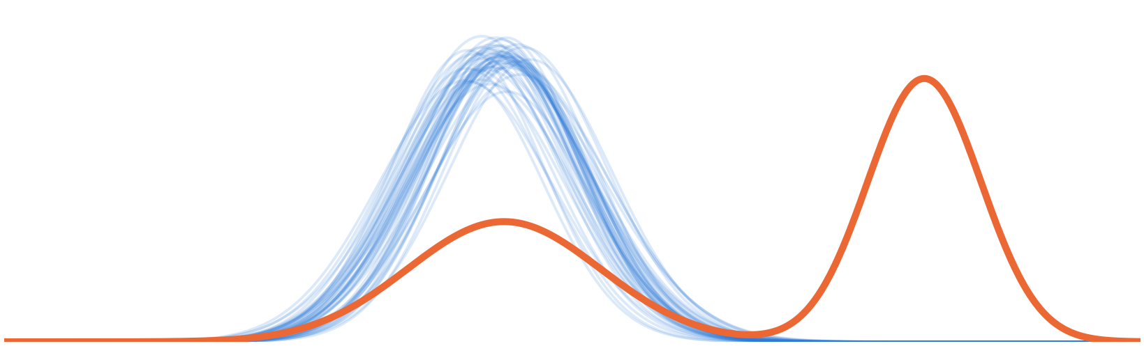
Many models, one shape. One person, their own.
Every AI can take any perspective.
None of them has yours.

Status: Concept stage, version 2. This version closes the loop, from measuring a way of seeing to growing it, in people and in AI. Use case and build follow from it.
Track fit: Open across all four tracks (section 9).
Date: 23 October 2026
Team: [to be added]

The idea on one page
AI has made the view from everywhere free. Ask a foundation model about anything and you receive a fluent distillation of everything ever written about it: competent, instant, and increasingly the same for everyone. Asked to write a metaphor about time fifty times each, twenty-five different language models gave answers that clustered around just two ideas: time is a river, and time is a weaver (Jiang et al., 2025).
What is still scarce is the view from somewhere: the particular way a person sees, formed by what they have built, studied, taught, repaired and lived through. It is the engineer who hears a bearing failing before any sensor flags it, the clinician who senses that a patient with normal readings is about to deteriorate, the teacher who can tell which student is about to give up. Today's AI adapts to what you like, what you said and how you write. It does not model how you see, because it has no way to separate your way of seeing from its own average.
Perspective Intelligence is the capability, in people and in machines, to form a distinct way of seeing, to see through it, to translate it so others can see it too, and to hold it lightly. In people, it is a skill. In AI, it is a missing layer of the stack.

The central move. We define a perspective as a residual: what a person notices in a situation, minus what an open foundation model notices in the same situation. The positive residual is what the person brings that no model has. The negative residual is their blind spot, and exactly where AI can help them most.
Why it closes the loop. Insight that stops at recommendations is a dashboard: the person does all the downstream work, and nothing learns from what they did. So Perspective Intelligence finds where your way of seeing beats the consensus, helps you build there, and keeps you ahead of your own lens as you grow. The residual decides who teaches whom: AI learns from you where you see more, and teaches you where you miss what matters.
Why it needs open infrastructure. A residual can only be measured against a baseline you can see. A closed model's average is hidden and changes silently. An open model with published weights, data and recipes, such as NVIDIA Nemotron, is a fixed, inspectable ruler for the view from everywhere. In Perspective Intelligence, the open model is the ruler, not the oracle.
Why it is hard. Eight unsolved problems stand between this idea and working systems, from capturing knowledge that people cannot put into words, to combining many people's lenses without averaging them back into consensus, to helping people grow with AI without being hollowed out by it (section 7).
What we are submitting. A definition, a framework (the Perspective Stack, closed into the Perspective Loop), two measurement standards (the Perspective Fidelity Test and the Growth Test) and a research agenda for AI that amplifies how individual people see, and helps them see further, instead of averaging it away.

1 The river problem
The thing foundation models do best is also their quiet failure mode. A model trained on everything written learns the centre of gravity of human expression. Post-training then pulls it further toward the answers most raters approve of. The result is a technology that is superb at the expected and systematically weak at the particular.
The convergence is now measurable
- Different models, same ideas. Across 70+ language models, each model tends to repeat itself on open-ended prompts, and different models produce strikingly similar outputs, the stronger of the two effects. The authors call it the Artificial Hivemind (Jiang et al., 2025; NeurIPS Best Paper).
- Individuals up, collective down. AI assistance made individual stories more creative, and made the stories more similar to each other (Doshi & Hauser, 2024).
- Alignment narrows. RLHF significantly reduces output diversity compared with supervised fine-tuning (Kirk et al., 2024).
- Role-play is not perspective. Asked to speak as members of identity groups, models tended to sound like what outsiders say about a group rather than what its members say, and flattened the variety within it (Wang et al., 2025; see also Cheng et al., 2023).
- Novel on paper is not the same as seeing. AI-generated research ideas were rated more novel than experts' ideas. When 43 researchers spent an average of more than 100 hours each executing them, the advantage vanished and on several measures reversed (Si et al., 2025).

Now scale this up. Hundreds of millions of people ask the same few models what to notice in their work, their code, their health and their companies. Each of them gets a better answer than they would have found alone. Together, they converge. We call this the monoculture of attention. The risk is not that AI thinks for us. It is that AI quietly teaches all of us to notice the same things.
The standard response is to make models more varied: raise the temperature, add personas, sample more models. That treats diversity as noise to be injected, and we think it is the wrong unit. The diversity that matters already exists, in people. It is not generated; it is lived. The question is whether AI can learn to carry it instead of erasing it, and help it grow.

2 The missing layer
AI now personalizes almost everything about how it responds to you, except the thing that matters most before any response exists.
What AI adapts to | The question it answers | How it is done today
Preference | What do you like? | RLHF, reward models, ratings
Memory | What have you told me? | Long context, retrieval, memory stores
Style | How do you write? | Examples in the prompt, fine-tuning
Persona | Who should I pretend to be? | Role prompts: “You are a senior engineer…”
Perspective | How do you see? What do you notice that others miss? | Nothing yet

Each row above is useful, and none of them is perspective. Preferences concern outputs you like; perspective concerns what you notice before there is any output. Memory stores what you said; perspective governs what you would notice next, in situations you have never described. And a persona prompt is the view from everywhere wearing a costume: ask a model to think like a nurse and you get what the internet thinks a nurse would say.
The table hides a second gap. Every row adapts the machine to the person; none of them helps the person see better. Today's AI either hands back information and leaves the person to do the rest, as a dashboard does, or does the work and leaves the person unchanged, as an agent does. Neither learns from what the person did next, and neither grows the person.
The closest research agenda, pluralistic alignment, asks how a model can represent the range of views across a population (Sorensen et al., 2024). Perspective Intelligence asks the complementary question: how can a model hold one particular way of seeing faithfully, extend it to situations it has never met, and know when it is wrong? And, because a person keeps changing, how can it help that way of seeing grow?

3 Perspective Intelligence

3.1 A skill, and a missing capability
Everyone has a perspective. Perspective Intelligence is skill with it. Emotional intelligence has the same structure: it never claimed that only some people have emotions, only that skill with them is a distinct capability that can be learned and practised. Perspective Intelligence makes the same claim about seeing, and extends it to machines: an AI system can also be more or less skilled at capturing, carrying and respecting a particular way of seeing. The aim is for the two skills to grow together: people become more skilled with their perspective by working with AI, and AI becomes more skilled at carrying it by working with people.

3.2 Four capabilities, mirrored
Capability | In a person | In an AI system | What crosses over, each turn
Forming | Building a lens from lived experience, deliberately seeking range and reflecting on it | Eliciting: capturing a lens from what a person actually notices, not from what they say about themselves | Person to AI: every edit and rejection is a residual sample. AI to person: blind spots and distant lenses widen what the lens forms from
Seeing | The lens decides what shows up as relevant, odd, beautiful or wrong (relevance realization) | Applying: noticing through a specific person's lens, at machine scale | The lens runs at machine scale; the person sees what it found in material they could never read
Translating | Making others able to see through the lens too: colleagues, customers, models | Representing: turning a lens into a portable, inspectable form that people and models can use | The lens becomes a versioned skill others can run; seeing it written down is itself reflection
Holding lightly | Telling insight from bias; knowing when the standard should win | Calibrating: tracking when a lens beats the consensus, and when it misleads | Outcomes teach both sides which parts of the lens to trust, and where the bias is

The human skill and the machine layer mirror each other. That symmetry is the framework: every capability a person needs to use their perspective well has a machine counterpart that AI currently lacks. The Perspective Loop (section 6) turns the mirror into an exchange: on every turn, something crosses from the person to the machine, and something crosses back.

3.3 What it is not
Perspective is the seeing that comes before creativity, taste and judgment. It decides what reaches the stage where they can act. So it is not:
- creativity, generating many options, which AI already does well;
- taste or judgment, choosing the best option and committing to it;
- empathy, feeling with another person, or wisdom, which is too broad to act on;
- personalization, persona prompting or sampling for diversity, which adapt a model's outputs, not its attention;
- an autonomous agent, which does the work for you and leaves you unchanged.
Perspective comes before creation, but a Perspective Intelligence system does not stop there. Building is how a lens meets reality, gets tested and grows. So the system builds, and what makes it different from an agent is that the residual decides what it builds, and who learns from it (section 6).

3.4 The claim we rest on
AI can adopt any perspective. A human is one. Ask a model to look at a problem as a physicist would and it will, instantly and at no cost to itself. Its perspectives are borrowed, available on demand and dropped when the conversation ends. A person's perspective is accumulated over a life, integrated into a single point of view, and comes with stakes: they own the problem and bear the consequences of the bet.
We deliberately do not rest this on claims that AI is not conscious, or that some task is permanently beyond it. Those claims are either unprovable or keep being overturned. Our claim is sturdier: even if AI has perspectives, no one, human or AI, has yours. The philosopher Thomas Nagel contrasted the view from nowhere with the view from somewhere. Large language models come close to a third thing, a view from everywhere: the average of everything written. When the average is free, the particular becomes valuable.

3.5 Larger than AI, and growing in value
Perspective Intelligence is larger than AI, though not as a superset. AI is a technology and Perspective Intelligence a capability; they overlap, and each region has a role.
Region | What it holds | Its role
Perspective, beyond AI | How perspectives form: lived experience, stakes, contact with reality | Why it matters
AI, beyond perspective | Commodity capability: writing, coding, analysis, building | What does the building
The overlap | The Perspective Stack and the Perspective Loop | What we build

AI is downstream of perspective. A foundation model is the compressed average of billions of past perspectives: every method, standard and idea that someone wrote down. If standards are perspectives that won and were frozen (section 4), a foundation model is the largest frozen standard ever built.
AI is the archive of perspectives that already won. Perspective Intelligence is about the ones that have not won yet.

Perspective becomes the scarce input. When something becomes cheap, whatever it depends on becomes valuable. AI is making capability cheap; it cannot make the view from somewhere cheap. So our claim is about direction rather than size: the better AI gets, the more perspective is worth. The claim can fail, and section 10 says how we would know.
There is precedent. Studies of user innovation found that many important innovations, from mountain-bike gear to surgical equipment, came from users rather than manufacturers, because users hold sticky local knowledge that is costly to transfer (von Hippel, 1994, 2005). That sticky knowledge is the residual. The bottleneck has been conversion: the nurse who sees a better workflow cannot build the software, and the vendor who can build it does not see the workflow. AI is collapsing the cost of conversion, which leaves perspective as the bottleneck.
Unique is not the same as valuable. Noise is unique too. A residual is worth building on only when it predicts outcomes the consensus misses, where missing them is costly, and in a form that can be built. Every person has a residual; not every residual has a use. Finding the one that does is a job for the system (section 6.1), and it is more likely to succeed for pairs of lenses than for single ones.

3.6 Old roots, new synthesis
The ingredients are old, and we say so openly: Koestler's bisociation, Gentner's structure-mapping, Polanyi's tacit knowledge, Nagel and Haraway on situated knowledge, Vervaeke's relevance realization, and March on exploration and exploitation. The loop has roots too. Licklider (1960) imagined a symbiosis of people and computers. Engelbart framed augmentation as one system of a person and their tools (1962), and later called for the two to co-evolve (1992). Argyris and Schön (1978) distinguished single-loop learning, which changes actions, from double-loop learning, which changes the assumptions behind them. Schön (1983) described professionals in a reflective conversation with their situation, in which the situation “talks back”. And von Hippel showed that users innovate from knowledge only they hold. What is new is the timing, and the move in the next section: turning perspective from a philosophical idea into a quantity a machine can measure, so that the symbiosis comes with a ledger.

4 The central idea: perspective as a residual
To build anything, a perspective needs a definition a machine can compute. We propose one.
Definition
Take any situation S: a document, a dataset, a codebase, a scene, a conversation.
C(S) is what an open foundation model notices in S: what it flags as relevant, odd, risky or promising.
H(S) is what one particular person notices in the same situation.
The person's perspective in S is the residual R(S) = H(S) − C(S)
A lens is anything that predicts R in situations the person has never seen.

We use notice broadly: what a person flags, corrects, questions, reorders, looks at first or refuses to accept.
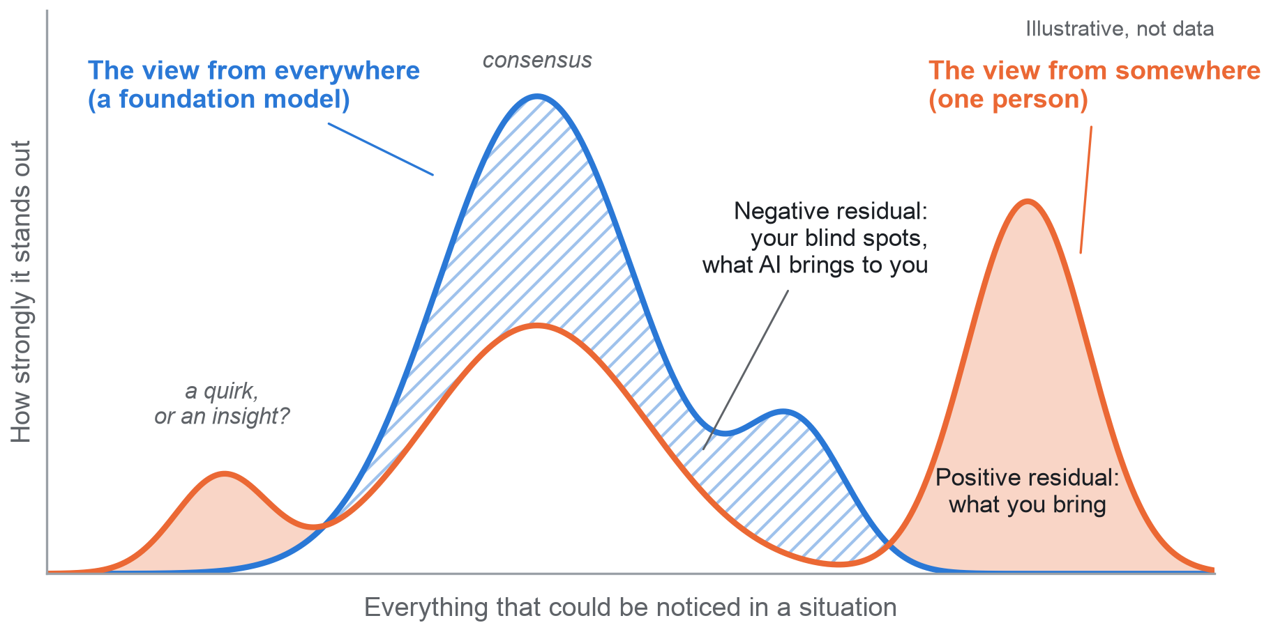
Figure 1. A perspective as a residual. Blue: the consensus salience of a foundation model. Orange: one person's. Where the person sees more (solid orange), they bring something no model has. Where the model sees more (hatched blue), the person has a blind spot, and AI helps most. Small peaks far from the consensus are where insight and bias are hardest to tell apart.
Four consequences follow.
- It works in both directions. The positive residual tells an AI what to amplify in you. The negative residual tells you what you are missing. Perspective Intelligence is not people against machines; it routes each to where the other is weak.
- It makes perspective measurable. Concepts like this usually stay labels because they can only be observed in outcomes. A residual can be measured directly, situation by situation and over time: how large it is, how stable, how much of it predicts outcomes the consensus missed, and whether it grows or shrinks as a person uses AI.
- It turns humility into computation. Part of any residual is insight, part is bias and part is noise. Holding a perspective lightly becomes a calibration problem: learn from outcomes which parts of a lens to trust in which situations, and when the consensus should win.
- It decides who teaches whom. Comparing what a person and a model each notice sorts every situation into four cases, and each gives AI a different job: automate, learn from the person, teach the person, or bring in someone else (section 6.2).
The consensus is not the enemy. In most situations it is right, and the residual should be small. Organizations need variance where they explore and standards where they exploit (March, 1991). Yet every standard began as someone's perspective: Taiichi Ohno looked at the American supermarket, which restocks a shelf only as customers empty it, and saw a way to run a factory. It became the kanban pull system. Standards are perspectives that won and were frozen. Perspective Intelligence is about knowing where the edge is, and making sure that at the edge, the view from somewhere is not averaged away.

5 The Perspective Stack
Turning the residual into working systems takes five layers above an open foundation, with a person at the top and governance running through all of them. The stack is the instrument: it measures and carries a way of seeing. Section 6 closes it into a loop that uses the instrument and feeds it.
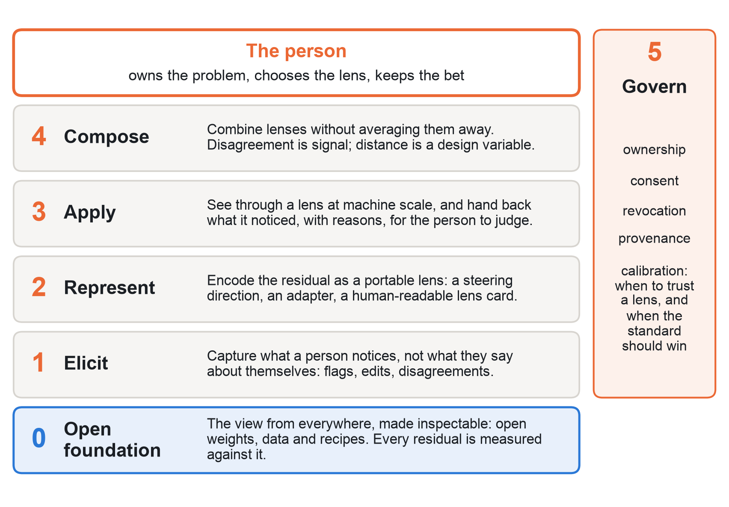
Figure 2. The Perspective Stack. Layer 0 is the open view from everywhere; layers 1 to 4 capture, encode, use and combine the view from somewhere; layer 5 keeps it owned and calibrated. Section 6 closes the stack into a loop (Figure 3).
Layer 0 · Open foundation. The view from everywhere, pinned and inspectable. Open weights let us read and steer a model's internal representations. Open data lets us ask whether an apparently original observation is already common in the corpus. Open recipes tell us what post-training did to diversity. Pinned also means growth can be measured: if the ruler moves silently, no one can tell whether a person grew or the baseline shifted.
Layer 1 · Elicit. Perspective is tacit: “we can know more than we can tell” (Polanyi, 1966). Ask people to describe their lens and you get who they think they are. So the stack learns from behaviour: what someone flags, corrects, rejects, reorders or lingers on. The richest signal of all is disagreement with the baseline, because every disagreement is a sample of the residual. The densest source of these disagreements is building: people who cannot describe their lens react at once to a concrete artefact (section 6.2).
Layer 2 · Represent. A lens needs a form that is portable, composable, inspectable and revocable. Candidates, from lightest to heaviest: a lens card, a human-readable account of what this person attends to and why; a salience model that predicts what they would flag; a steering direction in the model's activation space; a low-rank adapter. Interpretability research has shown that character traits such as sycophancy correspond to linear directions in a model's activations that can be monitored and steered (Chen et al., 2025). Whether a way of seeing has the same geometry is an open, testable question, and only open weights let anyone test it. At the far end, a lens becomes a skill: the lens plus procedures an agent can run, versioned as the person grows and owned by them.
Layer 3 · Apply. Agents that look through a chosen lens across far more material than any person could read, and return what they noticed with their reasons. They hand back observations, never the bet. What happens next is the job of the Perspective Loop (section 6): AI does the building; the person makes the choices that carry the bet.
Layer 4 · Compose. Combining lenses without averaging them. Averaging several perspectives rebuilds the consensus. Composition keeps disagreement as signal and treats lens distance, how differently two people see, as a design variable: for a hard problem, the most useful pair of lenses may be the two most distant credible ones. Inside a mixture-of-experts model, routing between specialist subnetworks is standard engineering. Perspective Intelligence asks for routing between people's lenses. Composition is also how people learn from each other. Learning from a distant expert's lens makes a learner more distinct; learning from the consensus makes them more alike. Compose is where apprenticeship lives.
Layer 5 · Govern. A lens may be the most personal artefact a person can produce: not a record of what they did, but of how they see. It needs ownership, consent, revocation and provenance, plus a calibration record of when it has been right. It must run on infrastructure its owner controls. And it needs a policy for the commons: a person's skill stays theirs, and any contribution to future models is opt-in and credited.
The person. At the top of the stack one rule holds. AI widens the search, applies the lens and does most of the building. The person owns the problem, chooses the lens, selects what to pursue and bears the bet. That rule is not a brake on automation. It is how the person grows: a loop that closes around a person, instead of through them, leaves them unchanged.

6 The Perspective Loop
A stack that only hands back observations is a dashboard. It leaves the person to do all the downstream work, and it never learns from what they did. Perspective Intelligence closes the loop. It finds where your way of seeing beats the consensus, helps you build there, and helps you grow ahead of your own lens.
The aim is augmentation in both directions: people get better with AI, and AI gets better from people. The loop is not an application bolted onto the stack. It runs downstream of Apply and Compose, but its data flows upstream: every turn produces the edits, outcomes and unassisted tests that the stack needs in order to learn (Figure 3). In Argyris and Schön's terms, today's tools do single-loop learning, better outputs from a fixed way of seeing. The Perspective Loop does double-loop learning: the way of seeing itself changes, on both sides.
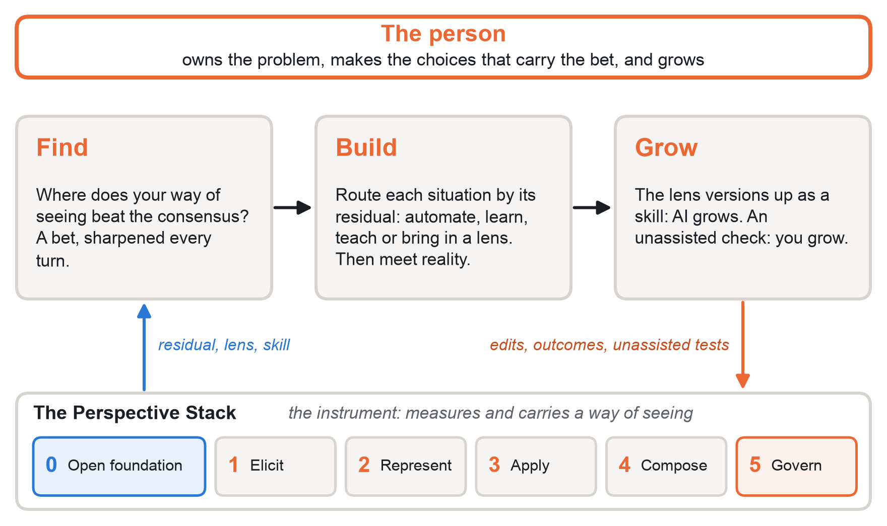
Figure 3. The Perspective Stack closed into a loop. The stack measures and carries a way of seeing. Find chooses where to aim it, Build routes each situation by its residual and meets reality, and Grow updates both the lens and the person. Edits, outcomes and unassisted tests flow back into the stack and sharpen the next turn.

6.1 Find: where your edge is worth the most
Every person has a residual; few residuals are valuable everywhere. Find looks for perspective–problem fit: situations where a person's validated residual is large, where a consensus miss is costly, and where reality answers quickly enough for the loop to turn. This is where we expect Perspective Intelligence to beat the state of the art: not everywhere, but in niches big enough to matter and specific enough that solutions built for the average fail.
Find is a bet, not a lookup. Knowing where a residual is valuable takes outcomes, and outcomes take building. So the first bet is cheap: run the baseline on situations the person has already handled, such as past reviews, decisions or designs, and compare. Build then tests the bet, and Find sharpens with every turn. When a lens has no strong use alone, Find searches pairs: a lens that is ordinary on its own may be decisive next to a distant one (Layer 4).

6.2 Build: the residual decides who teaches whom
Build does the downstream work. For each situation, it compares what the person notices with what the model notices. There are four cases, and each gives AI a different job (Figure 4).
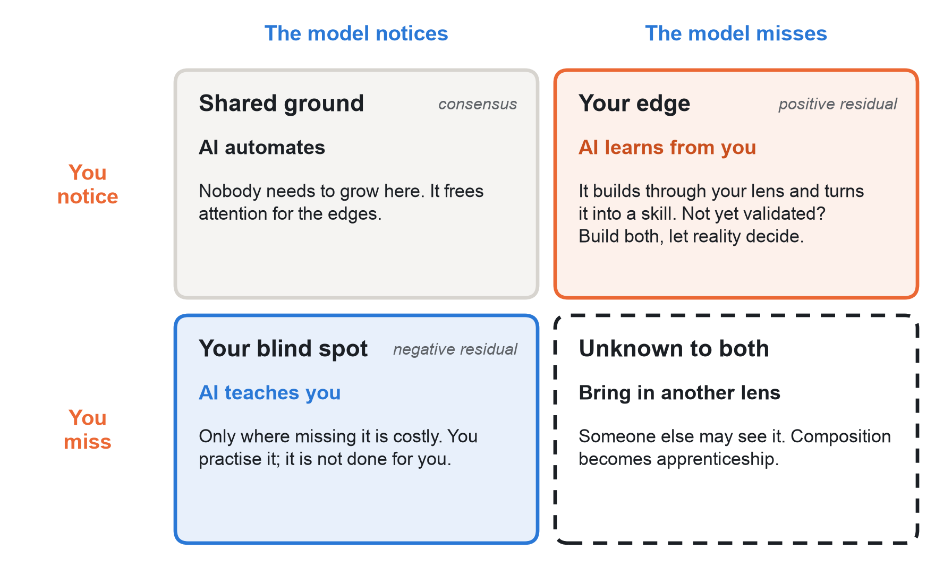
Figure 4. Who teaches whom. Each situation falls into one of four cases. AI automates shared ground, learns from the person's edge, teaches the person's costly blind spots, and brings in another person's lens where neither sees. Colours follow Figure 1: orange is the person, blue the model.
- Shared ground: AI automates. Nobody needs to grow here, and that is fine: it frees attention for the edges.
- Your edge: AI learns from you. It builds through your lens and turns the lens into a skill. If the edge is not yet validated, Build makes both versions, yours and the consensus, and lets reality decide.
- Your blind spot: AI teaches you, but only where it matters. Experts are good partly because of what they ignore, and filling every blind spot would make them average. Calibration (Problem 5) is the filter. The person practises what they missed rather than having it done for them.
- Unknown to both: bring in another lens. Neither you nor the model sees it, but someone else might. Here composition becomes apprenticeship.
Every artefact then meets reality: a test passes or fails, a simulation runs, a user reacts. People who cannot describe their lens react at once to something concrete; in Schön's words, the situation “talks back”. So building is also the richest way to elicit a lens (Problem 1), and the fastest source of the outcomes that calibration needs (Problem 5).

6.3 Grow: both sides get better
Each turn ends with two updates. The AI grows: the lens is updated from the person's edits and the outcomes, and versioned as a skill, v1, v2, v3, that agents can run and the person owns. The person grows: a short check on held-out situations, without assistance, shows whether their costly blind spots are closing and whether their edge holds. The person also sees a lens diff, a changelog of their own way of seeing: what they started noticing, what they stopped flagging, and what a blind spot cost.
Growth, measured
R⁺ is the positive residual: what the person notices and the model misses. R⁻ is the negative residual: what the model notices and the person misses.
L(S) is what the person's lens from the previous turn predicts they will notice in S.
The growth residual G(S) = H(S) − L(S): what the person notices now that their own earlier lens did not predict.
Healthy growth: costly R⁻ shrinks, measured without assistance, while validated R⁺ holds or grows, and G stays above zero.

The growth residual guards the sharpest risk in the loop. Once the system holds your lens, the lens can do your noticing without you. What keeps a person valuable is growing faster than their captured copy. If G falls to zero, the lens has caught up, and the system is replacing the person instead of growing them. The target also moves because of the system itself: the lens is chasing a person whom the lens is changing, a case of what machine learning calls performative prediction (Perdomo et al., 2020).
What we see | What it means
Costly R⁻ shrinks without assistance; validated R⁺ holds or grows | Healthy growth: fewer blind spots, edge intact
R⁻ and R⁺ both shrink | Absorbed: the person is becoming the model
R⁺ grows but its hit rate falls | Self-caricature: more different, less right
Assisted output rises; unassisted performance falls | Deskilling: help is hollowing the person out
G falls to zero | Replaced: the lens has caught up with the person

6.4 Three speeds
The loop turns at three speeds, and each has its own measure.
Loop | Speed | What evolves | Measured by
Build | Minutes to hours | The solution | The residual against the consensus: does the solution beat the baseline where the lens says it should?
Grow | Weeks to months | The person's lens and skill | The growth residual: does the person notice what their earlier lens did not predict?
Commons | Model generations | The baseline itself | Absorption: did this residual become consensus in the next model version?

Edges decay. A winning residual spreads, gets written up, enters training data and becomes part of the next model's consensus. Ohno's supermarket became kanban, and kanban became a textbook. That is how standards are made, and it is good for everyone, but it means any individual edge has a half-life. Continued growth is the only way to stay ahead, which is why the loop never closes for good. Absorption also raises a question of credit: when a person's perspective becomes the next standard, can it be traced and credited? With open training data and versioned open models, it can at least be checked (section 8).

6.5 Help without hollowing
Augmentation in both directions has a known failure. The fastest way to enhance AI is to capture a person's lens and automate it, and that is also how people lose skill. The evidence is already in:
- In a randomized trial with about 1,000 high-school maths students, unrestricted GPT-4 help raised practice scores, but on an exam without AI those students scored 17% lower than students who never had access; a tutor version with guardrails largely removed the harm (Bastani et al., 2025).
- Endoscopists who had routinely used AI detected fewer adenomas when working without it: the detection rate fell from 28.4% to 22.4% (Budzyń et al., 2025).
- Knowledge workers with more confidence in generative AI reported applying less critical thinking (Lee et al., 2025).
So the loop follows four rules.
- Route, do not default. The four cases decide, situation by situation, whether AI does the work or coaches the person.
- Keep difficulty where the lens is forming. Where a person's lens is still developing, the loop leaves deliberate practice to them; learning research calls this desirable difficulty (Bjork, 1994).
- Test without the tool. A growth claim counts only if it holds unassisted.
- Keep the person in contact with reality, and do not flatter. Perspective forms where the work meets the world, not where it meets AI output. If a residual is mostly bias, the loop says so.
Novices and experts need different loops. A novice has a small edge and many blind spots, so the loop is mostly a tutor, with the risk of producing copies of the consensus; the remedy is to teach through distant expert lenses rather than through the average. An expert is the reverse, and the loop is mostly an amplifier. The most interesting person is in between: someone whose lens is still forming.
Licklider imagined a symbiosis of people and computers. The residual gives that symbiosis a ledger: a running record of what crossed in each direction, and whether it worked.

7 Eight hard problems
We are proud of this idea because it is hard. Each layer of the stack hides an unsolved problem, and closing the stack into a loop adds one more. Any one of them is a research contribution on its own; together they define a new kind of AI system.
 | Problem | Why it is hard | What solving it unlocks
1 | The tacit problem | People cannot describe their own lens; self-reports describe who they think they are | Lenses learned from what people do, not what they say
2 | The baseline problem | The “average” must be fixed and inspectable; closed models are opaque and change silently | A stable ruler for originality
3 | The representation problem | Prompts caricature; full fine-tunes tangle seeing with style and facts; nobody yet knows the natural shape of a perspective | Lenses that are portable, composable and inspectable
4 | The fidelity problem | Proving a model sees through your lens, not through a caricature of you | A trustworthy test of whether a lens is really yours
5 | The calibration problem | The residual mixes insight, bias and noise; outcomes arrive late and rarely | Knowing when to trust a lens, and when the standard should win
6 | The composition problem | Averaging lenses rebuilds the consensus; keeping all of them overwhelms people | Teams of lenses that see more than their mean
7 | The sovereignty problem | A lens is intimate and valuable; it can be copied, misused or used to imitate a person | Lenses that people own, license and revoke
8 | The growth problem | Help that raises output can lower unassisted skill; and the person, their lens and the baseline all move at once, partly because of the system itself | AI that leaves people better than it found them, with growth that can be measured

Closing the loop also helps with two of the older problems. Building produces dense residual samples for the tacit problem, and fast outcomes for the calibration problem.

A measurement standard: the Perspective Fidelity Test
Problems 3 and 4 need a shared yardstick, so we propose one. Hold out situations a person has already judged. A lens passes if it predicts what that person noticed better than the baseline alone does, and does so without exaggerating the person's most obvious traits, the signature of caricature (Cheng et al., 2023).
Sounding like you is easy. Noticing like you is the test.

A second standard: the Growth Test
Problem 8 needs its own yardstick. Before and after a person works with the loop, test them on held-out situations without assistance. The loop passes if the person's costly blind spots shrink while their validated edge holds or grows, and if they notice things their own earlier lens did not predict. A rise in assisted output alone does not count.
Helping you is easy. Leaving you better is the test.

8 Why open infrastructure is a requirement
Most AI projects use a foundation model as the answer. Perspective Intelligence uses it as the average, so that it can find what is not average. That single inversion turns openness from a preference into a technical requirement. Closing the loop raises the bar again: to measure whether anyone has grown, the ruler has to hold still while the person moves.
What Perspective Intelligence needs | What open models and infrastructure provide
A fixed baseline to measure every residual against | Pinned open weights: the same ruler today and next year, not a silently updated API
Access to internal representations, for steering-based lenses | Open weights running on GPUs we control (Nebius AI Cloud)
A way to check whether an “original” observation is already common | Open training data: NVIDIA has released more than 10 trillion tokens of the data behind Nemotron 3
Knowing what alignment did to diversity | Open training recipes for pretraining, fine-tuning and reinforcement learning
Privacy for the most personal data a person has | Zero-retention inference and dedicated endpoints on Nebius Token Factory, or self-hosted weights
Always-on noticing that is cheap, and deep reasoning when it matters | The Nemotron 3 family: Nano for continuous, low-cost capture; Super for applying lenses; Ultra for calibration and composition; long context for a person's history
A baseline that holds still while a person grows | Pinned open model versions: a change in the person is never confused with a silent change in the model
Tracing when a perspective becomes the standard | Open training data across model versions: check whether one version's residual became the next version's consensus, and credit it
Skills that the person owns | Lenses as adapters or skills on open weights that the person can host, license or revoke

The hackathon asks builders to own the whole thing. Perspective Intelligence extends that principle to the last thing that should be owned: the way a person sees.

9 One primitive, every track
This paper deliberately leaves the use case open. But the primitive, a lens measured against an open baseline and grown through the loop, fits every track of the hackathon. These are illustrations of reach, not commitments.
Track | The same primitive
Personal AI | A private, always-on lens that you own: it notices on your behalf, shows you your blind spots and checks that you are growing
Apps and agents | Agents that see through a chosen expert's lens, or through several deliberately different ones, and learn from every correction
Coding and agentic engineering | A reviewer that notices what your most experienced engineer would notice, not what the average public repository suggests, and helps junior engineers grow toward that lens
Physical AI | Robots that attend to what an expert technician attends to: salience in sensor space, not only in text, so that apprentices can learn that lens too

When we choose, the framework tells us where to aim: wherever the residual is largest, the cost of missing it is highest, and the cycle from building to reality is short enough for the loop to turn.

What a first build must show
One full turn of the loop, in one domain with a short feedback cycle, with one expert and one learner:
- Find a niche in the expert's past work where their residual beats the baseline.
- Build: route real situations through the four cases, build one thing through the expert's lens, test it, and version the skill from v1 to v2 with a lens diff.
- Grow: expose the learner to the expert's lens and to the consensus, and test them on held-out cases, without assistance, before and after.
We will claim the mechanism and the instrument. Growth over months takes longer than a hackathon, and we will not claim it.

10 What would prove us wrong
A framework is only worth building if it can fail. These are the results that would falsify ours. Each is an experiment, not an argument.
If this turns out to be true… | …we would see it here
The residual is mostly noise | It predicts nothing that the consensus missed
Lenses do not transfer | On held-out situations, a lens does no better than the baseline
Fidelity collapses into caricature | Caricature measures rise as lenses are pushed toward fidelity
Perspective is just preference | What people notice cannot be separated from what they like
AI shrinks the people it learns from | A person's residual narrows the longer they use the system; we track this on every turn (section 6.3)
Help hollows | Unassisted performance falls after people use the loop, even as assisted output rises
The loop grows contrarians, not insight | Positive residuals grow while their hit rate falls
Perspective loses value as AI improves | Future models predict a person's residual from their history alone, with no live input from them

11 A hundred universes
“The only true voyage of discovery … would be not to visit strange lands but to possess other eyes, to behold the universe through the eyes of another, of a hundred others, to behold the hundred universes that each of them beholds, that each of them is.”
Marcel Proust, The Captive (1923), translated by C. K. Scott Moncrieff

For most of history, the only way to see through another person's eyes was art. Then AI gave everyone the same eyes: the eyes of everyone at once. Perspective Intelligence is the attempt to use machines for what Proust described: to keep a hundred universes from collapsing into one, and to let each person see further through their own. And because people keep living, their eyes keep changing. A system that only captured them would freeze them. Perspective Intelligence has to keep each person ahead of their own lens, and let what they see change what everyone else can see.

Questions we want to answer
- Is a way of seeing a direction in a model's activation space?
- How large is an expert's residual, and does it grow or shrink the more they use AI?
- How few situations does it take to capture a lens?
- How far apart must two lenses be before combining them reveals something neither could see alone?
- Can a retiring expert hand down a lens, and not just a manual?
- Can a person stay ahead of their own lens, and how fast must they grow to do so?
- Does learning from a distant expert's lens make a learner more distinct, where learning from the consensus makes them more alike?
- When a perspective is absorbed into the next model and becomes a standard, can its owner be credited?
Every AI can take any perspective.
We want to build the one that can carry yours,
and grow with you.

A Glossary
Perspective. The particular way a person sees, formed by lived experience: what shows up for them as relevant, odd or wrong.
Perspective Intelligence. The capability, in people and in machines, to form, see through, translate and hold lightly a way of seeing.
View from everywhere. The averaged standpoint of a model trained on everything written. Contrasted with the view from somewhere, a single lived standpoint.
Residual. What a person notices in a situation, minus what an open foundation model notices in the same situation.
Lens. A portable representation that predicts a person's residual in situations they have never seen.
Lens card. A human-readable description of a lens: what this person attends to, and why.
Lens distance. How differently two lenses see the same situations.
Monoculture of attention. The convergence of what people notice when they all rely on the same few models.
Perspective Fidelity Test. Proposed standard: a lens passes if it predicts what a person notices better than the baseline does, without caricature.
Perspective Stack. The six layers for building Perspective Intelligence systems: open foundation, elicit, represent, apply, compose, govern. The instrument the Perspective Loop runs on.
Perspective Loop. The stack closed into a loop: Find where a lens is worth the most, Build by routing each situation by its residual, and Grow both the lens and the person.
Perspective–problem fit. A situation where a person's validated residual is large, a consensus miss is costly and reality answers fast.
Who teaches whom. The loop's routing rule: AI automates shared ground, learns from the person's edge, teaches their costly blind spots and brings in another lens where neither sees.
Skill. A lens plus procedures an agent can run, versioned as the person grows and owned by them.
Growth residual. What a person notices now that their own earlier lens did not predict.
Lens diff. A changelog of a person's way of seeing between turns of the loop.
Absorption. A residual becoming part of the next model's consensus: how a perspective becomes a standard.
Growth Test. Proposed standard: the loop passes if, without assistance, a person's costly blind spots shrink while their validated edge holds or grows.

B References
Argyris, C., & Schön, D. A. (1978). Organizational Learning: A Theory of Action Perspective. Addison-Wesley.
Bastani, H., Bastani, O., Sungu, A., Ge, H., Kabakcı, Ö., & Mariman, R. (2025). Generative AI without guardrails can harm learning: Evidence from high school mathematics. Proceedings of the National Academy of Sciences, 122(26).
Bjork, R. A. (1994). Memory and metamemory considerations in the training of human beings. In J. Metcalfe & A. P. Shimamura (Eds.), Metacognition: Knowing about Knowing (pp. 185–205). MIT Press.
Budzyń, K., Romańczyk, M., Kitala, D., et al. (2025). Endoscopist deskilling risk after exposure to artificial intelligence in colonoscopy: A multicentre, observational study. The Lancet Gastroenterology & Hepatology, 10(10).
Chen, R., Arditi, A., Sleight, H., Evans, O., & Lindsey, J. (2025). Persona vectors: Monitoring and controlling character traits in language models. arXiv:2507.21509.
Cheng, M., Piccardi, T., & Yang, D. (2023). CoMPosT: Characterizing and evaluating caricature in LLM simulations. EMNLP 2023.
Doshi, A. R., & Hauser, O. P. (2024). Generative AI enhances individual creativity but reduces the collective diversity of novel content. Science Advances, 10(28).
Engelbart, D. C. (1962). Augmenting Human Intellect: A Conceptual Framework. Stanford Research Institute.
Engelbart, D. C. (1992). Toward high-performance organizations: A strategic role for groupware. Proceedings of GroupWare '92. Morgan Kaufmann.
Gentner, D. (1983). Structure-mapping: A theoretical framework for analogy. Cognitive Science, 7(2).
Haraway, D. (1988). Situated knowledges: The science question in feminism and the privilege of partial perspective. Feminist Studies, 14(3).
Jiang, L., Chai, Y., Li, M., Liu, M., Fok, R., Dziri, N., Tsvetkov, Y., Sap, M., Albalak, A., & Choi, Y. (2025). Artificial Hivemind: The open-ended homogeneity of language models (and beyond). NeurIPS 2025, Datasets and Benchmarks Track. arXiv:2510.22954.
Kirk, R., Mediratta, I., Nalmpantis, C., Luketina, J., Hambro, E., Grefenstette, E., & Raileanu, R. (2024). Understanding the effects of RLHF on LLM generalisation and diversity. ICLR 2024.
Koestler, A. (1964). The Act of Creation. Hutchinson.
Lee, H.-P., Sarkar, A., Tankelevitch, L., Drosos, I., Rintel, S., Banks, R., & Wilson, N. (2025). The impact of generative AI on critical thinking: Self-reported reductions in cognitive effort and confidence effects from a survey of knowledge workers. CHI 2025.
Licklider, J. C. R. (1960). Man-computer symbiosis. IRE Transactions on Human Factors in Electronics, HFE-1(1).
March, J. G. (1991). Exploration and exploitation in organizational learning. Organization Science, 2(1).
Nagel, T. (1986). The View from Nowhere. Oxford University Press.
NVIDIA (2025). NVIDIA Nemotron 3: Efficient and open intelligence. arXiv:2512.20856.
Ohno, T. (1988). Toyota Production System: Beyond Large-Scale Production. Productivity Press.
Perdomo, J. C., Zrnic, T., Mendler-Dünner, C., & Hardt, M. (2020). Performative prediction. ICML 2020. arXiv:2002.06673.
Polanyi, M. (1966). The Tacit Dimension. Doubleday.
Proust, M. (1923). La Prisonnière (The Captive). Trans. C. K. Scott Moncrieff, 1929.
Schön, D. A. (1983). The Reflective Practitioner: How Professionals Think in Action. Basic Books.
Si, C., Hashimoto, T., & Yang, D. (2025). The ideation–execution gap: Execution outcomes of LLM-generated versus human research ideas. arXiv:2506.20803.
Sorensen, T., et al. (2024). Position: A roadmap to pluralistic alignment. ICML 2024.
Vervaeke, J., Lillicrap, T. P., & Richards, B. A. (2012). Relevance realization and the emerging framework in cognitive science. Journal of Logic and Computation, 22(1).
von Hippel, E. (1994). “Sticky information” and the locus of problem solving: Implications for innovation. Management Science, 40(4).
von Hippel, E. (2005). Democratizing Innovation. MIT Press.
Wang, A., Morgenstern, J., & Dickerson, J. P. (2025). Large language models that replace human participants can harmfully misportray and flatten identity groups. Nature Machine Intelligence, 7, 400–411.

