USE CASES · NEBIUS × NVIDIA GLOBAL AI HACKATHON
Perspective
Intelligence
Three hard problems where the view from somewhere is the solution
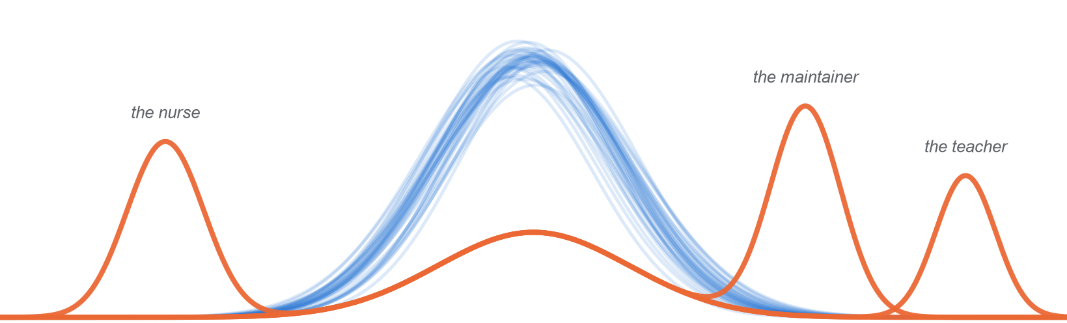
One consensus. Three people who see what it misses.
Expertise is retiring faster than it forms.
AI is filling the gap with the average.

Status: Companion to the idea paper (version 2). Three use cases, tested against the hackathon's rules and judging criteria, with a recommendation on which to build.
Tracks: Best Apps and Agents, Coding and Agentic Engineering, Personal AI.
Date: 23 October 2026
Team: [to be added]

The use cases on one page
We did not start from the idea and look for places to put it. We started from hard problems, and kept only those where the failure is a failure of attention: the people who notice what matters are scarce, their noticing is the signal that today's systems miss, and AI is currently making that worse. Three problems passed every test, in three different domains.
Use case | The pain | What the consensus misses | What the person gets
Vigil  the clinic | Patients deteriorate on general wards while early warning scores stay quiet, and the experienced nurses who would have noticed are leaving the bedside | The experienced nurse's concern, visible in what they check and write before the vital signs change | A worry turned into an escalation a doctor acts on, and novice nurses who learn to see it
Keeper  the codebase | Critical open source rests on a few overloaded maintainers, now flooded by AI-generated contributions | What this maintainer catches in review that a generic reviewer does not: the project's invariants, history and threat model | Reviews and tested fixes in the maintainer's lens, a triaged queue, and contributors who grow into successors
Margins  the classroom | New teachers cannot yet see student thinking, and the coaching that teaches it does not scale | What a master teacher notices in a lesson: the misconception behind an answer, the student about to give up | A private coach that shows what a master would have noticed today, and checks that the teacher learns to notice it alone

The same crisis, three times. In each domain, expertise forms slowly, through years of contact with reality, and is leaving faster than it forms. AI is filling the gap with the average: scores, reviews and lesson plans that are competent and the same for everyone. And in each, the residual is already visible in behaviour: what a nurse checks and charts, what a maintainer writes in review, what a teacher says next. That is why Perspective Intelligence is the central notion here, not a frame laid over the problem.
What we recommend. Build Keeper for the hackathon. Its data is public, reality answers in minutes through tests, and its Fidelity Test can be run on real reviews before the deadline. Vigil has the highest stakes and the strongest evidence, but open clinical data limits a one-week build to retrospective and simulated cases. Margins comes next: it is the clearest fit for the Personal AI track, and open data already pairs novice and expert responses. All three run on the same lens engine, so building one builds most of the others (section 5).

1 How we chose
A use case qualifies only if Perspective Intelligence is the reason it can be solved. We used four tests, then the hackathon's own constraints.
Test | The question | Why it matters
1 The failure is one of attention | Do today's systems miss something that specific, experienced people reliably notice, and is there evidence of it? | Without a residual, there is nothing for a lens to carry
2 The noticing is scarce and leaving | Is the expertise slow to form, held by few people, and leaving faster than it is replaced? | This is what makes it a pain, not a curiosity
3 AI is making it worse | Is the field being flooded with the average, or are people losing the skill by leaning on AI? | This is why the loop is needed, not only the lens
4 Reality answers | Do outcomes arrive fast enough for the loop to turn, and is there open data to show it? | Without this, nothing can be demonstrated or calibrated

The hackathon adds four constraints: a working build in under a week, Nemotron on Nebius Token Factory at the centre of the product, no real person's private data in the demo, and a clear fit to one track.

The candidates
Candidate | Against the four tests | Verdict
Patient deterioration on hospital wards | Passes all four; test 4 only on retrospective and simulated data | Chosen: Vigil
Open-source code review | Passes all four, test 4 strongly | Chosen: Keeper
Teaching and tutoring | Passes all four; open data already pairs novice and expert responses | Chosen: Margins
Industrial maintenance: the technician's ear | Strong on tests 1 to 3. Its signals are sound and vibration, which no Nemotron model on Token Factory's serverless tier takes in directly, and the demo needs hardware and a technician | Set aside. The right pick for a team with a test rig and an expert
Bridge and infrastructure inspection | Strong on tests 1 to 3. Per-inspector records are not public, and deterioration takes years to confirm | Set aside
Local weather forecasting: forecasters' edits to model guidance | The residual is measurable from public archives, but the build is mostly gridded-data engineering, for a small specialist audience | Set aside
Smallholder farming advice | Very large impact, but local expert noticing is rarely written down, so the residual cannot be measured on open data | Set aside
Diagnostic imaging | Strong evidence of deskilling, but expert annotations and gaze data need credentialed access | Set aside; partly covered by Vigil
Scientific peer review | The lens is real, but reviewers cannot be linked across papers in open data, and the impact is indirect | Set aside

2 Vigil: when a nurse's worry is the earliest vital sign
Domain hospital wards · Track Best Apps and Agents · User bedside and charge nurses, above all those in their first years

The problem
About 292,000 adults have a cardiac arrest in a US hospital each year (Holmberg et al., 2019), and most show signs of deterioration first: in one classic study, 84% had documented deterioration in the eight hours before (Schein et al., 1990). Hospitals respond with early warning scores computed from vital signs. These are the consensus in its purest form, the average pattern of decline across all patients. They fire late for the patient whose decline does not look average, and too often for everyone else: 72% to 99% of clinical monitor alarms are false (Sendelbach & Funk, 2013). A widely deployed commercial sepsis model, validated externally, missed 67% of sepsis cases while alerting on 18% of all hospitalized patients (Wong et al., 2021).
What catches the patient the score misses is often a nurse. Nurses' worry is a recognized early sign of deterioration, and can be present before the vital signs change (Douw et al., 2015). Adding nurse-worry indicators to an early warning score raised its accuracy, measured as AUC, from 0.86 to 0.91 (Douw et al., 2016). In another hospital, a nurse-worry score alone predicted transfer to intensive care within 24 hours with an AUC of 0.92, and nurses with under a year's experience were less accurate than their colleagues, 68% against 79% (Romero-Brufau et al., 2019).
Worry can also be read from behaviour instead of asked for: a worried nurse checks more often and writes more. A randomized trial across 74 units in four hospitals turned those documentation patterns into a real-time warning system. Patients on the intervention units had a 35.6% lower risk of dying in hospital and a 7.5% lower risk of sepsis, and were moved to intensive care sooner and more often (Rossetti et al., 2025). The residual is real, and acting on it saves lives.
Two things threaten it. The nurses who hold it are leaving: nearly 100,000 US registered nurses left during the pandemic, and 610,388 experienced nurses planned to leave or retire within five years (Martin et al., 2023), while the world is short of 5.8 million nurses (World Health Organization, 2025). And a worry is hard to act on: “I'm worried” without data is easy to dismiss at 3 a.m. Communication failures appeared in 30% of 23,658 malpractice cases, linked to 1,744 deaths over five years (CRICO Strategies, 2016).
The signal that saves patients lives in the heads of the nurses we are losing, and the systems replacing them see only the average.

Why perspective is the central notion
The residual on a ward
S is one patient's last 24 hours: vital signs, assessments, nursing actions and notes.
C(S) is what the consensus flags: the early warning score, and what Nemotron notices in the chart.
H(S) is what an experienced nurse notices: the extra checks, the note that the patient is not themselves, the call they make or would make.
R(S) = H(S) − C(S): concern where the score is quiet, and alerts the nurse discounts. Outcomes decide which part is insight and which is bias.

Three things make this more than a better score. It is per person and calibrated: Vigil learns whose concern predicts what, instead of averaging all nurses into a new consensus. It translates: it turns a tacit worry into evidence a doctor can act on. And it grows people: it teaches novices to see what experienced nurses see, and checks that they can without the tool.
What the evidence does and does not show. The evidence that worry carries signal is strong. The evidence that experience sharpens it rests on fewer studies, and the signal depends on setting: on intensive-care data, where charting follows a fixed schedule, documentation-frequency features only matched a standard score (AUC 0.67 each) rather than beating it (Wan et al., 2026). General wards, where extra checks are a nurse's choice, are where the signal lives. Vigil's per-nurse calibration is how that would be tested, not assumed.

The user and the moment
It is 3 a.m. on a medical ward. A nurse eight months out of training has five patients. One, admitted with pneumonia, is quieter than at handover and slow to answer. The early warning score is unchanged: no alert. The nurse is unsure whether this matters, or whether it is worth waking the doctor. The experienced charge nurse is two corridors away with a patient who is bleeding.

The solution
Vigil watches every chart on the unit through the lens of its experienced nurses, and acts in one of four ways.
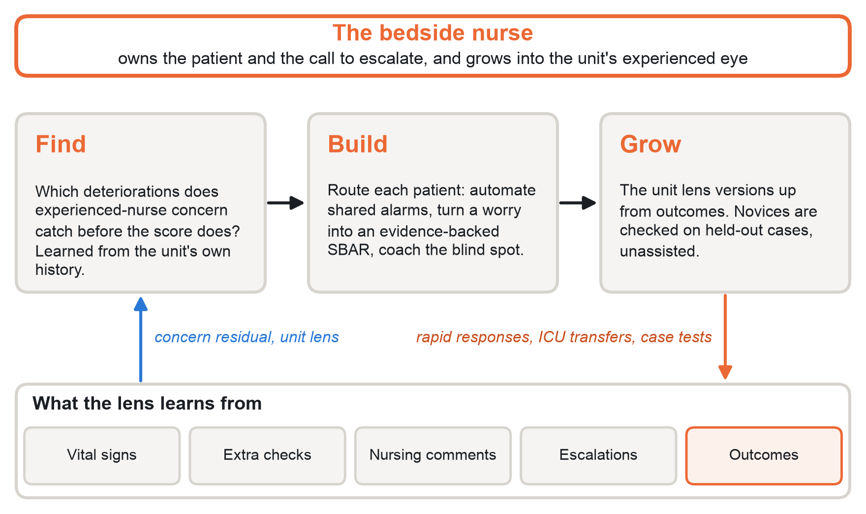
Figure 1. Vigil's loop. Find locates the deteriorations that experienced concern catches before the score; Build routes each patient; Grow recalibrates the unit lens against outcomes and tests novices on held-out cases.
The case | What Vigil does | Who grows
Shared ground: the score and the lens both flag | Drafts the escalation and the rapid-response call, so the nurse's paperwork shrinks | Nobody needs to; the work is automated
The nurse's edge: the nurse is worried, the score is quiet | Gathers the evidence behind the worry into an SBAR a doctor can act on, suggests the reassessment an experienced nurse would make, and records the outcome | The lens learns from the nurse
The novice's blind spot: the unit lens flags what the novice did not | A coaching prompt, not an alarm: what an experienced nurse would look at here, and why. The nurse assesses and decides | The novice learns from the lens
Unknown to both | Brings in another lens: the charge nurse, a pharmacist for a medication pattern, a second look | Both, through another person

One rule is absolute. The lens may raise an alarm; it never silences one. The early warning score keeps firing as it does today. Vigil adds escalations where experienced concern says the score is wrong, and never removes one.
Each week the unit lens is recalibrated against outcomes: rapid-response calls, unplanned ICU transfers, sepsis. Concern that predicted deterioration gains weight; concern that did not, or that tracks a patient's group rather than their condition, is flagged as bias. Novice nurses take a short unassisted check on held-out cases and see their own lens diff: what they now notice that they missed a month ago.

What the demo shows
- 0:00 to 0:30, the aha. A case built from a real de-identified timeline, in which the patient later deteriorated. The score stays quiet while an experienced nurse's annotations, made blind to the outcome, flag the patient hours earlier. Vigil, applying that nurse's lens, flags it too; the baseline does not.
- 0:30 to 1:30, the build. Vigil drafts the SBAR from the chart, routes four other patients into the other cases, and shows which Nemotron model did each step.
- 1:30 to 2:30, the growth. A novice nurse takes the held-out case check before and after a session with Vigil, and the costly signs they miss fall.
- 2:30 to 3:00, the numbers. The Fidelity Test on held-out cases: how much of the experienced nurse's concern the lens recovers, against the baseline.
Data. The eICU demo (more than 2,500 intensive-care stays from 20 hospitals) and the MIMIC-IV demo (100 patients) are openly licensed and de-identified, and both include nursing charting with timestamps. Neither has general-ward patients, nurse roles or experience, or narrative nursing notes. So the demo builds cases from real timelines, and an experienced nurse and a novice annotate about 40 of them, blind to the outcome, in a few hours. It illustrates the mechanism; it does not validate it, and we will say so.

How it is built
Step | Model on Token Factory | Why this model
Read each chart as it changes and summarize what moved | Nemotron 3.5 Lightning | Fast and cheap enough to run on every patient; its 1M-token context holds a whole stay
Apply the lens and route each patient into one of the four cases | Nemotron 3 Super | Judgment at moderate cost, with structured output
Draft the SBAR escalation, citing chart evidence | Nemotron 3 Super | Clear prose a clinician can check
Recalibrate the unit lens each week against outcomes | Nemotron 3 Ultra, through the Batch API | The hardest reasoning, run offline in bulk

The weekly recalibration runs as a Nebius Serverless Job. In a hospital, the same open weights could run on the hospital's own infrastructure, which a closed model cannot offer.

How we would know it works
- Fidelity: on held-out cases, the lens predicts the experienced nurse's concerns better than the baseline does, without exaggerating them.
- Growth: between the before and after checks, novices miss fewer costly signs, unassisted.
- In a hospital: time from first concern to escalation, rapid-response calls before arrest, unplanned ICU transfers and mortality, in a trial designed like CONCERN's.

Risks and limits we publish
- Clinical safety. Vigil supports licensed nurses; it never acts alone and never silences an alert. A real deployment needs clinical validation and regulatory review.
- Bias. Concern carries bias as well as insight. Calibration checks it across patient groups, and discards concern that tracks a group instead of a condition.
- Data. Open clinical data is small and weighted toward intensive care, so the hackathon result is retrospective and partly simulated, and we will say so.
- Workload. If Vigil adds alerts, it adds to fatigue. Its escalations must replace manual paperwork, not add to it.

3 Keeper: a maintainer's eye that scales
Domain open-source software · Track Coding and Agentic Engineering · User maintainers of widely used projects, and their contributors

The problem
Almost all software now contains open source: 98% of the commercial codebases audited in 2026 did, and 87% held at least one known vulnerability (Black Duck, 2026). Its value to the economy is estimated at $8.8 trillion, and 5% of developers produce 96% of that value (Hoffmann, Nagle & Zhou, 2024). Those few people are stretched: 60% of maintainers are unpaid, and 60% have quit or considered quitting (Tidelift, 2024). Their scarcest resource is attention. Every change needs someone who knows the project to decide whether it is safe.
In March 2024 that attention nearly failed. A backdoor rated 10.0, the maximum severity, was found in xz utils, a compression library in most Linux distributions. It had been planted over more than two years by “Jia Tan”, a contributor who earned the trust of the project's sole, unpaid maintainer while sock-puppet accounts pressed the maintainer to hand over control. The payload sat in build scripts and binary test files that no reviewer looked at, and it reached the testing branches of Fedora and Debian before a stable release shipped it. Review did not catch it. Andres Freund, a database engineer benchmarking PostgreSQL, noticed that failed SSH logins were taking about half a second longer and using too much CPU, and pulled the thread (Freund, 2024; Cox, 2024). It was caught by someone else's way of seeing.
AI is making this worse in three ways.
- It made contributions nearly free. curl ended its bug bounty in January 2026: about one submission in five had become AI slop, and fewer than one in twenty was a real vulnerability (Stenberg, 2025, 2026). tldraw began closing outside pull requests automatically, and GitHub shipped settings that let maintainers restrict or disable them.
- It reviews to the average. In nearly 280,000 review conversations across 300 projects, more than 95% of AI review comments fell into just two categories, and developers adopted 16.6% of AI suggestions against 56.5% of human ones (Zhong et al., 2026). Yet defects were only 14% of what human reviewers comment on; the rest is the project-specific judgment AI reviewers miss (Bacchelli & Bird, 2013).
- It is thinning the pipeline of successors. As AI-generated contributions rose, one-time contributors' merge rates fell by 18% against the expected trend (Afroz et al., 2026). Engineers who learned a new library with AI scored 50% on a concept quiz, against 67% for those without it (Shen & Tamkin, 2026). Employment of software developers aged 22 to 25 fell by nearly 20% from its late-2022 peak (Brynjolfsson, Chandar & Chen, 2025).
AI made contributions free. It made a maintainer's attention the scarcest thing in software.

Why perspective is the central notion
The residual in a codebase
S is a pull request: the diff, its description and the files it touches.
C(S) is what a generic reviewer notices: Nemotron's review, plus linters and scanners.
H(S) is what this project's maintainer notices: their review comments, change requests and rejections.
R(S) = H(S) − C(S): what the maintainer flags that the baseline misses, and baseline flags the maintainer ignores. Merges, reverts and later bugs decide which is insight.

No other domain records a lens so completely, or in public. A long-standing maintainer leaves thousands of review comments, each a sample of what they notice and the baseline does not. The lens can be learned from that behaviour, tested on held-out pull requests, and checked against reality in minutes by running the tests.

The user and the moment
A maintainer of a widely used library opens the queue on Monday: dozens of new pull requests, many of them AI-generated, and one from a helpful newcomer who has sent small, good patches for months and now proposes a change to the build scripts. The maintainer has two hours for review this week.

The solution
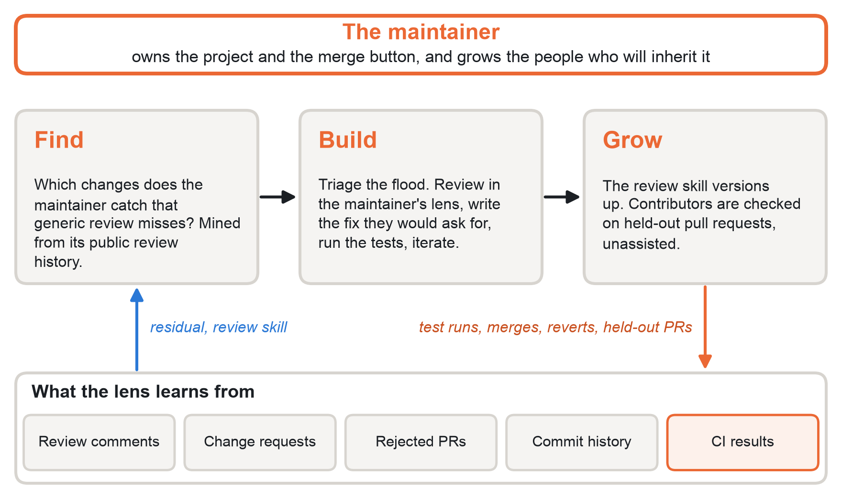
Figure 2. Keeper's loop. Find mines the project's review history for where the maintainer's residual is large and costly; Build triages, reviews in the lens and tests fixes; Grow versions the review skill and tests contributors on held-out pull requests.
The case | What Keeper does | Who grows
Shared ground: style, missing tests, known bug patterns | Comments and fixes automatically, runs the tests in a sandbox, and iterates until they pass | Nobody; the maintainer never needs to see it
The maintainer's edge: what they would flag that generic review misses | Drafts the review they would write, citing their own past reviews, writes the fix they would ask for, and tests it | The lens learns from the maintainer
The maintainer's blind spot: what security or consensus review catches that they tend to miss | Surfaces it with evidence; never merges on its own | The maintainer
Unknown to both: build-system or release changes, unusual dependencies | Routes to a person with a different lens, such as a security or performance reviewer | Both, through another person

Keeper also triages the flood. It ranks incoming contributions by how much of the maintainer's attention they need, so routine and AI-generated changes are handled in the shared-ground lane, and the build-script change from the trusted newcomer goes to a person with a security lens.
Contributors are reviewed in the maintainer's lens, with the reasons, and can take a held-out review check: given real past pull requests, do they flag what the maintainer flagged? This is how a project grows successors it can trust, with a record of how they grew. The lens itself becomes a versioned review skill that the project owns, can revoke, and can hand down.

What the demo shows
- 0:00 to 0:30, the aha. A real merged pull request from a popular open-source project. The baseline Nemotron review lists style points. The maintainer's actual review caught something subtle. Keeper, trained only on earlier reviews, catches it too.
- 0:30 to 1:30, the build. Keeper writes the fix the maintainer asked for, runs the project's tests in a Token Factory Sandbox, reads the failure, repairs it and passes.
- 1:30 to 2:30, triage and growth. A queue of recent contributions sorted into the four cases, and a team member's held-out review check before and after a session.
- 2:30 to 3:00, the numbers. The Fidelity Test on held-out pull requests: the share of the maintainer's substantive comments recovered, and the noise avoided, against the baseline.
Data. Public review history through the GitHub API, which allows 5,000 requests an hour with a token, from permissively licensed projects with long-serving maintainers. Review comments remain their authors' copyright, so we use them to evaluate, attribute every quotation, and ask maintainers before naming them in the demo. The CodeReviewer dataset (CC BY 4.0) gives a second, larger test set (Li et al., 2022).

How it is built
Step | Model or service | Why
Hold the maintainer's review history and the pull request together | Nemotron 3.5 Lightning | Its 1M-token context fits years of reviews plus the diff, cheaply enough to run on every pull request
Triage incoming contributions | Nemotron 3.5 Lightning | High volume, structured output
Review through the lens and draft comments | Nemotron 3 Super | Judgment at moderate cost
Plan and repair fixes inside the test loop | Nemotron 3 Ultra | The strongest coding model on Token Factory; NVIDIA reports 70.7 on SWE-Bench Verified
Run the project's tests | Token Factory Sandboxes | VM-isolated runs with checkpoints and branches, so two fixes can be tried and the passing one kept

If Sandboxes access is not granted in time, tests run in a local container and the README says why; every model call stays on Token Factory.

How we would know it works
- Fidelity: on held-out pull requests, the lens recovers more of the maintainer's substantive comments than the baseline, with less noise.
- Growth: contributors' unassisted review checks catch more of what the maintainer caught.
- In the wild: maintainer time per pull request, review latency, reverts and post-merge bugs, and newcomers who go on to become maintainers.

Risks and limits we publish
- Consent and impersonation. The lens belongs to the maintainer and is opt-in. Keeper never posts as them, and every comment is labelled as Keeper's.
- False confidence. Keeper reduces load, not responsibility. It never merges on its own.
- Gaming. An attacker who learned the lens could write changes that pass it. The lens is not published by default, and unusual changes go to the unknown-to-both lane, where a different person looks.
- Drift. A maintainer's taste changes, so the lens is versioned and refreshed, and its fidelity is re-tested on recent pull requests.

4 Margins: a master teacher's eye on every lesson
Domain teaching and tutoring · Track Personal AI · User teachers and tutors in their first years, starting with mathematics

The problem
UNESCO estimates that the world needs 44 million more teachers by 2030, and that more than half of that need comes from replacing teachers who leave (UNESCO, 2024). The skill that takes longest to form is not explaining; it is noticing: seeing the thinking behind a child's answer, and deciding what to do next. It differs sharply with expertise. On a 0-to-2 scale for deciding how to respond to children's thinking, prospective teachers averaged 0.14 and teacher leaders 1.45. Years in the classroom alone did not close that gap; sustained professional development did (Jacobs, Lamb & Philipp, 2010). Eye-tracking studies find that novice teachers' attention follows what is visually salient, while experts' attention is driven by what they know (Wolff et al., 2016).
Teachers learn to notice through coaching, and coaching works: across 60 causal studies it improved instruction by 0.49 standard deviations and student achievement by 0.18 (Kraft, Blazar & Hogan, 2018). But it costs several thousand dollars per teacher per year (Knight, 2012), and its effect on achievement falls from 0.28 to 0.10 standard deviations once a programme passes 100 teachers (Kraft et al., 2018). The expert eye does not scale by hiring.
AI is filling the gap with the average. Asked to coach teachers on real classroom transcripts, ChatGPT gave relevant feedback that was rarely novel, and 82% of its suggestions were things the teacher was already doing (Wang & Demszky, 2023). Of 2,230 activities in 310 AI-generated lesson plans, 90% asked only for lower-order thinking (Trust et al., 2025). And students who used AI without guardrails learned less than those who never had it (Bastani et al., 2025).
There is also evidence that AI can carry expert thinking to novices. In a randomized trial with more than 700 online tutors, a system built on models of expert decisions raised students' topic mastery by 4 percentage points, and by 9 points for the lowest-rated tutors, at about $20 per tutor per year (Wang, Ribeiro et al., 2024). Margins takes the next step: not an averaged expert, but a specific master teacher's lens, applied to this teacher's own lessons, with a test of whether the teacher is learning to notice without it.
Not a script for every teacher. A master's eye for each, and in time an eye of their own.

Why perspective is the central notion
The residual in a lesson
S is a stretch of a lesson: a transcript segment and the student work it produced.
C(S) is what the consensus notices: Nemotron's notes on the lesson against a standard rubric.
H(S) is what a master teacher notices: the misconception behind an answer, the idea worth pursuing, the student about to give up.
R(S) = H(S) − C(S): what the master notices that the baseline misses. A second residual matters too: what this teacher notices that neither does, such as what they know about their own students.

Teacher noticing is a research field of its own, with established ways to assess it: teachers watch or read a short moment of practice and say what they attend to, how they interpret it, and what they would do next (Jacobs et al., 2010; Sherin, Jacobs & Philipp, 2011). That gives Margins a ready-made Growth Test. And open data already records the residual: in the Bridge dataset, each of 700 real tutoring moments carries a novice tutor's response, an expert's response, and the expert's reading of the student's error, the strategy to use and the intention behind it (Wang, Zhang et al., 2024).

The user and the moment
A second-year maths teacher finishes a fractions lesson. A student said that 1/2 + 1/3 = 2/5, and the teacher corrected the answer and moved on. A master teacher would have stopped: the answer shows the student adding the tops and the bottoms, one of the most common fraction misconceptions, and three other students nodded. There is no mentor to say so, and tomorrow's lesson starts in fourteen hours.

The solution
Margins is a private assistant that belongs to the teacher. It listens to the lessons the teacher chooses to record, keeps the transcripts and its memory under the teacher's control, and writes margin notes.
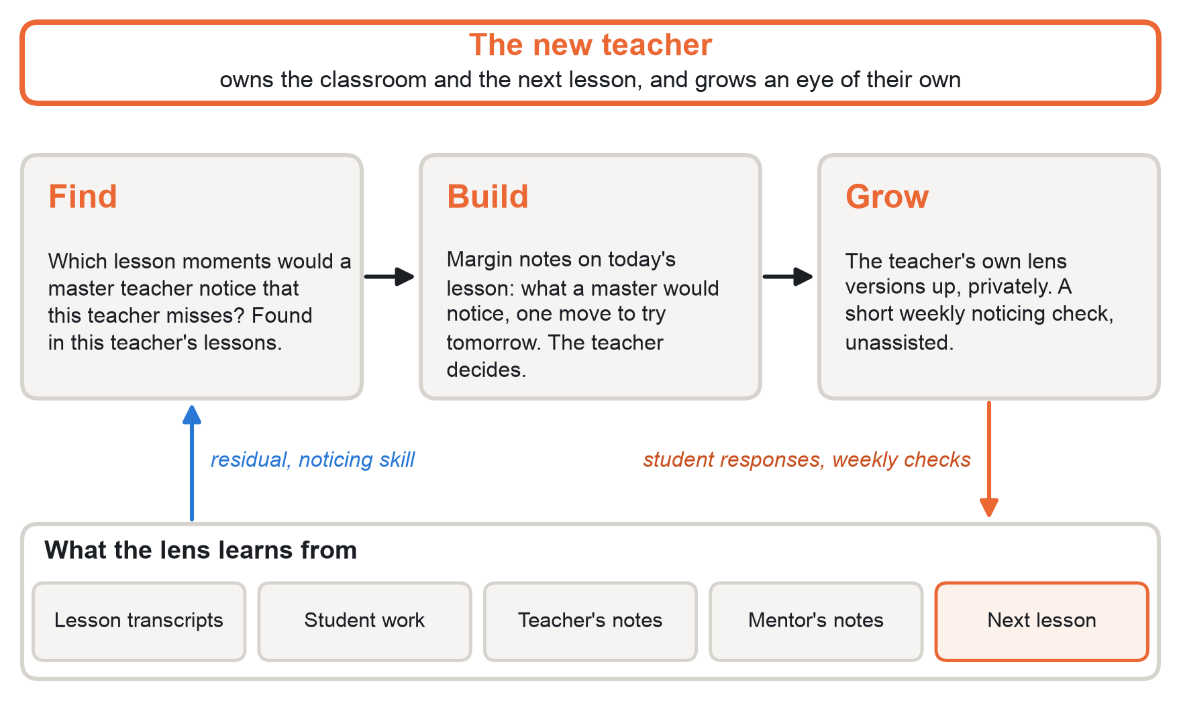
Figure 3. Margins' loop. Find locates the lesson moments where a master teacher's lens adds most for this teacher; Build writes margin notes and one move for tomorrow; Grow checks the teacher's unassisted noticing each week.
The case | What Margins does | Who grows
Shared ground | Lesson summary, talk-time patterns, administration | Nobody
The teacher's own edge: what they notice that the master and the model do not | Keeps it and names it in the teacher's own lens card, never overwritten by the master's | The lens learns from the teacher
The teacher's blind spot: what a master would have noticed | A margin note at the right line, and one move to try tomorrow. The teacher decides whether to use it | The teacher
Unknown to both | Brings in another lens, such as a special-education or language-learning specialist | Both, through another person

Margins shows the master's noticing, not the master's script. Teaching styles stay the teacher's own, and the teacher's residual against the baseline is tracked, so the system can show that it is not making teachers alike.
Each week, a five-minute noticing check on held-out moments, done without the assistant, shows what the teacher now notices unaided. The teacher's lens diff is theirs alone and is never shared with school leaders unless the teacher chooses. Master teachers whose lenses are used are credited, and can share them across a school or district as skills.

What the demo shows
- 0:00 to 0:30, the aha. A real tutoring moment: a student's wrong answer. The baseline offers a generic hint. The expert's reading names the misconception behind it, and Margins, using the expert's lens on held-out moments, names it too.
- 0:30 to 1:30, the build. Margin notes on a whole classroom lesson, at the right lines, and one move for tomorrow. Across sessions, Margins remembers the class and the teacher's goals.
- 1:30 to 2:30, the growth. A novice teacher's held-out noticing check, before and after three sessions.
- 2:30 to 3:00, privacy and numbers. What stays on the device, what reaches Token Factory, and the Fidelity Test against the baseline.
Data. Bridge (700 real tutoring conversations with paired novice and expert responses and expert labels, MIT licence) is the core test set. TalkMoves (567 classroom transcripts, CC BY-NC-SA 4.0) supplies whole lessons (Suresh et al., 2022). The larger NCTE transcripts are available on request, and we would not show excerpts publicly without the authors' permission. A master teacher annotates about 30 classroom moments for the lesson-level demo. Five days cannot show a teacher growing: the demo shows the residual, the lens and the Growth Test working, and a before-and-after check on held-out moments.

How it is built
Step | Model or tool | Why
Transcribe the lesson and remove student names | On-device speech recognition, such as NVIDIA's open Parakeet models | Audio never leaves the teacher's device
Remember the class, the goals and past lessons; run the lens as a reusable skill | NVIDIA NemoClaw with Hermes Agent, inside OpenShell | Persistent memory and skills, sandboxed, with credentials kept away from the agent
Hold a term of lessons in view | Nemotron 3.5 Lightning | Its 1M-token context fits months of transcripts
Notice moments and write margin notes | Nemotron 3 Super | Judgment at moderate cost
Update the lens and analyse growth each week | Nemotron 3 Ultra | The hardest reasoning, run rarely

Only redacted transcript segments reach Token Factory; no audio and no student names.

How we would know it works
- Fidelity: on held-out segments, the lens predicts the master teacher's notices better than the baseline.
- Growth: the teacher's unassisted noticing on held-out moments improves, while their own residual does not shrink toward the baseline.
- In schools: how teachers take up student ideas in later lessons, which can be measured from transcripts (Demszky et al., 2024); then student outcomes and teacher retention.

Risks and limits we publish
- Student privacy. Recordings stay on the device and only redacted text leaves it. Schools and families must consent.
- Surveillance. Margins belongs to the teacher. It is not an evaluation system, and its records are not shared without the teacher's consent.
- Sameness. Pushing every teacher toward one master's lens would recreate the monoculture we warn about. Margins measures this instead of assuming it away.
- Evidence gap. Better noticing does not guarantee better learning. The loop measures both, and we will report the first without claiming the second.

5 Which to build first
We assessed the three against the hackathon's four judging criteria, using our own validation framework, and added the two things a one-week build turns on: open data and risk. The scores are our judgment, not measurements.
 | Vigil | Keeper | Margins
Technological implementation | 4: multi-step, tiered models, batch recalibration | 5: plans, writes, tests and iterates on a real repository | 4: private agent with memory and skills
Design | 4: fits a nurse's existing escalation | 4: lives inside the review queue | 4: a daily, personal habit
Potential impact | 5: lives, and the strongest prior evidence | 4: software everyone depends on | 5: learning, at global scale
Quality of the idea | 5 | 5 | 5
Open data for the demo | 2: small and ICU-heavy, plus simulation | 5: public review history | 4: paired novice and expert data, plus transcripts
Risk to the build | High: clinical claims and data | Low | Medium: privacy design, and a master teacher's time for the lesson demo
Track | Best Apps and Agents | Coding and Agentic Engineering | Personal AI

Build Keeper first. It is the only one of the three whose central claim, that a lens learned from behaviour beats the baseline on held-out work, can be tested on real data before the deadline, and its loop is closed by reality in minutes. It also meets the Coding track's stand-out bar directly: an agent that plans, writes, tests and iterates on a real repository.
Then Margins, then Vigil, on the same engine. Every use case needs the same four parts: measure the residual against a pinned baseline, represent the lens, route each situation into one of four cases, and test fidelity and growth (Figure 4). Only the adapters differ: charts, pull requests or lessons in; escalations, reviews or margin notes out. A team that builds Keeper's engine has most of Margins and Vigil. Margins comes second because its paired novice and expert data is open; Vigil third, because it needs a clinical partner to move beyond illustration.
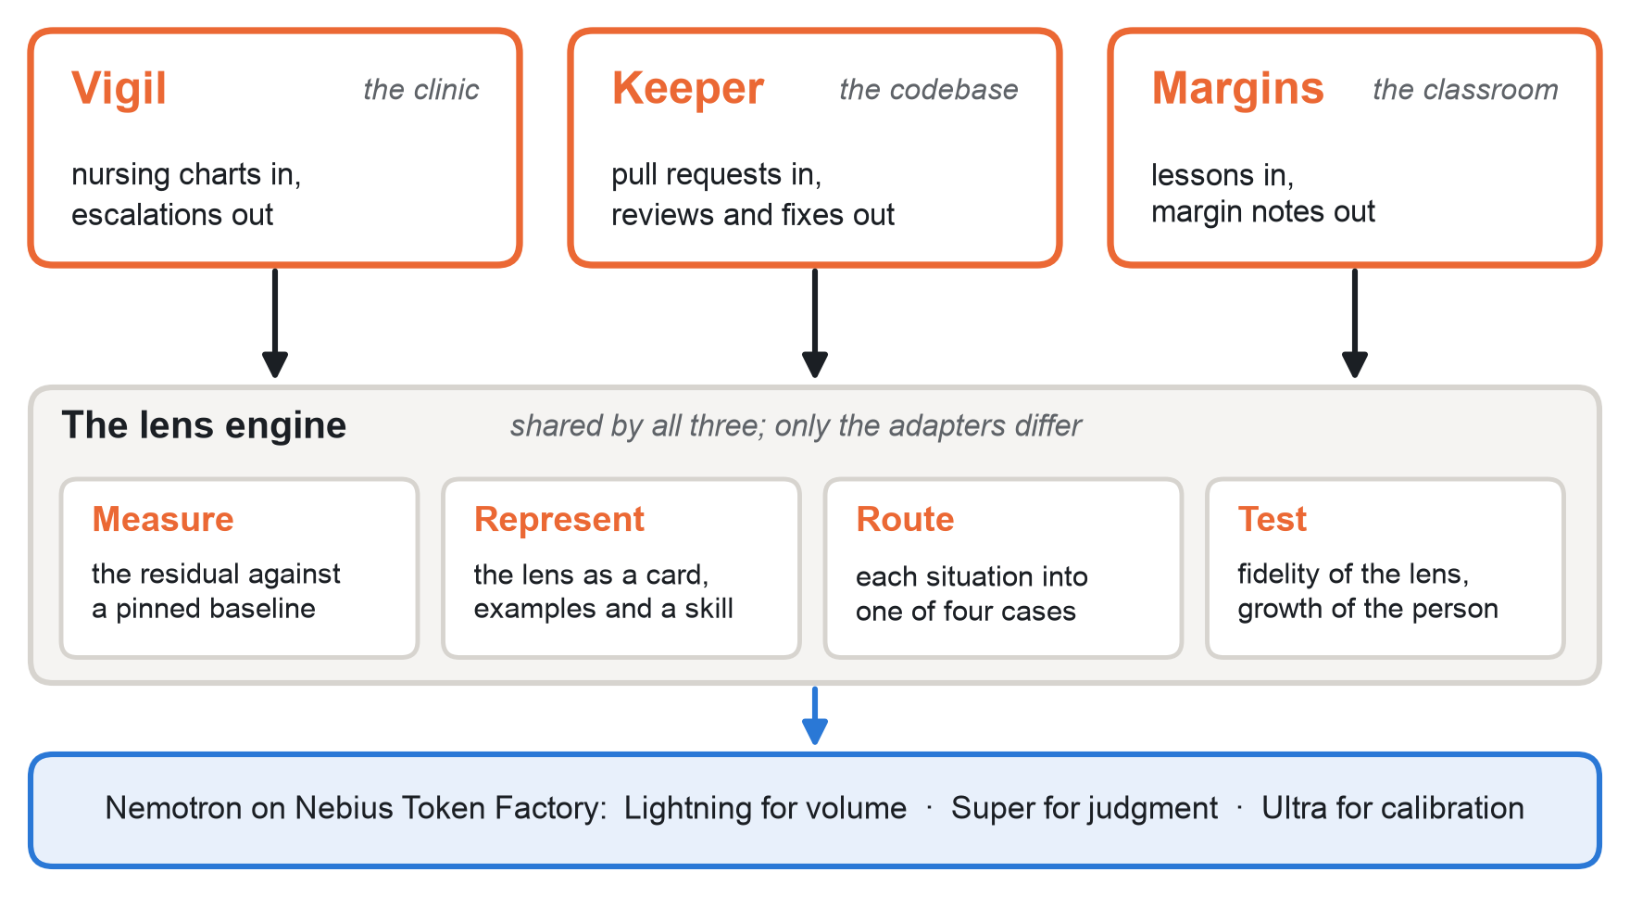
Figure 4. One engine, three front ends. The lens engine measures, represents, routes and tests; each use case adds only an adapter for its inputs and outputs.
What would change the order. If a nurse can give the team a few hours this week, Vigil moves up. Experienced annotations are the scarcest input, and Vigil has the strongest story for Potential Impact once it has them.

What would prove us wrong
Use case | We would see this
Vigil | The lens recovers no more of experienced nurses' concern than the baseline, or concern adds nothing to outcomes once the score is known
Keeper | The lens recovers no more of the maintainer's substantive comments than the baseline, or contributors' unassisted reviews do not improve
Margins | The lens does not predict the master's notices, or teachers' unassisted noticing does not improve, or teachers become more alike
All three | A person's residual shrinks the longer they use the system

References
Afroz, S., Miller, C., Menezes, T., Gilmour, E., Sarma, A., & Feng, Z. (2026). “AI slop is DDoSing open source”: Understanding the impact of AI-generated contributions on open source sustainability. arXiv:2607.04003.
Bacchelli, A., & Bird, C. (2013). Expectations, outcomes, and challenges of modern code review. ICSE 2013.
Bastani, H., Bastani, O., Sungu, A., Ge, H., Kabakcı, Ö., & Mariman, R. (2025). Generative AI without guardrails can harm learning: Evidence from high school mathematics. Proceedings of the National Academy of Sciences, 122(26).
Black Duck (2026). Open Source Security and Risk Analysis Report 2026.
Brynjolfsson, E., Chandar, B., & Chen, R. (2025). Canaries in the coal mine? Six facts about the recent employment effects of artificial intelligence. Stanford Digital Economy Lab working paper (revised 2026).
Cox, R. (2024). Timeline of the xz open source attack. research.swtch.com/xz-timeline.
CRICO Strategies (2016). Malpractice Risks in Communication Failures: 2015 Annual Benchmarking Report.
Demszky, D., Liu, J., Hill, H. C., Jurafsky, D., & Piech, C. (2024). Can automated feedback improve teachers' uptake of student ideas? Evidence from a randomized controlled trial in a large-scale online course. Educational Evaluation and Policy Analysis.
Douw, G., Huisman-de Waal, G., van Zanten, A. R., van der Hoeven, J. G., & Schoonhoven, L. (2016). Nurses' ‘worry’ as predictor of deteriorating surgical ward patients: A prospective cohort study of the Dutch-Early-Nurse-Worry-Indicator-Score. International Journal of Nursing Studies, 59, 134–140.
Douw, G., Schoonhoven, L., Holwerda, T., et al. (2015). Nurses' worry or concern and early recognition of deteriorating patients on general wards in acute care hospitals: A systematic review. Critical Care, 19, 230.
Freund, A. (2024, 29 March). Backdoor in upstream xz/liblzma leading to ssh server compromise. oss-security mailing list.
Hoffmann, M., Nagle, F., & Zhou, Y. (2024). The value of open source software. Harvard Business School Working Paper 24-038.
Holmberg, M. J., Ross, C. E., Fitzmaurice, G. M., et al. (2019). Annual incidence of adult and pediatric in-hospital cardiac arrest in the United States. Circulation: Cardiovascular Quality and Outcomes, 12(7), e005580.
Jacobs, V. R., Lamb, L. L. C., & Philipp, R. A. (2010). Professional noticing of children's mathematical thinking. Journal for Research in Mathematics Education, 41(2), 169–202.
Knight, D. S. (2012). Assessing the cost of instructional coaching. Journal of Education Finance, 38(1), 52–80.
Kraft, M. A., Blazar, D., & Hogan, D. (2018). The effect of teacher coaching on instruction and achievement: A meta-analysis of the causal evidence. Review of Educational Research, 88(4), 547–588.
Li, Z., Lu, S., Guo, D., Duan, N., Jannu, S., Jenks, G., Majumder, D., Green, J., Svyatkovskiy, A., Fu, S., & Sundaresan, N. (2022). Automating code review activities by large-scale pre-training. ESEC/FSE 2022.
Martin, B., Kaminski-Ozturk, N., O'Hara, C., & Smiley, R. (2023). Examining the impact of the COVID-19 pandemic on burnout and stress among U.S. nurses. Journal of Nursing Regulation, 14(1), 4–12.
Romero-Brufau, S., et al. (2019). The fifth vital sign? Nurse worry predicts inpatient deterioration within 24 hours. JAMIA Open, 2(4), 465–470.
Rossetti, S. C., Dykes, P. C., et al. (2025). Real-time surveillance system for patient deterioration: A pragmatic cluster-randomized controlled trial. Nature Medicine, 31, 1895–1902. Author correction, 2026.
Schein, R. M., Hazday, N., Pena, M., Ruben, B. H., & Sprung, C. L. (1990). Clinical antecedents to in-hospital cardiopulmonary arrest. Chest, 98(6), 1388–1392.
Sendelbach, S., & Funk, M. (2013). Alarm fatigue: A patient safety concern. AACN Advanced Critical Care, 24(4), 378–386.
Shen, J. H., & Tamkin, A. (2026). How AI impacts skill formation. arXiv:2601.20245.
Sherin, M. G., Jacobs, V. R., & Philipp, R. A. (Eds.) (2011). Mathematics Teacher Noticing: Seeing Through Teachers' Eyes. Routledge.
Stenberg, D. (2025, 14 July). Death by a thousand slops. daniel.haxx.se.
Stenberg, D. (2026, 26 January). The end of the curl bug-bounty. daniel.haxx.se.
Suresh, A., Jacobs, J., Harty, C., Perkoff, M., Martin, J. H., & Sumner, T. (2022). The TalkMoves dataset: K-12 mathematics lesson transcripts annotated for teacher and student discursive moves. LREC 2022, 4654–4662.
Tidelift (2024). 2024 State of the Open Source Maintainer Report.
Trust, T., Maloy, R., Xu, C., & Pelletier, K. (2025). Civic education in the age of AI: Should we trust AI-generated lesson plans? Contemporary Issues in Technology and Teacher Education, 25(3).
UNESCO & International Task Force on Teachers for Education 2030 (2024). Global Report on Teachers: Addressing Teacher Shortages and Transforming the Profession. UNESCO.
Wan, Y. J., Abdelrahman, S. E., Facelli, J. C., et al. (2026). Enhancing prediction of inpatient deterioration by combining clinical and nurse concern features, with or without temporal clustering. JAMIA Open, 9(3), ooag077.
Wang, R. E., & Demszky, D. (2023). Is ChatGPT a good teacher coach? Measuring zero-shot performance for scoring and providing actionable insights on classroom instruction. BEA 2023, 626–667.
Wang, R. E., Ribeiro, A. T., Robinson, C. D., Loeb, S., & Demszky, D. (2024). Tutor CoPilot: A human-AI approach for scaling real-time expertise. arXiv:2410.03017 (version 3, 2026).
Wang, R., Zhang, Q., Robinson, C., Loeb, S., & Demszky, D. (2024). Bridging the novice-expert gap via models of decision-making: A case study on remediating math mistakes. NAACL 2024, 2174–2199.
Wolff, C. E., Jarodzka, H., van den Bogert, N., & Boshuizen, H. P. A. (2016). Teacher vision: Expert and novice teachers' perception of problematic classroom management scenes. Instructional Science, 44(3), 243–265.
Wong, A., et al. (2021). External validation of a widely implemented proprietary sepsis prediction model in hospitalized patients. JAMA Internal Medicine, 181(8), 1065–1070.
World Health Organization (2025). State of the World's Nursing 2025.
Zhong, S., Noei, S., Zou, Y., & Adams, B. (2026). Human-AI synergy in agentic code review. arXiv:2603.15911.

