OpenExam Online –
Student Manual

Manual describing the OpenExam web interface for students.

Version 1.0 (Draft)

Logon to system

Click on “Start Examination” to open the examination online in the web browser.

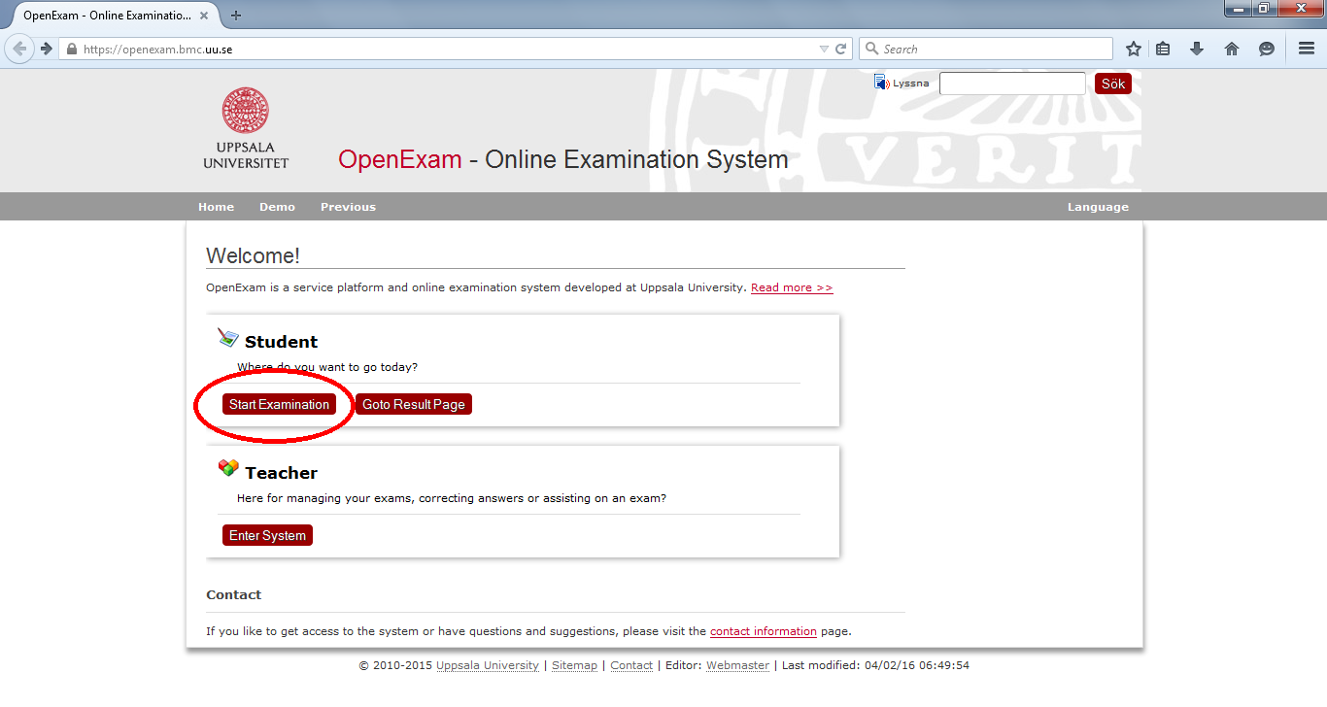

The system will enforce you to logon before opening the exam. Students at Uppsala University should use CAS as logon method.
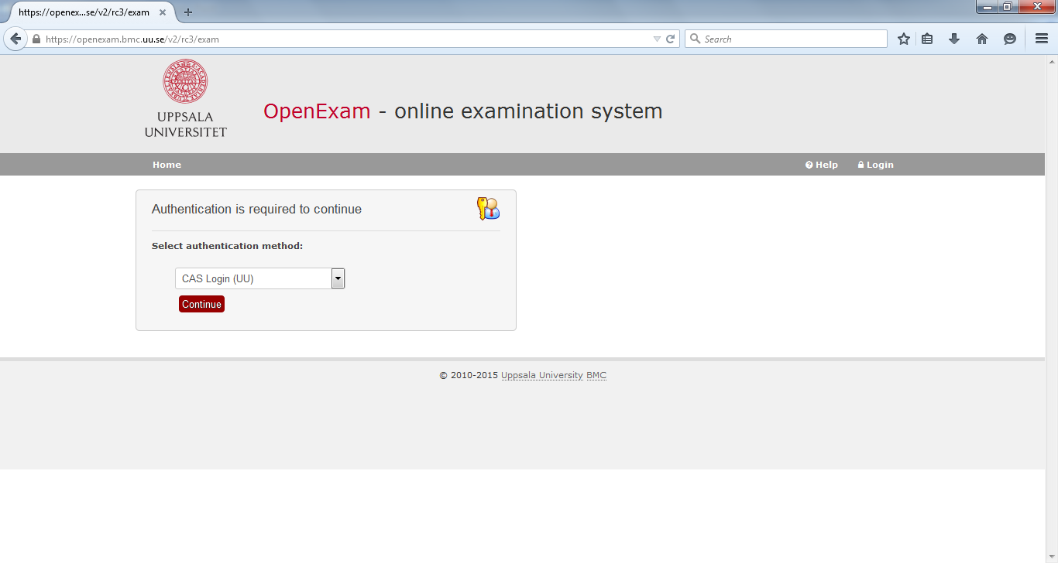

Logon as normal. You will be redirected back to the exam page on successful login.
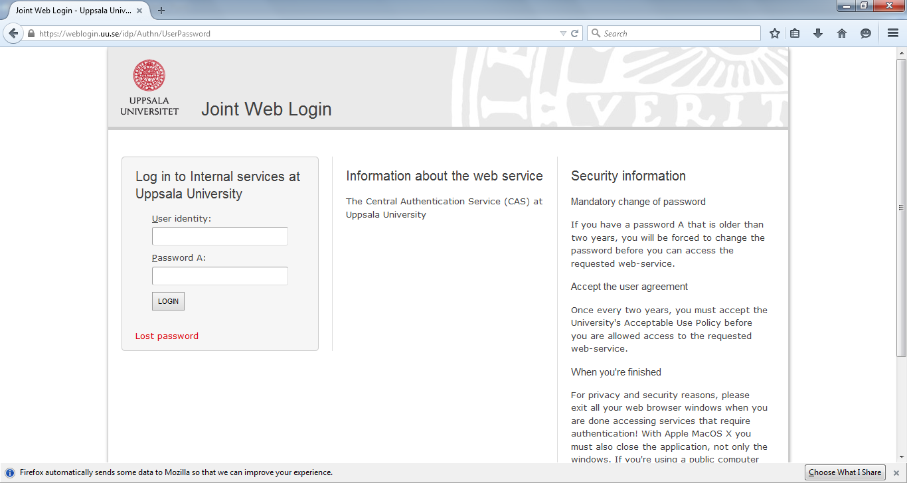

Starting the examination

If you are early you will get to a countdown page. When time is up the exam will automatically open for you.

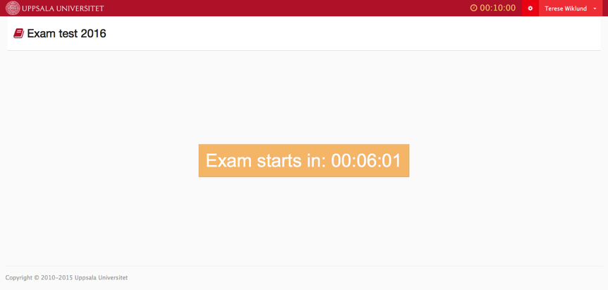

The clock in the rightmost corner shows the remaining examination time. When the time is up, you will be redirected to the start page.

Instructions

Before opening the exam, you will be shown a page with instructions. Read this information carefully as it is information about this exam, given to you by your teacher (1).

When you are ready you click “I am ready, start the exam” (2)

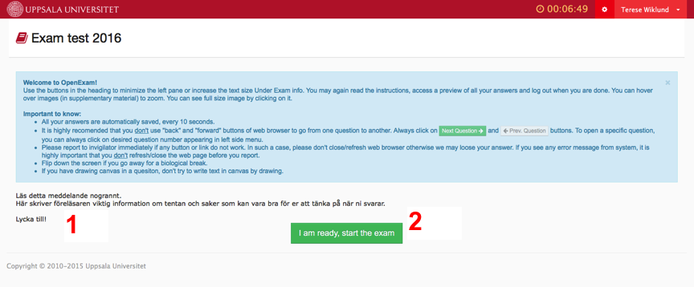

Questions

The field to the left in the examination page tells you how many questions this exam entails as well as which question you are currently answering.

You can go back and forth between questions by clicking the questions in this field for as long as there is time left in the exam.

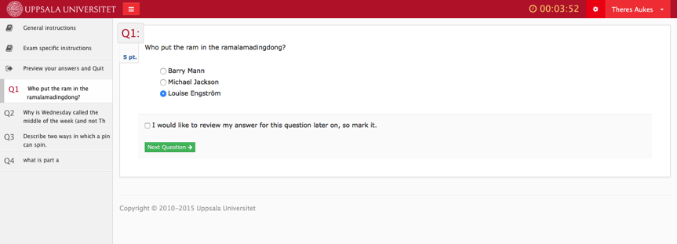

When you have answered the last question you click ”Preview your answers for all questions”

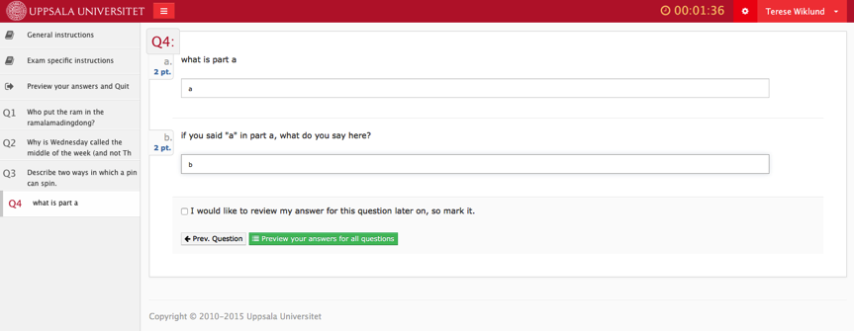

When you have previewed your answers and are happy with them you click ”I have previewed all my answeres here and I am satisfied. Quit my exam.”

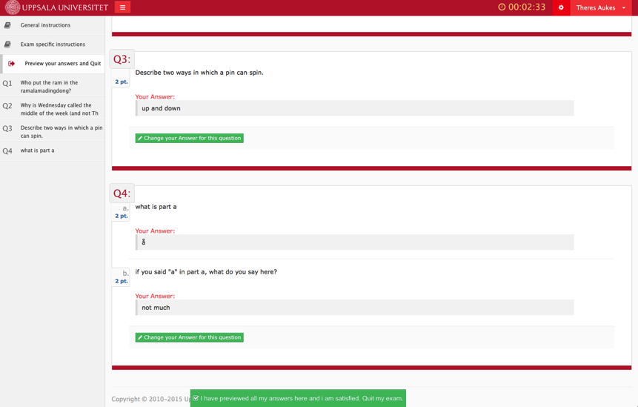

Done!
You will get to the below page that confirms that you are no longer logged in.

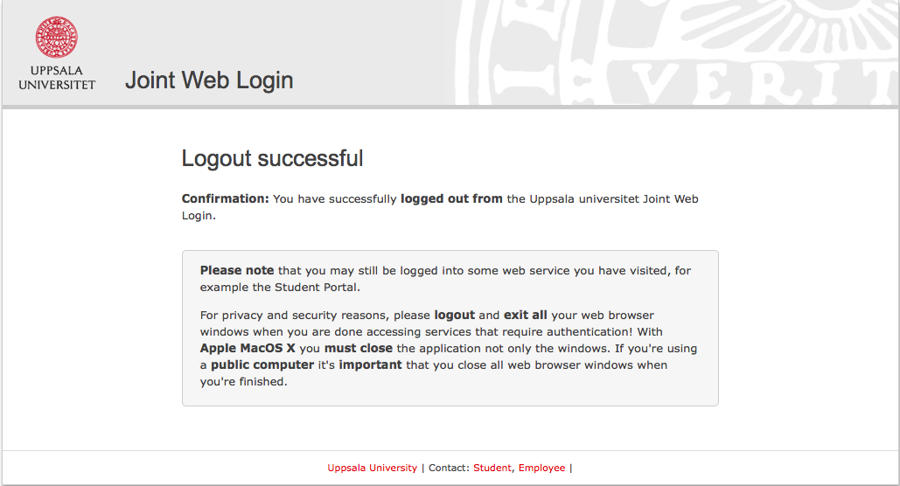

Table of Contents
OpenExam Online – Student Manual 1
Logon to system 2
Starting the examination 3

