# INT0001.Ladok2.Events operations instructions

Background

Ladok2 events are fetched from Ladok SQL staging table and transformed to Ladok3 events.

### Preliminary check

Before any investigation on any specific issue first make sure all receive locations, send ports and orchestrations are in a started state also make sure all host instances are started.

If nothing else is specified start the port, orchestration or host instances that is stopped. An admin could have stopped the port or orchestration on purpose if so a notification should exist on the port Description. Like bellow.

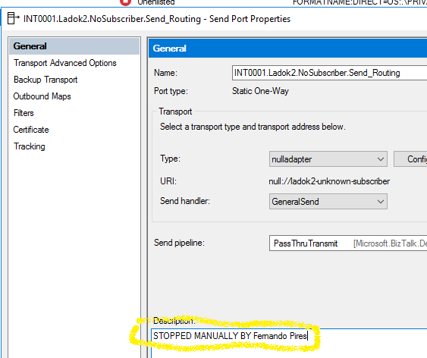

If a notification exists please contact the person that has stopped the port or orchestration.

For INT0001.Ladok2.Events application all ports and orchestrations should by default be started.

### Resume suspended messages

After starting all previously stopped ports, orchestrations and host instances make sure to resume all messages in the BizTalk admin console marked as Suspended. See below for an example of a suspended message.

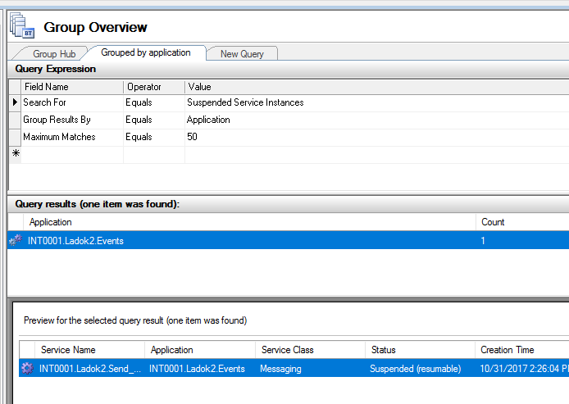

## Issues that could occur

### New ladok2 events are expected but none are produced

### Pre-check, Make sure no suspended message(s) exists.

1. Run sql statement exec [INT0001.Ladok2.Events.checkPending] to see if any pending updates exists.   
   Pending updates means messages that have been sent out but where an acknowledgment has not yet been received.   
   If the sql statement returns more than 0 records and no suspended messages exists, that belongs to the INT0001.Ladok2.Events application , then something has gone wrong with the acknowledgment update.   
     
   In the example bellow a person with id 4205058227 has a pending update.

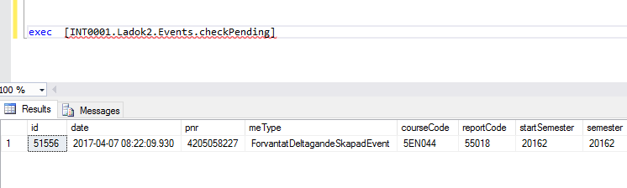

1. Check AKKA in the case of a pending update and if no Ladok2 message is suspended in BizTalk. If the person does not exist in AKKA run the statement below and the event will be processed again.

exec [INT0001.Ladok2.Events.openPending] @Id=51556

As you can see the input corresponds to the Id retrieved when running statement checkPending.

1. If the person exists in AKKA check the Active Directory to see if the person has already been created (In AKKA you will find the Active Directory id that AKKA used to create the user). If the person does not exist in the AD run the statement SQL openPending and the event will be processed again.