# INT0019.Delayed.Events installation instructions

General

In the deployment folder there is multiple folders with different “dates”, the latest folder should contain the latest package installed in TEST, the package to be deployed to PROD is located in the root folder of the application folder.

Background

Delayed events are fetched from Delayed events SQL table and transformed to Delayed events.

Dependencies

*Utilities*

* Shared.Utilities.PropertyPromotor

Make sure that the queue **SD-DISTRIBUTION** is created and that the BizTalk instance user has complete rights on the queue.

The BizTalk instance user must be able to reach the delayed events database and have read and write rights to all of its objects.

Includes files for installation package for INT0001.Ladok2.Events

* INT0019.Delayed.Events.msi
* INT0019.Delayed.Events.BindingInfo.xml
* INT0019.Delayed.Events.sql

Tables, view and Procedures

Application INT0019.Delayed.Events is dependent on multiple SQL objects

As INT0019.Delayed.Events sole purpose is to fetch events in the form of SQL records it is primary dependent on the source table delayed_events in the sd-delayed-db database.

Step 1. Run the SQL script file, INT0019.Delayed.Events.sql, in the source environment where sd-delayed-db database are located.

Main application

Step 2. Create application **INT0019.Delayed.Events** if it does not already exist.

Step 3. Import and run the MSI file INT0019.Delayed.Events.msi in the **INT0019.Delayed.Events** application.

Binding file

INT0019.Delayed.Events.BindingInfo.xml contains configuration information for the INT0019.Delayed.Events application.

The file contains specific information that needs to be replaced by administrator.

1. Replace SQL server name  
   **tmssql-ag2.user.uu.se.**
2. Replace SQL Server database  
   **sd-delayed-db.**
3. Replace MSMQ server location  
   **UUC-MSMQSRV001** Queue names must/should not be changed.

Step 4. Import the updated binding file.

Step 5. Save the updated binding file in the same location with the suffix _PROD. This will now reflect the current settings in PROD.

Step 6. SQL User and password on sendport INT019.Send_DelayedEvent must manually be set after import of the binding file

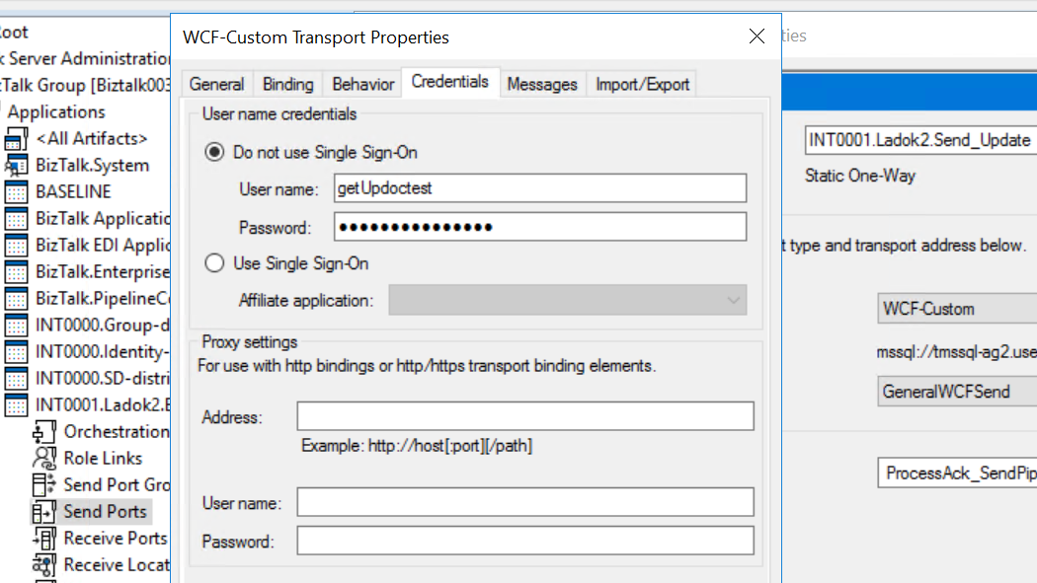

Step 7. Install the MSI on node 2.