Cyber Security Framework Planning and Establishment of Operational Technology Security Operations Centres (OT-SOCs) for Indian Railways
An architecture-driven methodology integrating IEC 62443, EN 50159, TS 50701 and Kavach cyber security requirements with field-proven OT-SOC foundational practice
[Author(s) and affiliation(s) to be completed per IRSE template] | Reviewed manuscript (incorporates peer-review revisions)
Audience: IRSSE Officers, RDSO, Railway Board, Signalling Engineers and OT Cyber Security Practitioners

Abstract
The nationwide deployment of the Train Collision Avoidance System (Kavach), electronic interlocking (EI), centralised Traffic Management Systems (TMS) and converged Multi-Protocol Label Switching (MPLS) telecom backbones has transformed Indian Railways signalling from a collection of electrically isolated vital circuits into a networked, safety-critical cyber-physical system. This convergence exposes Operational Technology (OT) to a threat surface that enterprise Information Technology (IT) Security Operations Centres (SOCs) are neither designed nor competent to monitor. This paper presents a structured, architecture-driven methodology for planning and establishing dedicated Operational Technology Security Operations Centres (OT-SOCs) for Indian Railways. Its central thesis is that a machine-validated, standards-traceable model of the signalling architecture - its IEC 62443 zones and conduits, its EN 50159 transmission categories and its Safety Integrity Level (SIL) allocations - must precede and continuously inform SOC operating-model selection, sensor placement, detection engineering, incident response and governance. The evidence base is an independent cyber security assessment of a reference railway OT architecture MODEL - a standards-traceable representation in which the semantic, governance and enforcement authorities were formally separated and validated; the findings reported here are therefore properties of that model and of the governance logic it encodes, and are presented as illustrative monitoring requirements rather than as measured deficiencies of any deployed Indian Railways installation. Field validation on representative Kavach and electronic-interlocking installations is identified as essential future work. With that scope understood, the assessment surfaced durable engineering findings (absence of cryptographic authentication on vital Category-1 buses, absence of multi-factor authentication on privileged engineering access, absence of timeliness monitoring on open radio bearers, incompletely instrumented trust boundaries and an unprotected telecom backhaul) and standards-compliance findings (the EN 50159 / IEC 62443 authentication-crediting tension and the need for TS 50701 lifecycle evidence). The paper integrates this railway-specific evidence with field-proven OT-SOC foundational practice: an evaluation of five OT-SOC operating models with a recommendation for Indian Railways; a five-layer visibility architecture applied to EI, Kavach, MPLS, radio networks, TMS, NMS, data loggers and engineering workstations; a risk-assessment and SL-T derivation method; the Monitoring Paradox grounded in SIL-4 signalling, IEC 62443 and EN 50159; a four-gate, safety-first incident-response doctrine; a railway SEV1-SEV4 severity model; threat-hunting practice; a three-audience (Board / SOC-Lead / Analyst) KPI framework; a railway OT-SOC staffing and competency model; a national governance model spanning Railway Board, RDSO, NCIIPC, CERT-In, Zonal Railways and Divisions; a residual-risk methodology with explicit risk-acceptance principles for SIL-4 systems; a five-level maturity roadmap; and a 90-day pilot-deployment programme.
Keywords: OT-SOC; Indian Railways; Kavach; IEC 62443; EN 50159; TS 50701; Electronic Interlocking; Zones and Conduits; Detection Engineering; MITRE ATT&CK for ICS; SIL-4; Incident Response; Monitoring Paradox; Residual Risk; SOC Maturity; NCIIPC; CERT-In; RDSO.

Nomenclature
Acronyms and key terms
Term | Meaning
ATP | Automatic Train Protection (Kavach)
BTS | Base Transceiver Station (radio)
EI | Electronic Interlocking (SIL-4 vital)
EWS | Engineering Workstation
IDMZ | Industrial De-Militarised Zone (IEC 62443 boundary zone, L3.5)
L-Kavach / S-Kavach | Loco Kavach (onboard) / Stationary Kavach (wayside)
MVB / CAN | Multifunction Vehicle Bus / Controller Area Network (onboard/field buses)
NMS / TMS | Network / Traffic Management System
SL-T | Target Security Level (IEC 62443 / TS 50701)
SPAN / TAP | Switched Port Analyser (mirror) / passive Test Access Point
E1/E2/E3 | OT-SOC echelons: Station, Zonal, National (this paper)
G1-G4 | Analyst grades: Operator, Investigator, Senior/Hunter, Lead (this paper)

Note on protocol nomenclature. Protocol identifiers used for the vital interfaces (the Kavach-EI interface, and the rolling-stock buses denoted CAN and MVB) and the Kavach radio protocol are those of the reference architecture model and of common rolling-stock practice; the authoritative definitions are given in the RDSO Kavach specification [9]. Claims about these interfaces should be read against that specification rather than as independent protocol assertions.

Table of Contents
Table of Contents - right-click and Update Field in Word to populate.

1. Introduction
For most of its history, the safety of railway signalling rested upon two principles: physical isolation and fail-safe design. Vital functions were realised in relay logic, hard-wired track circuits and electrically isolated lineside cabling; the cyber threat surface was, in practice, the perimeter fence. The doctrine of security through isolation was tenable because the signalling system genuinely was isolated.
That premise no longer holds. The contemporary Indian Railways signalling estate is a converged, IP-enabled, geographically distributed cyber-physical system. Electronic interlockings exchange vital state with object controllers over digital buses; the Kavach Automatic Train Protection (ATP) system extends vital communication across an open radio-frequency (RF) air interface between the Stationary Kavach (S-Kavach) at the wayside and the Loco Kavach (L-Kavach) onboard; TMS and Network Management Systems (NMS) supervise wide geographies over MPLS backbones; and engineering workstations (EWS) capable of downloading vital logic connect, through VPN access, jump hosts and the industrial de-militarised zone (IDMZ), into the heart of the safety domain. Each of these capabilities is a deliberate engineering advance; each also introduces a conduit through which a determined adversary may attempt to influence a safety function.
The instinctive institutional response - to extend the existing enterprise IT SOC to also cover signalling - is inadequate and, in places, dangerous. Cross-sector OT-SOC experience [17], and the wider OT-security literature [14], are unambiguous: extending an IT SOC into OT consistently fails because the tools, telemetry sources, threat models, response playbooks and human expertise required are fundamentally different, producing a false sense of security. An IT SOC optimises for confidentiality; an OT-SOC must optimise for the preservation of safety and the availability of a physical process. An IT SOC may legitimately quarantine an endpoint on detection; an OT-SOC that interrupts a vital communication path may itself precipitate the hazard it was deployed to prevent.
This paper argues that the establishment of OT-SOC capability for Indian Railways must be a discipline in its own right, and that its single most important precondition is an architecture that has been validated against standards before it is monitored. One cannot monitor what one has not modelled; one cannot prioritise detection on a flow whose criticality, transmission category and trust boundary are unknown; and one cannot defend a zone whose conduits have not been enumerated. The argument is developed from concrete evidence and fused with field-proven OT-SOC practice, so that Indian Railways need not re-derive at cost what other critical-infrastructure sectors have already learned.

2. Evolution of Cyber Security in Indian Railways
Four phases characterise the trajectory of railway signalling cyber security in India. Phase I - electromechanical isolation - comprised relay interlockings and token working; security was physical and procedural. Phase II - first-generation electronics - introduced solid-state and electronic interlockings, data loggers and digital axle counters; digital logic entered the vital domain but communication remained local, proprietary and serial, and data loggers became, almost incidentally, the first forensic record of events later recognised as security-relevant. Phase III - networked OT - brought MPLS backbones, centralised TMS, NMS and remote diagnostics, the first genuine IT/OT convergence; engineering access became remotely brokered and the threat surface expanded from the fence to the network. Phase IV - safety over open bearers - is the present, and its defining event is the nationwide rollout of Kavach, which carries vital movement-authority information across an open RF bearer and integrates with the EI at the station. For the first time a vital, SIL-4 function depends upon a transmission system that, in EN 50159 terms, is open. The RDSO Kavach specification [9] and the Kavach Cyber Security SOP [10] recognise that cryptographic protection of the Kavach interface is necessary but not sufficient: protection without monitoring provides no assurance that it is functioning and no evidence for incident response. The OT-SOC is the institutional mechanism through which protection is continuously verified.

3. Related Work
Railway cyber security has an established literature on which this paper builds. The CENELEC lifecycle standards EN 50126 [7] and EN 50129 [8] and the dedicated cyber standard CLC/TS 50701 [5] provide the safety-security integration framework; IEC 62443 [1-4] supplies the zone/conduit and security-level model adopted here; and EN 50159 [6] supplies the communication-threat taxonomy. EU research programmes (CYRAIL, X2Rail, SAFETY4RAILS) [21] have addressed railway-specific threat assessment and resilience, and ENISA has published transport and railway threat-landscape analyses [20]. In the operational OT-SOC domain, NIST SP 800-82r3 [14] and the ISA/IEC 62443 series define monitoring and management-system practice, MITRE ATT&CK for ICS [19] provides the adversary-technique reference now standard in detection engineering, and cross-sector OT-SOC foundational practice [17] supplies the operating-model, visibility, incident-response, KPI and maturity frameworks adapted in Sections 8-21. The distinctive contribution of the present paper relative to this body of work is twofold: the argument that a machine-validated, authority-separated architecture model must precede and configure the OT-SOC, and the end-to-end railway contextualisation - from operating-model selection to a 90-day programme - anchored to Kavach and to Indian Railways' institutional structure. The structural OT-SOC frameworks adapted here are drawn from cross-sector practice and are cited as such; they are not claimed as original.

4. The Railway OT Threat Landscape
The railway OT threat landscape differs from the enterprise landscape in its consequences, adversaries and constraints. Cross-sector incident response [14,17,19,20] shows that OT threats cluster into five operationally distinct categories; Table 1 maps these to their railway manifestations and to the consequence that matters in signalling - the wrong-side failure.
Table 1. Cross-sector OT threat categories mapped to Indian Railways
# | Generic OT threat category | Indian Railways manifestation | Consequence
1 | IT-sourced lateral movement (ransomware crossing a weak IT/OT boundary) | Enterprise to IDMZ to operations to interlocking traversal where boundary controls are incompletely instantiated | Disruption of TMS/NMS; staging toward vital zones
2 | Engineering-workstation compromise (TRITON/TRISIS, 2017) | Compromise of an EWS with logic-download access to EI / S-Kavach | Alteration of vital interlocking logic - wrong-side failure
3 | Supply-chain / vendor-access exploitation | Vendor laptop or update channel for Kavach / EI / TMS subsystems | Implant introduced into the vital supply chain
4 | Insider threat and sabotage (Maroochy Water, 2000) | Maintainer/contractor with privileged engineering access and protocol knowledge | Setpoint/logic change; alarm suppression on a vital system
5 | Nation-state pre-positioning (INDUSTROYER, TRITON, PIPEDREAM) | Persistent access to Kavach/EI/telecom infrastructure awaiting timing | Coordinated destructive disruption of national rail safety

The worst-case outcome is not data loss but a wrong-side failure: a signal cleared against a conflicting movement, a point moved under a train, a movement authority issued where none is safe, or the suppression of an emergency brake command. The SIL of the affected asset is therefore the primary axis along which monitoring effort is prioritised. The adversary spectrum runs from the opportunistic (commodity malware via an EWS or USB device) through the capable insider (a maintainer with privileged access and protocol knowledge) to the resourced nation-state actor. The capable insider is of particular concern because the vital buses rely, by standard, on closed-transmission assumptions and safety coding rather than cryptographic source authentication - a defence robust against the outsider but weaker against an actor inside the closed segment. Sectoral incident data indicate that the majority of OT incidents requiring SOC response begin with human error or supply-chain compromise rather than sophisticated attack [14,17,20]; a railway OT-SOC must therefore detect configuration drift, accidental connectivity changes and unauthorised removable media as reliably as it hunts nation-state implants.

5. Standards Framework: IEC 62443, EN 50159, TS 50701 and Kavach

5.1 IEC 62443 - Zones, conduits and security levels
IEC 62443-3-2 (risk assessment for system design) [1] and IEC 62443-3-3 (system security requirements and security levels) [2] decompose a system into zones connected by conduits, and define seven Foundational Requirements: FR1 Identification and Authentication, FR2 Use Control, FR3 System Integrity, FR4 Data Confidentiality, FR5 Restricted Data Flow, FR6 Timely Response to Events, and FR7 Resource Availability. FR6 (and SR 6.2 continuous monitoring) is itself a monitoring mandate. The reference architecture realises the model as a zone hierarchy mapped to the Purdue model - Enterprise (Level 5), IDMZ and Security-Management (Level 3.5), Operations (Level 3), Telecom Core and Radio Access (Levels 2 and 1 of the telecom sub-domain), Interlocking (Levels 2/1 of the signalling sub-domain), Field (Level 0) and Onboard. The dual use of Levels 1-2 for the telecom and signalling sub-domains is a railway-specific extension of the Purdue model and is annotated as such in Figure 1.

5.2 EN 50159 - Safety-related communication and transmission categories
EN 50159 [6] classifies safety-related transmission systems into three categories defined by the controllability of the medium and the consequent need for cryptographic protection. In a Category 1 (closed) system the participants and transmission characteristics are fixed and unauthorised access to the medium is excluded by design; the defences are non-cryptographic (safety code, sequence number, time-out). In a Category 2 (controlled) system the transmission system is not under the full control of the designer, but the residual risk of unauthorised access is assessed as negligible and can be excluded by design or procedure, so cryptographic protection is not mandated. In a Category 3 (open) system the possibility of unauthorised access must be assumed; cryptographic procedures are therefore required in addition to the non-cryptographic defences. The Kavach radio interface and the balise air-gap are Category 3; the managed MPLS/IP backhaul is Category 2; the vital station buses are Category 1. Because the category fixes the threat model, it fixes the detector set the OT-SOC must field; Table 2 makes the threat-defence-detection relationship explicit.
Table 2. EN 50159 threats mapped to safety defences and to OT-SOC detections
EN 50159 threat | EN 50159 defence(s) | OT-SOC detection
Repetition | Sequence number; time stamp; time-out | Duplicate-frame and freshness analysis (UC-03)
Deletion | Sequence number | Sequence-gap and loss-of-message detection (UC-04)
Insertion | Sequence number; source/destination identifier; identification procedure | Source-ID whitelist; insertion/rate anomaly (UC-01, UC-13)
Re-sequencing | Sequence number; time stamp | Out-of-order detection (UC-03)
Corruption | Safety code; cryptographic techniques | Safety-code/CRC failure-rate and integrity-flag monitoring (UC-02, UC-10)
Delay | Time stamp; time-out | End-to-end latency vs SIL-bounded threshold (UC-03)
Masquerade | Source/destination identifier; cryptographic identification | Closure/identity and unexpected-participant detection (UC-01, UC-13)

Two consequences follow and resolve the central evidence finding. First, for Category-1 vital buses EN 50159 does not mandate cryptographic source authentication - the closed-medium assumption and the safety code carry the assurance - so the reference model's vital protocols provide integrity and replay but not authentication; this is standards-consistent PROVIDED the closed-medium assumption holds, and the OT-SOC's role is to police that assumption continuously. Second, for Category-3 open bearers cryptographic protection is mandatory but not sufficient: timeliness, replay and RF-anomaly monitoring remain obligatory because delay and masquerade are first-class EN 50159 threats that cryptography alone does not detect in operation.

5.3 TS 50701 - Railway cyber security lifecycle
CLC/TS 50701 [5] adapts IEC 62443 to railways and binds it to the EN 5012x safety lifecycle. It requires a documented risk assessment, the allocation of target Security Levels (SL-T) to zones and conduits, and a cyber security case analogous to the safety case. The SL-T per zone is the input that calibrates monitoring intensity, alert prioritisation and response targets (Section 7).

5.4 Kavach cyber security requirements
The RDSO Kavach specification [9] and the Kavach Cyber Security SOP [10] impose railway-specific obligations: cryptographic protection of the Kavach radio interface, integrity and replay protection of vital telegrams, controlled key management, and the continuous-monitoring and incident-reporting obligations that an OT-SOC discharges. The interlock is the conceptual core of this paper: IEC 62443 tells the OT-SOC where the boundaries are; EN 50159 tells it what to look for on each conduit; TS 50701 tells it why and to what assurance target; and the Kavach SOP defines the railway-specific obligations it must satisfy and report against.

6. The Architecture-Driven Imperative: Validate Before You Monitor
The central methodological proposition is that architecture validation must precede OT-SOC deployment. A SOC detects deviation from expected behaviour, and the definition of expected is the architecture. If the architecture is not modelled, the baseline is whatever traffic existed when monitoring began - including any pre-existing compromise. In the reference assessment [18] the architecture was expressed as three separated authorities: a semantic authority (the ontology of asset types, protocols, conduit classes, Purdue levels and protocol capabilities), a governance authority (zoning, trust boundaries, flow rules, conduit security profiles and EN 50159 transmission categories) and an enforcement authority (the validators that consume the first two and emit findings). This separation is what allows a deviation to be classified unambiguously as a real security gap, a standards-compliance gap, a modelling defect or an enforcement defect.
The assessment demonstrated this concretely. Before validation, several legitimate flows - operator workstation to TMS, the network-management plane, the telecom backhaul and the Loco-to-Stationary Kavach safety association - were unmodelled, and a vital-to-open-RF flow that should never exist (S-Kavach directly cabled to the radio base station, Figure 3) was present but indistinguishable from the legitimate ones. Only after the governance model was completed could the forbidden flow be classified as forbidden and prevented, and the legitimate flows be classified as authorised-but-monitored. The validated architecture is thus not documentation; it is the configuration source for every sensor, detector and boundary control the OT-SOC deploys, and the residual findings become the OT-SOC's standing monitoring requirements (consolidated in the residual-risk register of Section 19).

6.1 Limitations of the evidence base
The findings cited here were obtained by assessing a reference architecture MODEL, not by instrumenting deployed Kavach or electronic-interlocking equipment. They are properties of the model and of the governance rules it encodes; their value is to illustrate, traceably, the classes of monitoring requirement an OT-SOC must satisfy. Whether any specific finding holds for a given fielded installation is a question of fact to be established by a field assessment under the TS 50701 lifecycle. Such field validation - on a representative Kavach corridor and a representative electronic interlocking - is the immediate next step and is recorded as future work (Section 23).

7. Risk Assessment and SL-T Derivation
TS 50701 [5] and IEC 62443-3-2 [1] require that target Security Levels be derived for each zone and conduit from a documented risk assessment, and the OT-SOC uses SL-T to calibrate monitoring intensity and response targets. This paper recommends a consequence-by-likelihood method. Consequence is scored primarily by the safety significance of the affected function - its SIL and its potential to cause a wrong-side failure - and secondarily by operational and reputational impact; a SIL-4 vital function takes the highest consequence band by default. Likelihood is scored from exposure (enterprise/Internet reachability, open RF, vendor/engineering access), the EN 50159 transmission category of the conduit and the strength of existing controls. The SL-T for a zone is the level required to reduce the residual risk of its highest-consequence credible scenario to acceptable; conduits inherit the higher SL-T of the zones they join. Table 3 is a worked extract for a Kavach corridor; the full register is an artefact of the cyber security case and is the Phase-0 prerequisite for any sensor deployment.
Table 3. Worked SL-T derivation (Kavach-corridor extract)
Zone | Consequence (SIL / wrong-side) | Likelihood drivers | SL-T | Monitoring implication
Interlocking (EI / S-Kavach) | Very high (SIL-4) | Engineering access; Cat-3 RF exposure via Kavach | SL-T 3 | Highest intensity; privileged-access and closure monitoring mandatory
Onboard (L-Kavach) | Very high (SIL-4) | Open RF; mobile | SL-T 3 | Cat-3 RF + timeliness monitoring; onboard recorder
Operations (TMS/NMS/EWS) | High (safety-adjacent) | EWS privilege; IDMZ-brokered access | SL-T 2-3 | Privileged-session and config-change monitoring
Telecom Core (MPLS) | Medium (no direct vital) | Managed Cat-2 core | SL-T 2 | Transport-security health monitoring
IDMZ / Security-Mgmt | Medium-high | Internet-adjacent; brokers access | SL-T 2-3 | Boundary-control and access-broker auditing
Enterprise | Low-medium | Internet-facing | SL-T 1-2 | Lateral-movement detection at the boundary

8. OT-SOC Operating Models: Evaluation and Recommendation
There is no single correct OT-SOC operating model; the right choice depends on scale, geographic footprint, regulatory obligation, existing IT-security capability and OT maturity. Five archetypes [17] cover the realistic spectrum. Table 4 evaluates each against the circumstances of Indian Railways - a national operator with thousands of dispersed wayside and Kavach sites, a zonal/divisional structure and SIL-4 assets.
Table 4. Evaluation of the five OT-SOC operating models for Indian Railways
Model | Description | Suitability for Indian Railways
A - Dedicated OT-SOC | Physically separate stack and OT-native staff | National (E3) level under RDSO/Railway Board; cost justified by SIL-4 criticality
B - Fused IT/OT SOC with dedicated OT tier | Shared SIEM/SOAR with ring-fenced OT tier and OT analyst per shift | Zonal/Divisional (E2); requires charter giving OT veto over IT actions affecting OT
C - MSSP-led | Lean internal team; monitoring outsourced | Transitional only; mandatory knowledge transfer; unsuitable as steady state for vital safety
D - Asset-owner collaborative (ISAC) | Pooled sector telemetry; shared intelligence | Railway-sector ISAC, RDSO-anchored, NCIIPC/CERT-In aligned
E - Virtual/distributed | Lightweight sensors per site, central analysis | Essential for the thousands of distributed wayside/Kavach sites

Recommendation - a federated hybrid. A dedicated national OT-SOC (Model A) at echelon E3, under RDSO and Railway Board governance, holds the validated architecture, the SL-T allocation, the cyber security case, national threat intelligence and a Railway-sector ISAC function (Model D). Zonal OT tiers (Model B), fused with existing IT-SOC infrastructure but with explicit authority to override IT actions affecting signalling, provide regional correlation. A distributed sensing layer (Model E) instruments the dispersed wayside, interlocking and Kavach sites. Model C is admissible only as a time-boxed transitional measure. Across all echelons the single non-negotiable control is a charter defining decision rights: the OT tier must be able to block any action - including from IT-SOC staff - that would affect a vital system.

9. Visibility Architecture: The Five Layers Applied to Railway Assets
Comprehensive visibility requires telemetry from five layers [17]: Network (L2/L3 switches, routers, firewalls, IDS); Asset/Endpoint (engineering and operator workstations, jump hosts); Application/Supervisory (TMS, NMS, SIEM/SOC servers); Process/Vital-state (EI vital state, data loggers, onboard recorders); and Identity and Access (IDMZ directory, VPN/remote-access gateways, vendor jump servers). Table 5 applies these to the railway assets; Figure 1 places them in the zone/conduit reference model.
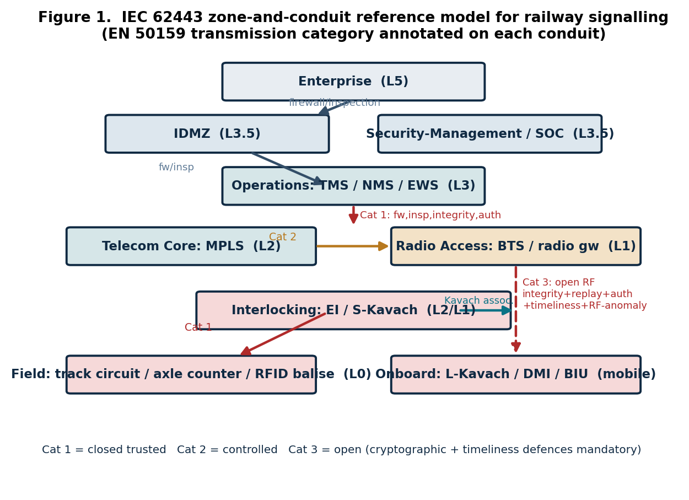

Table 5. Five visibility layers applied to Indian Railways OT assets
Railway asset | Dominant layer(s) | Collection method | Key telemetry
Electronic Interlocking (EI) | Process/Vital-state; Network | Passive TAP on EI vital buses | Route/occupancy state, Kavach-EI-interface reads/writes, safety-code failures, state-machine violations
Kavach (S-/L-Kavach) | Network; Process/Vital-state | Passive TAP + RF monitor; onboard recorder | Movement-authority frames, integrity, sequence/freshness, brake-command integrity, RF anomaly
MPLS / PE routers | Network | Passive flow monitoring on telecom-core conduit | IPsec/MACsec tunnel health, routing anomaly, unexpected participants
Radio networks (BTS/gateway) | Network; Process/Vital-state | RF spectrum monitor + conduit TAP | Signal-strength/error-rate anomaly (jamming), latency deviation, replay indicators
TMS | Application/Supervisory | Syslog/TLS; HTTPS session monitoring | Operator route/setpoint commands, supervisory-command integrity, failed logins
NMS | Application/Supervisory; Identity | SNMPv3 event capture | Unexpected SNMP set operations, config changes, off-hours management access
Data loggers | Process/Vital-state | Read-only ingestion (never inline) | Forensic stream; tamper indicators; time-sync drift; gap/reorder detection
Engineering workstations (EWS) | Asset/Endpoint; Identity | Agent or agentless read-only; PAM/VPN session recording | Logic-download and config-change actions, USB insertion, anomalous/privileged logins

Two planning points follow. First, the highest-consequence telemetry - the process/vital-state layer for EI and Kavach - is the hardest to obtain, because vital devices emit few logs and cannot be actively interrogated; it must be derived from passive observation and from the data loggers and onboard recorders. The balise air-gap concerns the Kavach trackside RFID tag and the onboard RFID reader; these are Kavach RFID balises and are distinct from the ETCS Eurobalise, with which they should not be conflated. Second, the identity layer (engineering and vendor/VPN access) is most often neglected yet most directly tied to the highest-value attack path, the EWS.

10. The Monitoring Paradox: Why Railway OT Monitoring Must Remain Passive
Every piece of monitoring infrastructure deployed inside the OT network is itself an attack surface [17]; a compromised sensor on a vital network is a bridge into the most sensitive environment a railway operates. In the railway context this Monitoring Paradox has a sharper edge than in any other sector, because the monitored assets are SIL-4 vital systems whose disturbance can directly cause a wrong-side failure. The passivity requirement has a precise engineering meaning: on vital (Category-1) and onboard segments the collection device must be a passive optical or copper TAP that is electrically and logically incapable of transmitting onto the monitored link; SPAN mirroring, which is a function of the production switch and can silently drop frames under load, is excluded from vital segments and reserved for non-vital ones. The Monitoring Paradox is then enforced architecturally (Figure 2): telemetry leaves the Station echelon strictly upward through a data diode, there is no online downward control path into the vital tier, and sensor configuration is applied through a separate, scheduled, out-of-band management channel under change control.
These constraints are grounded in the standards, not in preference. IEC 62443 FR7 (Resource Availability) and the OT priority order (Safety, then Availability, then Integrity, then Confidentiality) forbid security mechanisms that degrade the process. EN 50159's treatment of delay and corruption as first-class threats means that an in-line monitoring device on a SIL-4 bus would be a potential source of the very hazards the safety layer is designed to exclude. The Monitoring Paradox is therefore the railway expression of the principle that in OT the cure must never be more dangerous than the disease.

11. Three-Echelon OT-SOC Architecture
Terminology. To avoid ambiguity this paper distinguishes three uses of the word formerly rendered as 'tier'. The geographic SOC structure is described in ECHELONS - E1 Station/Wayside, E2 Zonal/Divisional, E3 National; the analyst workforce in GRADES - G1 Operator, G2 Investigator, G3 Senior/Hunter, G4 Lead; and the KPI framework by reporting AUDIENCE - Board, SOC-Lead, Analyst. The federated hybrid of Section 8 is realised as a three-echelon architecture (Figure 2). E1 (Station/Wayside) is co-located with the relay room and comprises passive TAP sensors on field and interlocking conduits, data-logger ingestion and a data-diode log export; it performs local detection and buffers evidence, and never hosts an in-line control on a vital path. E2 (Zonal) hosts the SIEM, correlation, IT/OT-boundary intrusion sensors in detection mode, vulnerability management for non-vital assets and case management, and correlates events across stations - for example a corridor-wide pattern of balise-telegram anomalies. E3 (National) is custodian of the validated architecture and detection-content repository, the SL-T and cyber security case, cross-zone correlation, national threat intelligence, the Railway-sector ISAC and KPI consolidation; when the architecture changes it re-validates and pushes updated baselines downward. Log flow is strictly upward and diode-enforced across the IT/OT boundary, preserving FR5 within the SOC's own architecture.
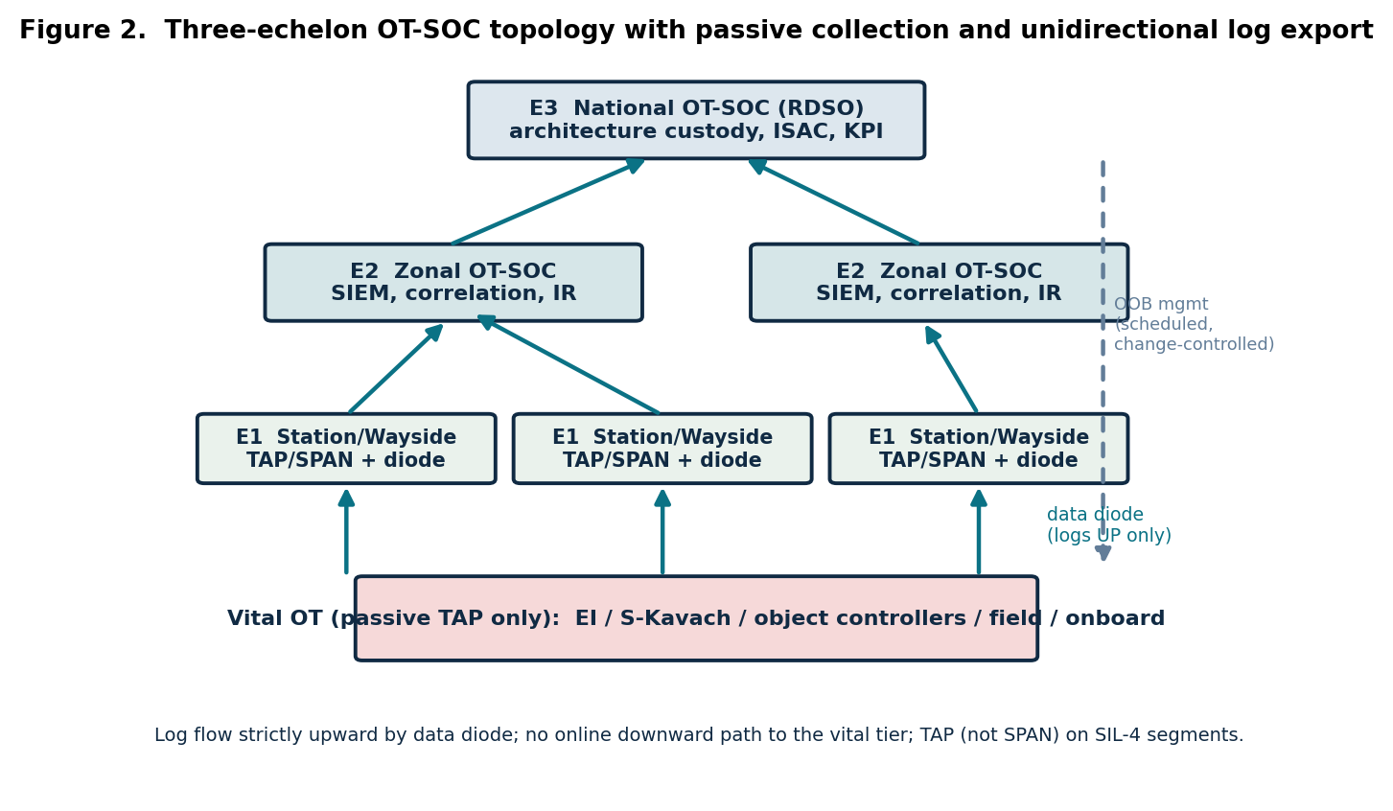

12. Detection Engineering and Railway-Specific Use Cases
Detection engineering converts the validated architecture and its findings into deployable content: every conduit security requirement and every assessment finding becomes a detection use case. The vital Category-1 buses - the EI to S-Kavach interface, EI to object controller and speed-sensor to L-Kavach over CAN, and L-Kavach to driver-machine interface and brake-interface unit over MVB (identifiers per the reference model and [9]) - provide integrity and replay through safety coding but not cryptographic source authentication; the SOC cannot add authentication but must detect the symptoms its absence would allow. Privileged engineering access is not, in the modelled flows, MFA-gated, so every privileged session is a high-value target. The open RF conduits require timeliness, jamming and RF-anomaly monitoring; several trust boundaries are not fully instrumented; and the telecom backhaul carries traffic without an evidenced transport-security overlay. Table 6 maps the threats to detections; Table 7 is the use-case library; and Table 8 maps the use cases to MITRE ATT&CK for ICS [19] so that coverage can be assessed against a recognised adversary model. Each use case additionally records, in the deployed content repository, its data source, detection logic, validated playbook reference and documented false-positive baseline.
Table 6. Threat-to-detection mapping (EN 50159 / IEC 62443)
Threat (reference) | Railway manifestation | Detection technique | Sensor / echelon
Masquerade/insertion (FR1) | Spoofed axle-counter or object-controller message | Source-ID whitelist; state-machine validation; rate anomaly | Interlocking TAP / E1
Corruption (FR3; EN 50159) | Manipulated EI-to-Kavach telegram | Safety-code/CRC failure rate; integrity-flag | EI/Kavach TAP / E1
Repetition/replay (EN 50159) | Replayed Kavach RF movement-authority frame | Sequence regression; freshness deviation | Radio conduit, recorder / E1-E2
Delay/timeliness (FR6) | Stale movement authority over RF | Latency vs SIL-bounded threshold | Radio conduit / E1-E2
Jamming/availability (FR7) | RF denial vs L-Kavach to BTS | RF signal-strength/error-rate anomaly | RF monitor / E1
Privileged misuse (FR2) | Unauthorised logic download from EWS | Engineering-session + config-change detection | Ops-to-interlocking / E2
Lateral movement (FR5) | Enterprise to operations traversal | Cross-boundary flow correlation | Boundary sensors / E2
Backhaul tampering (FR3/FR4) | Injection on unprotected MPLS/IP core | Transport-security health; unexpected participant | Telecom conduit / E2
Forbidden topology (FR5) | Direct vital-to-RF edge (S-Kavach to BTS) | Topology-conformance vs validated model | Conformance engine / E3

Table 7. Railway-specific OT-SOC detection use-case library
ID | Use case | Trigger | Sev | Safety-aware response
UC-01 | Spoofed vital field message | Source-ID not in EI whitelist / state-machine violation | SEV1 | Alert control; do not block; manual verification under safe-working rules
UC-02 | Kavach EI-interface integrity loss | Rising CRC/safety-code failure | SEV1 | Alert; correlate EI health; engineering investigation
UC-03 | Kavach RF replay / delay | Sequence regression / latency beyond SIL threshold | SEV1 | Alert; verify RF; no automated RF action
UC-04 | RF jamming / loss of comms | Signal-strength collapse / error-rate spike | SEV2 | Alert; invoke degraded-mode working
UC-05 | Unauthorised logic download | Logic/config change from EWS toward EI/S-Kavach | SEV1 | Alert; freeze change control; verify authorisation
UC-06 | Privileged access without MFA | Jump-host/VPN session, no MFA event | SEV2 | Alert; challenge session; review policy
UC-07 | Trust-boundary bypass | Flow crossing enterprise to operations without required controls | SEV2 | Alert; correlate lateral movement
UC-08 | Forbidden topology edge | S-Kavach to BTS (or any forbidden flow) detected | SEV1 | Alert; emergency architecture review
UC-09 | Backhaul transport-security failure | Loss/absence of IPsec/MACsec on TMS-MPLS path | SEV3 | Alert; verify tunnel health
UC-10 | Balise integrity / position anomaly | Telegram safety-code failure / position implausibility | SEV2 | Alert; NO crypto-encryption alarm (EN 50159 passive-telegram exemption)
UC-11 | Data-logger tampering / time drift | Gap, reorder or clock skew | SEV3 | Alert; preserve forensic chain
UC-12 | Management-plane anomaly | Unexpected SNMPv3 set on NMS | SEV3 | Alert; verify change authorisation
UC-13 | New device on vital segment | MAC/IP not in inventory on interlocking zone | SEV2 | Alert; verify closed-medium assumption
UC-14 | Removable media on EWS | USB device-ID not in approved list | SEV3 | Alert; isolate offline EWS per procedure

Table 8. Use cases mapped to MITRE ATT&CK for ICS
Use case | ATT&CK for ICS tactic | Representative technique
UC-01 Spoofed vital message | Impair Process Control | Spoof Reporting Message; Modify Parameter
UC-03 RF replay/delay | Inhibit Response Function | Adversary-in-the-Middle; Manipulation of Control
UC-04 Jamming | Inhibit Response Function | Denial of Service; Block Reporting Message
UC-05 Logic download | Lateral Movement / Execution | Program Download; Modify Controller Tasking
UC-07 Boundary bypass | Lateral Movement | Exploitation of Remote Services
UC-08 Forbidden edge | Initial Access / Persistence | Hardware Additions; Rogue Master
UC-13 New device | Initial Access | Rogue Master; Hardware Additions
UC-14 Removable media | Initial Access | Replication Through Removable Media

A deliberately exempt condition illustrates why the validated architecture matters. The passive balise telegram is protected by the passive safety-coded telegram, with freshness from location coding and odometry, not by cryptographic encryption or replay (EN 50159). The OT-SOC must therefore not raise a missing-encryption or missing-replay alarm on the passive telegram (a false positive, UC-10) while still monitoring telegram integrity and positional plausibility. Encoding standards-justified exemptions as carefully as detections is a discipline only a validated, authority-separated architecture makes reliable.

13. Trust Boundaries and Monitoring Matrix
The trust boundary is the unit of OT-SOC instrumentation; each boundary's required controls are simultaneously its monitoring specification. The assessment found several boundary controls declared in governance but not yet instantiated, so the OT-SOC must verify control presence rather than presume it. Table 9 gives the matrix.
Table 9. Trust-boundary monitoring matrix
Trust boundary | EN 50159 relevance | Required controls | OT-SOC monitoring obligation
Enterprise (L5) - IDMZ (L3.5) | IT/OT divide | Firewall, inspection | Verify controls; detect unauthorised ingress; diode log export
IDMZ (L3.5) - Operations (L3) | - | Firewall, inspection | Brokered-access audit; jump-host/VPN session + MFA-event verification
Operations (L3) - Interlocking (L2) | Cat 1 downstream | Firewall, inspection, integrity, authentication | Highest scrutiny; engineering-access and logic-download detection
Telecom Core (L2) - Radio Access (L1) | Cat 2 | Firewall, inspection, authentication | Transport-security health; participant verification
Radio Access (L1) - Onboard | Cat 3 (open RF) | Integrity, replay, authentication, radio monitoring | Full Cat-3 set: timeliness, jamming, RF anomaly, replay
Balise air-gap (Field - Onboard) | Cat 3 passive | Integrity (passive telegram); crypto exempt | Telegram integrity and positional plausibility; no crypto false positives

14. Incident Response Doctrine: The Four-Gate, Safety-First Model
Railway OT incident response inverts the IT assumption that speed is paramount: it assesses safety impact before every action, contains only when containment does not create a more dangerous state, and recovers in coordination with Operations and Engineering. A four-gate model (Figure 4, Table 10) governs every action, and no gate permits an action that interrupts a vital path or induces a wrong-side state. The repertoire is graduated - observe and enrich, then alert the controller, then recommend a manual protective action - the last always executed by signalling operations under safe-working rules, never automatically by the SOC tool.
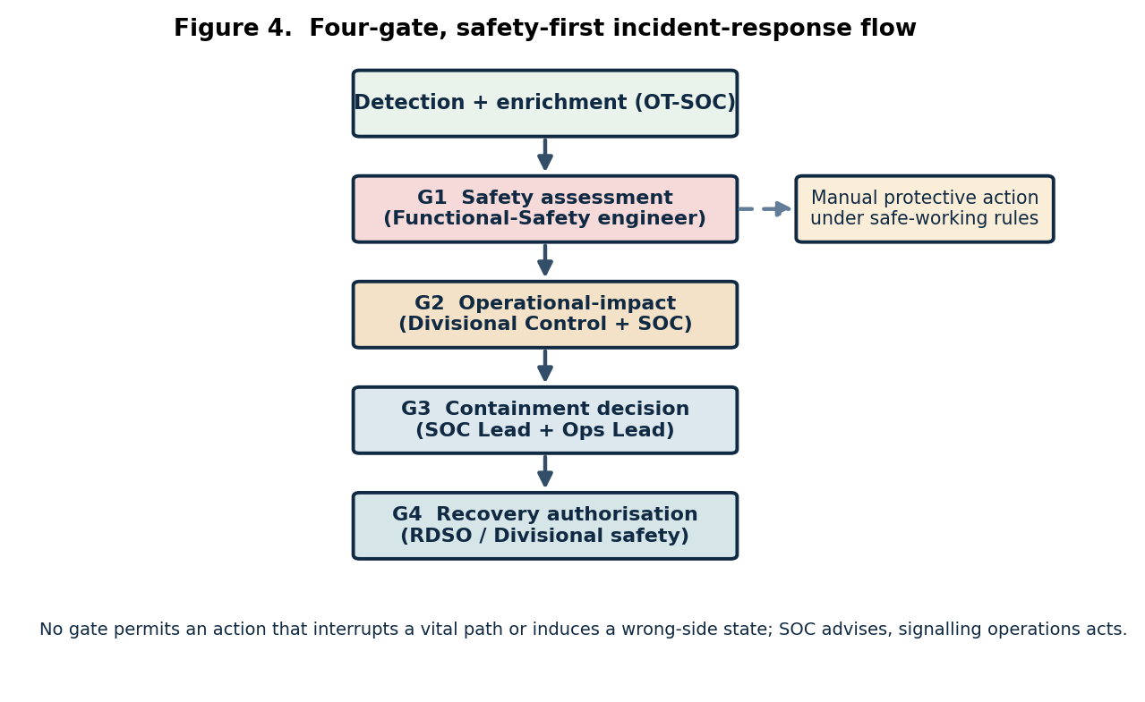

Table 10. Four-gate OT incident-response doctrine adapted for railway operations
Gate | Question | Decision authority
G1 Safety assessment | Does the incident or any response create/worsen a wrong-side or safety risk? | Functional-Safety engineer - mandatory before any containment
G2 Operational-impact | Consequence of the incident continuing vs of the response on live operations? | Divisional Control / Station Master with SOC
G3 Containment | Minimum viable action that halts progression without unacceptable impact; reversible? | OT-SOC Lead + Operations Lead - logged
G4 Recovery authorisation | Threat remediated, segment re-validated, safe to return to service? | RDSO / Divisional safety authority - formal sign-off

Decision rights are explicit: the OT-SOC owns detection, enrichment and recommendation; signalling operations owns any action affecting train movement; and RDSO / Railway Board governance owns escalation and external reporting. Forensic readiness is a precondition: data loggers and onboard recorders must have assured integrity and time-synchronisation before an incident.
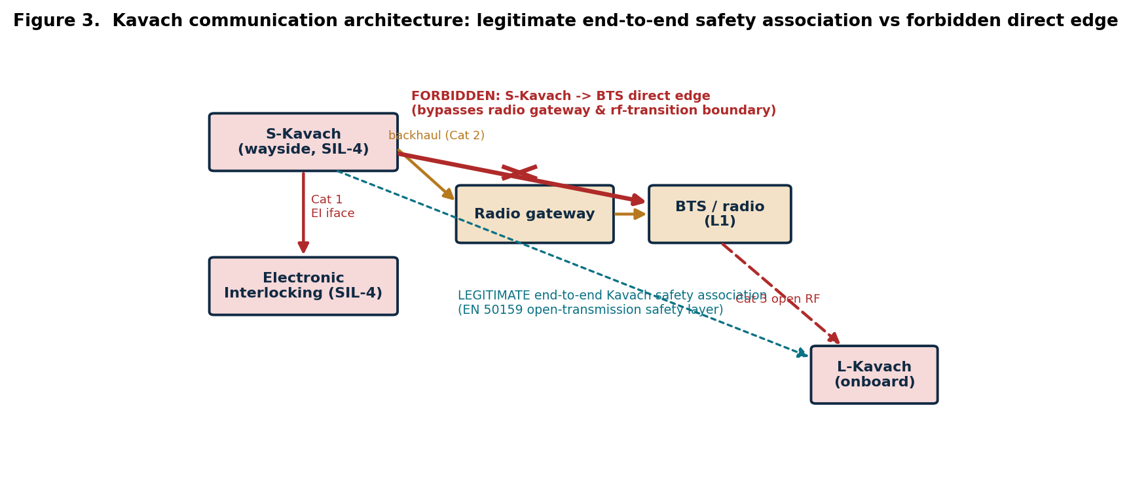

15. Railway Incident Severity Model (SEV1-SEV4)
Severity in OT is defined by potential physical consequence, not data value. Table 11 anchors severity to the wrong-side failure and the SIL of the affected asset. The escalation timelines below are the authors' recommended targets; they must be reconciled against the specific reporting timelines of the Kavach Cyber Security SOP [10] and the statutory CERT-In window [13] during Phase 0 of the programme.
Table 11. Railway OT incident severity classification
Level | Definition (consequence-based) | Examples | Response / escalation
SEV1 Safety-critical | Active threat to safety; vital/Kavach/EI compromise confirmed or highly probable; potential wrong-side failure | Manipulation of EI vital logic; spoofed Kavach movement authority | All-hands; G1 invoked; functional-safety + executive notice within 15 min; CERT-In within statutory window; NCIIPC engaged
SEV2 Operation-critical | Confirmed OT compromise able to disrupt operations; active lateral movement; containment will affect services | Ransomware on TMS/historian; compromised EWS with live EI/Kavach link | G3/Lead escalation within 15 min; Operations within 30 min; CISO/IRSSE within 1 hr
SEV3 OT-zone compromise | Confirmed malicious presence, not yet able/intending to affect the vital process | Malware on isolated EWS; phished engineer; rogue device | 1-hr investigation; Operations informed; CISO same business day
SEV4 Anomaly/policy | Policy violation or anomaly, no confirmed compromise | Unauthorised media; out-of-window vendor access; config drift | Next-business-day triage; trend-tracked

16. Threat Hunting
Reactive detection cannot find an adversary who has pre-positioned without triggering a rule; proactive threat hunting is the only mechanism that can. In the railway OT-SOC, hunting is hypothesis-led and anchored to MITRE ATT&CK for ICS [19] and to the validated architecture: hunters look for evidence of the techniques in Table 8 that would precede a wrong-side failure - rogue masters or hardware additions on a vital segment (UC-08, UC-13), program-download activity outside a change window (UC-05), and adversary-in-the-middle indicators on the Kavach bearer (UC-03). Hunts are conducted entirely on the passively-collected E2/E3 data and on data-logger and onboard-recorder archives, never by active interrogation of vital devices. Each hunt that yields a repeatable indicator is promoted to a new detection use case, feeding the KPI on new use cases per quarter (Section 17). A minimum of two hunt campaigns per quarter is recommended, rising for high-risk corridors.

17. KPI Framework: Board, SOC-Lead and Analyst Audiences
OT-SOC performance is measured by safety-weighted, standards-anchored indicators rather than volume metrics, distinguishing leading, lagging and operational-health classes across three reporting audiences. Targets are concrete and time-bound (Table 12). The mean-time-to-detect target is anchored to IEC 62443-3-3 SR 6.2 (continuous monitoring) and the operational hazard-exposure budget, not to EN 50129. Quantitative staffing and uptime figures are adopted from cross-sector practice [17] and are to be validated against an Indian Railways workload study during the pilot.
Table 12. Three-audience KPI framework adapted for Indian Railways
Audience: KPI | Concrete target | Class
Board: Vital-asset (SIL-3/4 conduit) monitoring coverage | 100% within 18 months of go-live; sustained | Leading
Board: MTTD (vital-affecting known technique) | < 1 hr; < 4 hr unknown | Lagging
Board: Mean time to safe advisory (SEV1) | < 1 hr | Lagging
Board: Incidents contained without operational impact | > 90% | Lagging
Board: Regulatory-evidence availability | 100% on demand | Op-health
SOC-Lead: Trust-boundary instrumentation | 100% within 12 months | Leading
SOC-Lead: EN 50159 detector completeness | 100% (detectors match each conduit's category) | Leading
SOC-Lead: Sensor/TAP uptime | >= 99.5% monthly | Op-health
SOC-Lead: Privileged-session audit coverage | 100% within 24 hr of session | Op-health
SOC-Lead: New use cases / threat hunts per quarter | >= 1 / >= 2 | Leading
Analyst: SPAN/TAP coverage of L1/L2 vital segments | 100% | Op-health
Analyst: Architecture-conformance drift; exempt-flow false positives | 0; 0 | Leading / Op-health

18. Staffing, Competency and Governance Model
The scarcest resource is the individual fluent in both signalling safety and cyber security; cross-sector experience confirms a 12-24-month development pipeline and warns that neither IT-only analysts nor signalling engineers without security training produce effective practitioners [17]. The model builds cyber capability atop IRSSE signalling expertise and embeds dedicated railway expertise with no analogue in a generic OT-SOC: the IRSSE signalling SME, the Kavach SME and the Functional Safety specialist (Table 13). Analyst grades G1-G4 are distinct from the geographic echelons E1-E3; the SMEs are grade-G2/G3 roles serving across echelons. A pilot corridor requires of the order of 14-18 full-time equivalents for 24x7 cover (a figure adopted from [17] for validation during the pilot); RDSO is the custodian of the competency curriculum and certification.
Table 13. Railway OT-SOC staffing and competency model
Role (grade) | Core function | Required background
G1 Monitoring Operator | Triage, classification, playbook execution, escalation | Signalling-aware; EI, Kavach, track circuits, data loggers; EN 50159 categories
G2 Investigator / Detection Engineer | Investigation, forensics, correlation, content authoring | Reads railway protocol captures (Kavach-EI iface, MVB, CAN); IEC 62443 FRs
G3 Senior Analyst / Threat Hunter | Hunting, campaign tracking, SIEM tuning, safety-response authority | Deep OT protocol expertise; ICS malware analysis
IRSSE Signalling SME (G2/G3) | Authoritative architecture interpretation; G2-gate operational input | IRSSE officer; interlocking/ATP design; SIL allocation
Kavach SME (G2/G3) | Kavach RF and EI-interface behaviour; balise semantics; SOP compliance | Kavach system engineering; RDSO Kavach specification [9]
Functional Safety Specialist (G3/G4) | Owns the G1 safety gate; bridges cyber and safety cases | EN 50126/50129; SIL and safety-case authorship
G4 OT-SOC Lead / IRSSE-CISO interface | Governance, KPI, reporting, risk-acceptance recommendation | Security management (CISM/CISSP) and ISA/IEC 62443 expert level

Governance spans the full institutional hierarchy and the national cyber-security apparatus. Signalling and train-protection systems are Critical Information Infrastructure; their protection therefore engages NCIIPC for designation and protection oversight under section 70 of the Information Technology Act 2000 [12], and CERT-In for statutory incident reporting under the CERT-In Directions of 28 April 2022, which require reporting within six hours of noticing a reportable incident [13], in addition to the internal railway hierarchy. The SOC charter must define the interplay: the OT-SOC notifies the internal RDSO/Railway-Board chain and, for incidents meeting statutory thresholds, CERT-In within the mandated window, with NCIIPC engaged for CII-level events. Table 14 defines the governance model.
Table 14. National OT-SOC governance and responsibility model
Entity | Scope (echelon) | Principal OT-SOC responsibility
Railway Board | National policy | Mandate, funding, national risk-acceptance authority for SIL-4 residual risk
RDSO | National technical (E3) | Custody of validated architecture and SL-T; detection-content repository; competency certification; national OT-SOC operation
NCIIPC | National CII protection | CII designation (IT Act s.70); protection oversight; national advisories and audits
CERT-In | National CERT | Statutory 6-hour incident reporting; national threat intelligence; coordination
Zonal Railways | Zonal (E2) | Operation of the zonal fused OT-SOC; cross-zone correlation; OT veto over IT actions
Divisions | Local (E1) | Station/wayside collection; local detection and evidence buffering; first-line response under safe-working rules

19. Residual-Risk Methodology and Risk Acceptance for SIL-4 Systems
Residual risk must be quantified, documented and owned. The open findings of the reference assessment are entered into a register with named ownership and a treatment decision (Table 15) and remain visible as standing monitoring requirements. For SIL-4 systems three constraints apply. First, residual risk affecting a SIL-4 vital function cannot be accepted at SOC or divisional level; it is escalated to the Railway Board with a supporting safety and cyber-security argument. Second, where a control mandated by IEC 62443 cannot be implemented for sound engineering reasons - the EN 50159 / IEC 62443 authentication tension on vital Category-1 buses is the archetype - the residual risk is reduced As Low As Reasonably Practicable through compensating controls, of which the OT-SOC's continuous monitoring is one, and is argued in the cyber security case. Third, no risk treatment may weaken a SIL-4 boundary, an EN 50159 protection, an authentication or MFA requirement, an integrity or replay-protection requirement, or a trust-boundary control.
Table 15. Residual-risk register (extract) with SIL-4 acceptance routing
Ref | Residual risk | Standing monitoring lesson | Treatment / acceptance route
A-01 | No cryptographic authentication on vital Cat-1 buses | Police closed-medium assumption (UC-01/02/13) | Mitigate; ALARP; cyber security case; SIL-4 - Board acceptance
A-02 | Missing integrity on field-vital train detection | Occupancy-integrity monitoring | Mitigate; SIL-4 - Board acceptance
A-03 | No MFA on privileged engineering access | Privileged-session monitoring (UC-05/06) | Mitigate now; enforce MFA in architecture; divisional owner
A-04 | No timeliness/RF-anomaly monitoring on open RF | Cat-3 RF instrumentation (UC-03/04) | Mitigate; SIL-4 - Board acceptance
A-05 | Forbidden vital-to-open-RF edge present | Topology-conformance monitoring (UC-08) | Avoid (remove) + detect; architecture authority
A-06 | Incompletely instrumented trust boundaries | Boundary verification (UC-07) | Mitigate; OT-SOC + network owners
B-01 | EN 50159 / IEC 62443 authentication crediting unresolved | Compensating closure-monitoring | Mitigate by documentation; assurance lead
B-02 | TS 50701 SL-T / risk-assessment / cyber-security-case evidence absent | Calibrates monitoring intensity | Mitigate by producing evidence; RDSO / Railway Board

20. OT-SOC Maturity Model for Indian Railways
The five-level roadmap below adapts cross-sector maturity practice [17] and IEC 62443-2-1 management-system concepts [3] to the railway context; the realistic near-term target is Level 3 across pilot corridors, progressing to Level 4 nationally.
Table 16. Five-level OT-SOC maturity roadmap for Indian Railways
Level | Name | Defining characteristics
1 | Initial | Ad-hoc passive monitoring at a few sites; no validated architecture; reactive only
2 | Defined | Validated architecture and conduit inventory; E1/E2 sensors on vital conduits; core use cases; SL-T documented
3 | Managed | Three-echelon OT-SOC operational; four-gate IR tested against the real process; KPI framework live; category-aware detectors complete
4 | Integrated | National E3 SOC and Railway-sector ISAC; proactive threat hunting; cyber security case maintained; conformance monitoring automated
5 | Optimised | Continuous architecture-to-detection synchronisation; leading-indicator-driven; intelligence exchange with NCIIPC and CERT-In

21. The 90-Day Pilot-Deployment Programme
The cross-sector 90-day launch programme [17] is adapted to a pilot on a representative Kavach corridor, assuming Phase 0 (validated architecture, conduit inventory and TS 50701 SL-T allocation) is complete - no sensor is deployed before the model that configures it. The guiding principle is that breadth never precedes vital depth, and deployment never precedes the validated model. An indicative budget envelope (passive TAP/NDR, OT-contextualised SIEM, RF monitors, staffing and RDSO certification) should accompany the programme for Railway Board approval; a corridor-scale pilot is modest relative to the Kavach programme itself and is the prerequisite for credible national costing.
Table 17. 90-day OT-SOC pilot-deployment programme (Kavach corridor)
Window | Focus | Key activities
Days 1-30 | Foundation and assessment | Confirm validated architecture and SL-T; passive asset discovery; ratify SOC charter and decision rights; identify TAP points on EI/field/boundary conduits; assign G1-G3 staff and SMEs (signalling-first hiring)
Days 31-60 | Technology and process | Deploy OT-native NDR with railway-protocol parsing; stand up OT-contextualised SIEM with asset/zone/criticality context; implement UC-01 to UC-08; draft and table-top the four-gate IR playbooks with Operations and the functional-safety specialist
Days 61-90 | Operationalisation and governance | Go live; tune false positives (passive-telegram exemption, UC-10); run one severity-graded IR exercise under safe-working rules; publish first Board and SOC-Lead KPI dashboards; enter A/B findings into the residual-risk register and route SIL-4 items to the Board

22. Lessons Learned
At the technical level the assessment's findings are durable monitoring requirements: vital buses rely on a closed-medium assumption the SOC must continuously police; field-vital integrity must be observed, not assumed; privileged engineering access is the principal cyber pathway to a wrong-side failure and must be monitored until MFA is universal; the open RF bearer demands timeliness and RF-anomaly monitoring that cryptography alone does not provide; forbidden topologies must be both prevented and detected; trust boundaries must be instrumented, not merely declared; the telecom backhaul is in scope; and standards-justified exemptions must be encoded as carefully as detections. At the programme level, an OT-SOC is an operational capability, not a technology purchase; the mundane and the sophisticated both matter; talent is the binding constraint; the SOC must remain outside the vital network; and residual risk on SIL-4 systems must be owned at Board level.

23. Future Work
The immediate next step is field validation of the model-derived findings on a representative Kavach corridor and electronic interlocking under the TS 50701 lifecycle. Further work includes: resolving the EN 50159 / IEC 62443 authentication tension in the cyber security case; curating railway-specific detection-content libraries (signatures and anomaly models for the Kavach interfaces, MVB and balise telegrams) under RDSO; machine-assisted architecture-conformance monitoring that diffs the validated model against observed topology (extending UC-08); integration of the safety and security cases under TS 50701 and EN 50129 cross-acceptance; resilience engineering of the OT-SOC itself; establishment of a Railway-sector ISAC aligned to NCIIPC and CERT-In; and standardisation of OT-SOC interfaces to the Kavach Cyber Security SOP.

24. Conclusion
The convergence that has modernised Indian Railways signalling has dissolved the isolation on which signalling security historically depended. Protecting this estate requires dedicated OT-SOCs that are passive-first, safety-aware, SIL-prioritised, protocol-literate and bound to a validated architecture. The central contribution of this paper is the argument, evidenced by an independent standards-traceable model assessment and reinforced by field-proven practice, that architecture validation must precede OT-SOC deployment, together with the demonstration of how a validated architecture mechanically yields the SOC's operating-model choice, its five-layer visibility plan, its SL-T calibration, its detection specification, its incident-response and severity models, its KPIs, its staffing and governance, its residual-risk register and its maturity roadmap. The recommendation to Indian Railways, RDSO and the Railway Board is unambiguous: invest first in the validated architecture and the TS 50701 evidence base; adopt a federated hybrid SOC model with explicit OT decision rights; instrument the vital conduits and trust boundaries before broadening coverage; build the dual-competency workforce under RDSO certification; govern across the Railway Board, RDSO, NCIIPC, CERT-In, the Zonal Railways and the Divisions; and constitute the OT-SOC as a permanent, standards-anchored assurance organ. Isolation can no longer be assumed; it must now be observed.

References
[1] IEC 62443-3-2, Security risk assessment for system design, IEC.
[2] IEC 62443-3-3, System security requirements and security levels, IEC.
[3] IEC 62443-2-1, Establishing an industrial automation and control system security programme, IEC.
[4] IEC 62443-4-2, Technical security requirements for IACS components, IEC.
[5] CLC/TS 50701, Railway applications - Cybersecurity, CENELEC.
[6] EN 50159:2010, Railway applications - Safety-related communication in transmission systems, CENELEC.
[7] EN 50126, Railway applications - RAMS, CENELEC.
[8] EN 50129, Railway applications - Safety-related electronic systems for signalling, CENELEC.
[9] RDSO, Specification for Train Collision Avoidance System (Kavach), Ministry of Railways, Government of India.
[10] RDSO / Indian Railways, Kavach Cyber Security Standard Operating Procedure (SOP) [document number and issue to be confirmed].
[11] Indian Railways / Railway Board, Signalling Cyber Security Policy and Guidelines [document number and issue to be confirmed].
[12] Government of India, Information Technology Act 2000, section 70; NCIIPC, Guidelines for the Protection of Critical Information Infrastructure.
[13] CERT-In, Directions under sub-section (6) of section 70B of the IT Act, 28 April 2022 (six-hour incident-reporting obligation).
[14] NIST SP 800-82 Rev. 3, Guide to Operational Technology (OT) Security, NIST.
[15] ISA/IEC 62443 Cybersecurity Expert competency programme; ISO/IEC 27001 (enterprise-tier governance reference).
[16] IRSE, International Technical Committee guidance on cyber security for signalling systems, Institution of Railway Signal Engineers.
[17] ShieldworkZ, OT SOC Foundational Guide (shieldworkz.com) - cross-sector OT-SOC foundations: operating-model archetypes, five-layer visibility model, Monitoring Paradox, four-gate IR doctrine, severity, KPI, maturity and residual-risk frameworks (adapted and railway-contextualised herein).
[18] Reference Railway OT Cyber Security Architecture Model and Independent Assessment - separated semantic, governance and enforcement authorities; zone/conduit, EN 50159 transmission-category and SIL traceability (primary evidence base).
[19] MITRE ATT&CK for ICS, The MITRE Corporation - adversary tactics and techniques for industrial control systems.
[20] ENISA, Railway Cybersecurity and Transport Threat Landscape reports, European Union Agency for Cybersecurity.
[21] EU railway-cyber research outputs: CYRAIL, X2Rail and SAFETY4RAILS project deliverables.

