**LET’S UPGRADE AWS**

[-ramyaiswarya727@gmail.com](mailto:-ramyaiswarya727@gmail.com)

**Assignment-1:**

**Project-1**: Create a windows instance using AMI :Windows 2012 R2 base

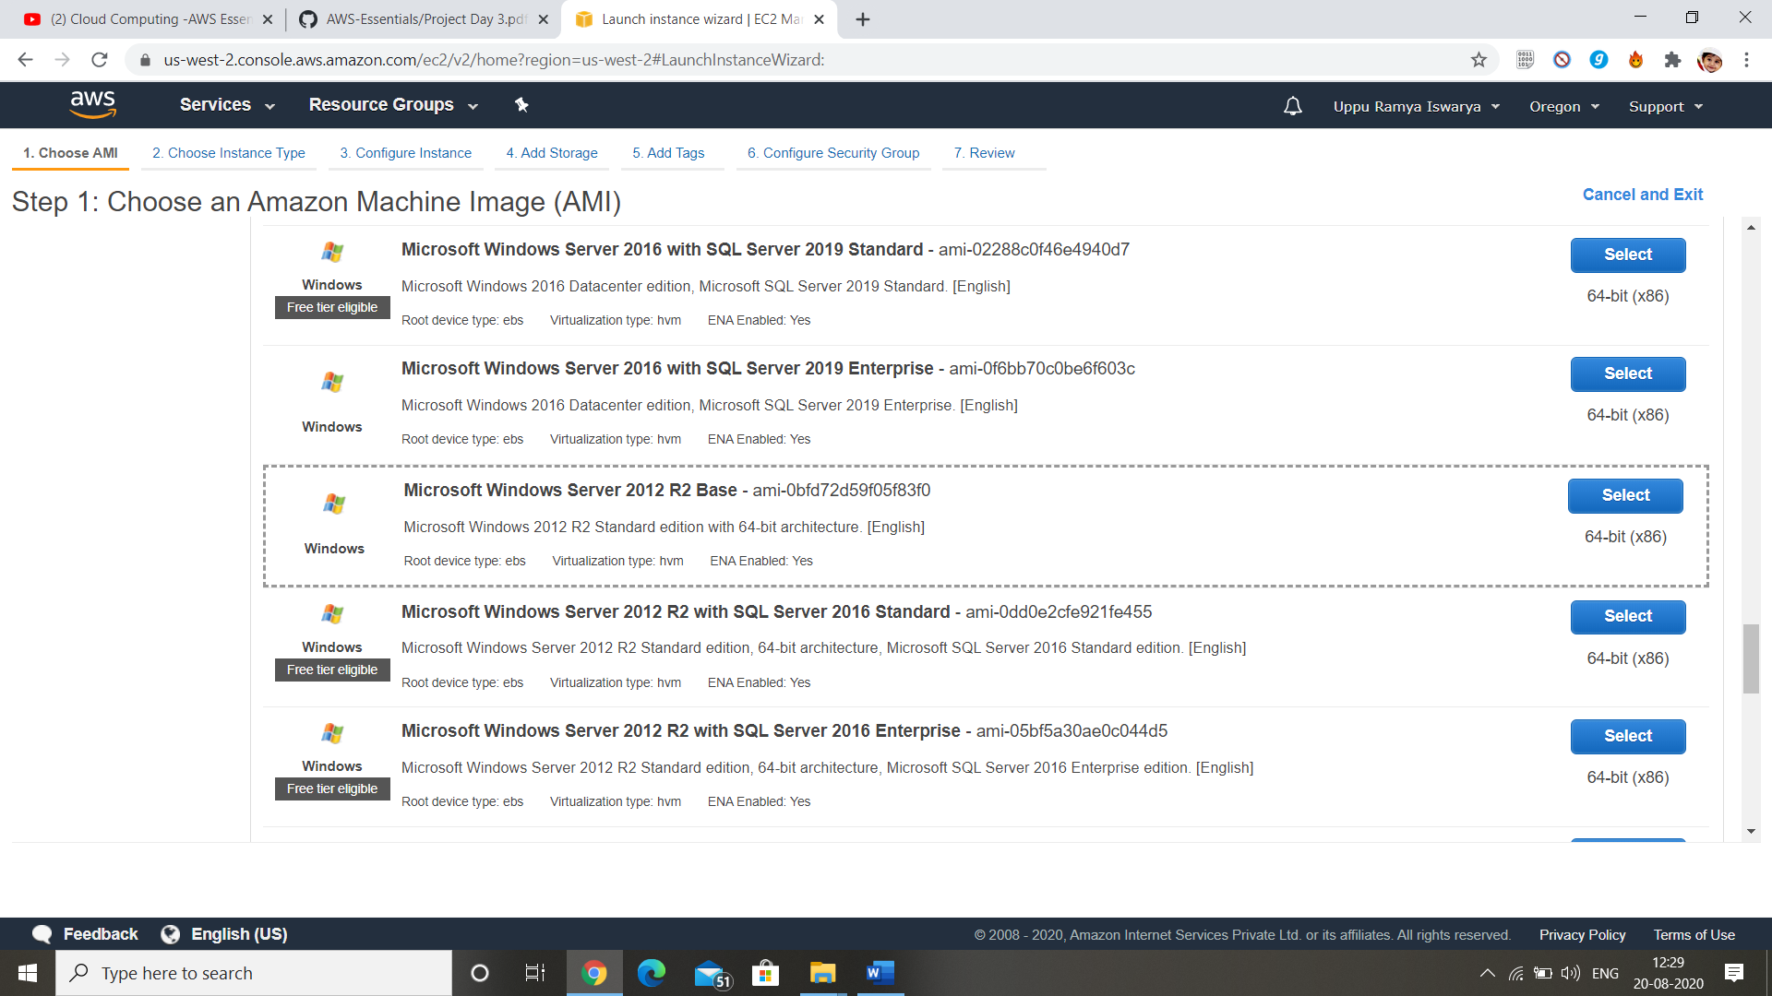

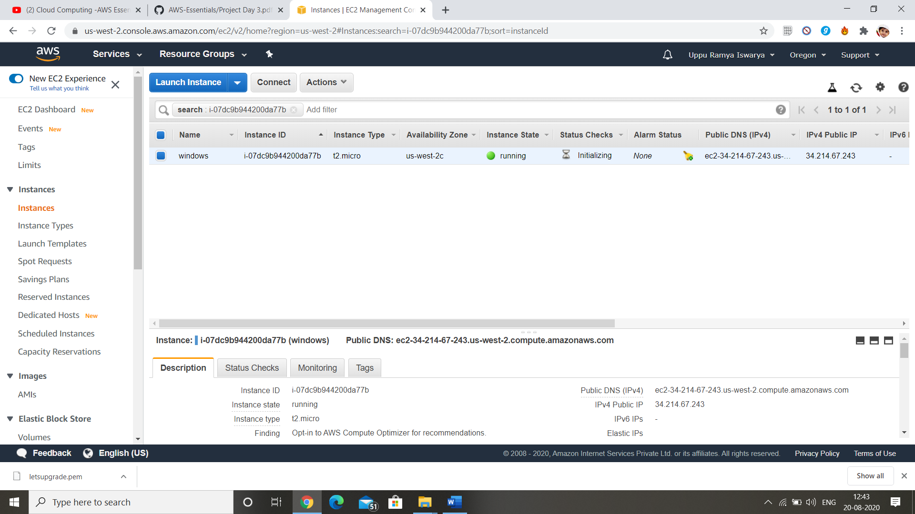

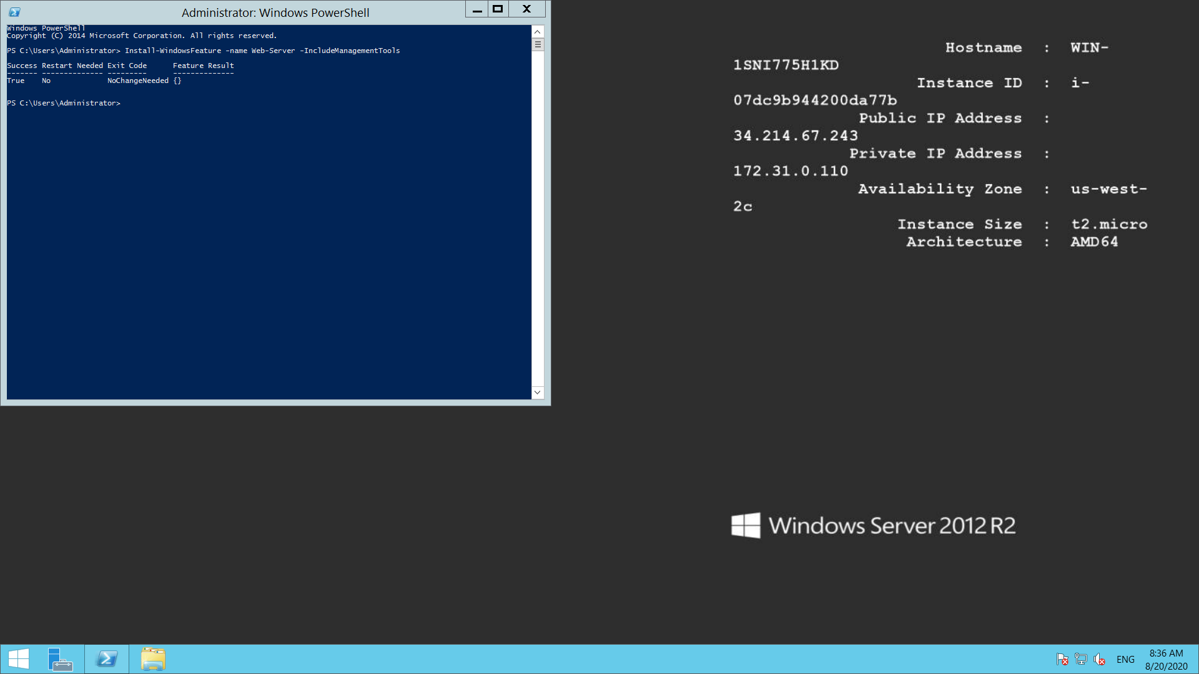

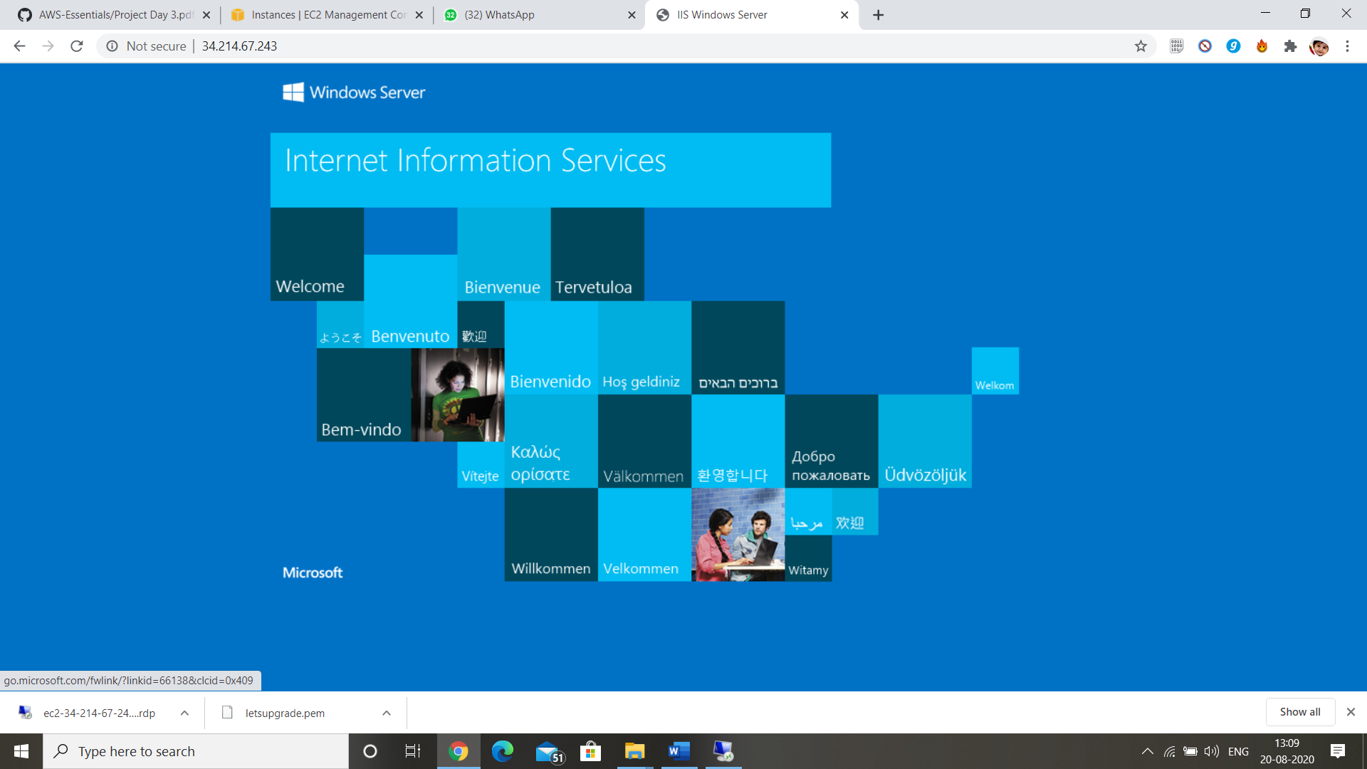

Ip: 34.214.67.243

**Project-2:** Creating a windows instance : Ubuntu server 18.04 LTS

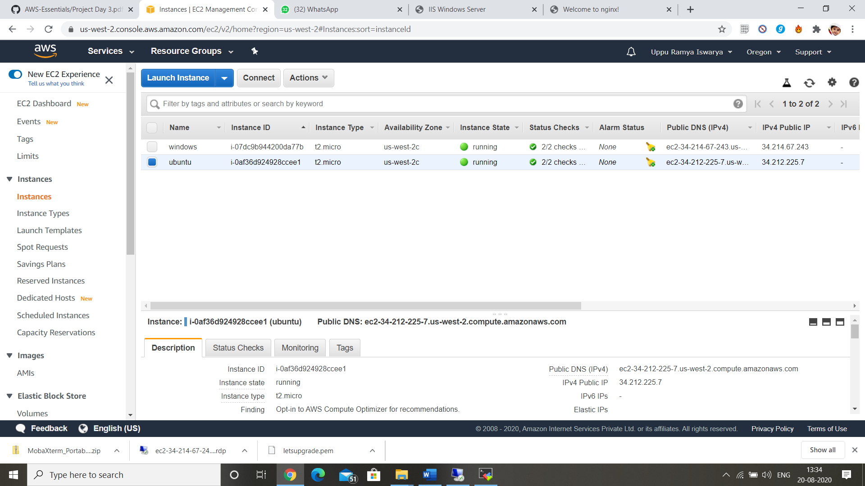

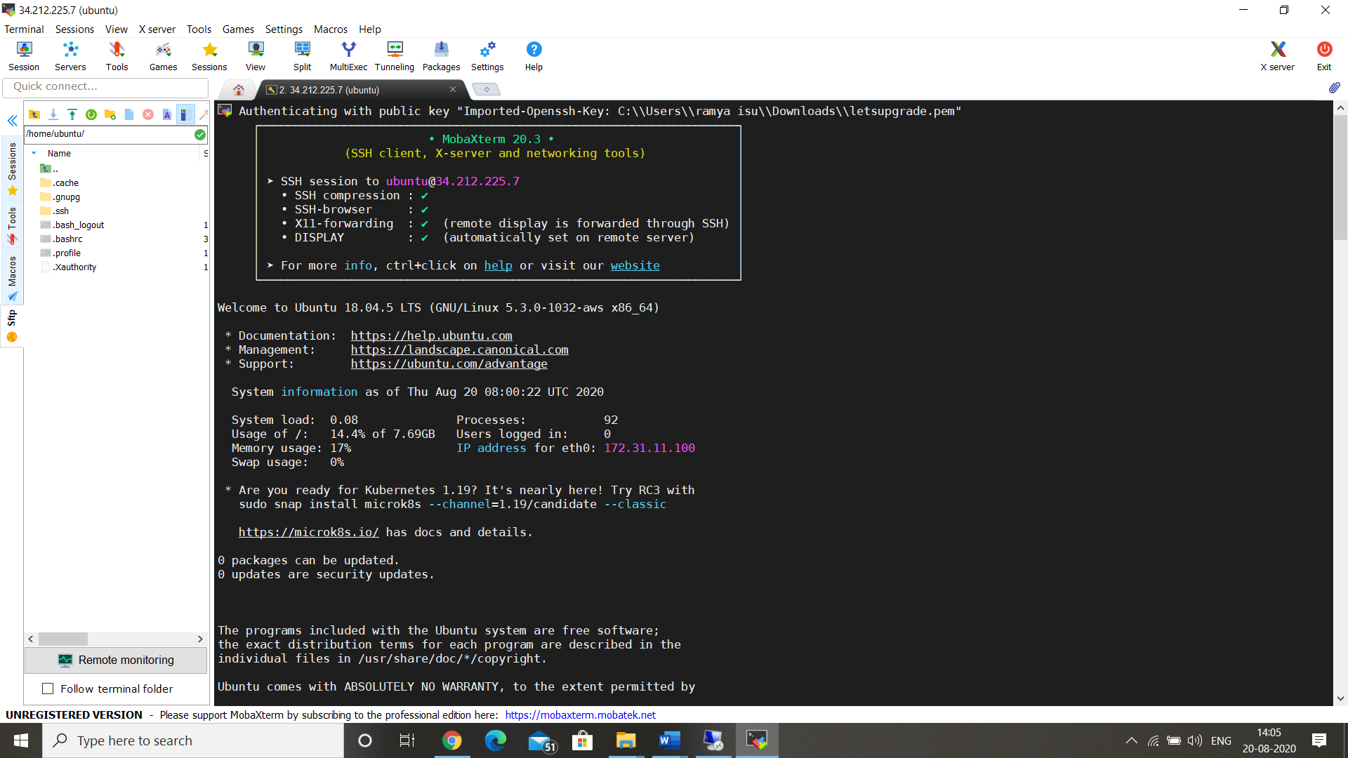

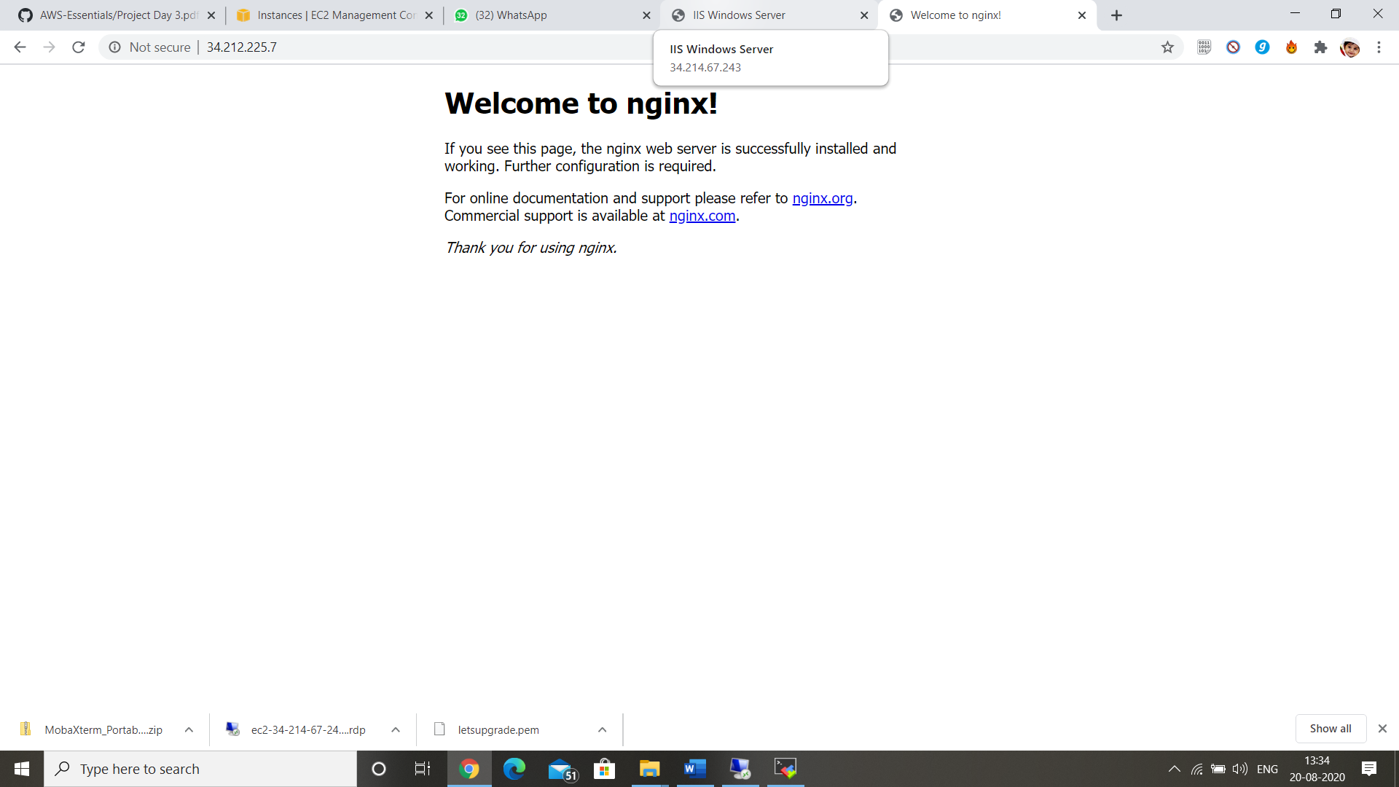

Ip: 34.212.225.7

**Managing States:**

**STOP:**

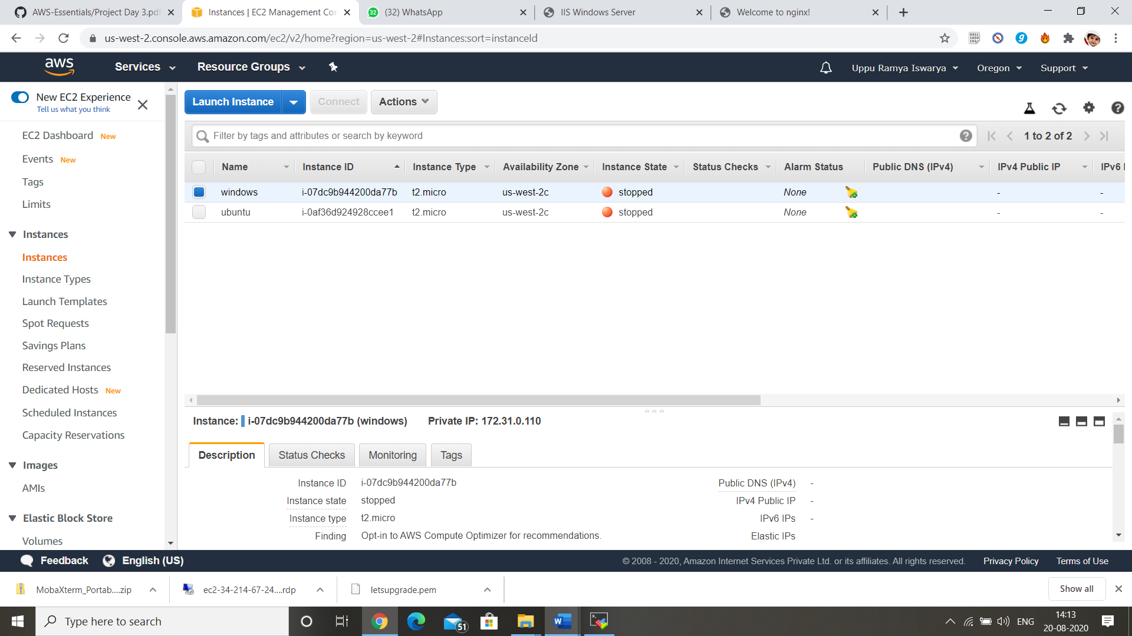

**TERMINATE:**

