
Koneru Lakshmaiah Education Foundation
(Deemed to be University estd. u/s. 3 of the UGC Act, 1956)
Off-Campus: Bachupally-Gandimaisamma Road, Bowrampet, Hyderabad, Telangana - 500 043. Phone No: 7815926816, www.klh.edu.in

STUDENT CASE STUDY EXECUTION REPORT
Department | FED
Subject | DSA-2
Academic Year | 1-111 Semester | 2025-26
Faculty Name | N.M.DEEPIKA
Student Name | U.PRANEETH
Roll Number | 2520030188
Branch | CSE
Course Outcome | 4

Case Study Topic:- “Google Maps Live Re-routing Using Dijkstra's Algorithm”

Work Done Summary:
In this case study, a Bangalore road network was modeled as a weighted graph and Dijkstra's Algorithm was implemented using Java PriorityQueue to find the shortest route from Koramangala (KOR) to Electronic City (EC). The original shortest path and travel time were computed, after which a road closure between MG Road (MGR) and HSR Layout (HSR) was simulated to represent a live traffic incident. The shortest path was then recomputed on the updated graph and the results were compared. The study demonstrated how route optimization algorithms support real-time navigation systems by quickly adapting to changing road conditions and finding alternative routes efficiently.

Implementation Details:
- Created a weighted graph representing the Bangalore road network with 8 nodes and 11 edges.
- Represented roads as graph edges and travel times as edge weights.
- Used an adjacency list data structure to store graph connections efficiently.
- Implemented Dijkstra's Algorithm to find the shortest path between source and destination nodes.
- Used Java's PriorityQueue (Binary Heap) for efficient minimum-distance node selection.
- Initialized source node distance as 0 and all other node distances as infinity.
- Applied edge relaxation to update shorter paths during traversal.
- Stored and updated shortest distances for all nodes.
- Simulated a live road closure by setting the weight of the edge MGR ↔ HSR to infinity.
- Recomputed the shortest path after the road closure event.
- Compared the shortest path and travel time before and after the closure.
- Analyzed the impact of dynamic traffic conditions on route selection.
- Evaluated the algorithm's performance with time complexity O((V + E) log V).
- Studied how real navigation systems perform live route re-planning using graph algorithms.
- Generated the final shortest path and travel time results for both scenarios.

Result: Screenshots / Output:-

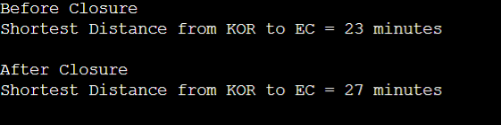

Result: The shortest path before closure is KOR → MGR → HSR → SRJ → EC (23 minutes), and after the road closure it changes to KOR → BTM → SRJ → EC (27 minutes), increasing travel time by 4 minutes.
Time Complexity: Dijkstra's Algorithm using a Binary Heap (PriorityQueue) runs in O((V + E) log V) time and efficiently supports real-time route re-computation in navigation systems.

GitHub Link: https://github.com/uppusonu/3-SEM-DSA-2
Student Signature | Faculty Signature

