
Koneru Lakshmaiah Education Foundation
(Deemed to be University estd. u/s. 3 of the UGC Act, 1956)
Off-Campus: Bachupally-Gandimaisamma Road, Bowrampet, Hyderabad, Telangana - 500 043. Phone No: 7815926816, www.klh.edu.in

STUDENT CASE STUDY EXECUTION REPORT:-
Department | FED
Sub'ect | DSA-2
Academic Year | 1-111 Semester | 2025-26
Faculty Name |  | N.M.DEEPIKA
Student Name |  | U.PRANEETH
Roll Number |  | 2520030188
Branch | CSE
Course Outcome | 1
Case Study Topic: AVL Tree-Based Patient Indexing System for Fast Hospital Appointment Lookup

Work Done Summary:
MediFlow Hospital maintains a patient indexing system using Patient-IDs for fast appointment and triage record retrieval. Since patient IDs are generated and entered in nearly sorted order according to appointment schedules, a standard Binary Search Tree (BST) can become highly unbalanced, increasing search depth and reducing lookup efficiency. To evaluate performance, patient IDs were inserted into both a Plain BST and an AVL Tree.
The study involved constructing the BST and AVL Tree using the given insertion sequence, analyzing tree height, lookup performance, and compliance with the hospital's response-time Service Level Agreement (SLA). AVL rotations were performed whenever balance violations occurred during insertion and deletion operations. Later, patient records 30, 70, and 50 were deleted, and the resulting structural changes were examined.
The results showed that the Plain BST became right-skewed due to the nearly sorted insertion order, while the AVL Tree maintained balance through rotations. Consequently, the AVL Tree achieved significantly lower height and faster lookup times, making it more suitable for hospital systems that require quick and reliable patient record access. This case study demonstrates the importance of self-balancing trees in maintaining efficient search performance in real-world healthcare applications.

Implementation Details:
1.Sorted insertions are worst-case for plain BST.
2. Plain BST became a right-skewed chain.
3.BST height = 12 edges.
4.Worst BST lookup = 2400 ns.
5.AVL automatically rebalances.
6.All insertion imbalances were RR cases.
7.AVL final height = 3 edges.
8.AVL insertion complexity = O(log n).
9.Deleting 30 required successor replacement.
10.Deleting 50 triggered an LL imbalance and right rotation.
11.Final AVL lookup = 600 ns, far below the 5 ms SLA.

Result: Screenshots / Output:-

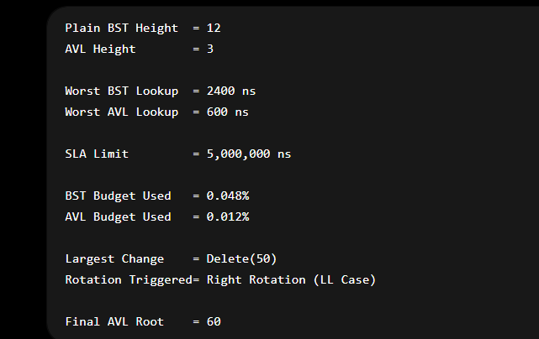

GitHub Link: https://github.com/uppusonu/3-SEM-DSA-2

Student Signature:- | Faculty Signature:-

