
Koneru Lakshmaiah Education Foundation
(Deemed to be University estd. u/s. 3 of the UGC Act, 1956)
Off-Campus: Bachupally-Gandimaisamma Road, Bowrampet, Hyderabad, Telangana - 500 043. Phone No: 7815926816, www.klh.edu.in

STUDENT CASE STUDY EXECUTION REPORT
Department | FED
Subject | DSA-2
Academic Year | 1-111 Semester | 2025-26
Faculty Name | N.M.DEEPIKA
Student Name | U.PRANEETH
Roll Number | 2520030188
Branch | CSE
Course Outcome |  | 2

Case Study Topic: - " Using Razorpay Monorepo CI Build Graph: Cycle Detection DFS and Topological Sort"

Work Done Summary:-
The Razorpay engineering monorepo experienced a CI build failure due to a suspected cyclic dependency among build targets. To investigate the issue, the dependency graph was constructed using the provided build relationships and analyzed using Depth-First Search (DFS) with color-based cycle detection. Each build target was represented as a node, and dependencies were represented as directed edges. During traversal, DFS tracked node states using WHITE (unvisited), GREY (currently being explored), and BLACK (fully processed). The algorithm successfully detected a cycle between the fraud and ledger modules, proving that the graph was not a Directed Acyclic Graph (DAG). Since topological sorting requires a DAG, the build coordinator could not generate a valid build sequence. The study demonstrates how DFS-based cycle detection helps quickly identify dependency issues and improves debugging efficiency in large software build systems.

Implementation Details:-

- Created a directed graph using an adjacency list.
- Represented each build target as a graph node.
- Added dependency edges according to the build manifest.
- Initialized all nodes with WHITE color (unvisited).
- Started DFS traversal from each unvisited node.
- Marked a node GREY when DFS entered it.
- Explored all adjacent dependency nodes recursively.
- Checked whether a neighbor was already GREY.
- Identified a back edge when a GREY node was encountered.
- Reported the cycle immediately after detection.
- Marked nodes BLACK after all dependencies were processed.
- Concluded that topological sorting was impossible because the graph contained a cycle.

Result: Screenshots / Output:-

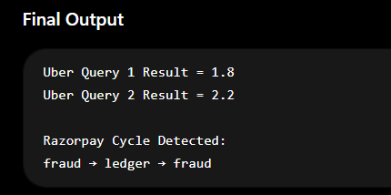

GitHub Link:- https://github.com/uppusonu/3-SEM-DSA-2

Student Signature:- | Faculty Signature:-

