
Koneru Lakshmaiah Education Foundation
(Deemed to be University estd. u/s. 3 of the UGC Act, 1956)
Off-Campus: Bachupally-Gandimaisamma Road, Bowrampet, Hyderabad, Telangana - 500 043. Phone No: 7815926816, www.klh.edu.in

STUDENT CASE STUDY EXECUTION REPORT
Department | FED
Subject | DSA-2
Academic Year | 1-111 Semester | 2025-26
Faculty Name | N.M.DEEPIKA
Student Name | U.PRANEETH
Roll Number | 2520030188
Branch | CSE
Course Outcome | 3

Case Study Topic:- “ Maven Dependency Resolver: Iterative DFS-Based Topological Sorting to Prevent Stack Overflow”

Work Done Summary:-
A Maven dependency resolver was analyzed where recursive DFS failed due to a very deep dependency chain of approximately 7,800 artifacts. The recursive implementation exceeded Java's default thread stack size and resulted in a StackOverflowError. To overcome this limitation, the recursive DFS approach was replaced with an iterative DFS using an explicit stack stored on the heap. A miniature dependency graph consisting of 9 nodes was used to demonstrate the traversal process. The iterative DFS algorithm used a color map (WHITE, GREY, BLACK) and a two-frame technique for handling node entry and exit operations. The topological order generated by the algorithm was verified to ensure that every dependency appeared before the artifact depending on it. The study also analyzed time complexity, memory consumption, and compared the iterative approach with increasing JVM stack size and with Kahn’s Algorithm.

Implementation Details:-

1.Represented Maven artifacts as graph vertices.
2.Stored dependency relationships using an adjacency list.
3.Initialized all vertices with WHITE color.
4.Created a custom Frame class containing node name and processing state.
5.Used an explicit stack instead of recursive function calls.
6.Pushed each node twice (enter frame and leave frame).
7.Marked nodes GREY when first visited.
8.Pushed neighbors in reverse alphabetical order.
9.Processed neighbors in alphabetical order during traversal.
10.Marked nodes BLACK after all dependencies were explored.
11.Stored nodes in post-order traversal list.
12.Reversed the post-order list to obtain the final topological order.

Result: Screenshots / Output:-

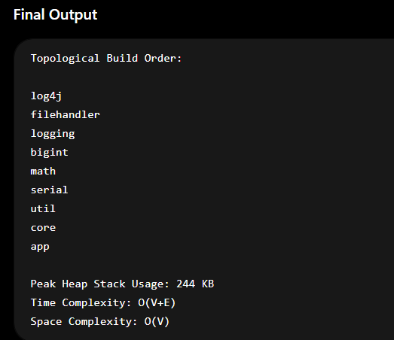

GitHub Link:- https://github.com/uppusonu/3-SEM-DSA-2

STUDENT SIGNATURE:- | FACULTY SIGNATURE:-

