GENAI & AGENTIC AI ENGINEERING · DAY 3 · HOMEWORK
The Content Engine Pro
Extend your lab engine into a full creative pipeline — with critique, iteration, and a new modality.
🌙 ~2–3 hours 🧩 Extend the lab code 🛠 Add at least two new capabilities 🚫 No new scaffold

WHAT’S NEW — A LEVEL UP FROM THE LAB
In the lab you built the engine — five AI calls, one button. Tonight you make it smarter: a self-critique loop that catches weak output, a new modality (voiceover), and a multi-channel adaptation. This is the step from prototype to production-aware system.

 | Content Engine · lab | Content Engine Pro · homework
What you build | Five AI calls, scaffold provided | Extended engine + critique + voiceover + adaptation
Quality control | Peer review at the end | AI self-critique loop catches weak output automatically
Modalities | Text + Image + Video | Text + Image + Video + Audio

The objective
In one sentence Take your lab Content Engine and add three capabilities: (1) an AI self-critique that grades and regenerates weak output, (2) a voiceover from the blog intro, and (3) a multi-channel adaptation that reshapes the suite for a different audience.

In the lab you built the prototype. Tonight’s homework is the production upgrade: what happens when output isn’t good enough? What if the client wants audio? What if the same campaign targets a different audience?

What it looks like
Your extended app adds three new panels below the generated suite: a self-critique verdict, a voiceover player, and a channel adaptation dropdown with live preview.

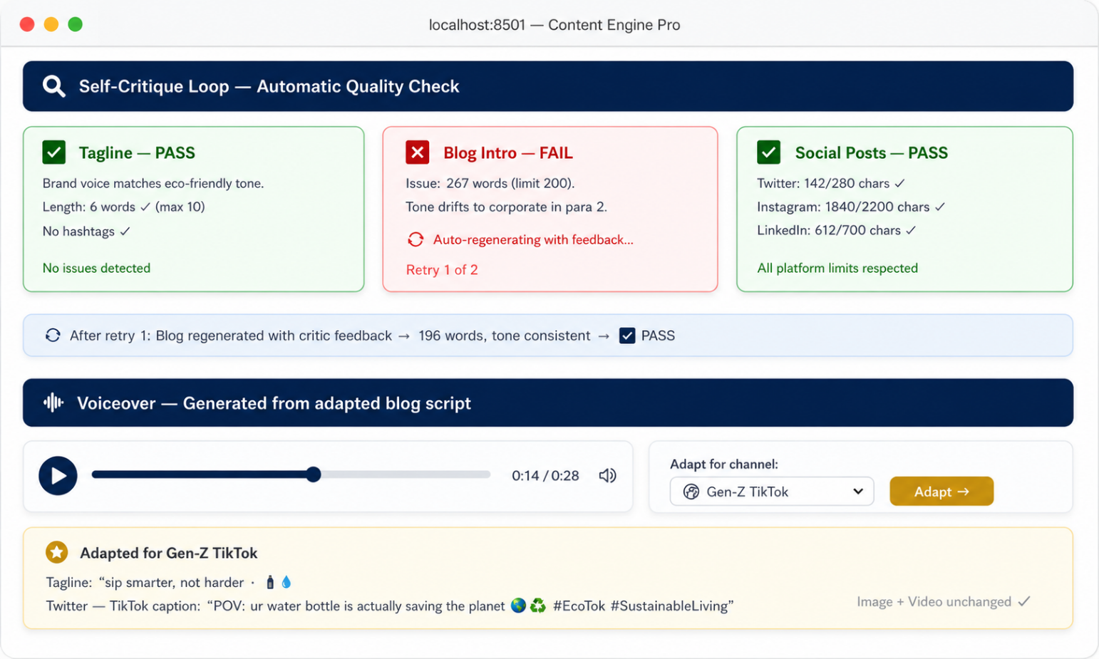
The Content Engine Pro: a self-critique loop catches a too-long blog intro and auto-regenerates it. Below, a voiceover plays from the adapted script, and a Gen-Z TikTok adaptation rewrites the text assets while keeping visuals unchanged.
The three additions
Addition 1 — The Self-Critique Loop
A critic prompt examines tagline, blog, and social posts against the brief. If any fail, auto-regenerate with feedback injected. Max 2 retries.
CRITIC_SYSTEM = """
You are a senior content strategist reviewing campaign copy.
Grade each asset: { \"tagline\": { \"pass\": bool, \"issue\": string|null },
\"blog\": { \"pass\": bool, \"issue\": string|null },
\"social\": { \"pass\": bool, \"issue\": string|null } }
Fail if: tone mismatch, audience ignored, length exceeded,
or product description contradicted.
"""

Addition 2 — Voiceover Generation
A “script adapter” prompt adds punctuation cues, then TTS generates audio. Display a player.
SCRIPT_ADAPTER = """
Rewrite this blog intro as a voiceover script.
- Add commas for breath pauses, ellipses for dramatic pauses.
- Short sentences (max 15 words each).
- Remove visual references. Output text only.
"""

Addition 3 — Multi-Channel Adaptation
A dropdown (B2B LinkedIn, Gen-Z TikTok, Parents Facebook) rewrites all text assets for the new channel. Image and video stay unchanged.
ADAPT_SYSTEM = """
Rewrite these three assets for {channel}:
1. Tagline: {tagline} 2. Blog: {blog} 3. Social: {social_json}
Adapt tone, vocabulary, emoji for the target channel.
Return JSON with the same three keys.
"""

The rules
• The self-critique loop runs automatically before output is shown. Max 2 retries. Show a warning flag if it still fails.
• The voiceover must be playable in the app or saved as .mp3.
• Channel adaptation rewrites text only — image and video stay unchanged.
• Run on at least two products; capture output including critic verdicts.
• Handle one bad input gracefully (empty name, nonsensical audience).
• Write one paragraph: which addition was hardest and what retrieval (Day 4) or agents (Day 6) would fix.

Why this is the step from prototype to production
A prototype generates output. A production system validates (the critic), serves multiple formats (voiceover), and adapts to context (channel). Day 5 formalises this as evaluation, memory, and observability.

Stretch goals
A/B testing with LLM-as-judge. Two versions of each text asset; a separate LLM judges which is better.
Campaign brief PDF. Export the entire suite as a formatted PDF deck.
Cost tracker. Log token counts and estimated costs per call. Display total.
Multilingual. Regenerate all text in a selected language.
What to submit
• Extended code with clear comments marking each addition.
• Two captured runs: critic verdicts, voiceover audio, and at least one channel adaptation.
• One-paragraph reflection on the hardest addition and what RAG or agents would improve.

GenAI & Agentic AI Engineering · Student Programme · Day 3 Homework — The Content Engine Pro

