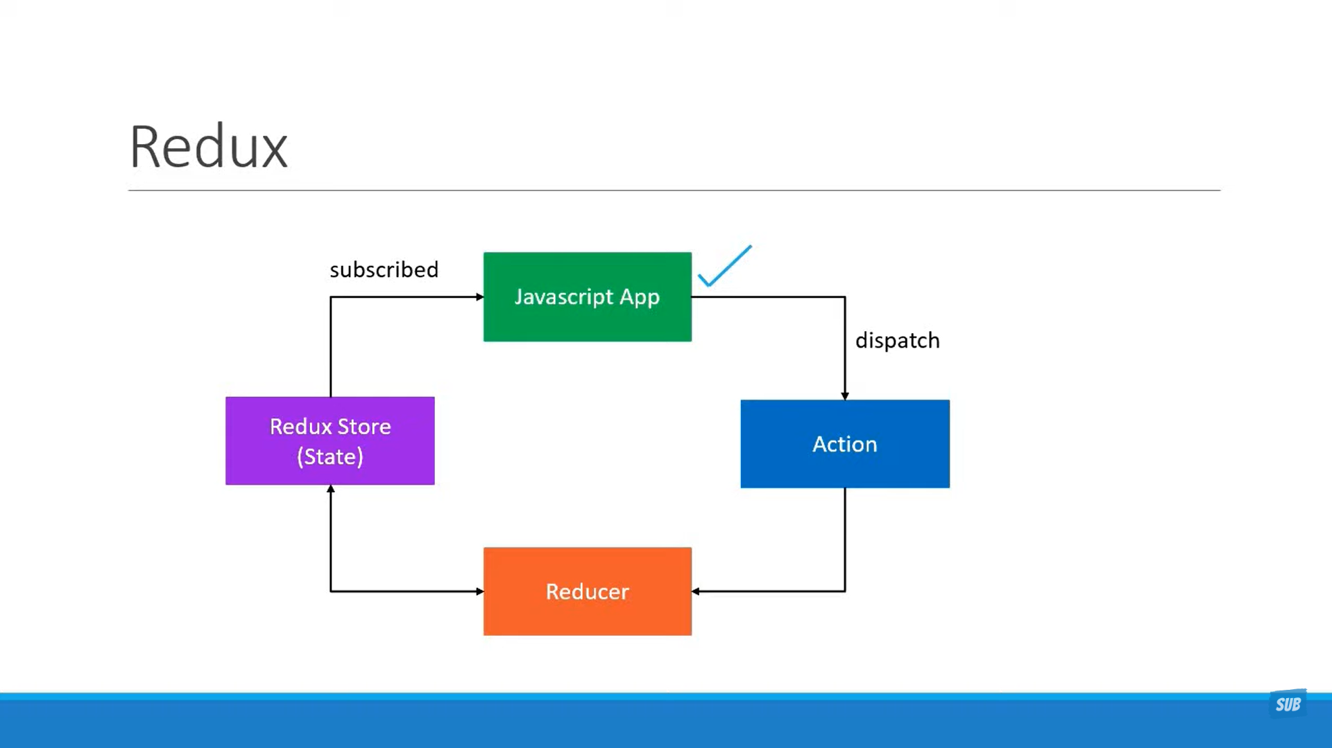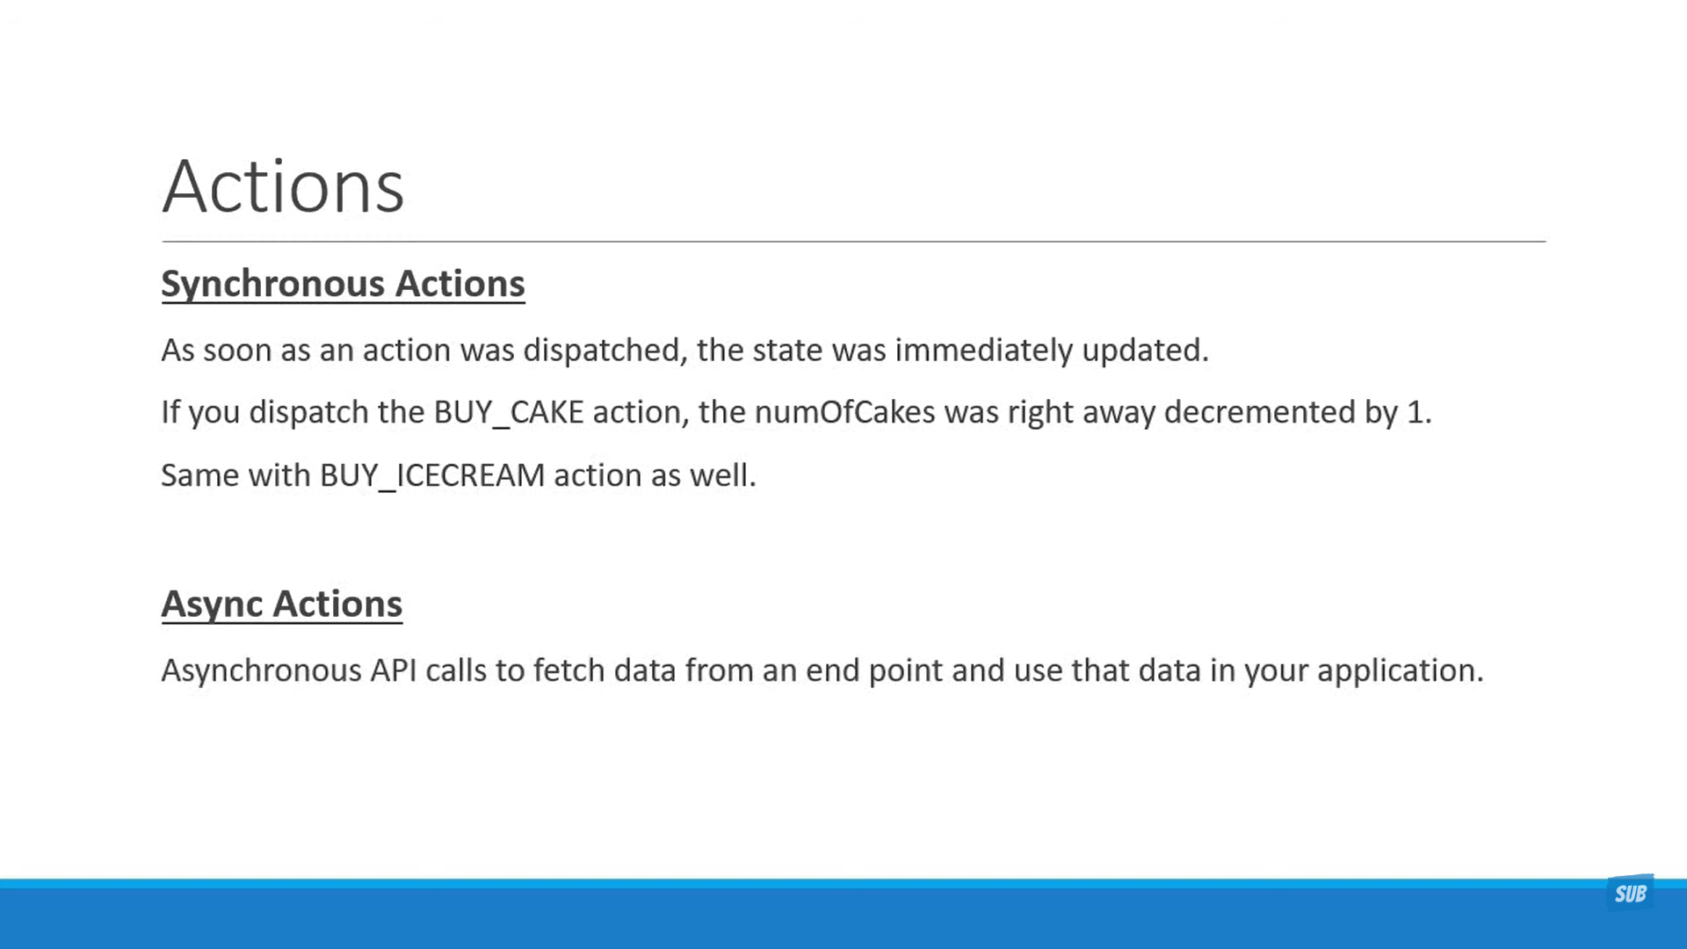

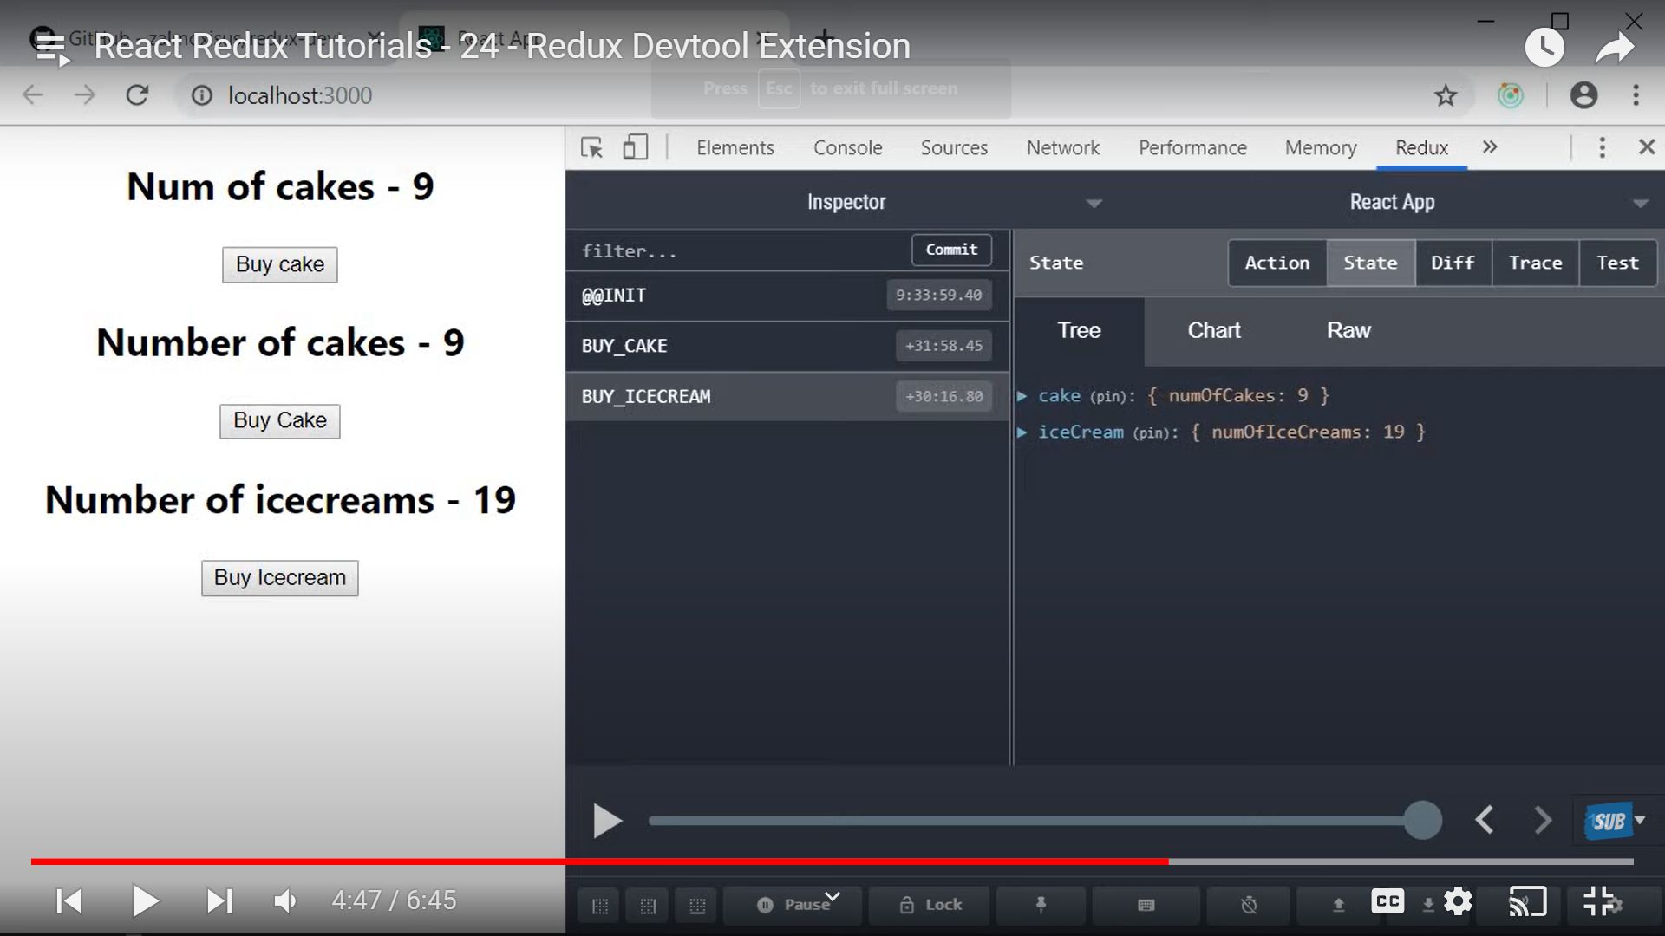https://github.com/zalmoxisus/redux-devtools-extension

