 | CLUB PROTOCOL  Roles, Responsibilities & Governance  NFC Nürnberg · Adopted: 26/07/2026 · Version 1.0

1. Purpose of This Protocol
This protocol defines how the club is organized and run. It sets out the club's mission, membership expectations, the roles that keep the club functioning, and the decision-making processes that apply to day-to-day and major decisions alike. It exists so that every member — new or long-standing — knows who is responsible for what, and how the club operates.

2. Mission and Values

2.1 Mission
The club exists to bring people together around a shared sporting and community activity, providing a structured, welcoming, and well-run environment for members to train, compete, and connect.

2.2 Core Values
- Respect — for teammates, opponents, officials, and volunteers.
- Commitment — showing up prepared and following through on responsibilities.
- Fairness — decisions are made consistently and communicated openly.
- Community — the club is a shared space, run for the benefit of its members.
- Accountability — every role carries clear duties, and role-holders are answerable for them.

3. Membership

3.1 Categories of Membership
- Active Member — regularly participates in training, matches/events, and club activities; full voting rights and priority for selection.
- Supporting Member — contributes to the club (financially or otherwise) without regular active participation; may join activities as space allows.
- Guest/Trial Member — attends on a temporary basis to assess fit, subject to the same conduct standards as full members.

3.2 General Member Expectations
- Attend regularly and communicate absences in advance through the agreed channel.
- Pay dues and fees on time, as set out in the club's finance rules.
- Treat teammates, opponents, officials, and the venue with respect.
- Follow the decisions of role-holders acting within their responsibilities.
- Raise concerns constructively through the appropriate role or at a club meeting.

4. Member Involvement in Friendly Games and Tournaments
Membership should stay open to anyone willing to commit to regular training and matches, rather than gated by skill level — this fits a semi-competitive, development-focused club. In practice this works as three tiers: Active members are the core, train regularly, pay dues, and are available for selection. Supporting members contribute without regular attendance and are not first in line for matches. New people enter through a short trial period as guests before being confirmed as active or supporting members, so both sides can assess fit before any commitment is locked in.

4.1 Friendly Games
Friendlies are the right place to be flexible — they are low-stakes and useful for development, so this is where the club can rotate lineups, give trialists real minutes, and let newer or less experienced members build match fitness.
- Active members get first claim on a spot.
- The Captain/Coach can fill remaining spots with supporting members, trialists, or external guests when numbers are short.
- Friendlies double as an evaluation ground — decide in advance how many friendlies a trialist play before a membership decision is made (e.g., 2–3 sessions).

4.2 Tournaments
Tournaments should be reserved for active, registered members only — this protects the competitive integrity of the team and keeps active membership meaningful.
- Selection stays anchored to attendance first, then effort and performance.
- Selection is decided jointly by the Coach and Captain.
- Squad lists are communicated with enough lead time for people to arrange availability.
- Guests and supporting members do not play tournament matches, since active membership carries both the obligations (dues, attendance) and the privileges (competitive selection).

4.3 Quick Reference
Membership Tier | Friendly Games | Tournaments
Active Member | Yes — priority selection | Yes — eligible, subject to selection
Supporting Member | Yes — if space allows | No, unless upgraded to Active
Guest / Trial | Yes — as needed, esp. for evaluation | No

4.4 Fast-Track Membership for Skilled Recruits
The club may actively recruit strong players through friendlies, trials, or personal networks. Talent can shorten the path to Active Membership, but it does not replace it — every player, however skilled, becomes tournament-eligible the same way: by becoming an Active Member first. This keeps selection fair and protects trust with members who have trained consistently.
- Recruitment: the Coach or Captain may actively invite promising players to friendlies or trial sessions rather than waiting for them to apply.
- Compressed evaluation: a skilled recruit's trial window may be shortened from the standard 2–3 friendlies (e.g., to 1–2 sessions) when fit is clearly established sooner — but the evaluation step is never skipped entirely.
- Same finish line: once evaluation is complete, the recruit becomes an Active Member with the same obligations as anyone else (dues, attendance, conduct) before being eligible for tournament selection.
- No shortcuts around attendance: a recruit cannot be entered into a tournament squad ahead of the standard Active Membership process, regardless of ability.
- Transparency: any accelerated trial should be visible to the Committee, not a private arrangement between the recruit and a single role-holder.
If the club wants an explicit exception allowing external guest players in specific high-stakes tournaments, that requires a formal protocol amendment under Section 9, approved by majority member agreement — not an informal exception to this section.

5. Governance Structure
The club is led by a Committee made up of the role-holders described in Section 6. The Committee is responsible for the club's overall direction; individual roles carry authority over their specific area. Major decisions affecting all members (large expenses, rule changes, membership fee changes) require Committee discussion and, where noted, member consultation.

5.1 Decision-Making Levels
- Routine decisions — made independently by the relevant role-holder within their area (e.g., training plans, minor purchases).
- Committee decisions — require agreement among Committee members (e.g., match/event calendar, disciplinary matters, moderate expenses).
- Club-wide decisions — require member consultation and majority agreement (e.g., changes to this protocol, membership fees, large expenditures).

5.2 Meetings
- Committee meets regularly (e.g., monthly) to review club matters.
- A general member meeting is held at least once or twice a year to review the season, finances, and any protocol changes.
- Minutes or a short summary should be shared with members after each meeting.

6. Club Roles and Responsibilities
Each role below has a defined scope. Roles may be combined in smaller clubs, and titles can be adapted, but the underlying responsibilities should always be assigned to someone so nothing falls through the cracks.

6.1 Roles at a Glance
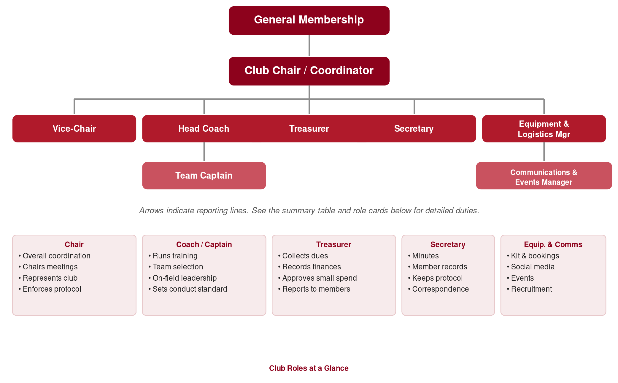
Figure 1. Reporting lines and core duties for each role, at a glance.

6.2 Detailed Role Descriptions

Club Chair / Coordinator
Reports to: General Membership
Holds overall responsibility for the club's organization, direction, and day-to-day coordination. Acts as the central point of contact and chairs Committee meetings.
- Coordinates the Committee and chairs regular meetings
- Sets and communicates the club calendar in coordination with other roles
- Ensures the club's rules and this protocol are followed and kept up to date
- Represents the club in external matters (venues, leagues, other clubs)
- Mediates disputes and escalates disciplinary matters to the Committee when needed

Vice-Chair / Deputy Coordinator
Reports to: Club Chair
Supports the Chair and steps in when the Chair is unavailable. Often takes on a specific focus area agreed with the Committee.
- Deputizes for the Chair at meetings and events when required
- Supports coordination of a specific area (e.g., membership, competitions)
- Helps onboard new Committee members and new club members

Head Coach / Trainer
Reports to: Club Chair
Responsible for the sporting and technical development of the club. Owns training content and has final say on team selection alongside the captain.
- Plans and runs training sessions
- Designs drills and monitors individual and team development
- Gives feedback to members on performance and progress
- Leads team selection decisions together with the captain
- Sets standards for conduct and effort during training and matches

Team Captain
Reports to: Head Coach
The on-field leader and link between members and the Committee. Represents the playing group's voice in club decisions.
- Leads the team during matches and events
- Co-decides team selection with the Coach
- Maintains discipline, morale, and team spirit
- Raises player concerns or feedback with the Committee

Treasurer
Reports to: Club Chair / Committee
Manages all club finances and ensures transparency in how funds are collected and spent.
- Collects membership fees and dues on schedule
- Records all income and expenses
- Approves routine, low-value expenses within agreed limits
- Shares regular financial updates with members
- Flags any budget concerns to the Committee

Secretary
Reports to: Club Chair / Committee
Keeps the club's administrative records and communications organized.
- Takes and distributes minutes from Committee and member meetings
- Maintains the membership list and contact details
- Keeps this protocol and any policy documents up to date
- Handles official correspondence (venues, leagues, insurers)

Equipment & Logistics Manager
Reports to: Club Chair
Ensures the club has what it needs, where it needs it, when it needs it.
- Manages kit, equipment, and supplies
- Ensures equipment is available and in good condition for training/matches
- Coordinates venue or field bookings
- Organizes transport or logistics for away matches/events where needed

Communications & Events Manager
Reports to: Club Chair
Owns the club's public presence and internal communication and helps organize social/community events.
- Manages social media and group chat announcements
- Shares results, highlights, and updates with members
- Supports recruitment of new members
- Organizes team activities and community events alongside the Committee

7. Conduct and Discipline
All members and role-holders are expected to always uphold the club’s values. Breaches of conduct are handled proportionately and fairly.
- First instance — verbal reminder from the relevant role-holder (Coach, Captain, or Chair).
- Repeated or serious issues — reviewed by the Committee; may result in temporary exclusion from matches/events.
- Severe or repeated misconduct — may result in suspension or removal from the club, decided by Committee vote.
Members have the right to explain their side before a disciplinary decision is finalized.

8. Finance
- Dues and fees are set by the Committee and communicated clearly to all members.
- The Treasurer records all transactions and shares updates on a regular schedule.
- Expense approval thresholds (e.g., small / moderate / major) should be defined in a separate finance policy or Section 8.1 below.

8.1 Expense Approval Thresholds (example — adapt to club size)
- Small expenses: approved directly by the Treasurer.
- Moderate expenses: approved by the Treasurer and Chair together.
- Major expenses: require Committee discussion and member notice.

9. Amending This Protocol
This protocol is a living document. Proposed changes should be brought to a committee meeting or general member meeting, discussed, and adopted by majority agreement. The Secretary is responsible for updating the document and version number and communicating the change to all members.
Version history: v1.0 — 26/07/2026 — Initial adoption.

