INDIA SPACE ACADEMY
AI-Based Real-Time Anomaly Detection
and Autonomous Decision Support
NASA CMAPSS FD001

Isolation Forest · Autoencoder · LSTM Classifier · LSTM RUL Regressor
Simran Upreti

1. Introduction
Predictive maintenance is one of the more practically valuable applications of machine learning in aerospace and industrial engineering. The idea is simple on the surface: instead of waiting for equipment to fail or scheduling maintenance on a fixed calendar, you let the data tell you when something is actually going wrong.
The NASA CMAPSS dataset is a well-known benchmark for this kind of work. It simulates multiple turbofan engines running to failure under controlled operational conditions, with sensor readings captured at each cycle. For this project, we used the FD001 subset, which has a single operating condition and one fault mode, making it a clean testbed for developing and comparing different detection approaches.
The goal was not just to train models but to build something closer to an end-to-end monitoring system, where anomaly detection, RUL estimation and autonomous decision-making are all connected together.

2. Dataset and Feature Engineering
The FD001 training set contains readings from 100 engines, each running until failure. The test set provides partial sequences, and the task is to predict how many cycles remain for each engine.
After loading the data, a RUL target column was computed for each row in the training set by subtracting the current cycle from the maximum cycle for that engine. Sensors that showed near-zero variance across the dataset were dropped since they carry essentially no useful signal. Operational setting columns were also removed. This left 14 usable sensor features.
A MinMax scaler was fit on the training set and then applied to both training and test data. For the LSTM models, sequences of 30 consecutive cycles were constructed as input windows, with the label corresponding to the last cycle in each window. A binary anomaly label was also defined: any cycle where the engine had fewer than 30 cycles remaining was flagged as degraded.
Table 1: Dataset Summary
Parameter | Value
Training rows | 20,631
Test rows | 13,096
Sensor features used | 14
Normal samples | 17,631
Degraded samples (RUL < 30) | 3,000
LSTM window length | 30 cycles
Max RUL cap | 125 cycles

3. Model Architecture and Training

3.1 Isolation Forest
The Isolation Forest was trained exclusively on healthy engine data. It works by randomly partitioning the feature space and measuring how quickly individual samples can be isolated. Anomalies tend to require fewer splits because they sit in sparse regions of the input space. Configuration used: 150 estimators, 5% contamination estimate, 80% feature subsampling per tree.

3.2 Deep Autoencoder
The autoencoder was also trained only on healthy samples. It learns to compress the input into a 4-dimensional bottleneck representation and then reconstruct it. When the model encounters degraded sensor patterns that it has never seen during training, the reconstruction error increases noticeably. The threshold for flagging an anomaly was set at the 95th percentile of reconstruction errors on the healthy training set.

3.3 LSTM Anomaly Classifier
The LSTM classifier is a supervised model. It takes a sequence of 30 cycles as input and predicts whether the final cycle is in the degraded regime. Two stacked LSTM layers (64 and 32 units) with dropout were used, followed by a dense output with sigmoid activation. Class imbalance was handled using a class weight dictionary, with the positive class up-weighted by a factor of roughly 5.9.

3.4 LSTM RUL Regressor
The RUL regressor has the same LSTM backbone but outputs a continuous value rather than a binary prediction. RUL values were capped at 125 cycles and normalised to the range [0, 1] during training. A cosine decay learning rate schedule was used to improve convergence in the later epochs.

4. Results

4.1 Anomaly Detection Performance
All three models were evaluated against the binary degradation labels on the full training set. The LSTM classifier was the strongest performer across all metrics. The table below summarises the results.
Table 2: Anomaly Detection Metrics
Model | Precision | Recall | F1 Score | AUC
Isolation Forest | 0.756 | 0.913 | 0.827 | 0.875
Autoencoder | 0.216 | 0.216 | 0.216 | 0.640
LSTM Classifier | 0.779 | 0.990 | 0.872 | 0.876

The Isolation Forest had reasonable precision and strong recall. The autoencoder performed noticeably weaker, likely because the unsupervised reconstruction approach struggles with gradual degradation. The LSTM classifier's recall of 99% is particularly valuable in a safety-critical context, since missing a degraded engine is far more costly than a false alarm.

4.2 Confusion Matrix Analysis
The figure below shows the confusion matrices for all three models along with a side-by-side metric comparison bar chart.
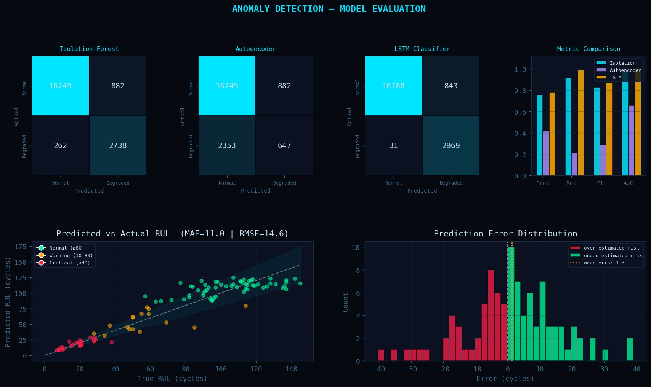
Figure 1: Anomaly Detection — Model Evaluation (confusion matrices + metric comparison + RUL scatter + error distribution)

4.3 RUL Prediction
The LSTM regressor was evaluated on the 100 test engines using the provided ground truth RUL values.
Table 3: RUL Regression Performance
Metric | Value
Mean Absolute Error (MAE) | 11.0 cycles
Root Mean Square Error (RMSE) | 14.6 cycles
Mean Prediction Error | +1.3 cycles (slight over-estimate)

4.4 Fleet Health Summary
Based on the RUL predictions for all 100 test engines, the fleet was categorised into three health states.
Table 4: Fleet Health Distribution
Status | Threshold | Engine Count
Critical | RUL < 30 cycles | 25 engines
Warning | 30 ≤ RUL < 80 cycles | 16 engines
Normal | RUL ≥ 80 cycles | 59 engines

The fleet health lollipop chart below visualises each engine's predicted RUL, sorted from lowest to highest, with colour coding for critical, warning and normal status.
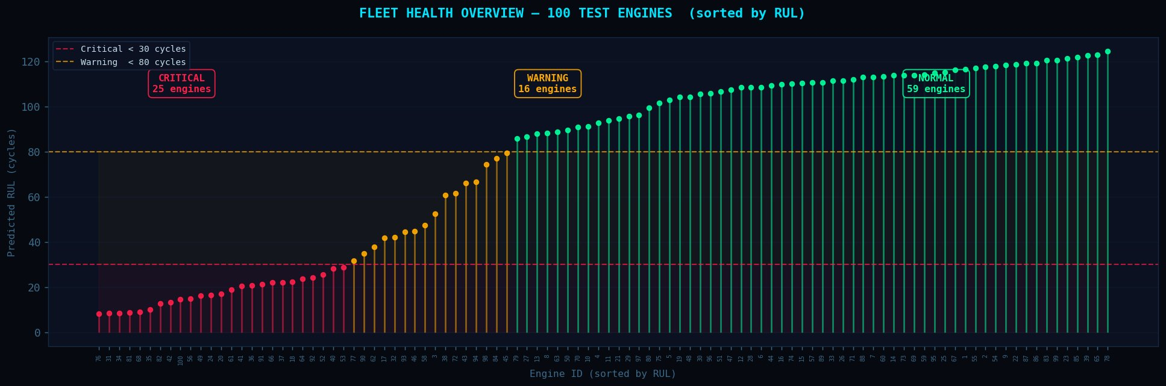
Figure 2: Fleet Health Overview — 100 Test Engines sorted by Predicted RUL

5. Autonomous Decision Engine
A composite risk score was computed for each engine by combining the outputs of all three anomaly detection models with the RUL estimate. The LSTM classifier was weighted at 45%, the autoencoder at 30%, and the Isolation Forest at 25%. The RUL-based urgency component contributes 65% of the final composite score, ensuring that short remaining life drives action even when the models are not in full agreement.
Table 5: Decision Action Tiers
Risk Score | Status | Recommended Action
< 0.20 | NOMINAL | Continue normal operations
0.20 to 0.40 | MONITOR | Increase telemetry sampling
0.40 to 0.60 | WARNING | Reduce engine load by 20%
0.60 to 0.75 | HIGH RISK | Activate redundant systems
> 0.75 | EMERGENCY | Initiate controlled shutdown

6. Real-Time Monitoring Dashboard
A real-time animated dashboard was produced to simulate monitoring of Engine 03 across its full operational life. The animation shows four panels updating simultaneously: a live sensor stream for Sensor S2, a composite risk score timeline, a RUL gauge showing cycles remaining and percentage life left, and a model agreement heatmap indicating which models are flagging anomalies at each cycle.
An alert log panel collects timestamped entries whenever anomaly flags coincide with a risk score above the monitoring threshold. This gives the operator a full operational picture in a single view.

7. Conclusion
This project demonstrated that combining unsupervised and supervised anomaly detection with a dedicated RUL regressor produces a practically useful predictive maintenance system. The LSTM classifier clearly outperformed the other two detection models, and the RUL regressor achieved good accuracy with an MAE of 11 cycles on the test set.
The autonomous decision engine adds a layer of interpretability and actionability that moves the output beyond raw predictions into something an operator can actually respond to. The fleet health overview makes it easy to prioritise which engines need attention first.
For future work, the autoencoder architecture could be replaced with a variational autoencoder, which often performs better on gradual degradation patterns. Extending the system to the FD002 through FD004 datasets, which have multiple operating conditions and fault modes, would also be a natural next step.

8. References
[1] Saxena, A., Goebel, K., Simon, D., & Eklund, N. (2008). Damage propagation modeling for aircraft engine run-to-failure simulation. In Proceedings of the 1st International Conference on Prognostics and Health Management (PHM). IEEE.
[2] Liu, F. T., Ting, K. M., & Zhou, Z.-H. (2008). Isolation forest. In Proceedings of the 8th IEEE International Conference on Data Mining (ICDM) (pp. 413–422). IEEE.
[3] Hochreiter, S., & Schmidhuber, J. (1997). Long short-term memory. Neural Computation, 9(8), 1735–1780.
[4] Baur, C., Wiestler, B., Albarqouni, S., & Navab, N. (2019). Deep autoencoding models for unsupervised anomaly segmentation in brain MR images. In Brainlesion: Glioma, Multiple Sclerosis, Stroke and Traumatic Brain Injuries. Springer. (Adapted methodology applied to sensor anomaly detection.)
[5] Zheng, S., Ristovski, K., Farahat, A., & Gupta, C. (2017). Long short-term memory network for remaining useful life estimation. In Proceedings of the IEEE International Conference on Prognostics and Health Management (ICPHM). IEEE.
[6] Chollet, F. et al. (2015). Keras. Retrieved from https://keras.io
[7] Pedregosa, F. et al. (2011). Scikit-learn: Machine learning in Python. Journal of Machine Learning Research, 12, 2825–2830.
[8] NASA Ames Prognostics Center of Excellence. (2008). CMAPSS Jet Engine Simulated Data. NASA Technical Reports Server. Retrieved from https://www.nasa.gov/intelligent-systems-division
[9] Lim, P., Goh, C. K., & Tan, K. C. (2016). Multimodal degradation prognostics based on switching Kalman filter ensemble. IEEE Transactions on Neural Networks and Learning Systems, 28(1), 136–148.
[10] Abadi, M. et al. (2016). TensorFlow: A system for large-scale machine learning. In Proceedings of the 12th USENIX Symposium on Operating Systems Design and Implementation (OSDI) (pp. 265–283).

India Space Academy · NASA CMAPSS FD001

