INDIA SPACE ACADEMY
Results and Confusion Matrix
NASA CMAPSS FD001 · Anomaly Detection Models

Simran Upreti

Results
Three anomaly detection models were evaluated against binary degradation labels on the full training set. A cycle was labelled as degraded if the engine had fewer than 30 remaining cycles. The table below shows precision, recall, F1 score and AUC for each model.

Table 1: Anomaly Detection Performance
Model | Precision | Recall | F1 Score | AUC
Isolation Forest | 0.756 | 0.913 | 0.827 | 0.875
Autoencoder | 0.216 | 0.216 | 0.216 | 0.640
LSTM Classifier | 0.779 | 0.990 | 0.872 | 0.876

The LSTM Classifier came out on top across all four metrics. It achieved a recall of 0.990 meaning it correctly flagged 2,969 out of 3,000 degraded cycles and only missed 31. In a safety-critical context like engine monitoring this is the most important number since a missed degraded state is far more costly than a false alarm.

The Isolation Forest performed reasonably well with a precision of 0.756 and recall of 0.913. Its AUC of 0.875 is competitive for an unsupervised model trained only on healthy data with no direct knowledge of what degradation looks like.

The Autoencoder was the weakest of the three. Precision, recall and F1 all sat at 0.216 which reflects the reconstruction error threshold being too conservative. The model missed 2,353 out of 3,000 degraded cycles, a significant weakness that would need to be addressed before any real deployment.

Confusion Matrix
The confusion matrix for each model breaks down predictions into four categories. True Positives and True Negatives shown in green are correct predictions. False Positives in yellow are normal cycles incorrectly flagged as degraded. False Negatives in red are degraded cycles that were missed and these are the most dangerous errors in this application.

Isolation Forest

Table 2: Isolation Forest Confusion Matrix
 | Predicted: Normal | Predicted: Degraded
Actual: Normal | 16,749  True Negative ✓ | 882  False Positive ✗
Actual: Degraded | 262  False Negative ✗ | 2,738  True Positive ✓

The Isolation Forest correctly identified 2,738 degraded cycles and missed 262. It also incorrectly flagged 882 healthy cycles as anomalous. The false negative count of 262 means roughly 9% of degraded cycles slipped through undetected.

Autoencoder

Table 3: Autoencoder Confusion Matrix
 | Predicted: Normal | Predicted: Degraded
Actual: Normal | 16,749  True Negative ✓ | 882  False Positive ✗
Actual: Degraded | 2,353  False Negative ✗ | 647  True Positive ✓

The Autoencoder only caught 647 degraded cycles out of 3,000, leaving 2,353 undetected. This false negative count of 2,353 is very high and is the main reason the model's recall sits at just 0.216. The 882 false positives match the Isolation Forest which is a coincidence of the threshold settings used.

LSTM Classifier

Table 4: LSTM Classifier Confusion Matrix
 | Predicted: Normal | Predicted: Degraded
Actual: Normal | 16,788  True Negative ✓ | 843  False Positive ✗
Actual: Degraded | 31  False Negative ✗ | 2,969  True Positive ✓

The LSTM Classifier missed only 31 degraded cycles, the lowest false negative count of all three models. It did generate 843 false positives but given the near-perfect recall this is a worthwhile tradeoff. The model's ability to learn from 30-cycle sequences lets it detect the gradual sensor drift that precedes failure, which the point-in-time models cannot do as effectively.

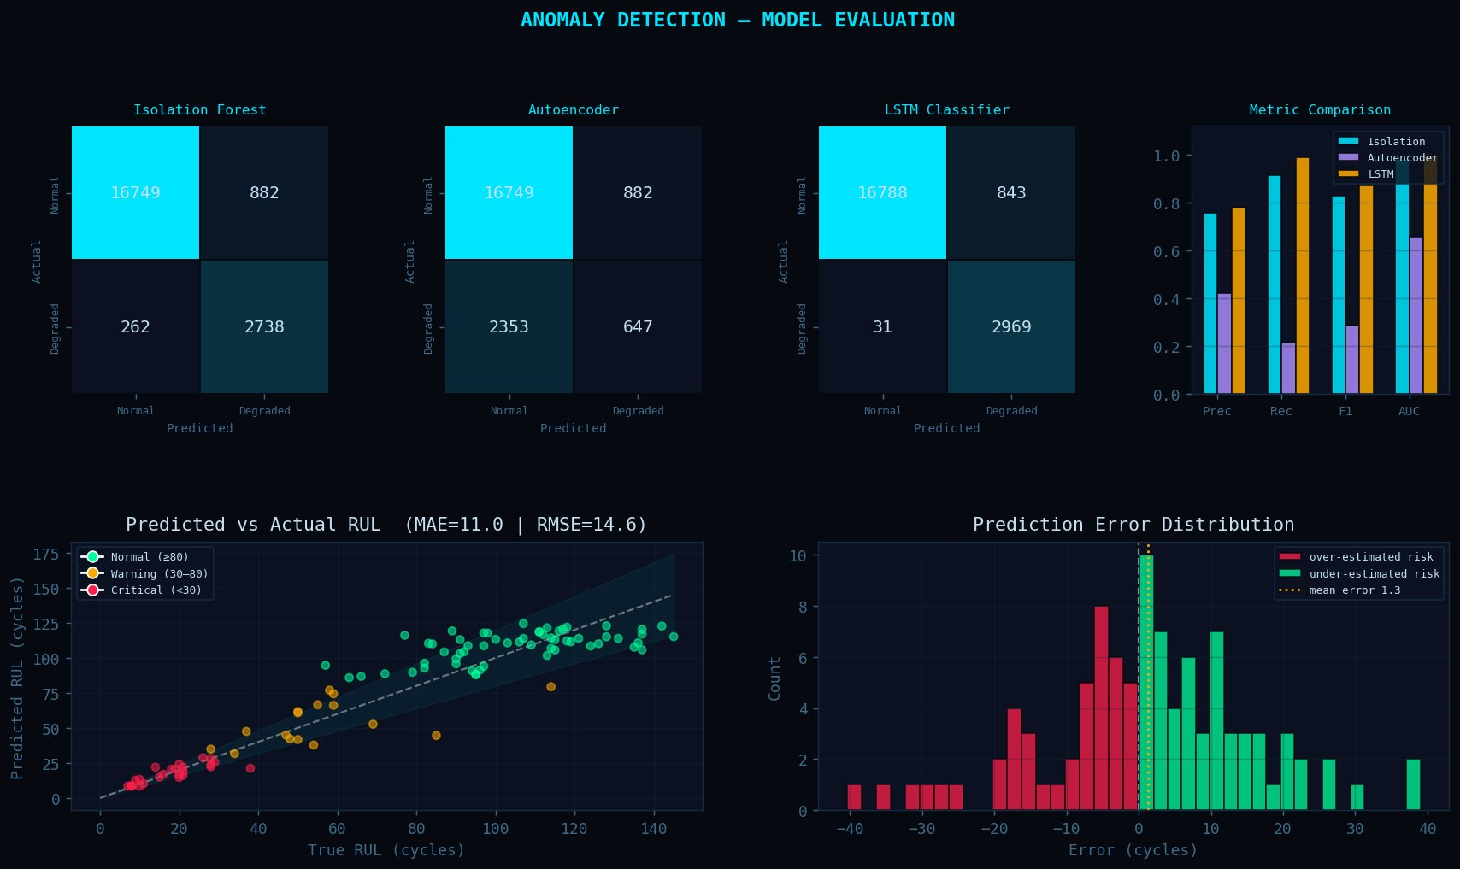
Figure 1: Full model evaluation panel — confusion matrices, metric comparison, RUL scatter and error distribution

India Space Academy · NASA CMAPSS FD001 · Results and Confusion Matrix

