**RUM EVENT HUB**

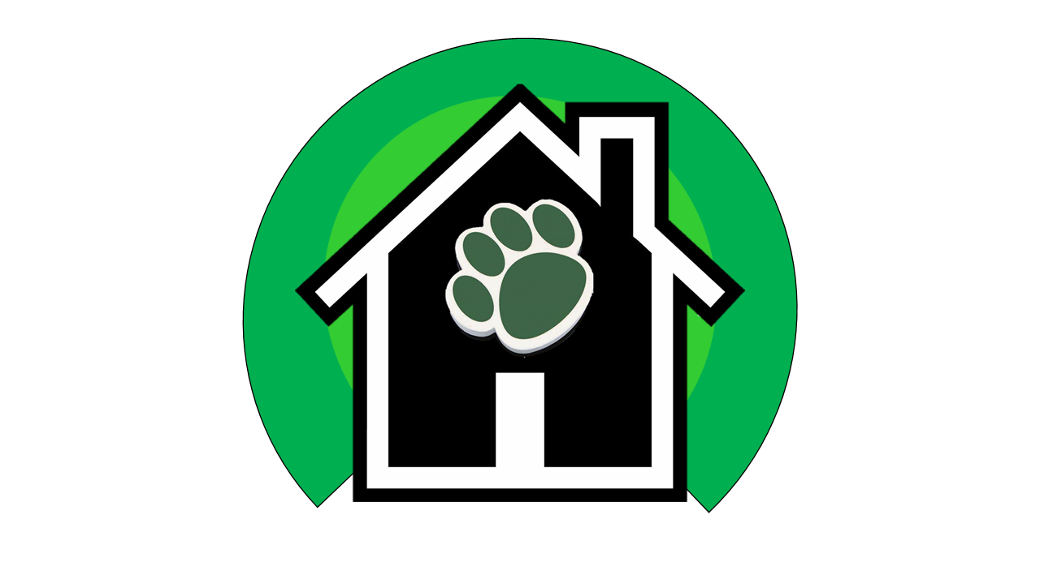

INSO4115-050

Professor Marko Schutz

14 Feb 2020

Yeniel Díaz Nieves Luis Rampolla Martínez

Javier Hernandez Novoa Valerie Reyes Ortiz

Christian López Martínez Gustavo Román Figueroa

Project Proposal:

February 14, 2020

**Name, place and date**

* RUM Event Hub, University of Puerto Rico at Mayagüez, February 14, 2020

**Current situation**

UPRM students face a hard time keeping up with the numerous UPRM events and, which might lead to missing the ones they deem important. Currently, events held within the university are usually promoted through various means, for example, “Cartero” which is the primary means for communication for all university students, with capabilities like filtering students and emailing them in bulk to inform them about current events. This approach causes emails detailing events to conflict with other emails that are sent out simultaneously. In turn, it makes keeping up with or even recognizing events of interest contained within these emails difficult for a student.

Alternatively, students find out about events through the different student association’s social media platforms and group chats. This approach delivers the desired result, but the student is forced to bounce between associations accounts and chats to attain the desired information. Lastly, there is the traditional method where events and activities are delivered via word of mouth; either by other students in and out of campus or by the professors themselves.

**Needs**

* A platform to show future/past UPRM events in a structured and organized way
* Standardize event management and accessibility for students and professors alike
* Facilitate event marketing to increase UPRM event attendance
* Expand event broadcasting without over saturating the users

**Ideas**

* A web app that UPRM organizations can use to create, update, search, and delete events
* This would also serve as a platform where users can view all university events

**Concepts**

* User - Person that utilizes our web app
* Event - Planned social occasion by association or any other organization type
* Association - Organization managed by students at a university or college institution
* Capacity - Quantity of people that can fit in the room where the event will be hosted
* Tags - Categories in which the event falls in, which will be used to filter, sort, and search
* Location - The room or specific area where the event will be situated
* Private event - Event that is only available to members of a specific organization
* Paid event - Event that has an entrance fee

**Scope**

The management of events that take place in UPRM.

**Span**

The process in which organizations create and share the information for their events and how students track them.

**Synopsis**

Our objective is to develop a system that will let organizations post and manage their upcoming events on campus and to let students have a place to see them all and track them.

**Assumptions and dependencies**

Every event on our platform has been approved by the “UPRM Departamento de Actividades Sociales y Culturales”. It is assumed that an association representative or department official will not only be available if there ever needs to be a clarification on part of the domain or the understanding of it, but they will also give a sufficient answer. Any company or resource outside of the UPRM must be affiliated with an association within the UPRM to market their event through our platform.

**Implicit/derivative goals**

Serve as a viable alternative for associations marketing events and for students tracking them.

**Stakeholders**

* UPRM Students
* UPRM Departamento de Actividades Sociales y Culturales (<https://www.uprm.edu/p/actividades-sociales/vision_y_mision>)
* UPRM Event promoters (professors, students, recruiters, etc.)

**Requirements / User Stories**

* As an unregistered user, I want to visit the app main page and learn about what the app can do
* As an unregistered user, I want to create a new account either as a regular user or as an association
* As a registered user, I want to login with my credentials
* As an unregistered user, I want to search for specific events based on categories
* As a user with an association account, upong login I will be led to a dashboard for the association where I want to see the list of upcoming events with their details
* As a user with an association account, from the dashboard I want to edit, delete or add an event to the association’s calendar
* As a registered user, I want to “ping” the events I am interested in
* As a user, I want to give feedback to the event coordinator

**Logbook**

* First group meeting on 27 Jan 2020; discussed initial A3s
* Group meeting on 29 Jan 2020; further discussed group project and went through preliminary project selection/proposal work
* Group meeting on 10 Feb 2020; worked on proposal and engaged in further brainstorming
* Final group meeting on 12 Feb 2020; discussed final stages of the proposal