# 

# **The University of Puerto Rico at Mayagüez**

# **Department of Engineering**

# **Software Requirements-4115**

# 

# 

# 

# 

# 

# 

# 

# 

# 

# **Project Proposal: Cine QR**

# 

# 

# 

# 

# 

# 

# 

# 

# 

# 

# 

# 

# 

# 

# **Javier D. Bustillo Hernandez**

# **Cristian A. Alapont Hernandez**

# **Armando Leon Gonzalez**

# **Moises A. Garip Barreiro**

# **César A. Justiniano Santiago**

# **Gabriela A. Santiago Cintron**

# Problem

When going to the movie theatre to watch a movie. You currently have two options of acquiring a ticket:

1. You can buy it online and then pick it up at a kiosk
2. You can go to the booth and buy a ticket

Both of these options have one bottleneck. They rely on the usage of a physical ticket to enter the theatre. If you lose this ticket, you have no way of proving you had one because the ticket itself is the receipt.

# Idea

Almost everyone nowadays carries with them a portable lightweight computer known as a smartphone. This smartphone has a camera and the ability to store data and access the internet. So what we’re proposing is an application that allows the user to scan a QR code located on their physical ticket (or some monitor) to digitize the ticket and that way not having to rely on the bottleneck that is human responsibility .

# Domain

### Stakeholders

* Customers
* Ticket booth clerk
* Movie theater manager
* Usher
* Movie theater owner

### Domain Description

### A movie theater is a place where people can go and enjoy a good time with family and friends while watching the most recent films that have been released on the market, or they can go to the arcade and play some games. It also has an area where they sell snacks like popcorn, nachos and cheese, candies, and many other things.

### Scope & Span

**Scope:**

The problem in general is that movie theaters are using an outdated ticketing system that lacks efficiency and insurance for the customer. The current system may lead to customer dissatisfaction.

**Span:**

Recently smartphones have been an essential part of many people's lives. Is where they keep most of their personal information, so why not keep their movie ticket there too?, and it’s not a thin piece of paper that can be lost at any time, which may lead to the customer losing the movie or having to buy another physical ticket. By introducing the idea proposed above, it would give customers a more reliable way of handling a ticket and an additional way of buying a ticket avoiding many hassles.

# User Stories

* As a customer, I want to have a digital version of my ticket so that I don't need to worry about not being able to enjoy the movie I paid for, in case I lose my ticket.
* As a customer, I want to be able to manage multiple digital tickets in case I need to purchase for another customer.
* As an usher, I want movie-goers to have easily identifiable digital tickets so that I may direct customers to their corresponding movie room.
* As an usher, I want digital tickets to be verifiable to avoid accidentally allowing entrance to a forged ticket.
* As a movie theatre owner, I want customers to be able to quickly verify their tickets to avoid waiting line congestion.
* As a movie theatre owner, I want digital tickets to appropriately expire to avoid unpaid reuses.

# Design

### State Charts

### 

### 

### 

### 

### 

### 

### 

### 

### 

### Architecture

### 

### There will be two client mobile applications. These clients will be written using SRI (Scala React Interface), an interface for react native using Scala. These clients will communicate with a REST API developed in Scala using akka. This API will communicate with a database using postgresql.

### Client-server interaction

### 

### 

### 

### 

### 

### 

### 

### 

### 

### ER Diagram

### 

### Modules

### 

### 

1. Routes: is able to call and has access to Handler’s classes and functions
2. Handlers: can call and has access to Model’s classes and functions
3. Models: has access into the Database and its properties

Routes:

* /users
* /users/match

Handlers:

* UserHandler

Models:

* Tickets
* Theaters
* Movie

### 

### 

### 

### 

### 

### Wireframe

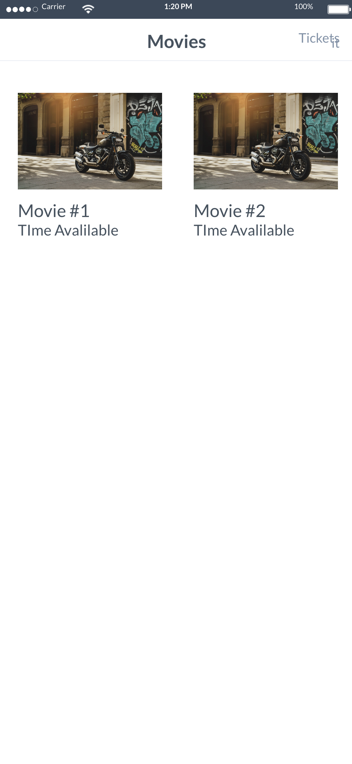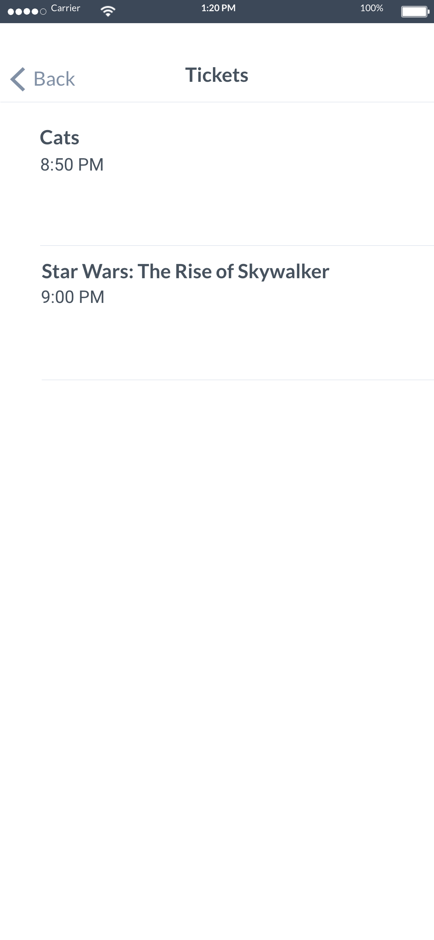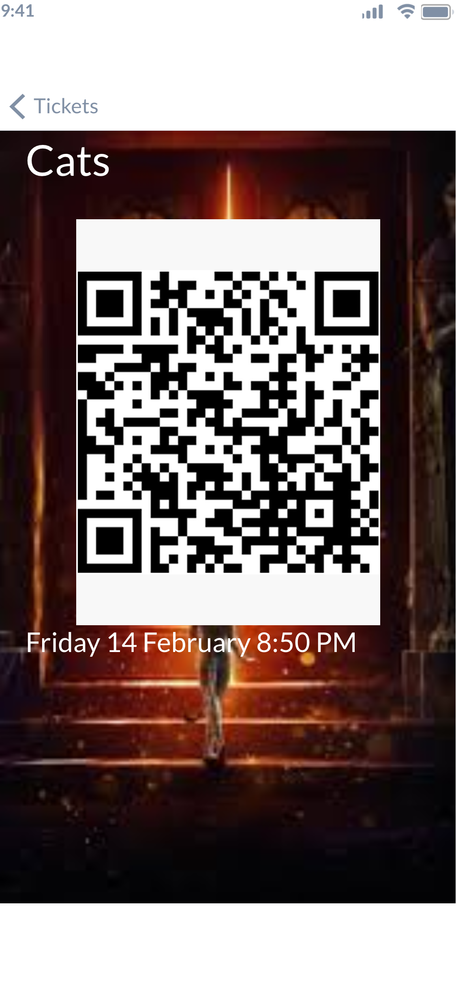

List of Movies List of tickets Ticket Detail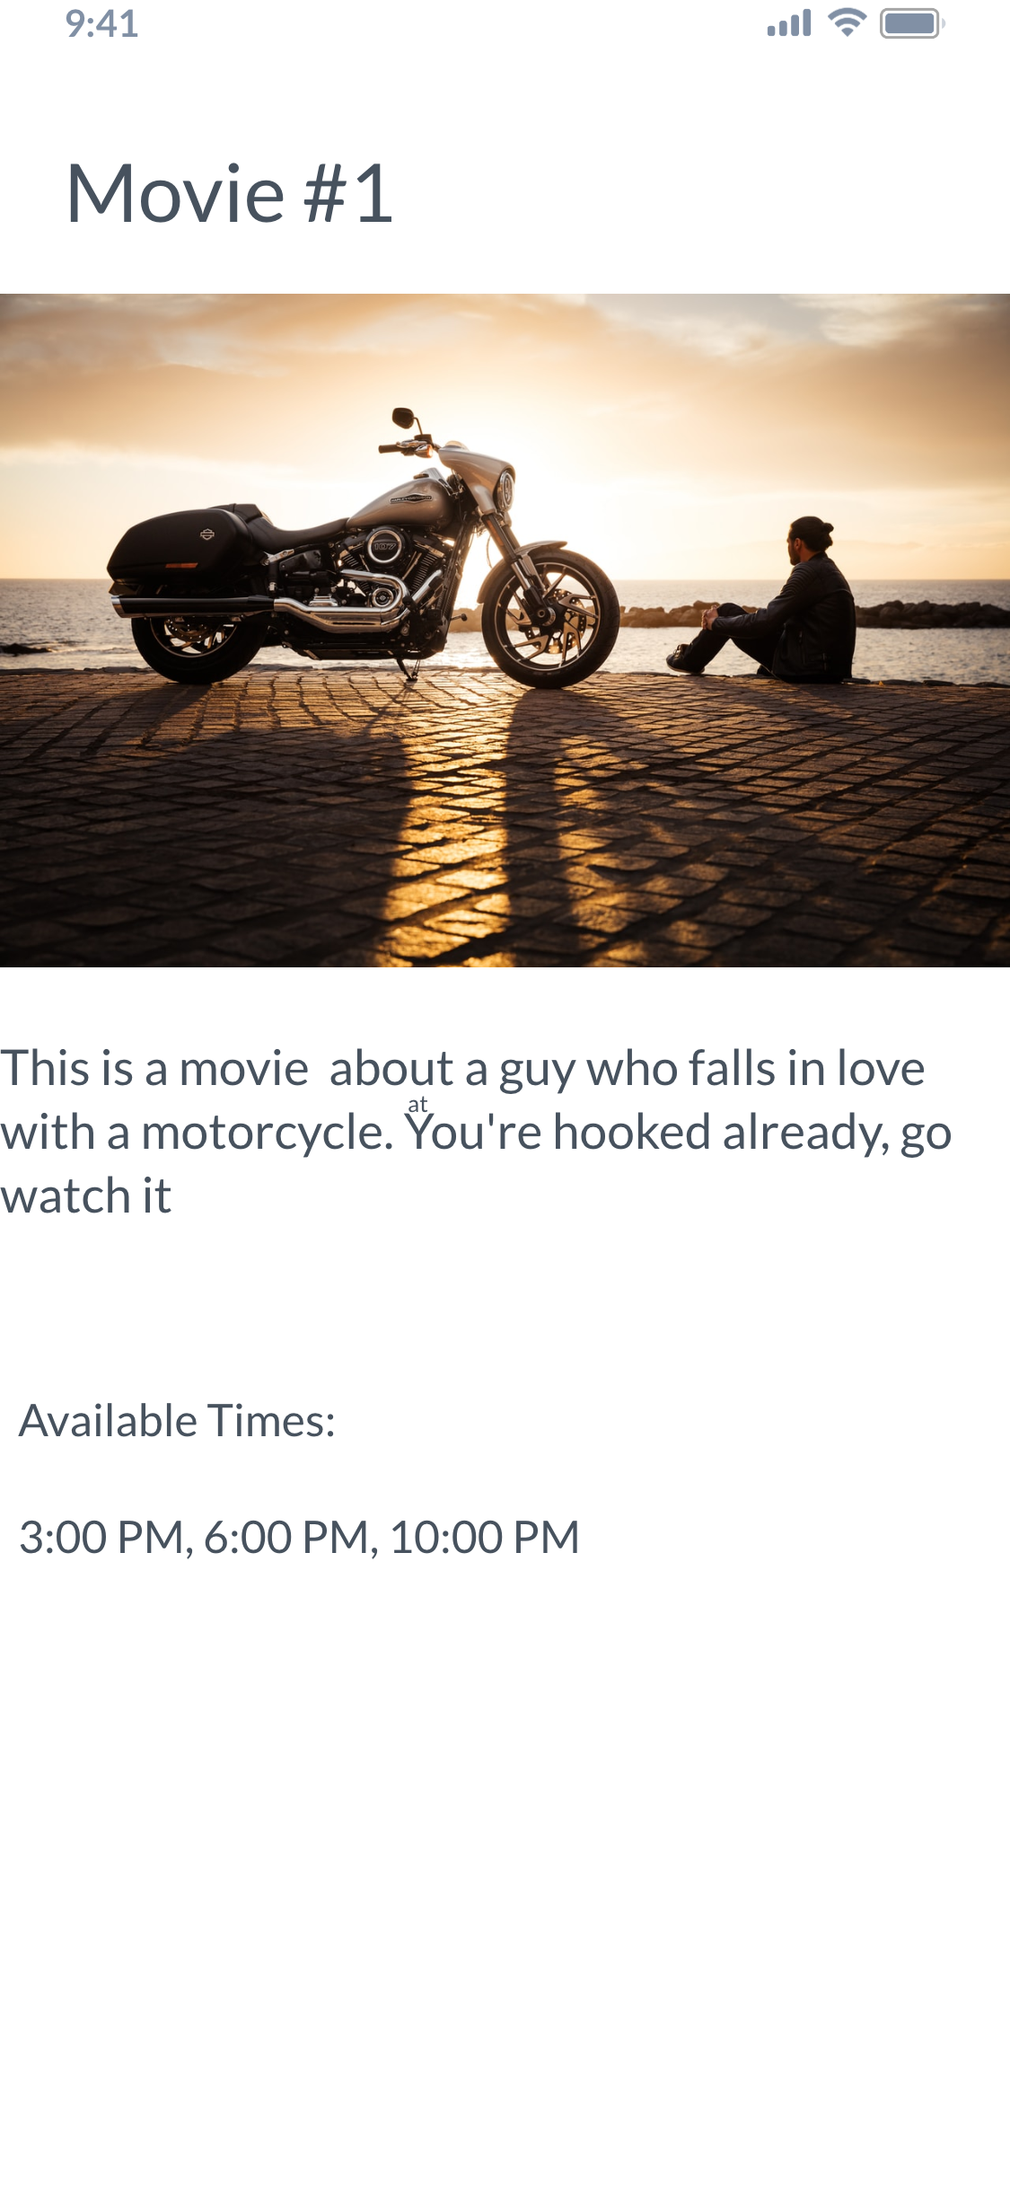

Movie Detail

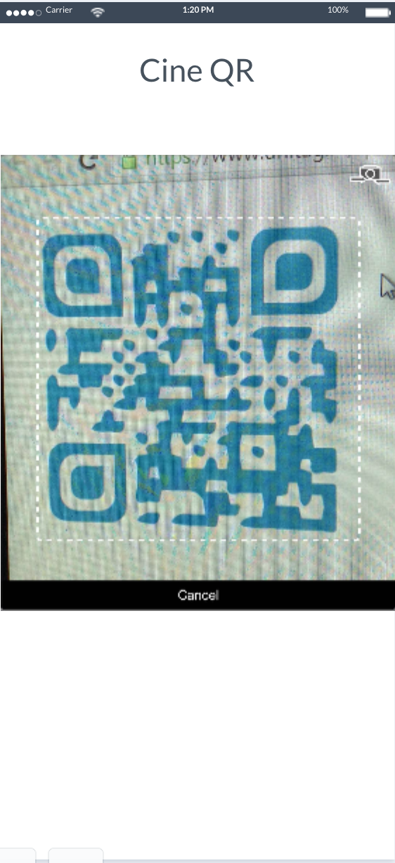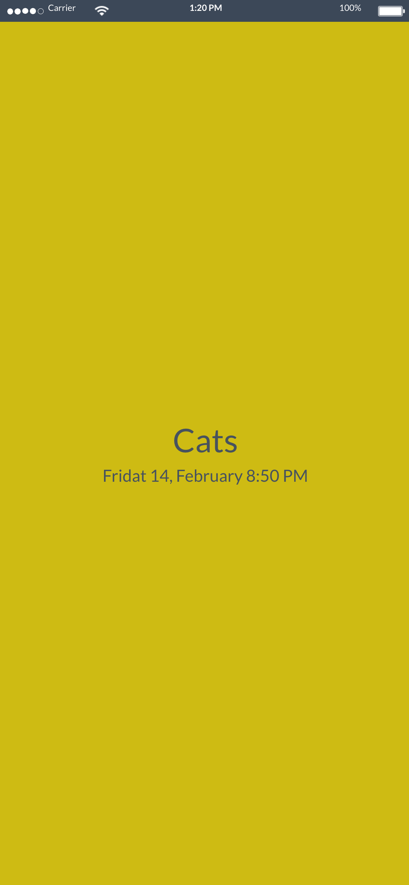

Usher Scanner Scanned before movie Scanned during movie



Used after the movie ended