Introduction
The lecture “Applying Analysis Patterns” explains that large software systems become easier to maintain when the domain is modeled with repeatable structural solutions. Instead of hiding behavior inside functions or UI components, Analysis Patterns expose key domain concepts explicitly, making the design reusable and extendable. In the Gamified Gym project, authentication is one of the core behaviors of the system. Logging in may seem simple on the surface, but it actually involves multiple domain elements: user identity, credentials, verification, failures, and security rules. By applying Analysis Patterns, we can reveal these hidden concepts and create a clear domain model instead of a single function call.

Domain Concepts in Login

User | The person owning the account
Credential | Authentication information (email + password)
Authentication Attempt | Every time a user tries to log in
Authentication Result | Outcome: success, failure, or error
Many apps hide these concepts inside UI logic, making the system harder to extend. The lecture states that implicit concepts lead to confusion and duplicated code, so the goal is to make them explicit.

Applying the “Account & Entry” Pattern
- Account: User identity + Credential
- Entry: Each Login Attempt (date, result, message)

UML Diagram
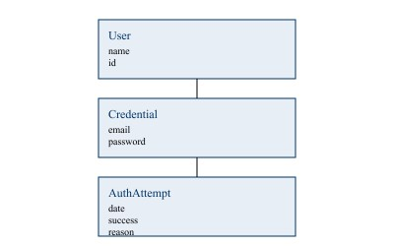

Code Examples

Credential Class
class Credential { constructor(email,
hashedPassword) { this.email = email; this.hashedPassword = hashedPassword;
}
}

AuthAttempt Class
class AuthAttempt {
constructor(date, success, reason) { this.date = date; this.success = success; this.reason = reason;
}
}

User With Attempts
class User { constructor(name,
credential) { this.name = name; this.credential = credential; this.history = [];
}
recordAttempt(success, reason = "") { const attempt = new AuthAttempt(new Date(), success, reason); this.history.push(attempt);
}
}

Why This Improves the Design
- Authentication history becomes visible
- Failed attempts can be counted or blocked
- We can add email verification or MFA without rewriting the login logic ✔ The system gains security features like lockout, audits, and metrics

Conclusion
Applying Analysis Patterns to Login reveals hidden structure and adds meaning to the authentication process. With User, Credential, and AuthAttempt, the Gamified Gym app gains a maintainable and secure foundation for all future authentication features, following the lecture’s teaching that explicit models reduce complexity and improve system design.

