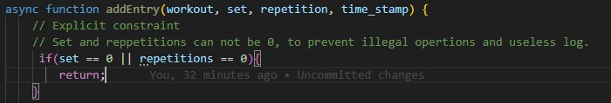
Added explicit constraint to function addEntry from workout_logs.js, now it does not allow sets or repetition with value 0. This adds clarity on what can be added as a log.
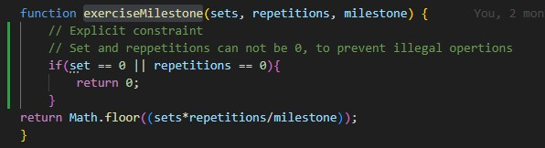
Added explicit constraint to function exerciseMilestone from function_exercise_milestone.js, now it does not allow sets or repetition with value 0. This adds clarity of a valid milestone and prevents illegal math operations.

Added comments to express explicit constraints more clearly in updateStreak from frunction_updateStreak.js.

