Lecture Topic Task: Putting the User Domain Model to Work with Supabase Auth
Lecture Reference: Putting the Domain Model to Work - Marko Schütz-Schmuck,
Completed Task:
- Integrated Sign Up page with Supabase Auth, replacing the old manual user table.
- Ensured all new users are securely registered with email and password.
- Profile information (username, first name, last name) is stored in users_profile_test table, linked to the Auth user ID.
- Email confirmation is automatically handled if enabled in Supabase.
How the Issue Was Implemented / How It Relates to the Lecture:
- Domain Model in Code:
  - User object includes email, password, username, first_name, last_name. o Password validation ensures security standards: +8 characters, uppercase, lowercase, number, special character.
  - Username uniqueness is verified in real-time.
- Putting the Domain Model to Work, Binding to Supabase Auth:
The Sign Up flow directly maps the User domain model to Supabase:
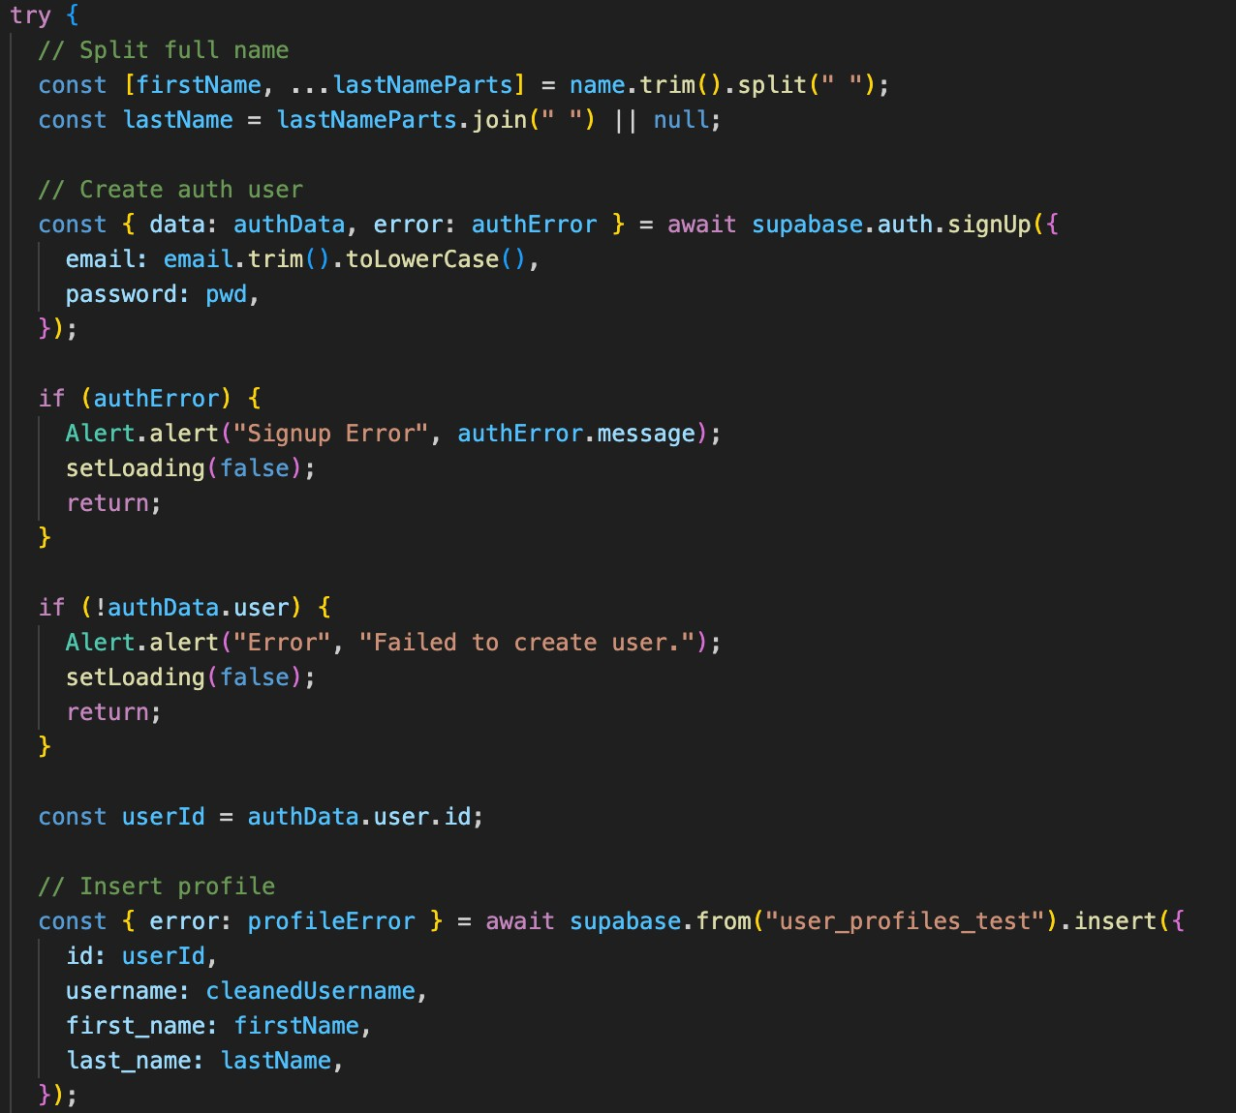
Connection to Lecture Concepts:
- Domain Model and Implementation Linked: The User model is directly tied to Supabase Auth, making the model relevant and actionable.
- Backbone of a Language Used by Team: The domain model enforces rules in the app, such as password strength and username uniqueness.
- Distilled Knowledge / Selective Abstraction: Only essential fields are included, ensuring clarity and simplicity in the model.
- Model Relevance for Maintenance: Future changes to the user profile can be easily implemented because the model and implementation are aligned.
3. Outcome / Benefits:
- Users can securely create accounts using Supabase Auth.
- Email confirmation works automatically if enabled.
- Login page correctly recognizes registered users.
- The User domain model and implementation are fully aligned, reducing errors and improving security.
Why This Matters:
- Security: Eliminates manual password storage. Auto hashing using supabase.
- Model Integrity: The domain model drives the actual implementation.
- Reliability: Ensures consistent, maintainable, and extendable user management.

