Introduction
This section documents the Bounded Context Map for the Gamified Gym Application, following the principles from Strategic Design (Schütz-Schmuck). The system is separated into multiple bounded contexts to avoid a monolithic and contradictory domain model. Each context contains its own coherent model with explicit integration points.
The documentation includes:
- A clean context map diagram
- Descriptions of each bounded context
- Relationship patterns (Shared Kernel, Customer–Supplier, etc.)
- Boundary definitions (modules, schemas, APIs)
- Rationale connected to large-scale structure & distillation principles
Bounded Context Map (Diagram)
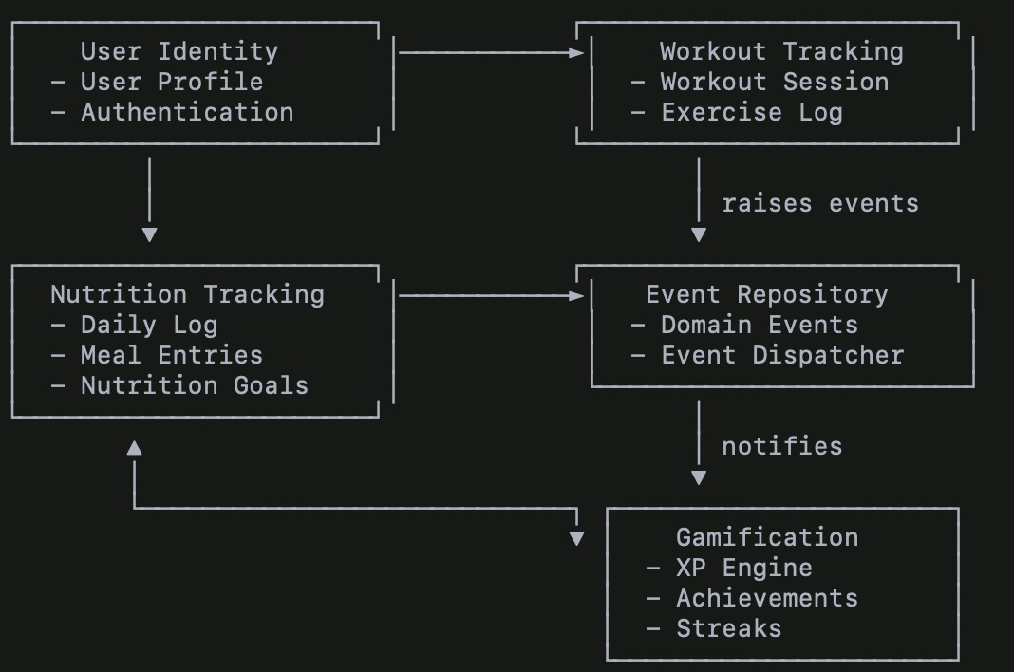
Bounded Context Descriptions
User Identity Context Responsibilities:
- Authentication
- Account creation
- Profile management
Purpose:
Provides canonical user identity data used across all other contexts.
This context forms part of the Shared Kernel, since user IDs and profile info are universally referenced.
Workout Tracking Context Responsibilities:
- Workout sessions
- Exercise logs
- Sets, reps, weights
Integration:
- Publishes domain events such as WorkoutCompleted. ● Uses User Identity data for ownership.
Pattern:
Customer–Supplier (Workout → Event Repository)
Nutrition Tracking Context Responsibilities:
- Daily nutrition logs
- Meal entries
- Calorie/macronutrient totals
- Nutrition goals
Integration:
- Publishes domain events such as DailyNutritionGoalReached. ● Uses User Identity for record ownership.
Pattern:
Customer–Supplier (Nutrition → Event Repository)
Event Repository Context
Responsibilities:
- Storage of all domain events
- Event dispatching
- Integration hub between contexts
Pattern:
Published Language (events form the universal integration messages)
Gamification Context
Responsibilities:
- XP
- Achievements
- Streaks
- Leveling
- Event-driven progression Integration:
- Subscribes to event stream
- Reacts to domain events from Workout & Nutrition Pattern:
Conformist toward the Published Language of domain events.
Relationship Patterns (Strategic Design)

Relationship | Pattern | Reason
User Identity → All | Shared Kernel | Identity fields must remain consistent
Workout → Event Repo | Customer–Supplier | Workout emits events; Event Repo ensures delivery
Nutrition → Event Repo | Customer–Supplier | Same integration pattern
Event Repo → Gamification | Published Language | Gamification reacts to published events
Workout ↔ Nutrition | Separate Ways | No direct dependency; independent models
Gamification → None | Conformist | Consumes events exactly as published

Boundaries (Modules, Schemas, APIs)
/contexts
/user_identity
/workout_tracking
/nutrition_tracking
/event_repository
/gamification

Context | Tables
User Identity | users, auth_tokens
Workout Tracking | workouts, exercises, exercise_logs
Nutrition Tracking | nutrition_logs, meal_entries
Event Repository | domain_events, event_queue
Gamification | achievements, xp_history

APIs
- POST /events/workout.completed
- POST /events/nutrition.goal_reached
- GET /events/subscribe
Rationale (Strategic Design Principles Applied)
Avoiding a Monolithic Model
Separating into bounded contexts prevents:
- duplicate concepts
- inconsistent terminology
- hidden coupling
Distillation
Core game logic (gamification) is distilled into its own context, enhancing clarity.
Large-Scale Structure
Event-driven integration provides a consistent architectural backbone.
Bounded Context Isolation
Each domain has its own model, terminology, and rules, allowing independent evolution.

