Anti-Corruption Layer (ACL) Documentation
Gamified Gym Application
Introduction
This section documents the Anti-Corruption Layer (ACL) used to integrate the Event
Repository Context with the Gamification Context in the Gamified Gym Application. Following the Maintaining Model Integrity lecture, the ACL prevents conceptual corruption between bounded contexts that use fundamentally different models.
Contexts Involved & Misalignment
Event Repository Context
- Stores domain events from multiple contexts
- Uses a generic event model
- Provides: eventType, payload, timestamp
Gamification Context
- Evaluates domain actions for XP, achievements, and streaks ● Requires rich semantic information ● Needs translated domain objects:
○ CompletedWorkoutSession
○ DailyNutritionGoalReached
Conceptual Misalignments
Splinters
Both contexts talk about “events,” but the meaning differs:
- Event Repo → loosely typed messages
- Gamification → gameplay-relevant domain objects
False Cognates
“goal_reached” means:
- Event Repo: a string label
- Gamification: a domain rule and semantic achievement trigger
An ACL is required to isolate and translate these interpretations.
ACL Design
Components
- Facade — isolates Event Repository internals
- Adapter — reformats raw event messages
- Translators — convert payloads into domain-rich objects
- ACL Service — orchestrates translation → dispatch → gamification updates ACL Component Diagram
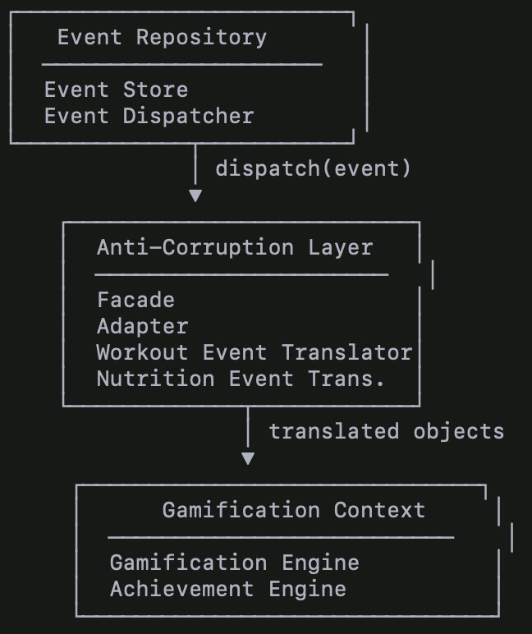
ACL Sequence Diagram
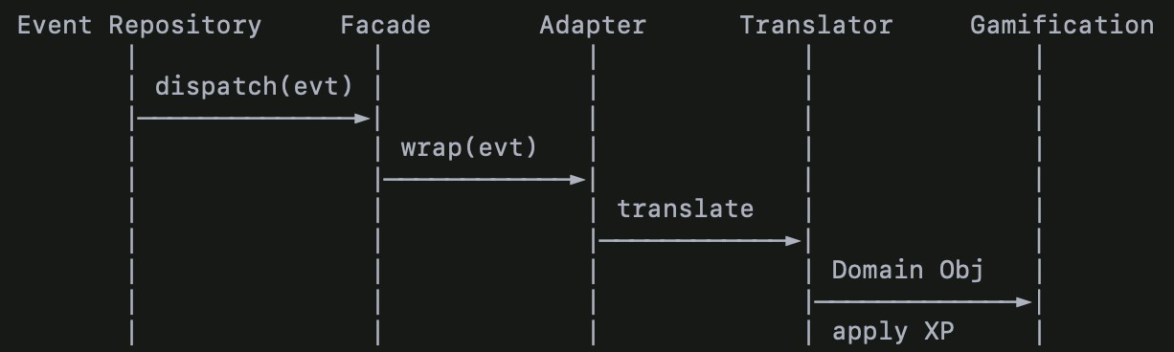
Explanation — How the ACL Preserves Model Integrity
The ACL ensures the Gamification Context never receives:
- raw JSON
- generic payloads
- ambiguous event names
- fields irrelevant to gameplay
Instead, the ACL transforms primitive event messages into pure domain concepts.
This preserves:
- Ubiquitous Language
- Context Isolation
- Semantic Boundaries
- Model Integrity
It prevents corruption from the Event Repository’s generic model.
Integration With the Context Map
Event Repository Context ───▶ (ACL) ───▶ Gamification Context This ensures:
- Event Repository keeps its role as neutral event infrastructure
- Gamification keeps its expressive game domain
- The ACL performs translation in between
Before vs After Summary
Before
- Gamification consumed raw events
- Domain rules relied on string comparisons
- Risk of corruption through false cognates
After
- ACL sits between contexts
- Raw events → Domain Objects via translators
- Gamification stays fully isolated and expressive

