Entities, Aggregates, and Bounded Contexts in the Gamified Gym App

Introduction
Domain-Driven Design (DDD) offers a disciplined way to handle complexity in large applications by organizing software around the business domain. Instead of letting features grow in an unstructured manner, DDD relies on constructs such as Entities, Value Objects, Aggregates, and Bounded Contexts to express the domain clearly and consistently. These concepts ensure the system reflects real business rules and remains adaptable as requirements evolve.
For the Gamified Gym App—which blends workout tracking, gamification, user management, social features, and progression—DDD helps prevent different parts of the system from interfering with each other. Without defined boundaries, it becomes easy for UI components to access unrelated business rules, for APIs to leak internal data structures, or for logic to be copied inconsistently across modules. Using Entities, Aggregates, and Bounded Contexts provides the structure needed for long-term maintainability.

Entities in the Gamified Gym App
Entities are distinguished by a stable identity rather than their attribute values. Their data may change, but their identity persists. Core Entities in this application include:

User
Identity: user_id (Supabase UUID)
Attributes: email, displayName, avatar, createdAt
A User retains the same identity throughout profile changes or workout history updates. Other domain objects reference it without owning its lifecycle.

WorkoutSession
Identity: session_id
Attributes: workoutType, duration, caloriesBurned, xpEarned, createdAt
Two workout sessions with identical data are still separate Entities because each represents a unique event.
LevelProgress

Identity: user_id
Attributes: xp, currentLevel, nextLevelThreshold
This Entity is conceptually tied to the User and exists only in relation to that User.
Reward

Identity: reward_id
Attributes: rewardType, requiredXP, claimStatus
Represents rewards that can be obtained as users accumulate experience.
These Entities clarify “who” owns or relates to each piece of data rather than just “what” information is recorded.

Aggregates and Their Rules
Aggregates bundle Entities and Value Objects into clusters managed by a single Aggregate Root. The Aggregate Root ensures that important rules—called invariants—are enforced.

User Aggregate
Root: User
Includes: profile details, preferences, progress references Invariants:
- Email must remain unique
- A profile cannot be removed if workout records still depend on it
- Authentication state transitions follow controlled rules

Workout Aggregate
Root: WorkoutSession
Includes: Duration VO, XPAmount VO Invariants:
- Duration values must be non-negative
- XP is derived from session metrics (not manually assigned)
- Completed sessions are immutable unless a specific rule allows changes

Progression Aggregate
Root: LevelProgress
Includes: XPAmount VO, ThresholdRules VO Invariants:
- XP never decreases
- Level-ups occur only when thresholds are met
- XP updates resulting from workouts must be atomic to avoid inconsistencies

Reward Aggregate
Root: Reward
Includes: EligibilityRules VO Invariants:
- Users can claim a reward only when their XP meets the requirement
- Rewards cannot be claimed multiple times
- Availability is governed by gamification logic
Aggregates ensure domain integrity even in cases of concurrency, offline usage, or unreliable network behavior.

Bounded Contexts in the Gamified Gym App
A Bounded Context defines the scope within which a particular model applies. A term like “User” may have different meanings across contexts.

Auth Context
- Manages login, signup, sessions, and password resets
- Driven by Supabase Auth
- Keeps the model minimal; it represents authentication identity only

Workout Context
- Handles workout sessions, timing, session validation, and XP calculation
- The term “session” refers specifically to a workout, not an authentication session

Gamification Context
- Governs XP accumulation, leveling rules, reward eligibility, and leaderboard prep
- “Level” here relates to progression, not security permissions

User Profile Context
- Manages personal details such as display name, avatar, and preferences
- Kept independent from both authentication and gamification concerns

Social Context
- Manages friendships, public profiles, and leaderboard data
- Consumes data from other contexts but does not dictate their rules
Communication Between Contexts
Contexts exchange DTOs rather than raw Entities to avoid accidental mixing of domain rules.

Supabase and Context Integration
Supabase tables serve as persistence sources rather than direct domain models. Repositories within each context translate raw data into Entities and Aggregates, enforce domain rules, and expose intent-driven operations.
Examples:
- auth.users → Auth Context
- workout_sessions → Workout Context
- user_progress → Gamification Context
- user_profile → User Profile Context
- leaderboard_view → Social Context (read-only model)
Each repository:
- Maps tables to domain objects
- Validates invariants before database writes
- Uses terminology aligned with the domain model

Risks and Mitigation
Risk | Mitigation
Entities becoming too large | Keep them focused; put rule enforcement in  Aggregates
Tight coupling between contexts | Use DTOs and maintain strict boundaries
Inconsistent XP or level tracking | Enforce invariants within the Progression  Aggregate
UI breaking due to domain model evolution | Expose read models tailored for UI; keep domain internals private
Creating overly complex “god” objects | Split Aggregates based on ownership and invariant scope

Diagrams

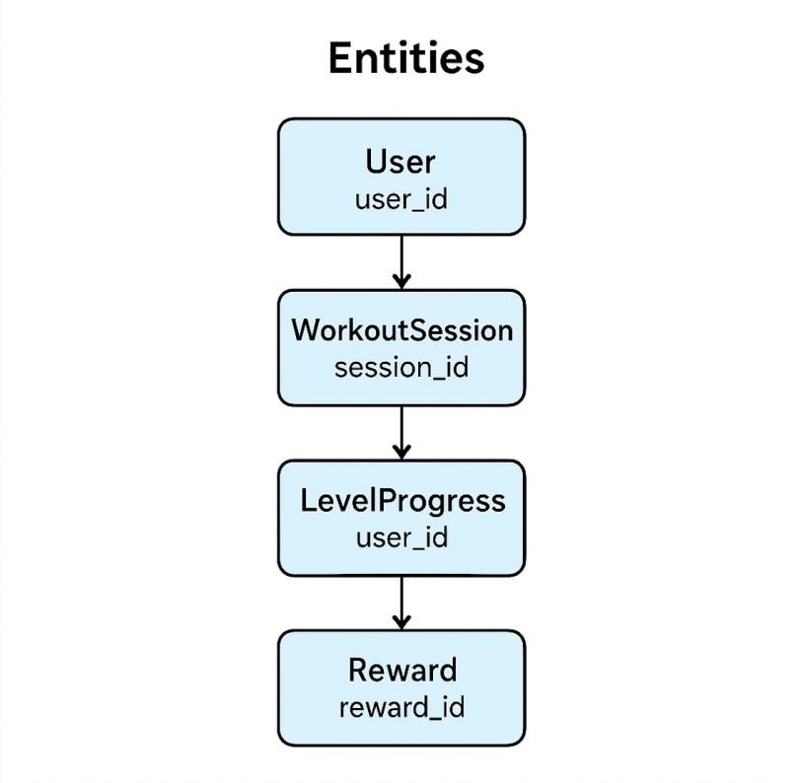

Figure 1.1 Entities Diagram

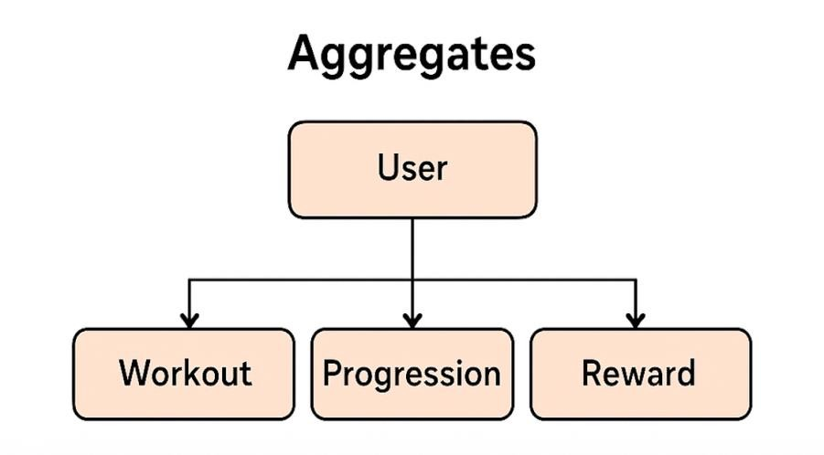

Figure 1.2 Aggregates Diagram
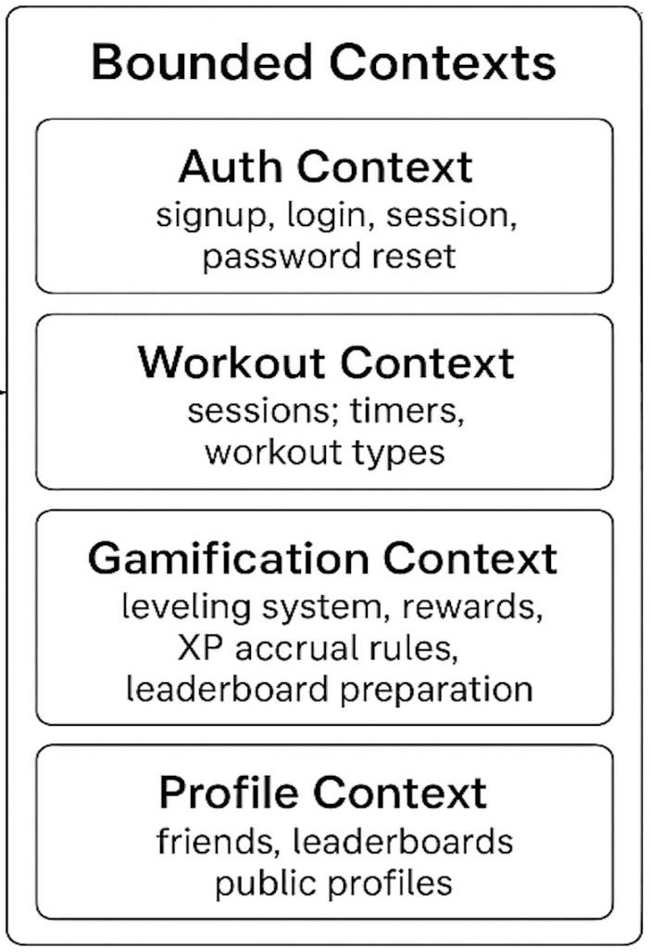
Figure 1.3 Bounded Contexts Diagram

