User Object Life Cycle for LogIn (with Supabase)

Introduction
In software design, understanding the life cycle of domain objects is crucial when implementing critical functionality like login. In Gamified Gym, the Foundations Team is responsible for the functional behavior of the login page, which uses email/password authentication, and Supabase as the backend service.
The User object governs login state and validation, while the UI elements—email and password fields, Log In button, and forgot password/sign-up URLs—interact directly with this object’s lifecycle. By linking theory to practice, the Foundations Team ensures secure, responsive, and consistent login functionality.

Identifying the Domain Object
The User object consists of:
- Email (identifier)
- Password (hashed and managed by Supabase)
- Session (token issued on successful login)
Supabase handles authentication and session storage. The Foundations Team’s task is to implement functional hooks: the Log In button triggers login attempts, errors are displayed inline, and redirects occur for password recovery or sign-up.

Life Cycle Analysis
- Retrieval (Login Attempt):
  - Triggered by pressing the Log In button.
  - Supabase Auth API fetches the User object using email.
- Validation (Password Check):
  - Supabase verifies the password.
  - Success → session token issued; Failure → error returned.
- Error Handling:
  - Invalid credentials → display “Incorrect email or password.” o Optional: track failed attempts and suggest password recovery or account creation.
- Session Management:
  - On success, JWT token stored locally.
  - Session validity drives user access to protected screens.
- Logout / End of Session:
  - Token cleared in UI; Supabase optionally invalidates session server-side.

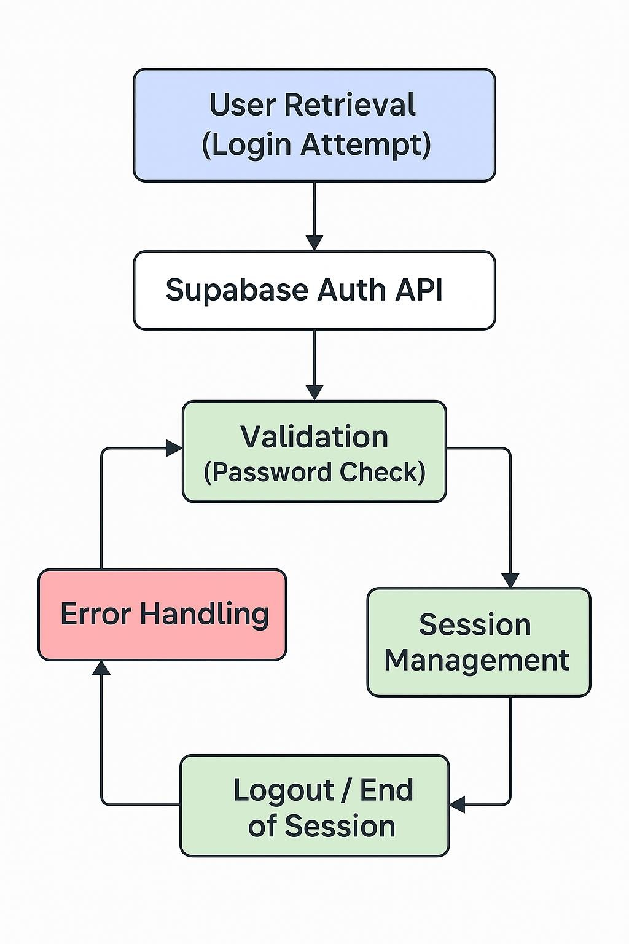
Figure 1.1 User Object Life Cycle for LogIn

Mapping Functionality to UI
- Log In Button: Calls Supabase API, triggers lifecycle stages.
- Error Messages: Update UI in response to failed validation.
- Forgot Password / Sign-Up URLs: Redirect users to appropriate workflows.
Reactive behavior ensures consistency between User object state and functional responses.

Applying Design Principles
- Modularity: Functional hooks (login, error handling, redirect) implemented as independent functions.
- Abstraction: UI interacts with login service layer instead of raw API calls.
- Effective Modeling: User object aligns with Supabase Auth schema; reduces integration errors.

Communication with Backend / Supabase
- Which API endpoints handle authentication, failed attempts, and session refresh?
- What error codes correspond to invalid credentials or network failures?
- How is session expiration handled, and what UI behavior should follow?

Risks and Mitigation
- Invalid sessions: Ensure token storage is secure and cleared on logout.
- Repeated failed attempts: Optionally limit attempts or suggest recovery.
- Network/API failures: Handle errors gracefully with UI feedback.

Tools and Patterns
- Repository / Service Layer: Handles login API calls and session management.
- Observer Pattern: Updates functional UI elements based on login state changes.
- MVC: Separates functional logic (controller/service), User object (model), and UI elements (view).

Conclusion
Focusing on the functional layer of the login page, the Foundations Team applies life cycle principles to ensure secure, consistent, and responsive authentication. Supabase handles backend verification and session management, while the team ensures correct integration, error handling, and workflow navigation. This demonstrates the direct application of theoretical object life cycle concepts to practical native app development.

