Workout Aggregate Boundaries - Gamified Gym
In the domain model of Gamified Gym, the Workout aggregate defines the core structure responsible for maintaining consistency across all elements involved in a user’s training session. This aggregate groups together, the Workout and its related entities (Exercises, Sets, and Performance Records) as a single unit of modification. The purpose of this design is to enforce domain invariants, prevent orphaned data, and ensure atomic updates when users modify their workouts The Workout acts as the aggregate root, which possesses a global identity and serves as the only entry point for operations affecting the aggregate. All other entities within its boundary have local identity and can only be accessed through the root. Following the aggregate principles discussed in The Life Cycle of a Domain Object Lecture, this design guarantees that every transaction leaves the internal state of the Workout consistent.

Contained Entities and Value Objects
Within the Workout aggregate, several entities and value objects capture the structure and semantics of a workout session.
Entities:
- Exercise represents an individual training activity, such as “Push-Ups” or “Bench Press.” ● Set defines a specific repetition configuration belonging to an Exercise.
- PerformanceRecord captures real-world outcomes such as repetitions completed, weight used, or total duration.
Value Objects such as Reps, Weight, Duration, Tempo, RestPeriod, and Intensity express measurable aspects of performance without requiring individual identity. These value objects are immutable, reusable, and ensure that data remains meaningful within each aggregate boundary. All entities exist strictly within the scope of a single Workout. They cannot be shared across different Workouts or referenced independently from external contexts.

Ownership and Deletion Rules
Ownership within the aggregate is hierarchical: the Workout owns its Exercises, each Exercise owns multiple Sets, and each Set may own a corresponding PerformanceRecord. When a Workout is deleted, all of its child entities (Exercises, Sets, and Performance Records) are deleted automatically as part of a single atomic operation. This cascade deletion ensures there are no orphaned records and that the domain model maintains internal consistency. Similarly, modifications can only be performed through the root entity. For example, adding a new Exercise or registering a Performance Record must be done via a method exposed by the Workout root. This rule ensures that invariants are verified centrally before any transaction is committed.

Domain Invariants
Several business rules, or invariants, must always hold true within the Workout aggregate:
- Every Set belongs to exactly one Exercise within the same Workout.
- Each PerformanceRecord must be linked to a valid Set or Exercise.
- Exercises maintain a consistent order index unique within their parent Workout.
- Numeric attributes such as reps, weight, and duration respect domain limits (e.g., positive and reasonable values).
- Once a Workout is marked as completed, no further modifications to its internal entities are allowed.
These invariants are enforced at the aggregate root level, meaning the Workout entity is responsible for validating its internal state before persistence.

Inter-Aggregate Relationships
In Gamified Gym, aggregates communicate only through their roots. Internal entities such as
Exercises or Sets are never referenced externally. The User aggregate serves as the owner of multiple Workouts, maintaining references only to their root identifiers. Each Workout stores the userId of its owner but has no direct link to the User’s internal structures. The Achievement aggregate, part of the gamification subsystem, operates independently from the Workout lifecycle. Instead of referencing Workouts directly, it reacts to domain events (e.g., WorkoutCompleted, PersonalBestRecorded) published by the Workout aggregate. These events allow asynchronous communication between aggregates, ensuring eventual consistency without coupling. Finally, a Workout may reference a PlanTemplate aggregate through its identifier to record the source of a training plan. However, the Workout copies necessary configuration details as Value Objects rather than maintaining a hard dependency.

Repositories and Persistence
Each aggregate root is managed through its dedicated repository. The WorkoutRepository provides operations such as findById, findByUserAndDateRange, save, and delete. Internal entities like Exercises, Sets, and Performance Records are never retrieved or stored independently. This guarantees that persistence always occurs at the aggregate level, maintaining the invariant that only complete and valid aggregates exist in storage.

Conceptual Structure
The conceptual diagram below illustrates the boundaries of the Workout aggregate:
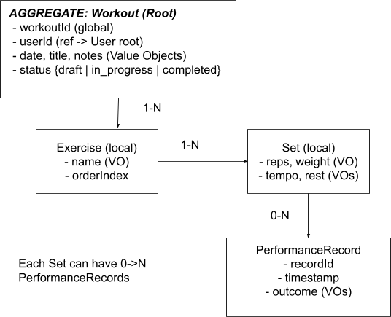

Consistency and Transactional Behavior
Consistency within the Workout aggregate is strong, meaning that all invariants must be valid when the transaction ends. Operations such as adding an Exercise or deleting a Workout occur atomically to preserve data integrity. Consistency between aggregates (e.g., Workout–Achievement) is eventual. When a Workout is completed, an event is published to notify the gamification subsystem, which updates achievements asynchronously. This design supports scalability and independence between subsystems.

Summary
The Workout aggregate in Gamified Gym defines the boundary for maintaining data consistency across workout-related entities. It establishes clear ownership, deletion, and validation rules, ensuring that each training session and its associated records remain logically complete and internally coherent. By enforcing strong invariants inside the boundary and using domain events for external communication, the system achieves both reliability and flexibility across the workout, user, and gamification domains.

