Clean Architecture in Gamified Gym UI/UX and DB Integration

Introduction

In contemporary software architecture, keeping concerns separate and isolating business logic are essential for building systems that are both maintainable and testable. At Gamified Gym, the Foundations Team follows Clean Architecture principles for its user interfaces and database operations. The project’s structure separates the code into layers for presentation, business use cases, and data repositories. This ensures that Supabase-specific details are kept apart from UI components, while the authentication domain remains independent and central.

Application of SOLID Principles
Single Responsibility: Every component has one defined purpose. For instance, LoginScreen.tsx manages input and presentation, AuthUseCase.ts handles authentication logic, and SupabaseUserRepository deals with all API communication. This modularity simplifies both debugging and testing.
Open–Closed Principle: Use cases depend on abstract interfaces such as AuthStrategy. New authentication methods (e.g., Google OAuth) can be introduced by adding new implementations of that interface without modifying existing logic. This ensures UI components remain unaffected.
Liskov Substitution: Any class that implements AuthStrategy can replace another. For testing or migration, a Firebase-based repository could be substituted without altering use-case behavior.
Interface Segregation: Interfaces are designed to be minimal. For example, the login screen depends only on the login(email, password) method, not on signup or password-reset functions, reducing unnecessary dependencies.
Dependency Inversion: High-level modules such as use cases rely on abstractions rather than concrete classes. The SupabaseUserRepository contains specific API calls, while UI and domain layers remain decoupled from backend details.

Domain Model & Repository
The User domain model includes:
- email: string
- password: string
- session: Supabase session token
The repository implements the following interface:
interface AuthStrategy { login(email: string, password: string): Promise<User>; signup(email: string, password: string): Promise<User>; resetPassword(email: string): Promise<void>; }
Example:
class SupabaseUserRepository implements AuthStrategy { async login(email: string, password: string): Promise<User> { const { data, error } = await supabase.auth.signInWithPassword({ email, password }); if (error) throw error; return { email: data.user.email, password: '', session: data.session }; }
// Other methods follow the same pattern }

UI/UX Layer Integration
User interactions in the login interface trigger methods in AuthUseCase. Errors are surfaced in the UI through alerts. Similarly, “Sign Up” and “Forgot Password” actions call their corresponding use cases, keeping Supabase logic confined to the repository layer.

Communication & Clarifications
The development team coordinates on Supabase-specific topics such as:
- Error codes for login or password reset failures
- Token expiration and JWT management
- Rate limits on repeated authentication attempts

Risks and Mitigation
Possible issues include authentication failures, session invalidation, or UI errors. Through Clean Architecture layering, these problems are isolated in the repository or use-case levels, preventing crashes in the presentation layer.

Conclusion
By employing Clean Architecture and the SOLID design principles, the Foundations Team maintains a clear domain boundary, expressive models, and a system that is easy to evolve and test. Supabase integration is hidden behind repository abstractions, promoting scalability and safe user interface changes.

Log-In Screen, Sign-Up Screen
AuthUseCase
SupabaseUserRepository

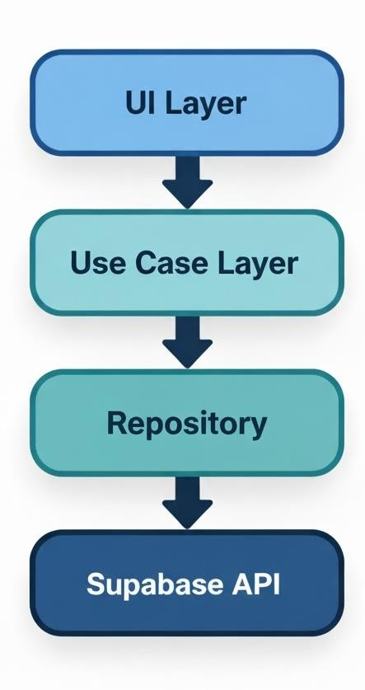
Diagram (example)

Figure 1.1 API Calls through repo

