The Nature of the Design Process in
Gamified Gym

Foundations Team – UI/UX (Home, Profile, Settings)

Core Challenge: Envisioning a Future State
As Professor Marko emphasized in his lecture on The Nature of the Design Process, the fundamental problem of design lies in envisioning a desired outcome that only comes into being if the design is correct. For the Foundations Team, this translates into anticipating how users will interact with the Home, Profile, and Settings screens of Gamified Gym. The challenge is not only to predict how users might navigate these pages, but also to ensure that the experience is intuitive, motivational, and sustainable. For example, when designing the Home page dashboard, we must assume that users prefer quick access to progress metrics (steps, calories, streaks) and will be discouraged by cluttered or confusing layouts.

Role of Design Activity: Modularity and Quality
Modularity is essential in structuring the Foundations Team’s work. Each screen — Home, Profile, Settings — is a distinct module, yet together they create the foundational UI framework of the app. The Home page functions as the user’s control center, the Profile reflects long-term progress and identity, and the Settings page ensures personalization and control. Designing them as modular components makes it easier to update or extend functionality (e.g., adding new workout types or notification options) without disrupting the rest of the system.
Quality, as Schütz highlighted, is both elusive and essential. In our scope, quality means usability, accessibility, and consistency. For instance, consistent typography and iconography across the Profile and Settings screens reinforce user trust, while ensuring that settings are clearly labeled prevents user frustration.

Communication: Gathering Requirements
The design process depends on communication with both stakeholders and end-users. To refine the UI/UX requirements, we would ask:
- What information do you expect to see immediately when opening the app?
- How much control do you want over customizing your Profile and Home dashboard?
- Which settings (e.g., notifications, privacy, integrations) are most important for your daily use?
These questions are designed to uncover not just functional requirements but also motivational and psychological needs, which directly shape interface design.

Domain Knowledge: Acquiring Expertise
UI/UX design requires integrating domain knowledge from multiple sources. First, usability heuristics (Nielsen’s principles) ensure the design avoids common pitfalls such as hidden navigation or poor error recovery. Second, accessibility standards (WCAG) guarantee inclusivity, allowing users of varying abilities to interact with the app effectively. Finally, reviewing fitness app design conventions (e.g., Fitbit, Strava) informs decisions about dashboard layouts and progress visualization, ensuring users encounter familiar, intuitive patterns.
Knowledge Area | Source | Importance
Usability heuristics | HCI Research | Prevents common design flaws and improves intuitiveness
Accessibility guidelines | WCAG Standards | Ensures inclusivity for users with diverse needs
Fitness app practices | Market analysis | Provides familiarity and benchmarks for dashboard  design
Table 1.1
By grounding our work in established principles and industry practices, we avoid reinventing the wheel while ensuring that Gamified Gym remains distinctive.

Design Outline: UI Components and Connections
The design of the Foundations Team can be conceptualized as a set of reusable components:
- Home: Dashboard cards (Steps, Calories, Streaks), Quick Actions, Notification Preview.
- Profile: Profile Header (user identity), Achievement Badges, Progress History (graphs).
- Settings: Toggles (notifications, privacy), Integration Options (Google Fit, Apple Health), Account Management.
These components are bound together by a shared navigation system and consistent design language. Reusability is central: a card widget designed for the Home screen can also appear in Profile summaries, and a toggle switch designed for Settings can be reused across multiple contexts.
Foundations Team UI
├─ Home
│ ├─ DashboardCard (Steps)
│ ├─ DashboardCard (Calories)
│ ├─ DashboardCard (Streak)
│ └─ QuickActionButton
├─ Profile
│ ├─ ProfileHeader
│ ├─ AchievementCard
│ └─ ProgressGraph
└─ Settings
├─ ToggleSwitch
└─ AccountControls
Diagram 1.1

Process Planning: Implementation and Integration
A staged process ensures both clarity and efficiency:
- Wireframing and mockups in Figma for Home, Profile, and Settings.
- Interactive prototypes tested for navigation and usability.
- Frontend implementation using reusable UI components in React Native or Flutter.
- Integration with backend services, beginning with fitness tracking, followed by gamification features.
- Usability testing and iteration, refining based on feedback.
Integration with other teams is crucial: the Home screen must display tracking data, while the Profile must display gamification achievements. Delivering placeholder UI elements early allows parallel development, ensuring smoother integration later.

Problem-Solving: Design Criteria
The Foundations Team applies clear design criteria to guide decisions:
- Usability: The interface must be simple and predictable.
- Inclusivity: Accessible features such as scalable text and high-contrast themes.
- Adaptability: Flexible layouts for new features and content.
- Engagement: Visual design that motivates continued app use.
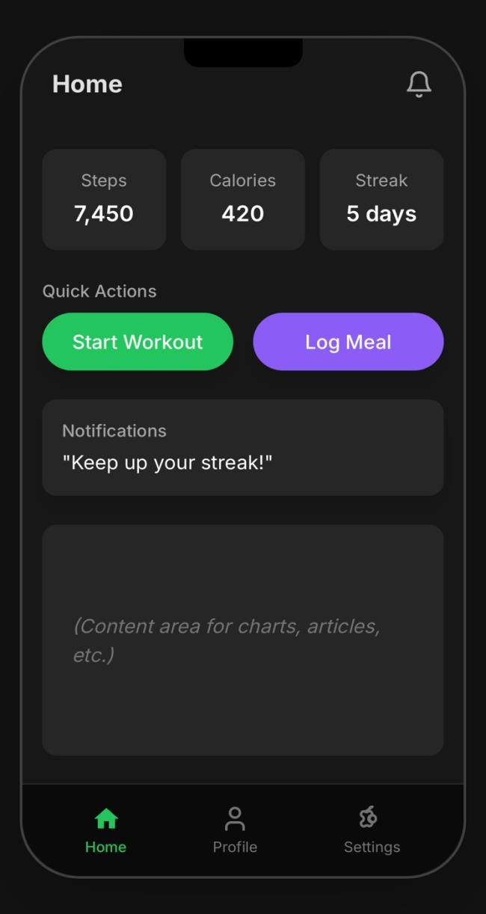
Figure 1.1

For instance, the decision to use card-based widgets on the Home page was driven by usability (scan-friendly layout) and adaptability (new cards can be added with minimal redesign).

Designer’s Tools: Patterns and Methods
Designers rely on tools and patterns to balance abstraction with practical execution. Wireframing in Canvas provides an abstract but testable representation of the UI, allowing early feedback without heavy coding investment. On the implementation side, the Factory Pattern supports the creation of reusable UI components such as dashboard cards and toggle switches. This ensures consistency and reduces redundancy in code, while also aligning with modular principles. Risks of Poor Design
Failure to apply theoretical principles in practice carries significant risks:
- Confusing navigation may lead to frustration and app abandonment.
- Inaccessible settings could exclude users with disabilities.
- Overly cluttered dashboards might overwhelm users, reducing motivation.
These risks highlight why a design process grounded in theory, communication, and domain knowledge is essential for long-term success.

Conclusion
The Foundations Team’s work on the Home, Profile, and Settings screens of Gamified Gym exemplifies how abstract design theory informs concrete design choices. By working backward from an envisioned future state — a motivating, accessible, and engaging fitness experience — and applying principles such as modularity, communication, and problem-solving, we create an interface that supports both user motivation and team integration. The success of the app ultimately depends on these foundational design decisions, demonstrating the profound importance of the design process in shaping usable, reliable, and engaging software.

