System Support Component and Self Healing Component Macro Design Document
Author: Liu Hai(Larry)

Revision History
Date | Version | Description | Author
2013/11/6 | 1.0 | Initial Version | Larry(Hai DL Liu)
2014/03/19 | 1.7 | SSE&SHE Phase 7 | Larry(Hai DL Liu)
2014/04/22 | 1.8 | SSE&SHE Phase 8 | Larry(Hai DL Liu)
2014/04/22 | 1.9 | SSE&SHE Phase 9 | Larry(Hai DL Liu)
2014/06/09 | 1.X | SSE&SHE Phase X | Larry(Hai DL Liu)

System Support Component and Self Healing Component Overview Architecture

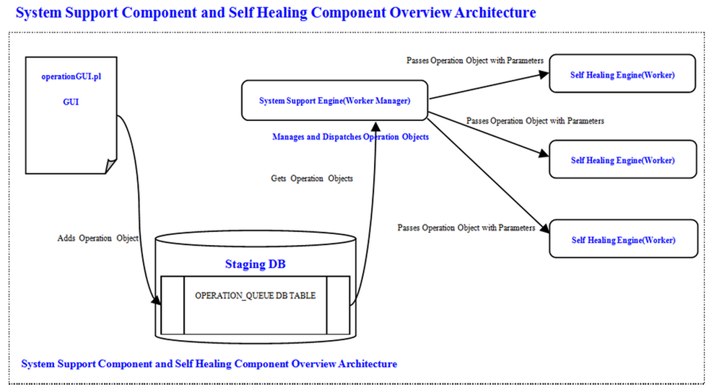

Self Healing Component Overview Architecture - Phase 1
Self Healing Core Engine
Log Component
Restart Loader on TAP Server
TDB

TDB

TDB

TDB

TDB

selfHealingEngine.properties

Self Healing Component Overview Architecture

Self Healing Component Overview Architecture - Phase 2

Self Healing Component Overview Architecture
Self Healing Core Engine
Log Component
Restart Loader on TAP Server
Restart Loader on TAP3 Server

TDB

TDB

TDB

TDB

selfHealingEngine.properties

Self Healing Component Overview Architecture - Phase 3

Self Healing Component Overview Architecture
Self Healing Core Engine
Log Component
Restart Loader on TAP Server
Restart Loader on TAP3 Server

Restart Child Loader on TAP Server

TDB

TDB

TDB

selfHealingEngine.properties

Self Healing Component Overview Architecture - Phase 4
Self Healing Component Overview Architecture

Self Healing Core Engine
Log Component
Restart Loader on TAP Server
Restart Loader on TAP3 Server

Restart Child Loader on TAP Server

Restart IBM HTTP Server on TAP Server
TDB

TDB

selfHealingEngine.properties

Self Healing Component Overview Architecture - Phase 5
Self Healing Core Engine
Log Component
Loader Group
Restart Loader on TAP Server
Restart Loader on TA3 Server
Restart Child Loader on TAP Server
Server Group
Restart IBM HTTP Server on TAP Server
Application Group
Restart Bravo Web Application
Restart Trails Web Application
TDB

selfHealingEngine.properties
Self Healing Component Overview Architecture

Self Healing Component Overview Architecture - Phase 6
Self Healing Core Engine
Log Component
Loader Group
Restart Loader on TAP Server
Restart Loader on TA3 Server
Restart Child Loader on TAP Server
Server Group
Restart IBM HTTP Server on TAP Server
Application Group
Restart Bravo Web Application
Restart Trails Web Application
Tool Group
Staging Bravo Data Synchronized Script
selfHealingEngine.properties
Self Healing Component Overview Architecture

stagingSyncGENAdvanceChild.pl
Integrate the current existing Staging and Bravo DBs Data SYNC function into the current SSE&SHE Architecture
Invokes

Self Healing Component Overview Architecture - Phase 7
Self Healing Component Overview Architecture

Self Healing Core Engine
Log Component
Loader Group
Restart Loader on TAP Server
Restart Loader on TA3 Server
Restart Child Loader on TAP Server
Server Group
Restart IBM HTTP Server on TAP Server
Application Group
Restart Bravo Web Application
Restart Trails Web Application
Tool Group
Staging Bravo Data Synchronized Script
Add Specific Id List Into Target Recon Queue
selfHealingEngine.properties

Self Healing Component Overview Architecture - Phase 8
Self Healing Component Overview Architecture

Self Healing Core Engine
Log Component
Loader Group
Restart Loader on TAP Server
Restart Loader on TA3 Server
Restart Child Loader on TAP Server
Server Group
Restart IBM HTTP Server on TAP Server
Application Group
Restart Bravo Web Application
Restart Trails Web Application
Tool Group
Staging Bravo Data Synchronized Script
Add Specific Id List Into Target Recon Queue
Remove Certain Bank Account
selfHealingEngine.properties

Self Healing Component Overview Architecture - Phase 9
Self Healing Component Overview Architecture

Self Healing Core Engine
Log Component
Loader Group
Restart Loader on TAP Server
Restart Loader on TA3 Server
Restart Child Loader on TAP Server
Server Group
Restart IBM HTTP Server on TAP Server
Application Group
Restart Bravo Web Application
Restart Trails Web Application
Tool Group
Staging Bravo Data Synchronized Script
Add Specific Id List Into Target Recon Queue
Remove Certain Bank Account
Clean History Data for all renamed Bank Accounts
selfHealingEngine.properties

Self Healing Component Overview Architecture - Phase X
Self Healing Component Overview Architecture

Self Healing Core Engine
Log Component
Loader Group
Restart Loader on TAP Server
Restart Loader on TA3 Server
Restart Child Loader on TAP Server
Server Group
Restart IBM HTTP Server on TAP Server
Application Group
Restart Bravo Web Application
Restart Trails Web Application
Tool Group
Staging Bravo Data Synchronized Script
Add Specific Id List Into Target Recon Queue
Remove Certain Bank Account
Clean History Data for all renamed Bank Accounts
Cleanup Recon Queues Duplicate Data
selfHealingEngine.properties

