


Tivoli License Compliance Manager v2.2 Agent
Deployment Guide

IBM Global Services
Asset Management Delivery Services

Document Owner: US TLCM TEAM
Department: Americas AMSD Software Asset Mgmt
Document Version: 14.0

Last Update: February 5, 2009

File Name: TLCM 2.2 Deployment Guide v14
I. Introduction 3
A. Target Audience 3
B. Project Scope 3
II. Basic TLCM Information 4
A. Product Description 4
B. Supported Platforms 4
1. TLCM v2.2 Agent Supported 4
2. TLCM Agent Communication to the RunTime Server 6
III. Agent Deployment Strategy and Planning 6
A. Agent Deployment start up and completion 6
B. Account Firewalls 6
C. Agent Roll out Plan 6
D. Tracking Deployed Servers/Desktops 7
E. Handling Discrepancies 7
F. Problems, Questions or Issues During Deployment 7
G. Pre-Deployment Preparation List 8
IV. Agent Installation 9
A. Agent prerequisites 9
1. WebSphere Application Server (for WebSphere Application Server applications) 9
2. Space prerequisites 9
3. GSKit prerequisites: 11
4. C Runtime Server prerequisites: 13
5. Web Registration Software Requirements: 13
B. Agent Installation Procedures 14
1. Software Distribution: 14
2. Command Line Registration: 14
3. Web Registration 19
C. Agent Uninstall Procedures 20
V. How to install with VMWare 22
VI. Appendix A 24
A. Example of the FTP web site 24

Introduction
This guide provides the information needed to deploy the Tivoli License Compliance Manager (TLCM) agent to the servers and/or desktops in your organization. Background information on TLCM and the overall TLCM deployment project are also provided as general information and to present the larger context into which this agent deployment activity fits.

This document is broken into the following major sections:
- Project Scope – Describes the scope of the TLCM deployment for this project.
- Basic TLCM Information – Provides general TLCM product information, an overview of the TLCM infrastructure implemented for this project, and links to additional TLCM information.
- Agent Deployment Strategy and Planning – Provides an overview of how the agent deployment activity is being handled, including the deployment methods available, roles and responsibilities, deployment timing, deployment support, etc.
- Agent Installation Procedure – Provides a step-by-step procedure for deploying the agent, based on the deployment methods available.

This document is not intended to provide detailed information on how TLCM functions or the data it generates. Neither is it intended to provide detailed information on the TLCM steady state service or cost models.

Target Audience
This Document is intended to be used by the following teams to understand the TLCM deployment and TLCM agent installation.

- SSO Delivery Architects
- SSO TLCM Subject Matter Experts
- Americas Asset Management Delivery Service (AMDS) - Software License Management (SwLM) Subject Matter Experts
- Service Delivery Account Teams
  - Transition and Project Managers
  - Account SwLM Administrators
  - Server System Administrators
  - Software Distribution
  - Deskside Support

Project Scope
Servers considered in scope for deployment include:
- IBM owned servers containing IBM owned software
- IBM owned servers containing customer owned software
- Customer owned servers containing customer owned software where IBM has a contractual obligation to provide software license management services for the customer
- Customer owned servers containing IBM owned software (even when there is no software license management contractual obligation on IBM’s part)

Servers considers out of scope include:
- Customer owned servers containing customer owned software where IBM has no contractual obligation to provide software license management services for the customer.
- Servers and accounts where an existing TLCM deployment project is already in progress.
- Specific servers and accounts may be exempted from deployment on a case-by-case basis as logistical, technical or legal circumstances dictate.

Basic TLCM Information

Product Description
TLCM is an enterprise IT Solution designed to monitor and manage software products running on a large infrastructure. Basic TLCM functionality includes the ability to:

- Extract the software executables about products installed and used at the customer site using the SigBank.

- Provide usage reports to determine how many times a product has been used in a given month.
- Provide inventory reports to show the software running on servers/workstations.

Supported Platforms

TLCM v2.2 Agent Supported
Table 4. Supported agent platforms
System | Version | Packs
Windows | Server 2003 Standard or Enterprise Edition (64-bit) on EM64T and AMD64
Windows | 2000 Advanced Server (32-bit) | Service Pack 3
Windows | 2000 Server (32-bit) | Service Pack 3
Windows | 2000 Professional (32-bit) | Service Pack 3
Windows | XP Professional | Service Pack 3
IBM AIX | 5.3 (32-bit) | xlC.aix50.rte.6.0.0.3 or later
IBM AIX | 5.3 (64-bit) | APAR IY51805
IBM AIX | 5.2 (32-bit)
IBM AIX | 5.2 (64-bit)
i5/OS™ (OS/400) | V5R3 | Option 13 of 5722SS1 PTF SI12116, SI17781
i5/OS™ (OS/400) | V5R2 | Option 13 of 5722SS1
HP-UX | 11i on PA-Risc 2.0 32-bit | Patches PHSS_26560, PHSS_26946, and PHCO_31923, PHCO_31903
HP-UX | 11i on PA-Risc 2.0 64bit (in 32-bit compatibility model) | Patches PHSS_26560, PHSS_26946, and PHCO_31923, PHCO_31903
Red Hat Enterprise Linux | ES/AS/WS 4.0 for EMT64T and AMD64 | Compatibility packs: 1. libgcc-3.4.3-9 (32-bit) 2. compat-libstdc++ (Must be installed in the specifc Order)
Red Hat Enterprise Linux | ES/AS/WS 4.0 for Intel x86 | Compatibility pack: compat-libstdc++ -33-3.2.3-47.3.s390.rpm
Red Hat Enterprise Linux | ES/AS/WS 3.0 for Intel x86 | Update 3
Red Hat Enterprise Linux | AS, version 4.0 for IBM iSeries and pSeries (64) | Compatibility packs:
Red Hat Enterprise Linux | AS, version 3.0 for IBM zSeries and IBM S/390 | Update 2
Red Hat Enterprise Linux | AS, version 4.0 for IBM zSeries and IBM S/390 (31-bit) on 64-bit hardware | Compatibility Pack: compat-libstdc++ -33-3.2.3-47.3.s390.rpm
Red Hat Enterprise Linux | AS, version 3.0 for IBM zSeries and IBM S/390 (31-bit) | Update 1
SUSE Linux Enterprise Server | 9 for Intel x86
SUSE Linux Enterprise Server | 9 for EMT64T and AMD64
SUSE Linux Enterprise Server | 9 for IBM iSeries/pSeries (64-bit)
SUSE Linux Enterprise Server | 9 for IBM zSeries and IBM S/390 (64-bit) on 64-bit hardware
SUSE Linux Enterprise Server | 8 for Intel x86 | Service Pack 3
SUSE Linux Enterprise Server | 8 for IBM iSeries/pSeries (64-bit) | Service Pack 3a for iSeries Service Pack 3 for pSeries
SUSE Linux Enterprise Server | 8 for IBM zSeries and IBM S/390 (31-bit )
Sun Solaris | 10 Operating System for SPARC platforms (32-bit)
Sun Solaris | 10 Operating System for SPARC platforms (64-bit)
Sun Solaris | 9 Operating System for SPARC platforms (32-bit)
Sun Solaris | 9 Operating System for SPARC platforms (64-bit)
IBM pSeries | SUSE Linux Enterprise Server, version 8 | LPAR
IBM pSeries | AIX® 5.2 | LPAR
IBM pSeries | AIX 5.3 | DLPAR
IBM pSeries | Red Hat Enterprise Linux, AS, versions 3.0 | LPAR Virtualization Engine™
IBM pSeries | Red Hat Enterprise Linux, AS, versions 4.0 | LPAR Virtualization Engine™
IBM pSeries | SUSE Linux Enterprise Server, version 9 | LPAR Virtualization Engine™
Intel x86 | Windows Server 2003 Standard or Enterprise Edition (32-bit) | VMWare ESX Server 2.5 VMWare GSX Server 3.1 Microsoft® Virtual Server 2005
Intel x86 | Windows 2000 Advanced Server (32-bit) | VMWare ESX Server 2.5 VMWare GSX Server 3.1 Microsoft® Virtual Server 2005
Intel x86 | Windows 2000 Server (32-bit) | VMWare ESX Server 2.5 VMWare GSX Server 3.1 Microsoft® Virtual Server 2005
Intel x86 | Windows 2000 Professional (32-bit) | VMWare ESX Server 2.5 VMWare GSX Server 3.1 Microsoft® Virtual Server 2005
Intel x86 | Windows XP Professional | VMWare ESX Server 2.5 VMWare GSX Server 3.1 Microsoft® Virtual Server 2005
Intel x86 | Red Hat Enterprise Linux ES/AS/WS 4.0 | VMWare ESX Server 2.5 VMWare GSX Server 3.1
Intel x86 | Red Hat Enterprise Linux ES/AS/WS 3.0 with update 3 | VMWare ESX Server 2.5 VMWare GSX Server 3.1
Intel x86 | SUSE Linux Enterprise Server, version 9 | VMWare ESX Server 2.5 VMWare GSX Server 3.1
Intel x86 | SUSE Linux Enterprise Server, version 8 | VMWare ESX Server 2.5 VMWare GSX Server 3.1
HP | HP-UX 11i on PA-Risc 2.0 | nPAR vPAR
Sun | Solaris, version 10 | Dynamic System Domains Containers
Sun | Solaris, version 9 | Dynamic System Domains
IBM iSeries | i5/OS V5R2 | LPAR
IBM iSeries | i5/OS V5R3 | LPAR
IBM z/Series | Red Hat Enterprise Linux, AS, versions 3.0 | Linux on z/VM
IBM z/Series | Red Hat Enterprise Linux, AS, versions 4.0 | Linux on z/VM
IBM z/Series | SUSE Linux Enterprise Server, version 9 | Linux on z/VM

TLCM Agent Communication to the RunTime Server

The TLCM agent once installed will communicate with the TLCM Runtime (collection) server.

Agent Deployment Strategy and Planning

The TLCM agent can be deployed in the three following ways:
- Software distribution, for those servers/desktops with software distribution capability
- Command line
- Web registration, for servers/desktops with a supported browser

Agent Deployment start up and completion
The agent deployment start up for each account is dependent on the completion of its associated TLCM account configuration. When the configuration is complete, tested and the deployment information delivered to and reviewed with the account teams performing the install, deployment will begin.

Account Firewalls
The TLCM infrastructure lives in a shared segment with in the IBM SNI (Shared Network Infrastructure). In order for the account endpoints to communicate to TLCM, port 80/443 must be open between the endpoint and the TLCM Runtime Server. The SwLM Coordinator will request a list of network segments that endpoints are located on from the account team. Using this list the TLCM Infrastructure team will work with the IBM SNI team to open the ports on the IBM side of the network. There are times where the account has firewalls that need to have the port opened as well. The account team will need to follow the local procedures for opening port 80/443 to the TLCM Runtime server. The IP of the TLCM Runtime server being used for this account will be supplied by the SwLM Coordinator.

If the account wishes to use DNS (Domain Name System), a DNS entry for the TLCM Runtime Server will need to be added into the account’s DNS. The TLCM runtime server name and IP will be supplied by the SwLM Coordinator.

Agent Roll out Plan
Once you have the information needed and the go-ahead from the SwLM Coordinator. Identify your approach to deployment before beginning the deployment process, especially if the number of servers/desktops being deployed is large. The order in which the servers/desktops are deployed is largely the account team decision and can be based on the typical deployment procedures used in the account organization. For instance, you may choose to deploy to a set of test servers in the account organization first, as an additional way of ensuring that TLCM will run properly in your environment. It is strongly recommended that you deploy to a set of test or pilot servers/desktops before beginning a large roll out. TLCM has been tested on most platforms. However, nothing can duplicate your account’s environment. Your SwLM Coordinator will be available to assist you if you have questions about how to organize the deployment in your organization.

Tracking Deployed Servers/Desktops
A method to track what has been deployed should be determined before roll out. This will assist you in tracking the progress of deployment. The SwLM Coordinators will monitor the progress of each account and assist in any situations where meeting the deployment end date appears to be in jeopardy.
Typically we track rollout in this manner.

Servers: Each account install team will be asked to submit an updated list of the hostnames of active servers in the environment. This list will be matched against the servers recognized by TLCM to ensure that each server was deployed correctly.

Desktops: In most cases we do not have a list of desktop hostnames. In the case of desktops, the account typically has a number of desktops believed to be in the each of the divisions created. The number of agents deployed in the division is compared to the division estimates to track the progress of deployment.

Handling Discrepancies
Because any environment is dynamic, and because a complete wall-to-wall inventory of servers/desktops is not performed as part of the TLCM deployment project, the project team expects that some servers/desktops on the in scope list will no longer be active and some are not originally identified should be added to the list. To ensure that all identified in scope servers/desktops are accounted for, you will be asked to handle server discrepancies as follows:
- For servers on the deployment list that are no longer active, indicate “Inactive” in the status column for that server.
- For newly identified servers not on the deployment list, enter the appropriate server information on the list and install the agent code on the server.
- As desktops are typically estimates, you may only want to investigate discrepancies beyond a certain tolerance. For example, if the TLCM agents in a division are within +/-10% of the original estimate, you may consider that acceptable. Anything beyond that range is considered a discrepancy and worth investigating. You should determine this tolerance level before deploying agents.

Problems, Questions or Issues During Deployment
Your SwLM Coordinator will be the single point of contact (SPOC) for any questions or problems that you have during the deployment process. The SwLM Coordinator will typically be the steady state TLCM Admin for your account. Team member assigned to your account, as identified below:

SwLM Coordinator | e-Mail | Phone
Darlene Fletcher | Darlene Fletcher/St Louis/IBM | 618-931-0217

Support during normal business hours:
Your SwLM Coordinator will be available during normal business hours by e-mail, Sametime, or phone. If the SwLM Coordinator cannot resolve your problem or answer your question immediately, they will coordinate with the appropriate TLCM support person(s) to get it resolved as soon as possible.

Alternatively, you can enter a ticket into HelpNow! (ManageNow!), or call the IBM HelpDesk and open a ticket into the TLCM Support Queue (NCA_C_TLMSPT).

Support after hours:
Enter a ticket into HelpNow! (ManageNow!) or call the IBM HelpDesk and open a ticket into the TLCM Support Queue (NCA_C_TLMSPT). The ticket will be routed to the appropriate support team member and will be addressed the next business day.

Pre-Deployment Preparation List

- Review this document in detail to ensure you understand it.
- Ensure that the firewall(s) port (we need 80/443) have been opened between the endpoints and the TLCM Runtime Server.
- Ensure that the DNS entry for the Runtime server has been created if you are using the hostname.
- Ensure that you have provided your SwLM Coordinator with the exact day and time the TLCM monthly scan for the servers in your account.
- Ensure all change control has been properly submitted and is complete
- Develop your approach to deployment
  - Do you want to deploy to test servers first? (strongly recommended)
  - Do you need additional resources from your organization to complete the deployment within the given timeframe?
  - Do you want to roll-out agents by location or some other strategy?
- If necessary, ensure everyone on your deployment team knows which servers they are responsible for deploying and that they have all the required information for those servers.
- Ensure everyone on your deployment team as the name and contact information of the SwLM Coordinator.
- Are you installing the TLCM Agent on a server that is running Web Sphere Application Server? If so, please review the Web Sphere Application Server section under the Agent prerequisites section below.

Agent Installation

Agent prerequisites

WebSphere Application Server (for WebSphere Application Server applications)
If WebSphere Application Server is installed on the node where the agent is installed, the agent deployment installs an additional agent module called the WebSphere Application Server agent, to recognize and monitor applications running on WebSphere Application Server. The versions WebSphere Application Server running at the agent that are supported by this module are 5.0.x and 5.1.x.

Cause/Usage of wasagent threaded/forked by the TLCM Agent;

If you have WebSphere Application Server deployed on an agent, an additional agent process is used, which detects products running on WebSphere Application Server. This process is the WebSphere Application Server agent, normally referred to as the wasagent. In order for the wasagent to determine applications running under the WebSphere Application Server environment the security cell access credentials must be provided to the wasagent, i.e. (<serverID>, <userName>, and <password>) for any server identified by the wasagent.

This feature of the TLCM agent process (spawning/forking) can not be disabled or altered to not run.

Contact Darlene Fletcher, SwLM Coordinator, for procedures to configure the wasagent fork/thread with the serverID, userName and password of the server running under the WebSphere Application Server.

Space prerequisites

Space
 | For all agents
 | Platform | Resource type |  | Space required
 | AIX^{(R)} | For the agent code, in the agent installation directory (default /var/itlm). |  | 105 MB
 |  | For temporary storage of files before agent installation in the directory /tmp |  | 175 MB
 |  | For unpacking the files for agent installation, in the root file system |  | 50 MB
 |  | For deploying CIT component (default /opt/tivoli/cit) |  | 25 MB
 |  | Logs and traces in the Tivoli^{(R)} Common Directory |  | 30 MB
 |  | In the directory /usr/sbin | Space required at installation time only. No files actually stored. | 2 MB
 |  | In the directory /lib |  | 2 MB
 |  | In the directory /etc |  | 2 MB
 |  | In the root home directory |  | 20 MB
 | HP-UX (PARISC) | For the agent code, in the agent installation directory (default /var/itlm). |  | 250 MB
 |  | For temporary storage of files before agent installation in the directory /tmp |  | 310 MB
 |  | For unpacking the files for agent installation, in the root file system |  | 50 MB
 |  | For deploying CIT component (default /opt/tivoli/cit) |  | 20 MB
 |  | Logs and traces in the Tivoli Common Directory |  | 30 MB
 |  | In the directory /usr/sbin | Space required at installation time only. No files actually stored. | 2 MB
 |  | In the directory /lib |  | 2 MB
 |  | In the directory /etc |  | 2 MB
 |  | In the root home directory |  | 20 MB
 | HP-UX (IA64) | For the agent code, in the agent installation directory (default /var/itlm). |  | 210 MB
 |  | For temporary storage of files before agent installation in the directory /tmp |  | 270 MB
 |  | For unpacking the files for agent installation, in the root file system |  | 50 MB
 |  | For deploying CIT component (default /opt/tivoli/cit) |  | 20 MB
 |  | Logs and traces in the Tivoli Common Directory |  | 30 MB
 |  | In the directory /usr/sbin | Space required at installation time only. No files actually stored. | 2 MB
 |  | In the directory /lib |  | 2 MB
 |  | In the directory /etc |  | 2 MB
 |  | In the root home directory |  | 20 MB
 | Linux | For the agent code, in the agent installation directory (default /var/itlm). |  | 105 MB
 |  | For temporary storage of files before agent installation in the directory /tmp |  | 160 MB
 |  | For unpacking the files for agent installation, in the root file system |  | 50 MB
 |  | For deploying CIT component (default /opt/tivoli/cit) |  | 10 MB
 |  | Logs and traces in the Tivoli Common Directory |  | 30 MB
 |  | In the directory /usr/sbin | Space required at installation time only. No files actually stored. | 2 MB
 |  | In the directory /lib |  | 2 MB
 |  | In the directory /etc |  | 2 MB
 |  | In the root home directory |  | 20 MB
 | Solaris (Sparc) | For the agent code, in the agent installation directory (default /var/itlm). |  | 125 MB
 |  | For temporary storage of files before agent installation in the directory /tmp |  | 220 MB
 |  | For unpacking the files for agent installation, in the root file system |  | 50 MB
 |  | For deploying CIT component (default /opt/tivoli/cit) |  | 25 MB
 |  | Logs and traces in the Tivoli Common Directory |  | 30 MB
 |  | In the directory /usr/sbin | Space required at installation time only. No files actually stored. | 2 MB
 |  | In the directory /lib |  | 2 MB
 |  | In the directory /etc |  | 2 MB
 |  | In the root home directory |  | 20 MB
 | Solaris (x86) | For the agent code, in the agent installation directory (default /var/itlm). |  | 175 MB
 |  | For temporary storage of files before agent installation in the directory /tmp |  | 225 MB
 |  | For unpacking the files for agent installation, in the root file system |  | 50 MB
 |  | For deploying CIT component (default /opt/tivoli/cit) |  | 15 MB
 |  | Logs and traces in the Tivoli Common Directory |  | 30 MB
 |  | In the directory /usr/sbin | Space required at installation time only. No files actually stored. | 2 MB
 |  | In the directory /lib |  | 2 MB
 |  | In the directory /etc |  | 2 MB
 |  | In the root home directory |  | 20 MB
 | Windows | For the agent code, in the agent installation directory (default%WINDIR%). |  | 85 MB
 |  | For temporary storage of files before agent installation in the directory %TEMP% |  | 95 MB
 |  | For unpacking the files for agent installation, in the directory %WINDIR% |  | 50 MB
 |  | For deploying CIT component (default %WINDIR%\cit) |  | 10 MB
 |  | Logs and traces in the Tivoli Common Directory |  | 30 MB

Notes: If the agent or host has other Tivoli products installed, TLCM will put the log/trace files under the same structure. If TLCM is the first Tivoli product installed, it will be under /usr/ibm/tivoli/common/COD.

If you prefer to have the trace logs in another location of your choice, you need to create the file /etc/ibm/tivoli/common/cfg/log.properties with the command tivoli_common_dir=<Directory of your choice> before running the installagent command.

GSKit prerequisites:

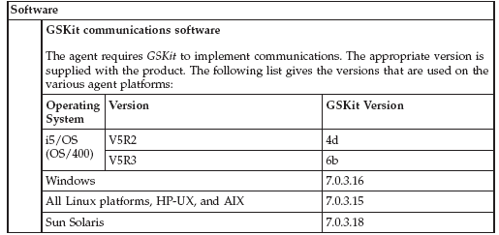

GSKit Installation Rules:

1. If the target machine has already installed GSKit 6 version or earlier versions the agent will install also GSKit version 7.

2. If the target machine has already installed GSKit 7a, the agent will update it to the 7b or 7c version, but a reboot of the machine is needed.

3. If the target machine has already installed a later version of the GSKit, the agent will install also GSKit version 7.

 Note: On Windows endpoints, if the install agent command finds that GSKit is already in use, it cannot complete the installation until the computer is rebooted. It creates a file in the agent’s directory called reboot_needed.txt in which it stores this requirement by setting a variable called GSKFilesLocked to the value 1. A message is displayed informing the user that a reboot is required. The presence of this variable in this file prevents the agent from starting. When the computer is rebooted, and the GSKit files are unlocked, the installation of the agent is completed, and the file is deleted.

How check what version of GSKit is installed on the machine.

Windows platform registry keys should be checked:

HKEY_LOCAL_MACHINE\SOFTWARE\IBM\gsk7\CurrentVersion\

All other platforms check the files in the installation paths.

AIX
/usr/opt/ibm/gskta (for 32-bit application)
/usr/opt/ibm/gsksa (for 64-bit application)
SUN
/opt/ibm/gsk7

HP
/opt/ibm/gsk7

LINUX
/usr/local/ibm/gsk7
/usr/local/ibm/gsk7_gcc295 (for version compiled with gcc 2.95.3)

C Runtime Server prerequisites:

C Runtime server must be at level 6 or later.

AIX: Fix xlC.aix50.rte.6.0.0.3 APAR IY51805

Web Registration Software Requirements:

- The Internet Deployment or Installation method only allows the Web Deployment Method to be used. This requires a Web Browser to pull the agent code and install it on the target machine.

Browser
Windows | Microsoft Internet Explorer, version 6.x or later
iSeries and pSeries platforms | Mozilla, version 1.0
Other platforms | Mozilla, versions 1.4 or 1.5
Java Runtime Environment
iSeries and pSeries | Version 1.3.1 from Sun
Other platforms: | Version 1.4

 Note: If JRE is not present, and you are using Internet Explorer as your browser on a Windows platform and are connected to the Internet, the prerequisite version of JRE is installed automatically. In other circumstances, the Web deployment option directs you to the appropriate Web site, from where you can download and install JRE manually. Alternatively, you should install the required version of JRE before commencing the Web deployment.

Agent Installation Procedures

Software Distribution:
If software distribution is a possibility, the account will create a distribution package and will create a schedule to distribute. If your account was not initially targeted for software distribution but you do have that capability and would like to use it to deploy the TLCM agent, contact your SwLM coordinator.

 Note: however, that modifying the TLCM distribution package template that has been created may require substantial effort and may not be possible within the timeframe available for deployment. In this case, Web or command line deployment will have to be used.

 Note: To avoid assigning servers/desktops to the incorrect division when an electronic distribution package (i.e. ESD) to install. Please ensure that the btbs.division id corresponds to the division ids provided by the SwLM Coordinator. See below for example:

Parameter | Value | Comments
btbs.division | 8 | Unique identifier of the division to which the new agent is assigned. This is provided by your SwLM coordinator.

Command Line Registration:

The responses file contains values for options that enable the Tivoli License Manager Install setup file to be run from the command line.

A common use of an options file is to run the wizard in silent mode. This lets the options file author specify wizard settings without having to run the wizard in graphical mode. To use this options file in silent mode, use the following command line arguments when running the wizard:

sourcePath -options ResponsePath –silent

Ex: c:\temp\platform –options c:\temp\acct-response.txt –silent

TLCM Agent Install Command lines:

WINDOWS:
sourcePath -options ResponsePath –silent

AIX (5.2, 5.3):
sourcePath -options ResponsePath –silent

Sun (32 Bit):
sourcePath -options ResponsePath –silent

Sun (64 Bit):
sourcePath -options ResponsePath –silent

HP:
sourcePath -options ResponsePath –silent

Linux Intel (2.1):
sourcePath -options ResponsePath –silent

Linux Intel (sles8):
sourcePath -options ResponsePath –silent

Linux Intel (sles9-rhel3):
sourcePath -options ResponsePath –silent

Linux iSeries/pSeries (sles8):
sourcePath -options ResponsePath –silent

Linux iSeries/pSeries (sles9-rhel3):
sourcePath -options ResponsePath –silent

Linux zSeries/s390 (sles8):
sourcePath -options ResponsePath –silent

Linux zSeries/s390 (sles9-rhel3):
sourcePath -options ResponsePath –silent

TLCM AGENT CODE:
ftp://ftp.software.ibm.com/software/tivoli_support/patches/patches_2.2.0/2.2.0-TIV-TLCM-FP0004/

Estimated time to download is approximately 15 – 30 minutes.

Please be sure to download the “Manual Deploy” for your operating system. This file must be unzipped and copied to any directory on the server. The approximate time is 3 – 5 minutes

The response file will be sent directly to the System Administrator by the SwLM Coordinator. This file contains the unique parameters for each account; such as division, organizational name, and TLCM runtime server IP address.

TLCM Internet Deployment:

The internet server ONLY allows the Web Deployment method to be used. This requires a web browser to be available on the machine to pull the agent.

The required parameters found in the response file are as follows:

Parameter | Description | Value
Sourcepath | The location path to the exe file. | Depended on where you put the unzip files.  Example: Windows C:\tmp\win32  Unix /tmp/agentdownload/OS
ResponsePath | The location path of the *_response.txt file. | Example: Windows - c:\temp\  Unix /tmp/agentdownload
Division Name | The name of the division to which the new agent is assigned. This division must be already set up for the runtime server to which the agent is to be attached. | Provided to you by the SwLM Coordinator
Organization Name | The name of the organization to which the divisions are assigned. The organization is set up on the TLCM runtime server during configuration and setup. | Provided to you by the SwLM Coordinator
Runtime server Address | The host name or IP address of the runtime server that this agent is to use. | 129.39.204.XX provided by the SwLM Coordinator

Again, the response file will be provided to you by the SwLM Coordinator.

Command Line Install Steps:

- 1. Download the TLCM agent code from the website, ftp://ftp.software.ibm.com/software/tivoli_support/patches/patches_2.2.0/2.2.0-TIV-TLCM-FP0004/
- Save file and note the location where this file has been saved.
- Unzip the TLCM agent code that was just saved in step 2.
- Save the response file sent to you from the SwLM Coordinator to the same directory that you used in step 2 (example: account name_response.txt).
- Please note this is the recommended place to save the files.
c:\temp\ to save the account name_response.txt
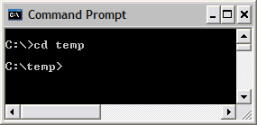

6. This is where the executable file resides.
c:\temp\win32\
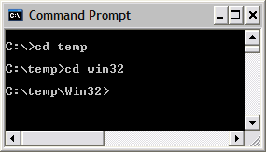

Sample Command Line - The executable and the response file name will vary by Operating System

C:\temp>c:\temp\win32\2.2.0-TIV-TLCM-FP0004-Manual-Deployment.exe -options c:\temp\2.2_account name_test.txt –silent

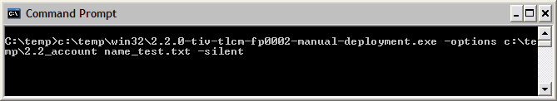

Confirm the agent is communicating with the following commands:

- Confirm the agent is communicating to the Runtime Server by issuing the following command:

C:\windows\itlm\tlmagent –p

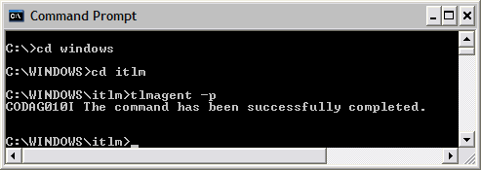

- You can also run an initial scan of the endpoint by issuing the following command.

C:\windows\itlm\tlmagent –s

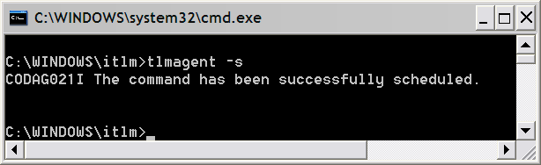

UNIX Installs:

- Create a directory called agentdownload under /tmp directory
- Download agent code (based on OS) from the website below:

ftp://ftp.software.ibm.com/software/tivoli_support/patches/patches_2.2.0/2.2.0-TIV-TLCM-FP0004/
Note: If a browser is not available on the target machine, download it to your machine, and FTP the agent code it to the target machine. Continue with the Steps below:

- Save the file to: /tmp/agentdownload
- CD to that directory
- Unzip the TLCM agent code that was saved in Step 1
- Save the response file that was sent to you from the SwLM coordinator to the same directory in step 1 (/tmp/agentdownload)

- You must be a root user to install the TLCM agent code.
- Make the setup (2.2.0-TIV-TLCM-FP0004-Manual-Deployment.bin) file an executable (chmod 755) before running it.

This is where the executable file resides.
/tmp/agentdownload/OS/

Note: The executable and response file name will vary by Operating System (OS).

Sample Command Line

/tmp/agentdownload/OS>/tmp/agentdownload/OS/2.2.0-TIV-TLCM-FP0004-Manual-Deployment.bin -options /tmp/agentdownload/2.2_account name_test.txt –silent

Note: On Unix Platform, commands must be run from the /usr/sbin folder, or the command must be included in the PATH variable. The user again must be root.

Confirm the agent is communicating with the following commands.

/usr/sbin/tlmagent -p

/usr/sbin/tlmagent –s

Web Registration
Web registration involves logging in to the TLCM website from each endpoint server and following the registration process to download the TLCM agent code to that server.

The internet server ONLY allows the Web Deployment method to be used. This requires a web browser to be available on the machine to pull the agent.

Web registration should take no longer than seven minutes per server, and will usually take significantly less than that. Note that one or more security warnings may appear during the Web registration process. All such warnings should be accepted.

Web Registration Install Steps:

    - Logon to your browser and enter the proper URL for the server being deployed as follows:

https://Runtime Server Name/slmruntime/register

Runtime Server Name is the hostname or IP address of the runtime server associated with that endpoint.

    - Complete the web form by providing the following information:

- Division (the TLCM Division name assigned to the endpoint)
- Server Name (the name of the TLCM runtime server associated with the endpoint)
  - DO NOT CHANGE SERVER NAME

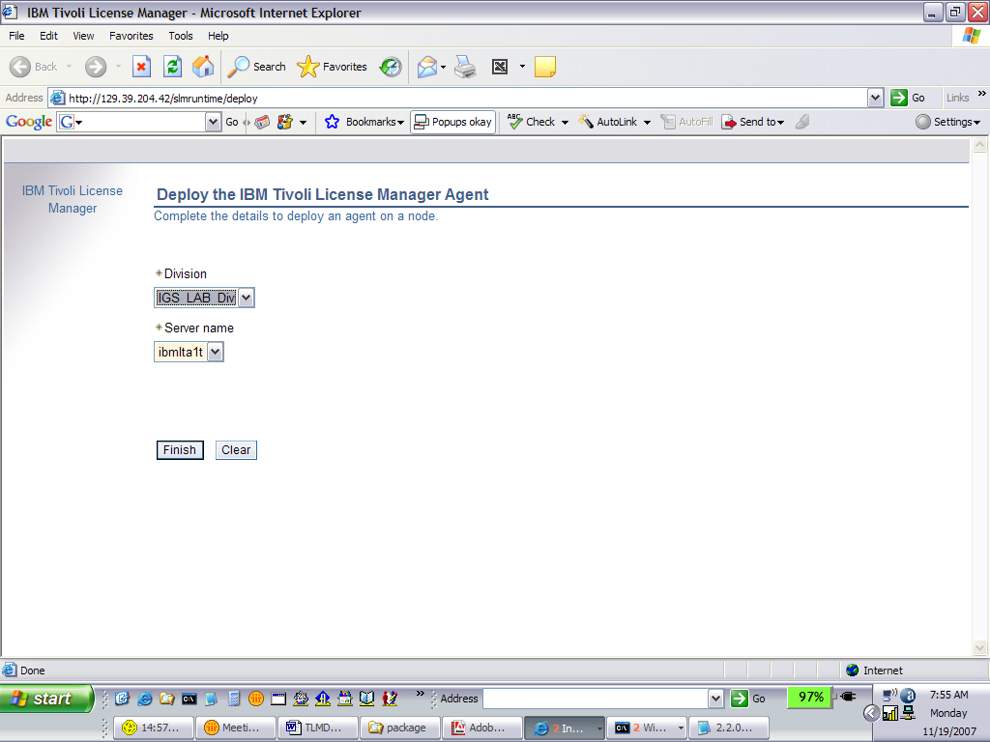

- Click the Finish button and agree to all security warnings that appear. (Once this registration process is complete and the TLCM code has been downloaded, TLCM will have the ability to monitor software usage and scan for software products installed on the endpoint server.)

Agent Uninstall Procedures

Uninstall agents on Windows platforms

To uninstall the Tivoli License Manager agent from a Windows node, complete the following steps:

1. On the node where the agent is installed, open a command prompt window.

2. Change to the directory: WINDOWS\ITLM

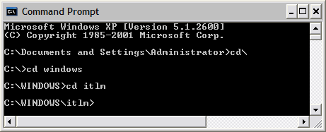
3. Enter the command: tlmunins.bat. If the agent is running it will be stopped. The agent files will be deleted.
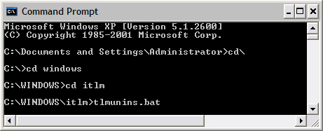

- Delete the ITLM folder from c:\windows.
- If unable to locate, please do a search on ITLM.

Uninstall agents on UNIX platforms

To uninstall the Tivoli License Manager agent from a UNIX node, complete the following steps:

1. On the node where the agent is installed, open a shell window.

2. Change to the directory: /var/ITLM

3. Enter the command: ./tlmunins.sh. If the agent is running it will be stopped. The agent files will be deleted.

- Delete the directory to remove any remaining files that were not cleaned up with the tlmunins command(s)

How to install with VMWare

First, the TLCM agent is not supported on the Host Server because of the VMWare Host OS.

Secondly, the TLCM agent install on the clients is the basic installation procedures for the agent (regardless of OS)

Note: Perl must be installed on the Host Server and the following files MUST be present on the Host server:

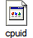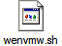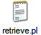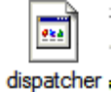

Run the wenvmw.sh script (this will callthe other 3 files).
Once that is performed successfully, the client agents can be installed using normal installation methods.

************************************************************************

1. On the VM HOST run the CIT Enabler code using the -v option.
How to run CIT Enabler
For VMWare Windows HOST
- Place the wenvmw.exe, cpuid.exe, and retrieve.pl in the same dir
- Run wenvmw.exe -v
- Check the two log files created in the same dir to determine if run was successful
- retr_out.txt and en_out.txt
- If not successful the log files will tell you what was missing/culprit

For VMWare Linux HOST
- Place the wenvmw.sh, cpuid.exe, dispatcher and retrieve.pl in the same dir
- Run wenvmw.sh -v
- Check the two log files created in the same dir to determine if run was successful
- retr_out.txt and en_out.txt
- If not successful the log files will tell you what was missing/culprit

For MS Virtual Server Windows HOST
- Place the wenmsvs.exe and cpuid.exe in the same dir
- Run wenmsvs.exe -v
- Check the two log files created in the same dir to determine if run was successful
- retr_out.txt and en_out.txt
- If not successful the log files will tell you what was missing/culprit

2. Install the agent on the VM GUEST machine using the same LMT code/mechanism as you did for your other LMT agent installs. (Reminder please check the NOTES section below)

Online Link -->
http://publib.boulder.ibm.com/infocenter/tivihelp/v3r1/index.jsp?topic=/com.ibm.license.mgmt.planinconf.doc/tlminmst04.htm

Common Inventory Technology (CIT) enabler The enabler is a script that enables the CIT to obtain information about partitioned environments. It is required on hosts that have guest operating systems running under VMWare or Microsoft Virtual Server. You can find the necessary files in the enabler directory on the installation DVD, or, in the platform-specific zip file if you have downloaded the agent installer from the Passport Advantage® web site. You can find the necessary files in the enabler directory on the installation DVD, or, in the platform-specific zip file if you download the agent installer from the Passport Advantage web site. Copy the files that are relevant to your partitioning technology and platform to any directory on the host virtual server system (for example, VMWare ESX Server). You must run the enabler script for the first time before deploying an agent (wenvmw.exe on Windows and wenvmw.sh on Linux). All guest operating systems must be active when the script runs.

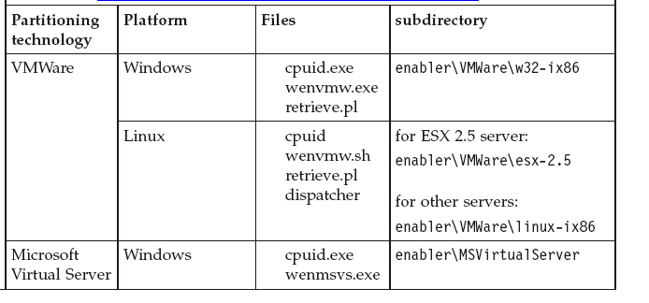

Notes:

1. Fix Pack 1 On platforms where Microsoft Virtual Server is installed, the Microsoft Virtual Machine Additions service must be installed and active.
2. Fix Pack 1 On platforms where VMware is installed, VMware Tools must be installed.
3. Fix Pack 1 On platforms running Red Hat Linux, the enabler requires the compatibility packs. Contact your TLCM support team for details.
4. Fix Pack 1 The enabler requires compat-libstdc++ library to be installed in the Linux operating system.

Online Link ====>
http://publib.boulder.ibm.com/infocenter/tivihelp/v3r1/index.jsp?topic=/com.ibm.license.mgmt.planinconf.doc/tlminmst07.htm
(Click on Deploying and managing agents in partitioned environments)

If you are deploying agents on the guest operating systems hosted by VMware ESX Server 2.5, ensure that the VMware Guest API is enabled in the guest operating systems. On platforms where Microsoft Virtual Server is installed, the Microsoft Virtual Machine Additions service must be installed and active. If you are deploying agents on the guest operating systems hosted by any of the supported VMware servers or Microsoft Virtual Server, schedule the script - CIT enabler on the host to run at regular intervals to detect any changes in the configuration of partitions. The script does not provide a scheduling mechanism - you need to use the mechanism built into your operating system (for example, you might use cron time-based scheduling service on a Unix machine). It is advisable to set the scheduling mechanism to run the script every hour but a different frequency might be set depending on the unique configuration of your partitions. All guest operating systems must be active when the script runs. The script should be run for the first time before agents are deployed. If an agent is deployed before the script runs, it cannot obtain complete information about the configuration of partitions and when it is registered on the administration server it is assigned a status of "Agent Incomplete". Running the script resolves this problem. In order to start the script you need to run the wenvmw.exe file on Windows and wenvmw.sh one on Unix machines. It is important to run the script in verbose mode (as no output is recorded) and the log files are created in the script directory. If the scripts and related files are not present on the host computer, you must copy them from the server DVD or the administration server. After you have installed an agent in a VMware partition, use the VMware utilities to associate the command that stops the agent to the operation that puts the virtual machine in stand-by mode and the command that starts the agent to the operation that resumes the virtual machine.

Appendix A

Example of the FTP web site

ftp://ftp.software.ibm.com/software/tivoli_support/patches/patches_2.2.0/2.2.0-TIV-TLCM-FP0004/

04/14/2008 01:38PM 197,090,391 2.2.0-TIV-TLCM-FP0004-ManualDeploy-AIX.zip
04/14/2008 12:36PM 220,013,653 2.2.0-TIV-TLCM-FP0004-ManualDeploy-Hpux.zip
04/14/2008 01:38PM 200,254,672 2.2.0-TIV-TLCM-FP0004-ManualDeploy-Linux.zip
04/14/2008 11:36AM 184,380,134 2.2.0-TIV-TLCM-FP0004-ManualDeploy-Solaris.zip
04/14/2008 11:36AM 196,508,999 2.2.0-TIV-TLCM-FP0004-ManualDeploy-Win32.zip
04/14/2008 11:35AM 194,662,548 2.2.0-TIV-TLCM-FP0004-ManualDeploy-linux390.zip
04/14/2008 12:36PM 194,737,275 2.2.0-TIV-TLCM-FP0004-ManualDeploy-linux390_64.zip
04/14/2008 12:36PM 205,397,391 2.2.0-TIV-TLCM-FP0004-ManualDeploy-linuxPPC_64.zip
04/14/2008 01:37PM 197,732,525 2.2.0-TIV-TLCM-FP0004-ManualDeploy-linuxSLES8PPC_64.zip
04/14/2008 12:36PM 192,994,483 2.2.0-TIV-TLCM-FP0004-ManualDeploy-linux_64.zip

