


Tivoli License Compliance Manager v2.3 Agent
Deployment Guide

IBM Global Services
Asset Management Delivery Services

Document Owner: US TLCM TEAM
Department: Americas AMSD Software Asset Mgmt
Document Version: 3.0

Last Update: March 25, 2009

File Name: TLCM 2.3 Deployment Guide v3
I. Introduction 3
A. Target Audience 3
B. Project Scope 3
II. Basic TLCM Information 4
A. Product Description 4
B. Supported Platforms 4
1. TLCM v2.3 Agent Supported 4
2. TLCM Agent Communication to the RunTime Server 6
III. Agent Deployment Strategy and Planning 6
A. Agent Deployment start up and completion 6
B. Account Firewalls 6
C. Agent Roll out Plan 6
D. Tracking Deployed Servers/Desktops 7
E. Handling Discrepancies 7
F. Problems, Questions or Issues During Deployment 7
G. Pre-Deployment Preparation List 8
IV. Agent Installation 9
A. Agent prerequisites 9
1. WebSphere Application Server (for WebSphere Application Server applications) 9
2. Space prerequisites 12
3. GSKit prerequisites: 15
4. C Runtime Server prerequisites: 16
5. Web Registration Software Requirements: 16
B. Agent Installation Procedures 17
1. Software Distribution: 17
2. Command Line Registration: 17
3. Web Registration 22
C. Agent Uninstall Procedures 23
D. Example of the FTP web site 25

Introduction
This guide provides the information needed to deploy the Tivoli License Compliance Manager (TLCM) agent to the servers and/or desktops in your organization. Background information on TLCM and the overall TLCM deployment project are also provided as general information and to present the larger context into which this agent deployment activity fits.

This document is broken into the following major sections:
- Project Scope – Describes the scope of the TLCM deployment for this project.
- Basic TLCM Information – Provides general TLCM product information, an overview of the TLCM infrastructure implemented for this project, and links to additional TLCM information.
- Agent Deployment Strategy and Planning – Provides an overview of how the agent deployment activity is being handled, including the deployment methods available, roles and responsibilities, deployment timing, deployment support, etc.
- Agent Installation Procedure – Provides a step-by-step procedure for deploying the agent, based on the deployment methods available.

This document is not intended to provide detailed information on how TLCM functions or the data it generates. Neither is it intended to provide detailed information on the TLCM steady state service or cost models.

Target Audience
This Document is intended to be used by the following teams to understand the TLCM deployment and TLCM agent installation.

- SSO Delivery Architects
- SSO TLCM Subject Matter Experts
- Americas Asset Management Delivery Service (AMDS) - Software License Management (SwLM) Subject Matter Experts
- Service Delivery Account Teams
  - Transition and Project Managers
  - Account SwLM Administrators
  - Server System Administrators
  - Software Distribution
  - Deskside Support

Project Scope
Servers considered in scope for deployment include:
- IBM owned servers containing IBM owned software
- IBM owned servers containing customer owned software
- Customer owned servers containing customer owned software where IBM has a contractual obligation to provide software license management services for the customer
- Customer owned servers containing IBM owned software (even when there is no software license management contractual obligation on IBM’s part)

Servers considers out of scope include:
- Customer owned servers containing customer owned software where IBM has no contractual obligation to provide software license management services for the customer.
- Servers and accounts where an existing TLCM deployment project is already in progress.
- Specific servers and accounts may be exempted from deployment on a case-by-case basis as logistical, technical or legal circumstances dictate.

Basic TLCM Information

Product Description
TLCM is an enterprise IT Solution designed to monitor and manage software products running on a large infrastructure. Basic TLCM functionality includes the ability to:

- Extract the software executables about products installed and used at the customer site using the SigBank.

- Provide usage reports to determine how many times a product has been used in a given month.
- Provide inventory reports to show the software running on servers/workstations.

Supported Platforms

TLCM v2.3 Agent Supported
Table 4. Supported agent platforms
Platform
system | Version | packs
Windows | 2000 Server (32/64 - bit)
Windows | 2000 Advanced Server (32/64 - bit)
Windows | Server 2003 Standard or Enterprise Edition (32-bit)
Windows | Server 2003 Standard or Enterprise Edition (64-bit) on EMT64 and AMD64
Windows | XP Professional
Windows | Vista
IBM AIX | 5.3 (32-bit) | xlC.aix50.rte.6.0.0.3 or later APAR IY51805 Maintenance level 3 to support sub capacity pricing on Power 5
IBM AIX | 5.3 (64-bit) | xlC.aix50.rte.6.0.0.3 or later APAR IY51805 Maintenance level 3 to support sub capacity pricing on Power 5
IBM AIX | 5.2 (32-bit) | xlC.aix50.rte.6.0.0.3 or later APAR IY51805
IBM AIX | 5.2 (64-bit) | xlC.aix50.rte.6.0.0.3 or later APAR IY51805
i5/OS | V5R4 | Options 13 and 30 of 5722SS1
i5/OS | V5R3 | Options 13 and 30 of 5722SS1
i5/OS | V5R2 | ##############################################
HP-UX | 11i v2 on PA-RISC 2.0 32-bit | Patches PHSS_26560, PHSS_26946, PHSS_28880, PHSS_33033, PHCO_31923, and PHCO_31903
HP-UX | 11i v2 on PA-RISC 2.0 64-bit (in 32-bit compatibility mode) | Patches PHSS_26560, PHSS_26946, PHSS_28880, PHSS_33033, PHCO_31923, and PHCO_31903
HP-UX | 11i v2 on Itanium® 2 Integrity Server
Red Hat Enterprise Linux | ES/AS/WS 4.0 for EM64T and AMD64 | Compatibility packs: 1. libgcc-3.4.3-9 (32-bit) 2. compat-libstdc++ -33-3.2.3-47.3.i386.rpm (must be installed in the specified order)
Red Hat Enterprise Linux | ES/AS/WS 4.0 for Intel x86 | Compatibility packs: compat-libstdc++ -33-3.2.3-47.3.i386.rpm
Red Hat Enterprise Linux | ES/AS/WS 3.0 for Intel x86 | Update 3
Red Hat Enterprise Linux | AS, version 4.0 for IBM iSeries and pSeries (64-bit) | Compatibility packs: 1. libgcc-3.4.3-9 (32-bit) 2. compat-libstdc++ -33-3.2.3-47.3.ppc.rpm (must be installed in the specified order)
Red Hat Enterprise Linux | AS, version 3.0 for IBM iSeries and pSeries (64-bit) | Update 2
Red Hat Enterprise Linux | AS, version 4.0 for IBM zSeries and IBM S/390 (31-bit ) on 64-bit hardware | Compatibility pack: compat-libstdc++ -33-3.2.3-47.3.s390.rpm
Red Hat Enterprise Linux | AS, version 3.0 for IBM zSeries and IBM S/390 (31-bit ) | Update 1
SUSE Linux Enterprise Server | 10 for Intel x86
SUSE Linux Enterprise Server | 10 for EMT64 and AMD64
SUSE Linux Enterprise Server | 10 for IBM iSeries/pSeries (64-bit)
SUSE Linux Enterprise Server | 10 for IBM zSeries and IBM S/390 (64-bit) on 64-bit hardware
SUSE Linux Enterprise Server | 9 for Intel x86 | Service pack 1 to support sub-capacity pricing on Power 5
SUSE Linux Enterprise Server | 9 for EMT64 and AMD64 | Service pack 1 to support sub-capacity pricing on Power 5
SUSE Linux Enterprise Server | 9 for IBM iSeries/pSeries (64-bit) | Service pack 1 to support sub-capacity pricing on Power 5
SUSE Linux Enterprise Server | 9 for IBM zSeries and IBM S/390 (31-bit ) | Service pack 1 to support sub-capacity pricing on Power 5
Sun Solaris | 10 Operating System for EMT64 and AMD64 platforms (64-bit)
Sun Solaris | 10 Operating System for SPARC platforms (32-bit)
Sun Solaris | 10 Operating System for SPARC platforms (64-bit)
Sun Solaris | 9 Operating System for SPARC platforms (32-bit)
Sun Solaris | 9 Operating System for SPARC platforms (64-bit)
HP | HP-UX 11i on PA-RISC 2.0 | nPAR vPAR
HP | HP-UX 11i v2 on Itanium 2 Integrity Server | HP Integrity Virtual Machines nPAR
IBM iSeries | i5/OS V5R4 | LPAR
IBM iSeries | i5/OS V5R3 | LPAR
IBM iSeries | i5/OS V5R2 | LPAR
IBM iSeries | Red Hat Enterprise Linux, AS, versions 4.0 | LPAR Virtualization Engine™
IBM iSeries | Red Hat Enterprise Linux, AS, versions 3.0 | LPAR Virtualization Engine™
IBM iSeries | SUSE Linux Enterprise Server, version 10 | LPAR Virtualization Engine™
IBM iSeries | SUSE Linux Enterprise Server, version 9 | LPAR Virtualization Engine™
IBM pSeries | AIX® 5.3 | LPAR DLPAR
IBM pSeries | AIX 5.2 | LPAR DLPAR
IBM pSeries | Red Hat Enterprise Linux, AS, versions 4.0 | LPAR Virtualization Engine
IBM pSeries | Red Hat Enterprise Linux, AS, versions 3.0 | LPAR Virtualization Engine
IBM pSeries | SUSE Linux Enterprise Server, version 10 | LPAR Virtualization Engine
IBM pSeries | SUSE Linux Enterprise Server, version 9 | LPAR Virtualization Engine
IBM zSeries | Red Hat Enterprise Linux, AS, versions 3.0 | Linux on z/VM®
IBM zSeries | Red Hat Enterprise Linux, AS, versions 4.0 | Linux on z/VM®
IBM zSeries | SUSE Linux Enterprise Server, version 9 | Linux on z/VM®
Intel x86 | Windows Server 2003 Standard or Enterprise Edition (32-bit) Windows XP Professional | VMware ESX Server 3.0 VMware ESX Server 2.5 VMware GSX Server 3.1 Microsoft® Virtual Server 2005VMware Server 1.0
Intel x86 | Red Hat Enterprise Linux ES/AS/WS 4.0 | VMware ESX Server 3.0 VMware ESX Server 2.5 VMware GSX Server 3.1 VMware Server 1.0
Intel x86 | Red Hat Enterprise Linux ES/AS/WS 3.0 with update 3 | VMware ESX Server 3.0 VMware ESX Server 2.5 VMware GSX Server 3.1 VMware Server 1.0
Intel x86 | SUSE Linux Enterprise Server, version 10 | VMware ESX Server 3.0 VMware ESX Server 2.5 VMware GSX Server 3.1 VMware Server 1.0
Intel x86 | SUSE Linux Enterprise Server, version 9 | VMware ESX Server 3.0 VMware ESX Server 2.5 VMware GSX Server 3.1 VMware Server 1.0
Sun | Solaris, version 10 | Dynamic System Domains Containers
Sun | Solaris, version 9 | Dynamic System Domains
Windows 2000
VMWARE | ESX/GSX 2.5/3.1
VMWARE | ESX --> 2.5
VMWARE | GSX --> 3.1
and MS Virtual Server 2005

TLCM Agent Communication to the RunTime Server

The TLCM agent once installed will communicate with the TLCM Runtime (collection) server.

Agent Deployment Strategy and Planning

The TLCM agent can be deployed in the three following ways:
- Software distribution, for those servers/desktops with software distribution capability
- Command line
- Web registration, for servers/desktops with a supported browser

Agent Deployment start up and completion
The agent deployment start up for each account is dependent on the completion of its associated TLCM account configuration. When the configuration is complete, tested and the deployment information delivered to and reviewed with the account teams performing the install, deployment will begin.

Account Firewalls
These are IBM servers and should be on the 9 Dot

Agent Roll out Plan
Once you have the information needed and the go-ahead from the SwLM Coordinator. Identify your approach to deployment before beginning the deployment process, especially if the number of servers/desktops being deployed is large. The order in which the servers/desktops are deployed is largely the account team decision and can be based on the typical deployment procedures used in the account organization. For instance, you may choose to deploy to a set of test servers in the account organization first, as an additional way of ensuring that TLCM will run properly in your environment. It is strongly recommended that you deploy to a set of test or pilot servers/desktops before beginning a large roll out. TLCM has been tested on most platforms. However, nothing can duplicate your account’s environment. Your SwLM Coordinator will be available to assist you if you have questions about how to organize the deployment in your organization.

Tracking Deployed Servers/Desktops
A method to track what has been deployed should be determined before roll out. This will assist you in tracking the progress of deployment. The SwLM Coordinators will monitor the progress of each account and assist in any situations where meeting the deployment end date appears to be in jeopardy.
Typically we track rollout in this manner.

Servers: Each account install team will be asked to submit an updated list of the hostnames of active servers in the environment. This list will be matched against the servers recognized by TLCM to ensure that each server was deployed correctly.

Desktops: In most cases we do not have a list of desktop hostnames. In the case of desktops, the account typically has a number of desktops believed to be in the each of the divisions created. The number of agents deployed in the division is compared to the division estimates to track the progress of deployment.

Handling Discrepancies
Because any environment is dynamic, and because a complete wall-to-wall inventory of servers/desktops is not performed as part of the TLCM deployment project, the project team expects that some servers/desktops on the in scope list will no longer be active and some are not originally identified should be added to the list. To ensure that all identified in scope servers/desktops are accounted for, you will be asked to handle server discrepancies as follows:
- For servers on the deployment list that are no longer active, indicate “Inactive” in the status column for that server.
- For newly identified servers not on the deployment list, enter the appropriate server information on the list and install the agent code on the server.
- As desktops are typically estimates, you may only want to investigate discrepancies beyond a certain tolerance. For example, if the TLCM agents in a division are within +/-10% of the original estimate, you may consider that acceptable. Anything beyond that range is considered a discrepancy and worth investigating. You should determine this tolerance level before deploying agents.

Problems, Questions or Issues During Deployment
Your SwLM Coordinator will be the single point of contact (SPOC) for any questions or problems that you have during the deployment process. The SwLM Coordinator will typically be the steady state TLCM Admin for your account. Team member assigned to your account, as identified below:

SwLM Coordinator | e-Mail | Phone
Darlene Fletcher | Darlene Fletcher/St Louis/IBM | 618-931-0217

Support during normal business hours:
Your SwLM Coordinator will be available during normal business hours by e-mail, Sametime, or phone. If the SwLM Coordinator cannot resolve your problem or answer your question immediately, they will coordinate with the appropriate TLCM support person(s) to get it resolved as soon as possible.

Alternatively, you can enter a ticket into the Global Tools Problems / Requirement.

http://tap.raleigh.ibm.com/

Support after hours:
Alternatively, you can enter a ticket into the Global Tools Problems / Requirement.

http://tap.raleigh.ibm.com/

Pre-Deployment Preparation List

- Review this document in detail to ensure you understand it.
- Ensure that you have provided your SwLM Coordinator with the exact day and time the TLCM monthly scan for the servers in your account.
- Ensure all change control has been properly submitted and is complete
- Develop your approach to deployment
  - Do you want to deploy to test servers first? (strongly recommended)
  - Do you need additional resources from your organization to complete the deployment within the given timeframe?
  - Do you want to roll-out agents by location or some other strategy?
- If necessary, ensure everyone on your deployment team knows which servers they are responsible for deploying and that they have all the required information for those servers.
- Ensure everyone on your deployment team as the name and contact information of the SwLM Coordinator.
- Are you installing the TLCM Agent on a server that is running Web Sphere Application Server? If so, please review the Web Sphere Application Server section under the Agent prerequisites section below.

Agent Installation

Agent prerequisites

WebSphere Application Server (for WebSphere Application Server applications)

The Tivoli License Compliance Manager agent has a subagent, named WebSphere agent, that is responsible for monitoring J2EE applications. The WebSphere agent is automatically downloaded to monitored computers when at least one of the
following Web application servers is present on the computer:

WebSphere Application Server, version 5.1
WebSphere Application Server, version 5.0
WebSphere Portal, version 5.0
WebSphere Portal, version 5.1
WebSphere Portal, version 6.0
Websphere Portal, version 6.1
Websphere Portal, version 7.0

The WebSphere agent is controlled by the Tivoli License Compliance Manager agent. The WebSphere agent is downloaded from the Tivoli License Compliance Manager runtime server at the agent installation. It is started by the Tivoli License
Compliance Manager agent when a specific agent procedure, called discovery, identifies installations of WebSphere products on the monitored system. The WebSphere agent, based on Java technology, analyzes each WebSphere installation
looking for WebSphere Servers to monitor: for each server found, it creates a Java Management eXtensions (JMX) client that tracks the usage of the server itself and the hosted J2EE applications. The WebSphere agent is installed in the Tivoli License Compliance Manager agent home directory; specifically it is located in the <AGENT_HOME>\wasagent directory.

Additional Space

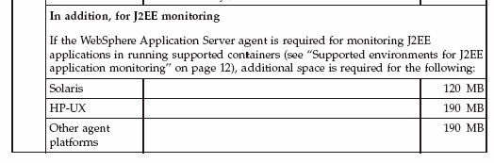

You will need the userid/password that is used to get access to the Websphere Administration console (e.g. wasadmin/mypassword).

The TLCM agent needs to have a look into the Websphere configuration to find which J2EE applications are installed. If you are running WebSphere in secure mode (what is usually needed because of ITSC104) you will need the userid/password to get access to the WebSphere configuration and to detect the installed WebSphere applications. Contract your Websphere support for this ID\Password.

The userid and encrypted password is stored in: /var/itlm/wasagent/credentials.properties

Accessing WebSphere agent command line:
This topic describes the methods of accessing the command-line interface for Tivoli License Compliance Manager Agents on Windows and UNIX platforms by entering the command WASAgentClient. When you access the WebSphere agent command line using the WASAgentClient command, you will be in interactive mode.

To leave the command line interactive mode you must enter the following command:

Exit

Accessing the WebSphere agent command line on Windows and UNIX agents

Windows Open a Windows command prompt session and do the following:
1. Change to the directory:
<AGENT_HOME>\wasagent

2. Enter the command:
./WASAgentClient.bat

UNIX

1. Open a shell window and change to the directory:
<AGENT_HOME>/wasagent
2. Enter the command:
./WASAgentClient.sh

WebSphere agent commands
This topic describes the commands available in the WebSphere agent command line.

servers
Lists the WebSphere servers identified by the WebSphere agent.

Comments
This command provides a list of the WebSphere servers which have been identified by the WebSphere agent. The servers command also detects the status of the identified WebSphere servers. The possible servers’ status:

INVALID

The WebSphere server has been discovered but it is not running.

MANAGED

The WebSphere server is currently managed by the WebSphere agent.

UNMANAGED

The identified WebSphere server is running but the WebSphere agent
cannot manage it because the global security is enabled and the credentials
used are not known to the WebSphere command).

Parameters
None.

Authorization
Windows - a user with administrator rights.

UNIX - root

Examples
To know the list of servers currently detected by the WebSphere agent, from the
WebSphere agent command line, enter the command as follows:

C:\WINNT\itlm\wasagent\wasagentclient
---------------------------------------------------
-------------- WAS AGENT CLI ----------------------
---------------------------------------------------
CODWA1012I Now type the command servers

CODWA1011I Waiting for a resource to handle the connection...
ID-> 2 SERVERNAME-> IBM_TLM_Runtime_Server STATUS-> UNMANAGED
PRODUCT-> IBM WebSphere Application Server - BASE - 6.0.2.0
SOAP-PORT-> 8881 RMI-PORT-> 2810 HOSTNAME-> 9.132.237.61
CONFIGURATION-> C:\Program Files\IBM\WebSphere\AppServer:
default:lab237061Node1Cell:lab237061.romelab.it.ibm.com:
IBM_TLM_Runtime_Server
ID-> 1 SERVERNAME-> server1 STATUS-> UNMANAGED
PRODUCT-> IBM WebSphere Application Server - BASE - 6.0.2.0
SOAP-PORT-> 8880 RMI-PORT-> 2809 HOSTNAME-> 9.132.237.61
CONFIGURATION-> C:\Program Files\IBM\WebSphere\AppServer:
default:lab237061Node1Cell:lab237061.romelab.it.ibm.com:
server1
CODWA1008I The List Servers command has been successfully completed.

Credentials
Allows you to enter the security credentials to enable the monitoring of an UNMANAGED WebSphere server.

Comments
You can use this command to provide the security credentials to enable the monitoring of a WebSphere server detected in UNMANAGED status by the servers command of the WebSphere agent.

Parameters
<server ID>
Required. The WebSphere server ID as reported by the servers command.
<username>
Required. The user name used by WebSphere server as security credential during the global security enablement procedure.
<password>
Required. The password used by WebSphere server as security credential during the global security enablement procedure.
persist
Optional however recommended. If you use persist, the next time the agent starts it uses the credentials you gave. If you do not use the persist option, you have to enter the credentials each time you start the agent.

Authorization
Windows - A user with administrator rights.
UNIX – root

Examples:

reloadconf
Reloads the WebSphere agent trace and logs configuration.

Comments
This command reloads the trace and logs configuration of the WebSphere agent, usually under supervision of the IBM Support team.

Parameters
None.
Authorization

Windows - A user with administrator rights.
UNIX – root

Examples
If you make any changes to the configuration, you can immediately apply them by launching the reloadconf command to reload the trace configuration, as follows:

C:\WINNT\itlm\wasagent\wasagentclient
---------------------------------------------------
-------------- WAS AGENT CLI ----------------------
---------------------------------------------------
CODWA1012I Now type the command.
reloadconf
CODWA1001I The WebSphere Application Server agent configuration file has been successfully reloaded.

Help

Provides a brief help about the WebSphere agent.

Comments

Provides a brief help about the WebSphere agent.

Space prerequisites

Space
 | For all agents
 | Platform | Resource type |  | Space required
 | AIX^{(R)} | For the agent code, in the agent installation directory (default /var/itlm). |  | 105 MB
 |  | For temporary storage of files before agent installation in the directory /tmp |  | 175 MB
 |  | For unpacking the files for agent installation, in the root file system |  | 50 MB
 |  | For deploying CIT component (default /opt/tivoli/cit) |  | 25 MB
 |  | Logs and traces in the Tivoli^{(R)} Common Directory |  | 30 MB
 |  | In the directory /usr/sbin | Space required at installation time only. No files actually stored. | 2 MB
 |  | In the directory /lib |  | 2 MB
 |  | In the directory /etc |  | 2 MB
 |  | In the root home directory |  | 20 MB
 | HP-UX (PARISC) | For the agent code, in the agent installation directory (default /var/itlm). |  | 250 MB
 |  | For temporary storage of files before agent installation in the directory /tmp |  | 310 MB
 |  | For unpacking the files for agent installation, in the root file system |  | 50 MB
 |  | For deploying CIT component (default /opt/tivoli/cit) |  | 20 MB
 |  | Logs and traces in the Tivoli Common Directory |  | 30 MB
 |  | In the directory /usr/sbin | Space required at installation time only. No files actually stored. | 2 MB
 |  | In the directory /lib |  | 2 MB
 |  | In the directory /etc |  | 2 MB
 |  | In the root home directory |  | 20 MB
 | HP-UX (IA64) | For the agent code, in the agent installation directory (default /var/itlm). |  | 210 MB
 |  | For temporary storage of files before agent installation in the directory /tmp |  | 270 MB
 |  | For unpacking the files for agent installation, in the root file system |  | 50 MB
 |  | For deploying CIT component (default /opt/tivoli/cit) |  | 20 MB
 |  | Logs and traces in the Tivoli Common Directory |  | 30 MB
 |  | In the directory /usr/sbin | Space required at installation time only. No files actually stored. | 2 MB
 |  | In the directory /lib |  | 2 MB
 |  | In the directory /etc |  | 2 MB
 |  | In the root home directory |  | 20 MB
 | Linux | For the agent code, in the agent installation directory (default /var/itlm). |  | 105 MB
 |  | For temporary storage of files before agent installation in the directory /tmp |  | 160 MB
 |  | For unpacking the files for agent installation, in the root file system |  | 50 MB
 |  | For deploying CIT component (default /opt/tivoli/cit) |  | 10 MB
 |  | Logs and traces in the Tivoli Common Directory |  | 30 MB
 |  | In the directory /usr/sbin | Space required at installation time only. No files actually stored. | 2 MB
 |  | In the directory /lib |  | 2 MB
 |  | In the directory /etc |  | 2 MB
 |  | In the root home directory |  | 20 MB
 | Solaris (Sparc) | For the agent code, in the agent installation directory (default /var/itlm). |  | 125 MB
 |  | For temporary storage of files before agent installation in the directory /tmp |  | 220 MB
 |  | For unpacking the files for agent installation, in the root file system |  | 50 MB
 |  | For deploying CIT component (default /opt/tivoli/cit) |  | 25 MB
 |  | Logs and traces in the Tivoli Common Directory |  | 30 MB
 |  | In the directory /usr/sbin | Space required at installation time only. No files actually stored. | 2 MB
 |  | In the directory /lib |  | 2 MB
 |  | In the directory /etc |  | 2 MB
 |  | In the root home directory |  | 20 MB
 | Solaris (x86) | For the agent code, in the agent installation directory (default /var/itlm). |  | 175 MB
 |  | For temporary storage of files before agent installation in the directory /tmp |  | 225 MB
 |  | For unpacking the files for agent installation, in the root file system |  | 50 MB
 |  | For deploying CIT component (default /opt/tivoli/cit) |  | 15 MB
 |  | Logs and traces in the Tivoli Common Directory |  | 30 MB
 |  | In the directory /usr/sbin | Space required at installation time only. No files actually stored. | 2 MB
 |  | In the directory /lib |  | 2 MB
 |  | In the directory /etc |  | 2 MB
 |  | In the root home directory |  | 20 MB
 | Windows | For the agent code, in the agent installation directory (default%WINDIR%). |  | 85 MB
 |  | For temporary storage of files before agent installation in the directory %TEMP% |  | 95 MB
 |  | For unpacking the files for agent installation, in the directory %WINDIR% |  | 50 MB
 |  | For deploying CIT component (default %WINDIR%\cit) |  | 10 MB
 |  | Logs and traces in the Tivoli Common Directory |  | 30 MB

Notes: If the agent or host has other Tivoli products installed, TLCM will put the log/trace files under the same structure. If TLCM is the first Tivoli product installed, it will be under /usr/ibm/tivoli/common/COD.

If you prefer to have the trace logs in another location of your choice, you need to create the file /etc/ibm/tivoli/common/cfg/log.properties with the command tivoli_common_dir=<Directory of your choice> before running the installagent command.

GSKit prerequisites:

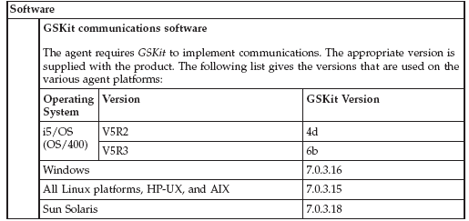

GSKit Installation Rules:

1. If the target machine has already installed GSKit 6 version or earlier versions the agent will install also GSKit version 7.

2. If the target machine has already installed GSKit 7a, the agent will update it to the 7b or 7c version, but a reboot of the machine is needed.

3. If the target machine has already installed a later version of the GSKit, the agent will install also GSKit version 7.

 Note: On Windows endpoints, if the install agent command finds that GSKit is already in use, it cannot complete the installation until the computer is rebooted. It creates a file in the agent’s directory called reboot_needed.txt in which it stores this requirement by setting a variable called GSKFilesLocked to the value 1. A message is displayed informing the user that a reboot is required. The presence of this variable in this file prevents the agent from starting. When the computer is rebooted, and the GSKit files are unlocked, the installation of the agent is completed, and the file is deleted.

How check what version of GSKit is installed on the machine.

Windows platform registry keys should be checked:

HKEY_LOCAL_MACHINE\SOFTWARE\IBM\gsk7\CurrentVersion\

All other platforms check the files in the installation paths.

AIX
/usr/opt/ibm/gskta (for 32-bit application)
/usr/opt/ibm/gsksa (for 64-bit application)
SUN
/opt/ibm/gsk7

HP
/opt/ibm/gsk7

LINUX
/usr/local/ibm/gsk7
/usr/local/ibm/gsk7_gcc295 (for version compiled with gcc 2.95.3)

C Runtime Server prerequisites:

C Runtime server must be at level 6 or later.

AIX: Fix xlC.aix50.rte.6.0.0.3 APAR IY51805

Web Registration Software Requirements:

- The Internet Deployment or Installation method only allows the Web Deployment Method to be used. This requires a Web Browser to pull the agent code and install it on the target machine.

Browser
Windows | Microsoft Internet Explorer, version 6.x or later
iSeries and pSeries platforms | Mozilla, version 1.0
Other platforms | Mozilla, versions 1.4 or 1.5
Java Runtime Environment
iSeries and pSeries | Version 1.3.1 from Sun
Other platforms: | Version 1.4

 Note: If JRE is not present, and you are using Internet Explorer as your browser on a Windows platform and are connected to the Internet, the prerequisite version of JRE is installed automatically. In other circumstances, the Web deployment option directs you to the appropriate Web site, from where you can download and install JRE manually. Alternatively, you should install the required version of JRE before commencing the Web deployment.

Agent Installation Procedures

Software Distribution:
If software distribution is a possibility, the account will create a distribution package and will create a schedule to distribute. If your account was not initially targeted for software distribution but you do have that capability and would like to use it to deploy the TLCM agent, contact your SwLM coordinator.

 Note: however, that modifying the TLCM distribution package template that has been created may require substantial effort and may not be possible within the timeframe available for deployment. In this case, Web or command line deployment will have to be used.

 Note: To avoid assigning servers/desktops to the incorrect division when an electronic distribution package (i.e. ESD) to install. Please ensure that the btbs.division id corresponds to the division ids provided by the SwLM Coordinator. See below for example:

Parameter | Value | Comments
btbs.division | 8 | Unique identifier of the division to which the new agent is assigned. This is provided by your SwLM coordinator.

Command Line Registration:

The responses file contains values for options that enable the Tivoli License Manager Install setup file to be run from the command line.

A common use of an options file is to run the wizard in silent mode. This lets the options file author specify wizard settings without having to run the wizard in graphical mode. To use this options file in silent mode, use the following command line arguments when running the wizard:

sourcePath -options ResponsePath –silent

Ex: c:\temp\platform –options c:\temp\acct-response.txt –silent

TLCM Agent Install Command lines:

WINDOWS:
sourcePath -options ResponsePath –silent

AIX (5.2, 5.3):
sourcePath -options ResponsePath –silent

Sun (32 Bit):
sourcePath -options ResponsePath –silent

Sun (64 Bit):
sourcePath -options ResponsePath –silent

HP:
sourcePath -options ResponsePath –silent

Linux Intel (2.1):
sourcePath -options ResponsePath –silent

Linux Intel (sles8):
sourcePath -options ResponsePath –silent

Linux Intel (sles9-rhel3):
sourcePath -options ResponsePath –silent

Linux iSeries/pSeries (sles8):
sourcePath -options ResponsePath –silent

Linux iSeries/pSeries (sles9-rhel3):
sourcePath -options ResponsePath –silent

Linux zSeries/s390 (sles8):
sourcePath -options ResponsePath –silent

Linux zSeries/s390 (sles9-rhel3):
sourcePath -options ResponsePath –silent

TLCM AGENT CODE:
ftp://service.boulder.ibm.com/software/tivoli_support/patches/patches_2.3.0/2.3.0-TIV-TLCM-FP0004/

Estimated time to download is approximately 15 – 30 minutes.

Please be sure to download the “Manual Deploy” for your operating system. This file must be unzipped and copied to any directory on the server. The approximate time is 3 – 5 minutes

The response file will be sent directly to the System Administrator by the SwLM Coordinator. This file contains the unique parameters for each account; such as division, organizational name, and TLCM runtime server IP address.

TLCM Internet Deployment:

The internet server ONLY allows the Web Deployment method to be used. This requires a web browser to be available on the machine to pull the agent.

The required parameters found in the response file are as follows:

Parameter | Description | Value
Sourcepath | The location path to the exe file. | Depended on where you put the unzip files.  Example: Windows C:\temp\win32  Unix /tmp/agentdownload/OS
ResponsePath | The location path of the *_response.txt file. | Example: Windows - c:\temp\  Unix /tmp/agentdownload
Division Name | The name of the division to which the new agent is assigned. This division must be already set up for the runtime server to which the agent is to be attached. | Provided to you by the SwLM Coordinator
Organization Name | The name of the organization to which the divisions are assigned. The organization is set up on the TLCM runtime server during configuration and setup. | Provided to you by the SwLM Coordinator
Runtime server Address | The host name or IP address of the runtime server that this agent is to use. | 129.39.204.XX provided by the SwLM Coordinator

Again, the response file will be provided to you by the SwLM Coordinator.

Command Line Install Steps:

- 1. Download the TLCM agent code from the website, ftp://service.boulder.ibm.com/software/tivoli_support/patches/patches_2.3.0/2.3.0-TIV-TLCM-FP0004/
- Save file and note the location where this file has been saved.
- Unzip the TLCM agent code that was just saved in step 2.
- Save the response file sent to you from the SwLM Coordinator to the same directory that you used in step 2 (example: account name_response.txt).
- Please note this is the recommended place to save the files.
c:\temp\ to save the account name_response.txt
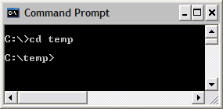

6. This is where the executable file resides.
c:\temp\win32\
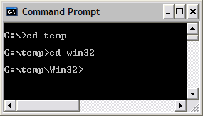

Sample Command Line - The executable and the response file name will vary by Operating System

C:\temp>c:\temp\win32\2.3.0-TIV-TLCM-FP0004-Manual-Deployment.exe -options c:\temp\2.3_account name_test.txt –silent

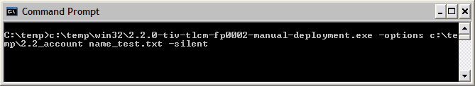

Confirm the agent is communicating with the following commands:

- Confirm the agent is communicating to the Runtime Server by issuing the following command:

C:\windows\itlm\tlmagent –p

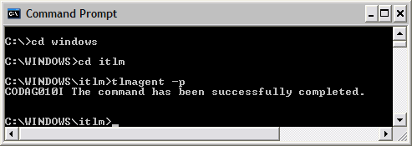

- You can also run an initial scan of the endpoint by issuing the following command.

C:\windows\itlm\tlmagent –s

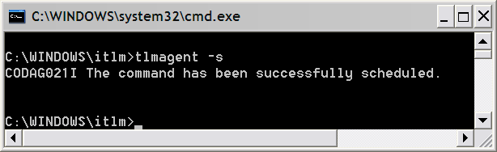

UNIX Installs:

- Create a directory called agentdownload under /tmp directory
- Download agent code (based on OS) from the website below:

ftp://service.boulder.ibm.com/software/tivoli_support/patches/patches_2.3.0/2.3.0-TIV-TLCM-FP0004/

Note: If a browser is not available on the target machine, download it to your machine, and FTP the agent code it to the target machine. Continue with the Steps below:

- Save the file to: /tmp/agentdownload
- CD to that directory
- Unzip the TLCM agent code that was saved in Step 1
- Save the response file that was sent to you from the SwLM coordinator to the same directory in step 1 (/tmp/agentdownload)

- You must be a root user to install the TLCM agent code.
- Make the setup (2.3.0-TIV-TLCM-FP0004-Manual-Deployment.bin) file an executable (chmod 755) before running it.

This is where the executable file resides.
/tmp/agentdownload/OS/

Note: The executable and response file name will vary by Operating System (OS).

Sample Command Line

/tmp/agentdownload/OS>/tmp/agentdownload/OS/2.3.0-TIV-TLCM-FP0004-Manual-Deployment.bin -options /tmp/agentdownload/2.3_account name_test.txt –silent

Note: On Unix Platform, commands must be run from the /usr/sbin folder, or the command must be included in the PATH variable. The user again must be root.

Confirm the agent is communicating with the following commands.

/usr/sbin/tlmagent -p

/usr/sbin/tlmagent –s

Web Registration
Web registration involves logging in to the TLCM website from each endpoint server and following the registration process to download the TLCM agent code to that server.

The internet server ONLY allows the Web Deployment method to be used. This requires a web browser to be available on the machine to pull the agent.

Web registration should take no longer than seven minutes per server, and will usually take significantly less than that. Note that one or more security warnings may appear during the Web registration process. All such warnings should be accepted.

Web Registration Install Steps:

    - Logon to your browser and enter the proper URL for the server being deployed as follows:

https://Runtime Server Name/slmruntime/register

Runtime Server Name is the hostname or IP address of the runtime server associated with that endpoint.

    - Complete the web form by providing the following information:

- Division (the TLCM Division name assigned to the endpoint)
- Server Name (the name of the TLCM runtime server associated with the endpoint)
  - DO NOT CHANGE SERVER NAME

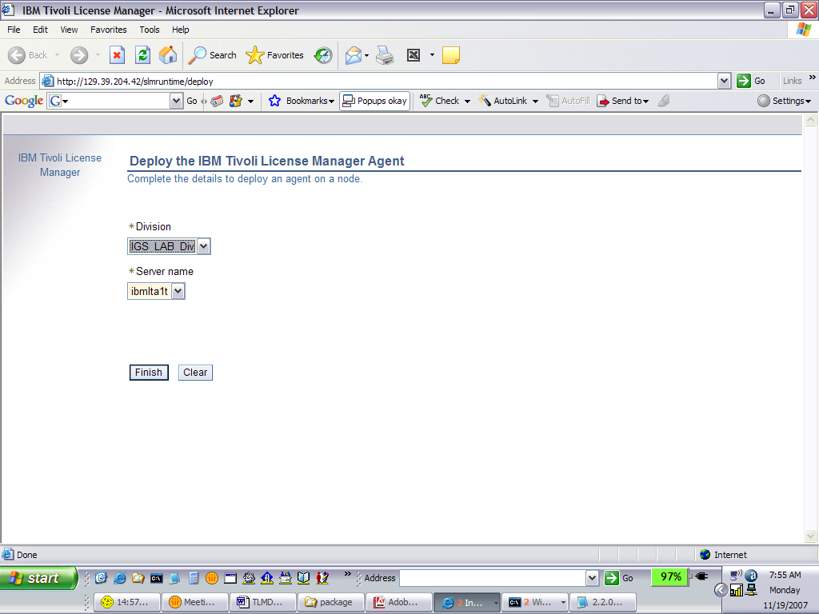

- Click the Finish button and agree to all security warnings that appear. (Once this registration process is complete and the TLCM code has been downloaded, TLCM will have the ability to monitor software usage and scan for software products installed on the endpoint server.)

Agent Uninstall Procedures

Uninstall agents on Windows platforms

To uninstall the Tivoli License Manager agent from a Windows node, complete the following steps:

1. On the node where the agent is installed, open a command prompt window.

2. Change to the directory: WINDOWS\ITLM

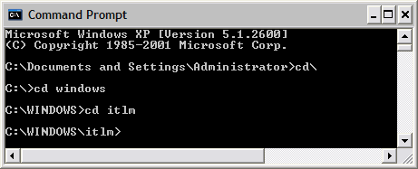
3. Enter the command: tlmunins.bat. If the agent is running it will be stopped. The agent files will be deleted.
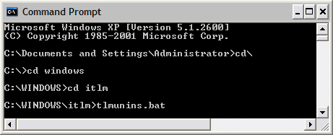

- Delete the ITLM folder from c:\windows.
- If unable to locate, please do a search on ITLM.

Uninstall agents on UNIX platforms

To uninstall the Tivoli License Manager agent from a UNIX node, complete the following steps:

1. On the node where the agent is installed, open a shell window.

2. Change to the directory: /var/ITLM

3. Enter the command: ./tlmunins.sh. If the agent is running it will be stopped. The agent files will be deleted.

4. Delete the directory to remove any remaining files that were not cleaned up with the tlmunins command(s)
Appendix A

Example of the FTP web site

ftp://service.boulder.ibm.com/software/tivoli_support/patches/patches_2.3.0/2.3.0-TIV-TLCM-FP0004/

2.3.0-TIV-TLCM-FP0004-ManualDeploy-AIX.zip
2.3.0-TIV-TLCM-FP0004-ManualDeploy-HPIA64.zip
2.3.0-TIV-TLCM-FP0004-ManualDeploy-Hpux.zip
2.3.0-TIV-TLCM-FP0004-ManualDeploy-Linux.zip
2.3.0-TIV-TLCM-FP0004-ManualDeploy-Solaris.zip
2.3.0-TIV-TLCM-FP0004-ManualDeploy-Solaris_x86.zip
2.3.0-TIV-TLCM-FP0004-ManualDeploy-Win32.zip
2.3.0-TIV-TLCM-FP0004-ManualDeploy-linux390.zip
2.3.0-TIV-TLCM-FP0004-ManualDeploy-linux390_64.zip
2.3.0-TIV-TLCM-FP0004-ManualDeploy-linuxPPC_64.zip
2.3.0-TIV-TLCM-FP0004-ManualDeploy-linux_64.zip

