Health Check And Monitoring Service Macro Design Document
Author: Liu Hai(Larry)

Revision History
Date | Version | Description | Author
2013/5/15 | 1.0 | Initial Version | Larry(Hai DL Liu)
2013/5/28 | 1.1 | HealthCheck and Monitoring Service Overview Architecture - Phase 4 | Larry(Hai DL Liu)

HealthCheck and Monitoring Service Overview Architecture

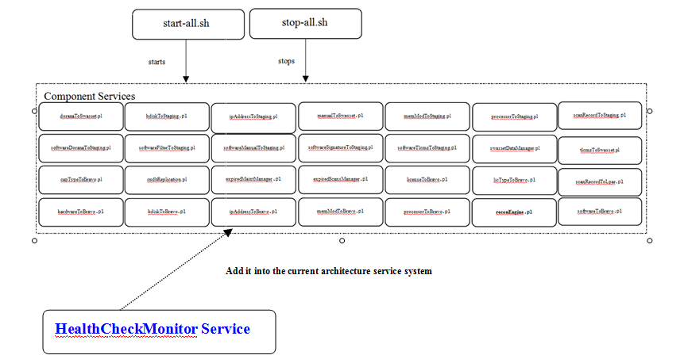

HealthCheck and Monitoring Service Overview Architecture

HealthCheck and Monitoring Core Engine
Log Component
Email Notify Component
Continuous Running Scripts Component

Start/Stop Scripts Component
File System Component
Database Component

TBD

TBD

healthCheckMonitoring.properties
eventCheckRuleDefinition.properties

High Level Module Architecture Design for phase 2B
Start/Stop Business Loader Services

HealthCheck and Monitoring Service
- Start/Stop Scripts Component

Staging DB

Analysis Event Realtime Monitoring Data
EVENT DB Table
Collect Event Realtime Monitoring Data
Alert Message
Send alert message
to corresponding persons if have

Business Logic Metrics For Phase 2B
The Status Code For The Last Event Record  If has query ressult for certain  period of time for certain loader | STOPPED | ERRORED | STARTED
Y | 1) If the status of the last event is ‘STOPPED’ and also there is only one query result, then it means that the loader ran for a long period of time to process and also just finished in this cycle. So there is no alert for this case.  2) If the status of the last event is ‘STOPPED’ and also there are more than one query result, it means that the loader has been started and stopped in this cycle successfully. There is no alert for this case. | It means that the loader ran failed for the last time and also one loader run failed alert needs to be generated based on it. - Done - Passed | It means that the loader has been started successfully and also the process is under progress. So there is no alert for this case.
N | It means that the loader has not been started in this cycle. The last successfully run for the started and stopped event records need to be found out in the last cycle. - Done - Passed  (Assumption: one loader must be ran one time whatever success or failed in one cron cycle - for example 24(hours)

HealthCheck and Monitoring Service Overview Architecture - Phase 3
HealthCheck and Monitoring Service Overview Architecture

HealthCheck and Monitoring Core Engine
Log Component
Email Notify Component
Continuous Running Scripts Component

Start/Stop Scripts Component
File System Component
TBD

TBD

TBD

healthCheckMonitoring.properties
eventCheckRuleDefinition.properties

HealthCheck and Monitoring Service Overview Architecture - Phase 4
HealthCheck and Monitoring Service Overview Architecture

HealthCheck and Monitoring Core Engine
Log Component
Email Notify Component
Continuous Running Scripts Component

Start/Stop Scripts Component
File System Component
Database Component

TBD

TBD

healthCheckMonitoring.properties
eventCheckRuleDefinition.properties

