Salvation
  - By Grace, Through Faith
Kimani Upshur, M.Ed.
Table of Contents

Salvation
Introduction: The Best Gift Ever
Chapter 1: What Is Sin?
Chapter 2: God Loves You
Chapter 3: Jesus Came
Chapter 4: Jesus Died on the Cross
Chapter 5: The Empty Tomb — Jesus Is Alive!
Chapter 6: Grace — A Gift You Don’t Earn
Chapter 7: Faith — Trusting Jesus
Chapter 8: How a Child Can Come to Jesus
Chapter 9: Praying to Receive Jesus
Chapter 10: What Comes Next?
A Special Invitation: Give Your Life to Jesus
MORE FROM KIMANI UPSHUR, M.Ed.
About the Author

Copyright
Copyright © 2026 by Kimani Upshur, M.Ed. All rights reserved. Published by Upshur Unlimited, LLC
No part of this book may be reproduced or used in any manner without written permission of the copyright owner except for the use of quotations in a book review.
Scripture quotations are from the King James Version (KJV), which is in the public domain.
Children’s edition 2026, adapted from the adult edition of Salvation: By Grace, Through Faith (KJV-based Scripture quotations).
The stories and examples in this book are illustrative. Any resemblance to actual persons is coincidental.

Salvation
By Grace, Through Faith
Children’s Edition — For Children Ages 6–12
Kimani Upshur, M.Ed.
Rescued. Redeemed. Restored.

Introduction: The Best Gift Ever
Have you ever been given a gift so good that you did not know what to say?
Maybe it was on your birthday. Maybe it was a surprise on an ordinary day. You held it in your hands, and you knew one thing for sure: you did not earn it. Nobody gave it to you because you were perfect. They gave it to you because they love you.
This little book is about the best gift ever given — a gift from God Himself.
The gift is called salvation. That is a big word, but it means something a child can understand: God rescues us, forgives us, and makes us His own children, because He loves us. We do not earn it. We cannot buy it. We receive it by trusting Jesus.
In this book you will learn what sin is, and why it is a problem. You will meet Jesus — who He is, why He came, what He did on the cross, and the wonderful morning when His tomb was found empty because Jesus is alive. You will learn what grace means, what faith means, and how a child — yes, a child like you — can receive God’s gift.
Ask a parent, a grandparent, or a trusted grown-up to read this book with you. Talk about the questions together. Some of the most important talks a family ever has start with a small book and a big question.
Here is the big question: Do you know Jesus — not just know about Him, but know Him as your own Savior and Lord?
By the end of this book, you will know how to answer. And at the very end, there is a special invitation written just for you, and a prayer you can pray with a grown-up you trust.
Let’s begin.

Chapter 1: What Is Sin?
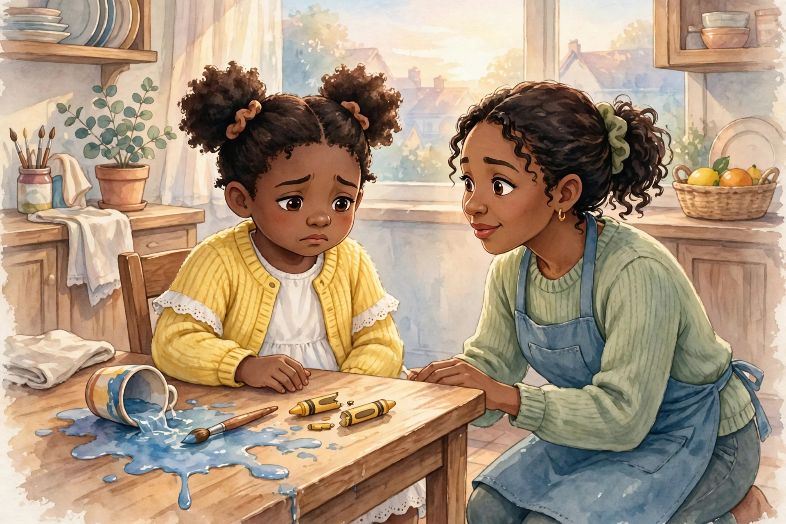
Chapter 1
Mia loved to color. She had a box of crayons with every color she could name, and two she had named herself.
One rainy afternoon, Mia was coloring at the kitchen table while her mother cooked supper. She reached for the red crayon — and knocked her cup of paint water right off the table. Blue water splashed across the floor. The cup rolled under a chair. And the crayon box tipped, and her favorite red crayon snapped in two.
Mia froze. Her first thought was not, I should clean this up. Her first thought was, Maybe nobody saw.
Have you ever had a thought like that?
That little moment — the spill, the hiding, the hoping nobody saw — is a small picture of something the Bible talks about on almost every page. It is called sin.
Sin is anything we think, say, or do that breaks God’s loving rules. God made us, and God knows how life works best, so His rules are good rules: love God, love people, tell the truth, be kind, obey your parents, share, forgive. Sin is when we go our own way instead. We lie instead of telling the truth. We keep the toy instead of sharing it. We say the mean thing because it feels good for one second. We disobey, we hide, we blame somebody else.
And here is the hard part: sin is not just a kid problem. Listen to what the Bible says:
“For all have sinned, and come short of the glory of God” (Romans 3:23, KJV).
All have sinned. That means your parents. Your teacher. Your pastor. Every grown-up you admire, and every child you know. Nobody gets left out of that word all. We fall short — like trying to jump across a river that is too wide. No matter how far we jump, we cannot reach the other side by ourselves.
That might sound like bad news. But wait — it is honest news, and honest news is the start of good news. A doctor tells you the truth about a sickness because the doctor has the medicine. God tells us the truth about sin because God has the rescue.
You see, sin does something sad: it separates us from God. God is perfect and holy and good, all the way through. Sin cannot live close to Him, the way darkness cannot stay when the light comes in. That is the problem every person on earth has — the problem this whole book is about.
But do not close the book yet, because here is the most important thing Mia learned that rainy afternoon. When her mother found the blue water — and mothers always find out — she did not stop loving Mia. Not even a little. She knelt down, helped her clean, and held the broken crayon gently, like it still mattered.
Mia’s mother did not love her less because of the mess. She helped her because of the mess.
Remember that picture. It is almost the whole next chapter.
Talk about it: What is one rule in your home that is there to keep you safe? Why do you think God gives us rules — is it because He loves us, or because He does not?

Chapter 2: God Loves You
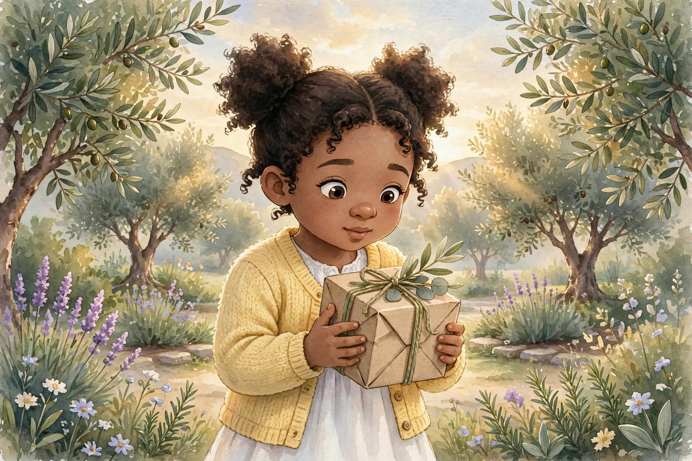
Chapter 2
Before we talk about anything else — before the cross, before the tomb, before the gift — you need to know this first, and you need to know it deep down where you can keep it forever:
God loves you.
Not the perfect version of you. Not the future, better-behaved version of you. You — today, with your mistakes and your bad days and your broken crayons. God has always loved you, and His love is where the whole story of salvation begins.
Salvation was God’s idea. Before you ever thought about Him, He was thinking about you. Before you ever said a prayer, He had already made a plan to rescue you — because that is what love does. Love sees someone in trouble and moves toward them, not away from them.
There is one verse in the Bible that tells this better than any other. Many children learn it by heart. If you learn only one verse from this whole book, learn this one:
“For God so loved the world, that he gave his only begotten Son, that whosoever believeth in him should not perish, but have everlasting life” (John 3:16, KJV).
Let’s walk through it slowly, the way you would open a gift one ribbon at a time.
For God so loved the world — the whole world. Every country, every city, every street, every house — and every child in every house. That includes you.
That he gave his only begotten Son — love that only talks is not real love. Real love gives. And God gave the most precious gift He had: His own Son, Jesus. We will meet Him properly in the next chapter.
That whosoever believeth in him — whosoever is a big, wide-open word. It means anyone who. Anyone who believes in Jesus. No one is too young. No one is too small. No one has been too bad. The door of that word is wide enough for you.
Should not perish, but have everlasting life — that is the promise at the end of the verse. Life with God that starts now and lasts forever.
Do you see? The whole gift of salvation is inside this one verse: God’s love, God’s Son, our believing, and God’s promise.
Mia’s mother loved her in the middle of her mess. But even the best mother’s love is only a small picture of God’s love. God’s love is bigger than the sky, stronger than anything, and it never runs out. You cannot make God stop loving you. You cannot use it all up. You cannot be too far away for it to reach you.
And God’s love did not just sit in heaven and feel warm feelings about us. God’s love came down. It came all the way down to a manger, to a little town, to a real baby with a real name.
His name is Jesus. Let’s go meet Him.
Remember this: God’s love came first. You do not have to make God love you. He already does — and salvation is His loving rescue, planned before you were ever born.

Chapter 3: Jesus Came
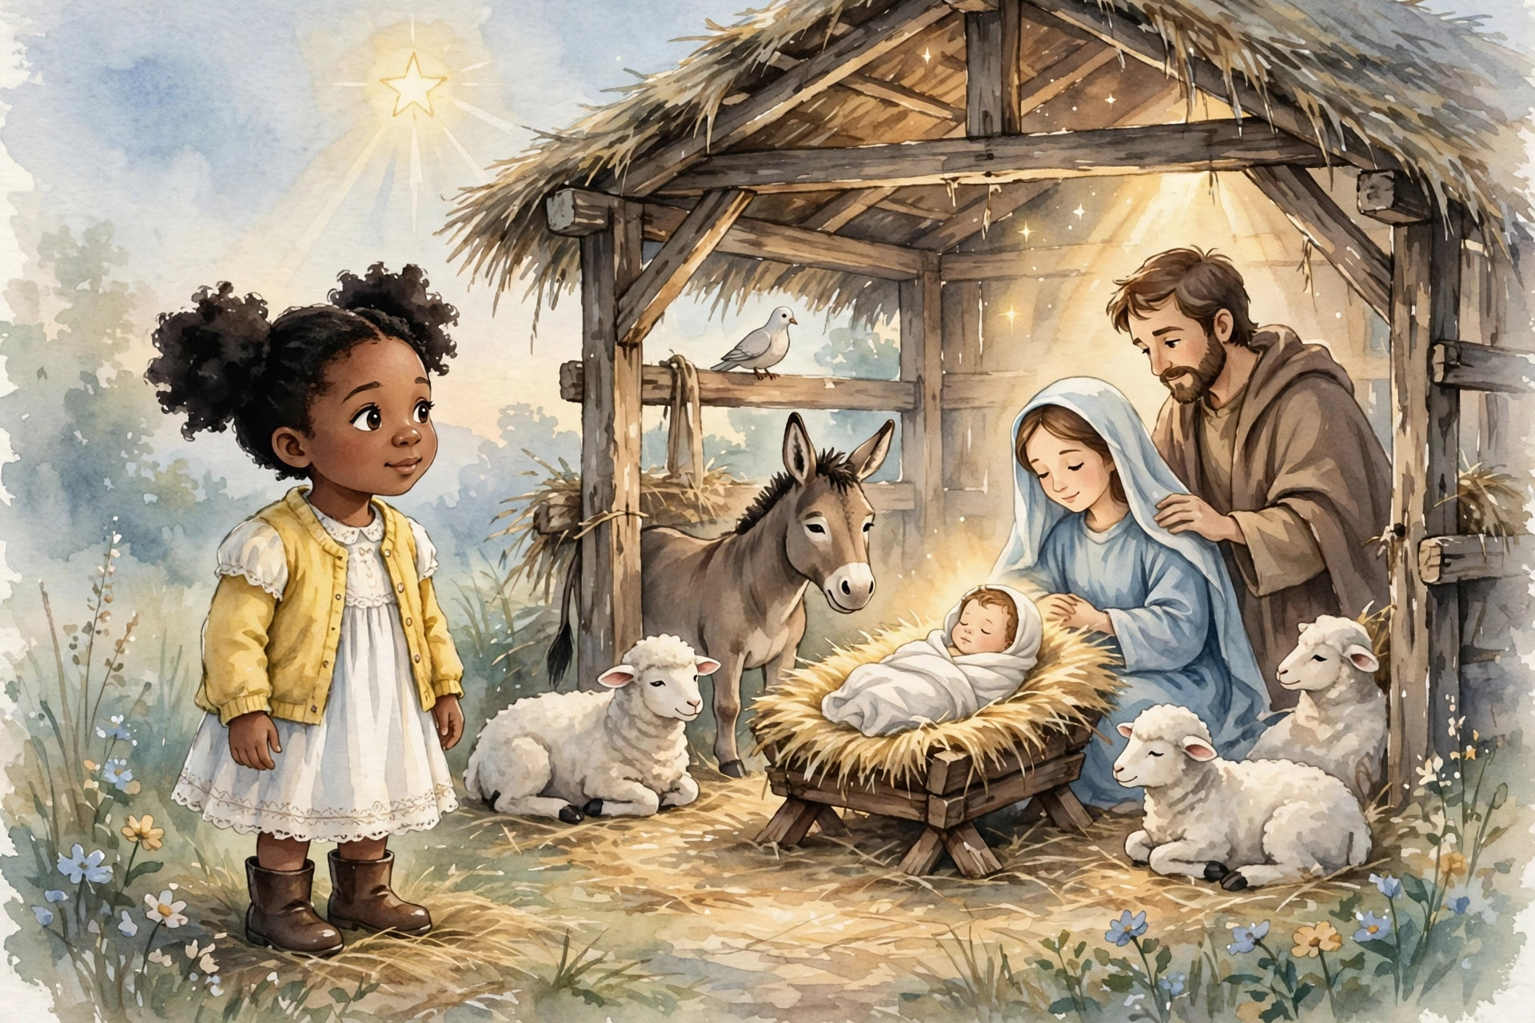
Chapter 3
Long ago, in a small town called Bethlehem, something happened that the whole world is still talking about.
There was no palace. There was no golden cradle. There was a young mother named Mary, a kind man named Joseph, a stable full of animals — and a baby lying in a manger, which is a feeding box for animals. Shepherds came to see Him. Wise men traveled a long, long way to bring Him gifts. Angels sang about Him in the night sky.
The baby was Jesus. And Jesus was not an ordinary baby.
Jesus is God’s Son. He had always been with God the Father in heaven — and He came down to earth, born as a real baby, growing up as a real boy, living as a real man. That is one of the most amazing truths in the whole Bible: God did not shout His rescue from far away. He came Himself.
Why did Jesus come? He came for you.
Jesus grew up and did the things no one else could do. He taught crowds about God’s kingdom, and His words were full of love and truth. He healed people who were sick. He gave sight to a man who was born blind. He fed thousands of hungry people with a little boy’s lunch. He calmed a storm with His words. He welcomed children — children just like you — when the grown-ups tried to send them away. He was kind to people everyone else ignored.
And through His whole life, Jesus never sinned. Not once. Not one lie, not one selfish thought, not one disobedient moment. Remember Romans 3:23 — all have sinned. Jesus is the one great exception: the only person who ever lived a perfect life. That matters more than you might think, and in the next chapter you will see why.
Jesus came to do the one thing we could never do for ourselves. We could not cross the river. We could not fix the separation between us and God. We could not pay for our own sins. So Jesus came to be the bridge, the rescuer, the Savior — Savior is even what His name means: the One who saves His people from their sins.
Think of it this way. If you were lost in a deep, dark forest, you would not need a lecture about forests. You would need a rescuer — someone who knows the way, who comes in after you, who takes your hand and brings you home. Jesus is that rescuer. He did not wait for us to find our way out. He came in after us.
But the rescue cost Him more than we can imagine. The forest, for Jesus, led to a hill outside Jerusalem, and to a cross.
That part of the story is hard. It is also the most loving part. Let’s go there together — gently, and truthfully, the way the Bible tells it.
Talk about it: Jesus welcomed children when others tried to send them away. What does that tell you about how Jesus feels about you?

Chapter 4: Jesus Died on the Cross
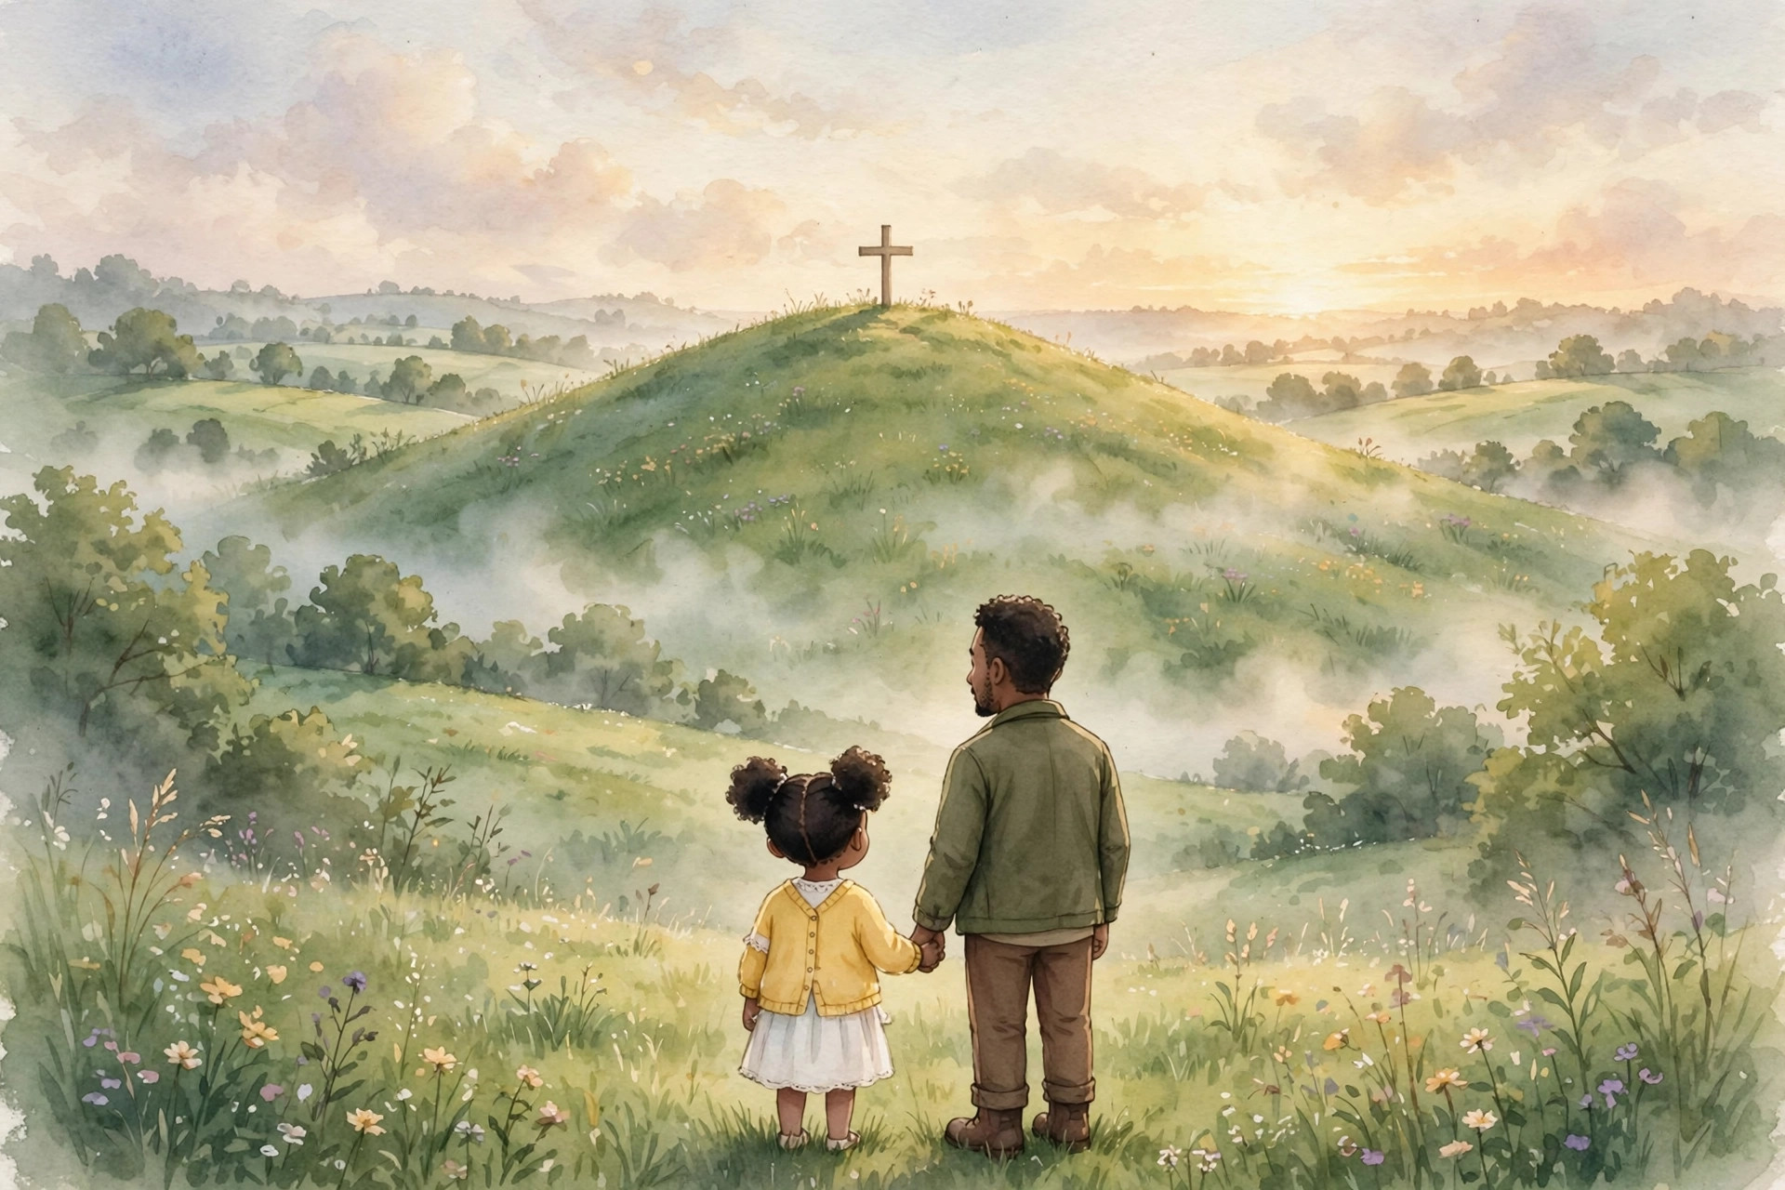
Chapter 4
This is the most serious chapter in this book. Read it slowly, with a grown-up close by.
Jesus had never done anything wrong. But some people did not want to hear His words. They were jealous of Him, and angry at Him, and they made a terrible plan. Jesus was arrested, even though He was innocent. He was put on trial, even though He had done nothing wrong. And He was sentenced to die on a cross — the hardest, saddest kind of death in those days.
Here is what we must understand, and it is the heart of the whole Bible: Jesus did not die by accident. He gave His life on purpose. He died for us.
Remember the problem from chapter one. Sin separates us from God, and sin has a price. We could not pay it. So Jesus — the one perfect person, the one who never sinned — stepped in and took our place. The punishment that belonged to sinners fell on Him instead of us. Long before Jesus was born, God’s prophet Isaiah wrote about it:
“But he was wounded for our transgressions, he was bruised for our iniquities: the chastisement of our peace was upon him; and with his stripes we are healed” (Isaiah 53:5, KJV).
That is a hard verse, so let’s say it in a child’s words: Jesus was hurt because of our wrongs, not His. He took the pain that our sins deserved, so that we could have peace with God. He carried our place, so we would not have to carry it.
It is like this: imagine the broken crayon, the spilled water, every lie, every mean word, every hidden wrong thing you have ever done — and everything you will ever do wrong — all gathered up into one great weight. On the cross, Jesus lifted that weight off of us and onto Himself. He loved us that much. He said, in effect: Let it fall on Me, so it will never have to fall on them.
After Jesus died, His friends took His body down from the cross and laid it in a tomb — a small cave cut into rock — and a huge stone was rolled across the door. Soldiers guarded it. His friends went home heartbroken. It looked like the end of the story.
It looked like love had lost.
If the story ended there, there would be no gift, no rescue, no salvation, and no reason for this book. A rescuer who stays in the tomb cannot rescue anybody.
But the story does not end there.
Because Sunday morning was coming.
Remember this: Jesus died on the cross to take the place of sinners — your place and mine. It is the greatest act of love the world has ever seen. And it is not the end of the story.

Chapter 5: The Empty Tomb — Jesus Is Alive!
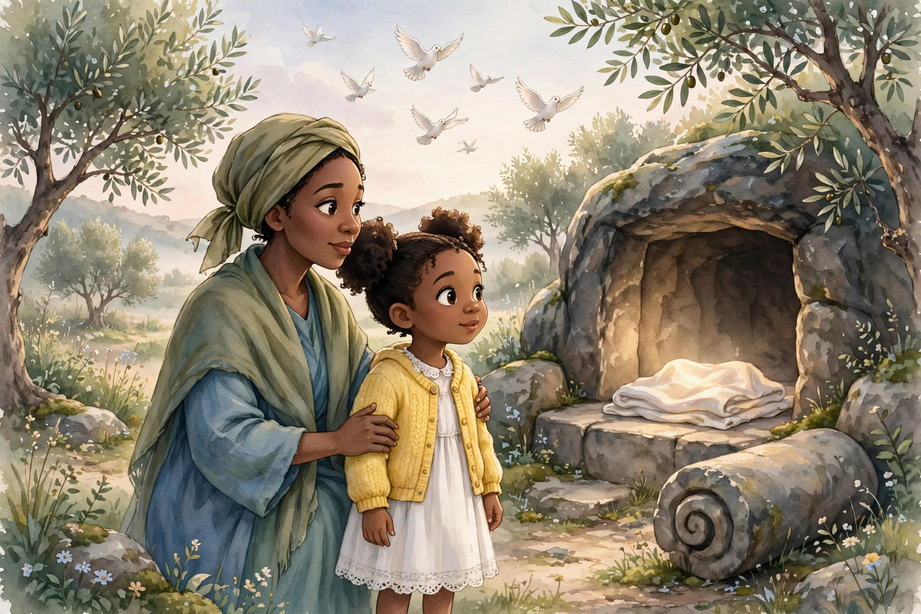
Chapter 5
Early on Sunday morning, while the sky was just beginning to turn gold, some women who loved Jesus walked to His tomb. They carried spices for His body. Their hearts were heavy. As far as they knew, they were going to say goodbye.
But when they arrived, the great stone was rolled away — and the tomb was empty.
An angel was there, and the angel had the best news that has ever been announced on this earth:
“He is not here: for he is risen, as he said. Come, see the place where the Lord lay” (Matthew 28:6, KJV).
He is risen. Jesus is not in the tomb. Jesus is alive.
Mary Magdalene ran to tell the disciples. Peter and John ran to the tomb and saw it themselves: the cloth that had covered Jesus lay folded, and Jesus was gone — not stolen, not moved. Risen. Then Jesus appeared to Mary. Then to His disciples. Then to more and more of His friends — hundreds of people saw Him alive with their own eyes.
The apostle Paul sums up the whole gospel — the good news — in two short verses:
“For I delivered unto you first of all that which I also received, how that Christ died for our sins according to the scriptures; And that he was buried, and that he rose again the third day according to the scriptures” (1 Corinthians 15:3–4, KJV).
Died. Buried. Rose again. That is the gospel in six words.
Why does it matter so much that Jesus rose? Because it proves everything worked. It proves His death on the cross really did pay for sin — God accepted the payment. It proves death is not stronger than Jesus. And it means Jesus is alive right now — not just a person we read about, but a living Savior who hears you when you pray, who knows your name, who will be with you forever.
This is the part of the story our family loves best, and we want you to love it too: the empty tomb is the emphasis. Jesus is alive.
A dead teacher can be admired. A living Savior can be trusted, loved, followed, and prayed to — today, by a child, in a kitchen, at a bedside, anywhere.
Mia heard this story at church, and afterward she asked her mother a wonderful question: “If Jesus is alive, can He hear me when I talk to Him?” Her mother smiled and said, “That is exactly what it means, sweetheart. He is alive, and He hears every word.”
He hears you too.
Now — if Jesus died for our sins and rose again, what do we do with that? Is there a price we pay Him back? Do we have to earn our way into His family?
The next chapter has the answer, and it is the happiest word in this whole book: grace.
Talk about it: Why is it important that Jesus did not stay in the tomb? What can a living Savior do that no one else can?

Chapter 6: Grace — A Gift You Don’t Earn
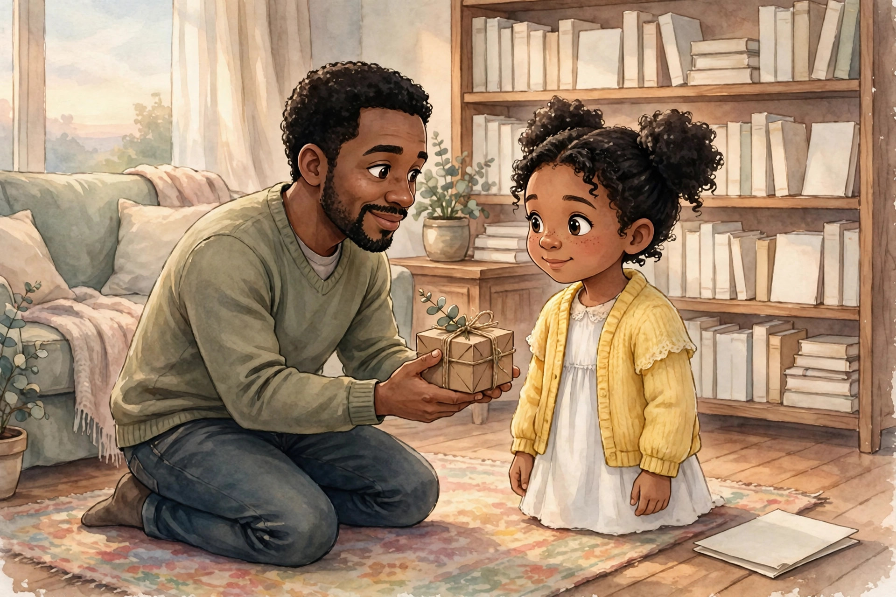
Chapter 6
Mia had a good week. She shared her snack. She helped her little cousin with his shoes. She told the truth about the broken crayon, even though it was hard. On Friday, her father came home, knelt down to her level, and handed her a small wrapped box.
“Is this because I was good this week?” Mia asked.
Her father shook his head and smiled. “No. If it were because you were good, it would be a payment. This is a gift. I am giving it to you because you are mine, and because I love you.”
Inside the box was a smooth stone from the river near her grandparents’ house, painted gold — worth almost nothing at a store, and worth everything to Mia.
That little moment carries one of the biggest truths in the Bible. Listen to the verse on the cover of this book — our family’s favorite verse about salvation:
“For by grace are ye saved through faith; and that not of yourselves: it is the gift of God: Not of works, lest any man should boast” (Ephesians 2:8–9, KJV).
Grace means God’s gift of love and forgiveness that we could never earn. Saved means rescued — rescued from sin, and brought safely to God. And notice the words: it is the gift of God. Not of works.
That means you cannot earn salvation by being good. You cannot earn it by going to church, or memorizing verses, or helping old ladies cross the street, or being the best-behaved child in your class. Those are all good things — but they are not the price of the gift. A gift that you have to pay for is not a gift anymore. It is a purchase. And God does not sell salvation. He gives it.
Think of it like the gold-painted stone. If Mia had paid her father for it, it would just be a stone she bought. Because he gave it freely, it is a treasure. Salvation is God’s treasure, given freely, out of His love.
Why does God give it instead of selling it? Two reasons. First, because the real price was far too high for us — Jesus already paid it on the cross. There is nothing left to pay. Second, because God wants no one boasting. In heaven, nobody will say, “I got here because I was so good.” Everybody will say, “I am here because God is so gracious — because Jesus saved me.”
Now, does grace mean being good does not matter? Not at all! Good works matter a lot — as a thank-you, not as a ticket. We obey God because we love Him and belong to Him, the way Mia hugged her father because of the gift — not to earn another one. First comes the gift. Then comes the grateful life. Never the other way around.
So if salvation is a gift, how do we receive it? Gifts are not earned — but they are received. Someone gives, and someone takes with open hands and a trusting heart.
That taking, that trusting, has a name. It is called faith — and it is the very next chapter.
Remember this: Grace means God gives. You do not earn salvation, and you never could. You receive it — the way you receive any gift — with open hands and a thankful heart.

Chapter 7: Faith — Trusting Jesus
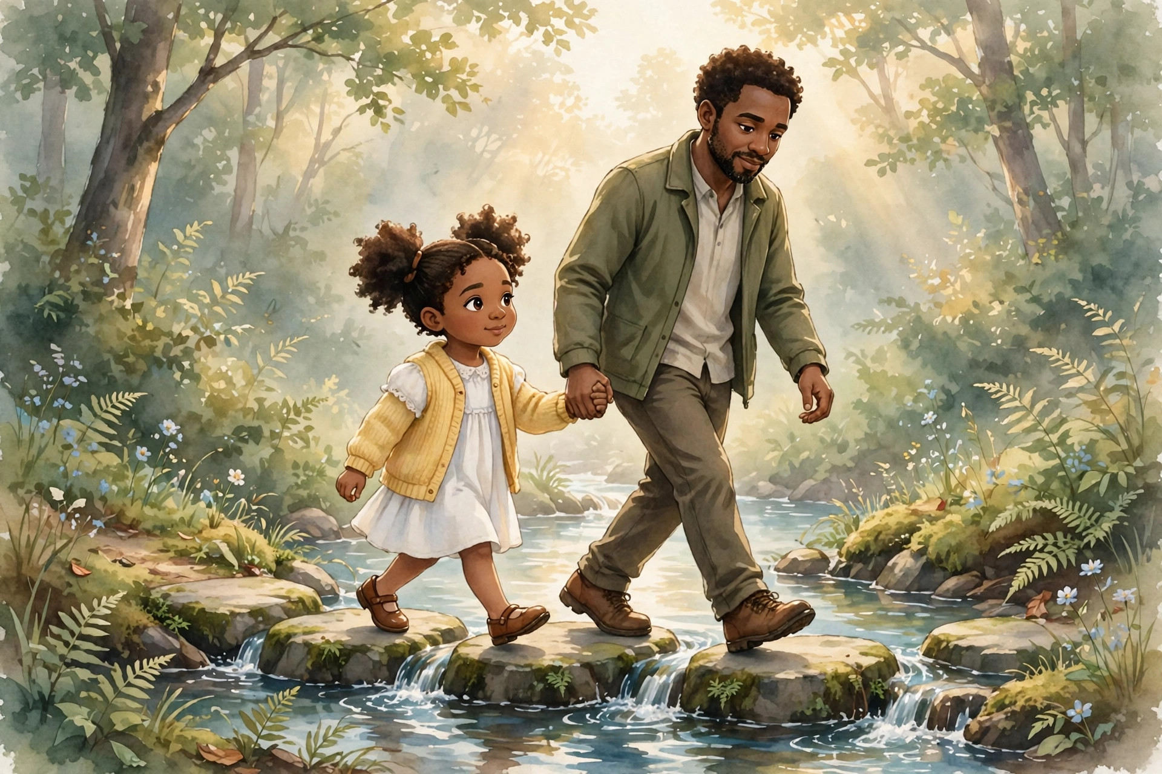
Chapter 7
Near Mia’s grandparents’ house, the river runs cold and bright over smooth stones. To get to the picnic field on the other side, you have to cross on flat stepping stones. The water is not deep, and the stones are not far apart — but the first time Mia tried, she stood on the bank a long time, looking at the rushing water.
Her father crossed first. Then he turned around, held out both hands, and said, “The stones will hold you, Mia. I have walked them a hundred times. Step where I stepped. I’ve got you.”
Mia had two choices. She could believe the stones were strong — standing on the bank, nodding, saying, “Yes, those are very strong stones” — and never cross. Or she could trust — put her foot on the first stone, and the second, and take her father’s hands.
She crossed. And on the other side she laughed, because the water was shining and the field was green and her father’s hands had been exactly as strong as he said.
That is the difference between knowing about faith and having it.
Faith means trusting Jesus — not just believing facts about Him in your head, but putting your weight on Him with your heart. Lots of people know facts about Jesus: that He was born in Bethlehem, that He died on a cross, that He rose again. Those facts are true and important. But faith is more than facts. Faith is stepping onto the stones. Faith is saying, “Jesus, I am trusting You — not my good behavior, not my church, not my family — You — to save me.”
Remember our verse: “For by grace are ye saved through faith” (Ephesians 2:8, KJV). Grace is the gift — God’s part. Faith is the open hands that receive it — our part. The gift does all the saving. The hands just take hold.
Here is a secret that takes some people a whole lifetime to learn: your faith does not have to be huge to be real. You do not need to feel a special feeling. You do not need to understand everything in the Bible. A small hand can hold a strong hand. What makes you safe on the stepping stones is not how tightly you grip — it is how strong your father is. And Jesus is strong enough to hold everyone who comes to Him. He has never dropped one yet.
Maybe you are thinking, “But what if my trust feels small?” Then hear this: bring your small trust to Jesus anyway. He welcomes it. Faith is not about how big it feels. It is about who it rests on.
So faith means trusting Jesus with your heart — believing He died for you, believing He rose for you, and receiving Him as your Savior and Lord. It means stepping off the bank.
But how does a child actually do that? How do you come to Jesus — really come, for yourself?
That is exactly what the next chapter is about.
Talk about it: What is the difference between knowing facts about Jesus and trusting Jesus? Who is the strongest person you trust — and how is Jesus stronger still?

Chapter 8: How a Child Can Come to Jesus
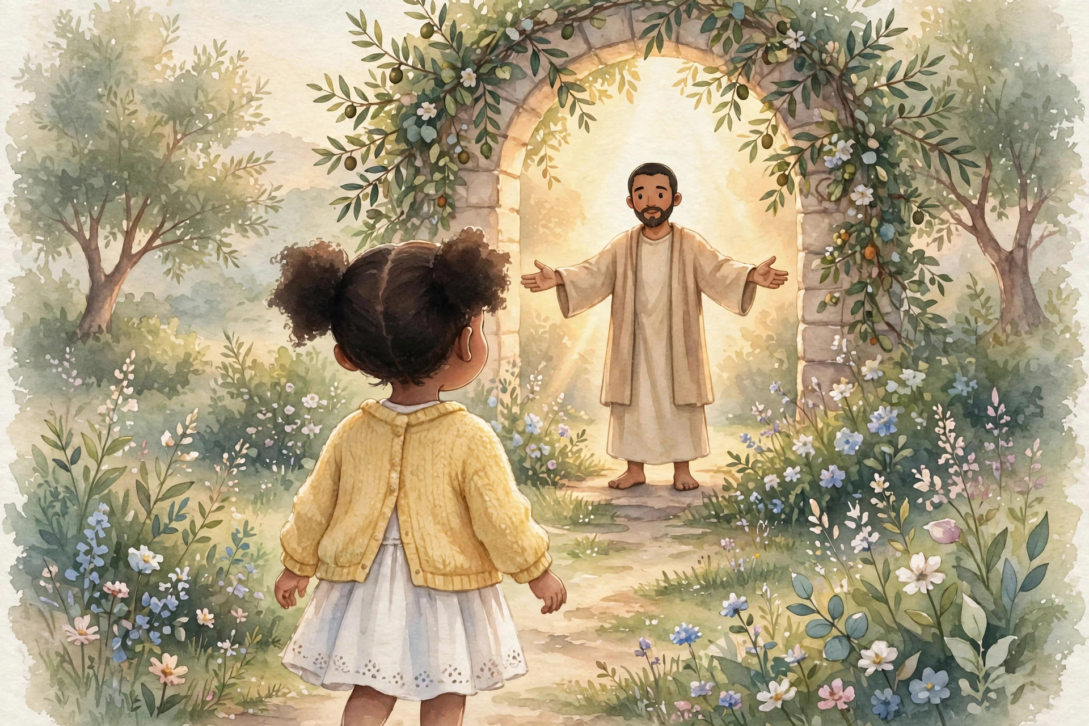
Chapter 8
Coming to Jesus is not a puzzle, and it is not a test. God made it plain enough for a child — because He wants children to come. Jesus Himself welcomed little children and blessed them. No child has ever been too small, too young, or too ordinary for Jesus.
So how does a child come to Him? The Bible shows us the way, step by step.
First, admit the truth about sin. Remember chapter one: all have sinned — you too. Coming to Jesus starts with honesty. You tell God the truth: “Lord, I have sinned. I have done wrong things. I need Your forgiveness.” You do not hide the blue water. You do not blame somebody else. Honest hearts are the ones God fills.
Second, believe in Jesus with your heart. Believe that He is God’s Son. Believe that He died on the cross for your sins. Believe that God raised Him from the dead — that He is alive today. Listen to God’s promise:
“That if thou shalt confess with thy mouth the Lord Jesus, and shalt believe in thine heart that God hath raised him from the dead, thou shalt be saved” (Romans 10:9, KJV).
Did you catch it? Believe in your heart — that is faith, from the last chapter. Confess with your mouth — that means saying it out loud: telling God, and one day telling others, “Jesus is my Lord.”
Third, receive Him. Believing is taking hold. The Bible says:
“But as many as received him, to them gave he power to become the sons of God, even to them that believe on his name” (John 1:12, KJV).
When you receive Jesus, something wonderful happens: you become a child of God. Not just a creature He made — a child He calls His own, in His family, forever.
Fourth, turn to follow Him. Coming to Jesus means turning — away from sin, and toward Him. That is what the word repent means: a change of direction. You were walking your own way; now you walk His way. You will not walk it perfectly — no one does. But you walk it with Him, and He helps you every step.
That is the whole way: admit, believe, receive, turn. A child can do every one of those — with a true heart, and with a grown-up beside her to help her understand.
And how do we talk to God about all this? We pray. Prayer is simply talking to God honestly, from the heart. In the next chapter, we will talk about praying to receive Jesus — what it means, and what it does not mean. And at the end of this book, there is a special invitation with a prayer written out for you, to pray together with a parent or another trusted grown-up.
Get ready. The best part is almost here.
Remember this: Admit your sin. Believe in your heart. Receive Jesus as your Lord. Turn and follow Him. That is how anyone — child or grown-up — comes to Jesus.

Chapter 9: Praying to Receive Jesus
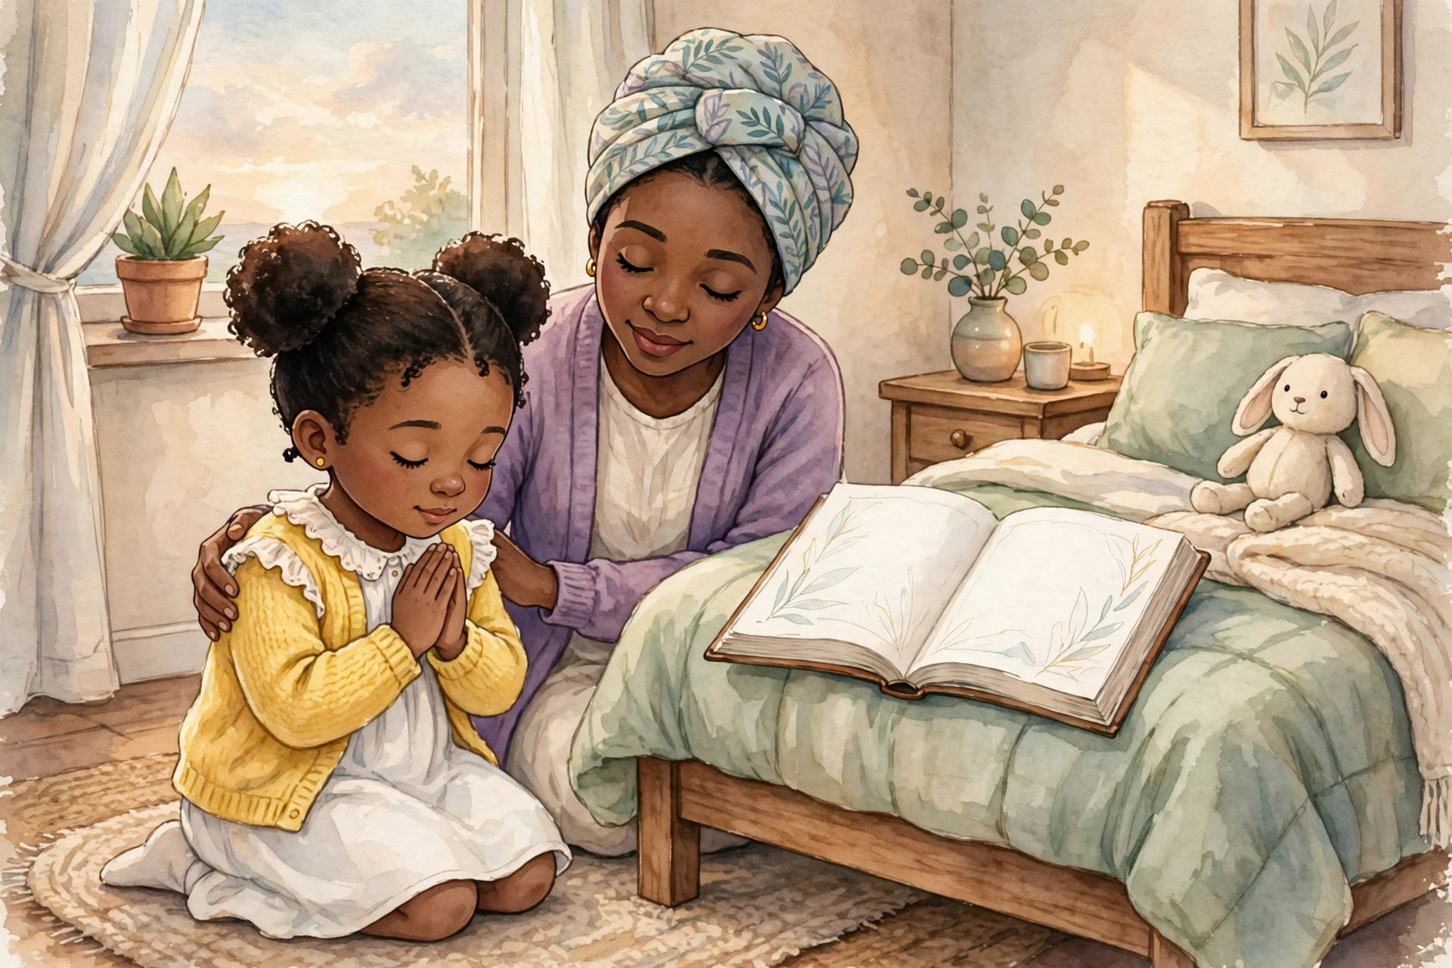
Chapter 9
One evening, after supper, Mia sat on the edge of her bed with her hands folded and a question turning over in her heart.
“Mom,” she said, “if I want Jesus to be my Savior — my Lord, not just our family’s — what do I say to Him?”
Her mother sat down beside her. “You say the truth, sweetheart. You talk to God the way you talk to me — only He already knows everything, so you never have to pretend. You tell Him you’re sorry for your sins. You tell Him you believe Jesus died and rose for you. You ask Him to forgive you and make you His child. And you tell Him you want to follow Him.”
“Is there a special prayer?” Mia asked.
“There is a beautiful prayer at the end of this book,” her mother said. “And praying it from your heart is a wonderful way to come to Jesus. But Mia — listen carefully, because this matters — the prayer itself does not save you. There are no magic words. God’s gift of salvation is received through real faith in Jesus. The prayer is just how you tell God, from your heart, that you believe in Him. God is listening to your heart, not checking your words.”
That is one of the most important things in this whole book, so let’s make sure it sticks:
- Praying words you do not mean saves no one.
- Trusting Jesus from your heart — that is what matters.
- The prayer is the door you walk through by faith. Jesus is the One who saves.
Mia’s mother also told her something else. When we come to God sorry for our sins, He is not angry, and He is not reluctant. Listen to His promise:
“If we confess our sins, he is faithful and just to forgive us our sins, and to cleanse us from all unrighteousness” (1 John 1:9, KJV).
Faithful — He always does what He promised. Just — because Jesus paid for our sins, it is right and fair for God to forgive us. When you confess — when you tell God the truth about your sins — He forgives. Every time. Completely. That is who He is.
So when you pray to receive Jesus, you can pray with confidence. You are not begging a God who might say no. You are coming to a Father who sent His Son because He wants you in His family.
At the end of this book, you will find A Special Invitation: Give Your Life to Jesus, and in it, the Sinner’s Prayer — the same prayer in this book’s grown-up edition, written so a child can pray it with a trusted grown-up. If, in your heart, you are ready to trust Jesus, that invitation is for you. Read it slowly. Talk about it first. Then pray it like you mean it — because God will hear you like He means it.
One more chapter first, though. Because after a child receives Jesus, a brand-new life begins — and it is a wonderful life. Let’s peek at what comes next.
Talk about it: Why do the words of a prayer not save us — and what does save us? Who is a trusted grown-up you could talk to about receiving Jesus?

Chapter 10: What Comes Next?
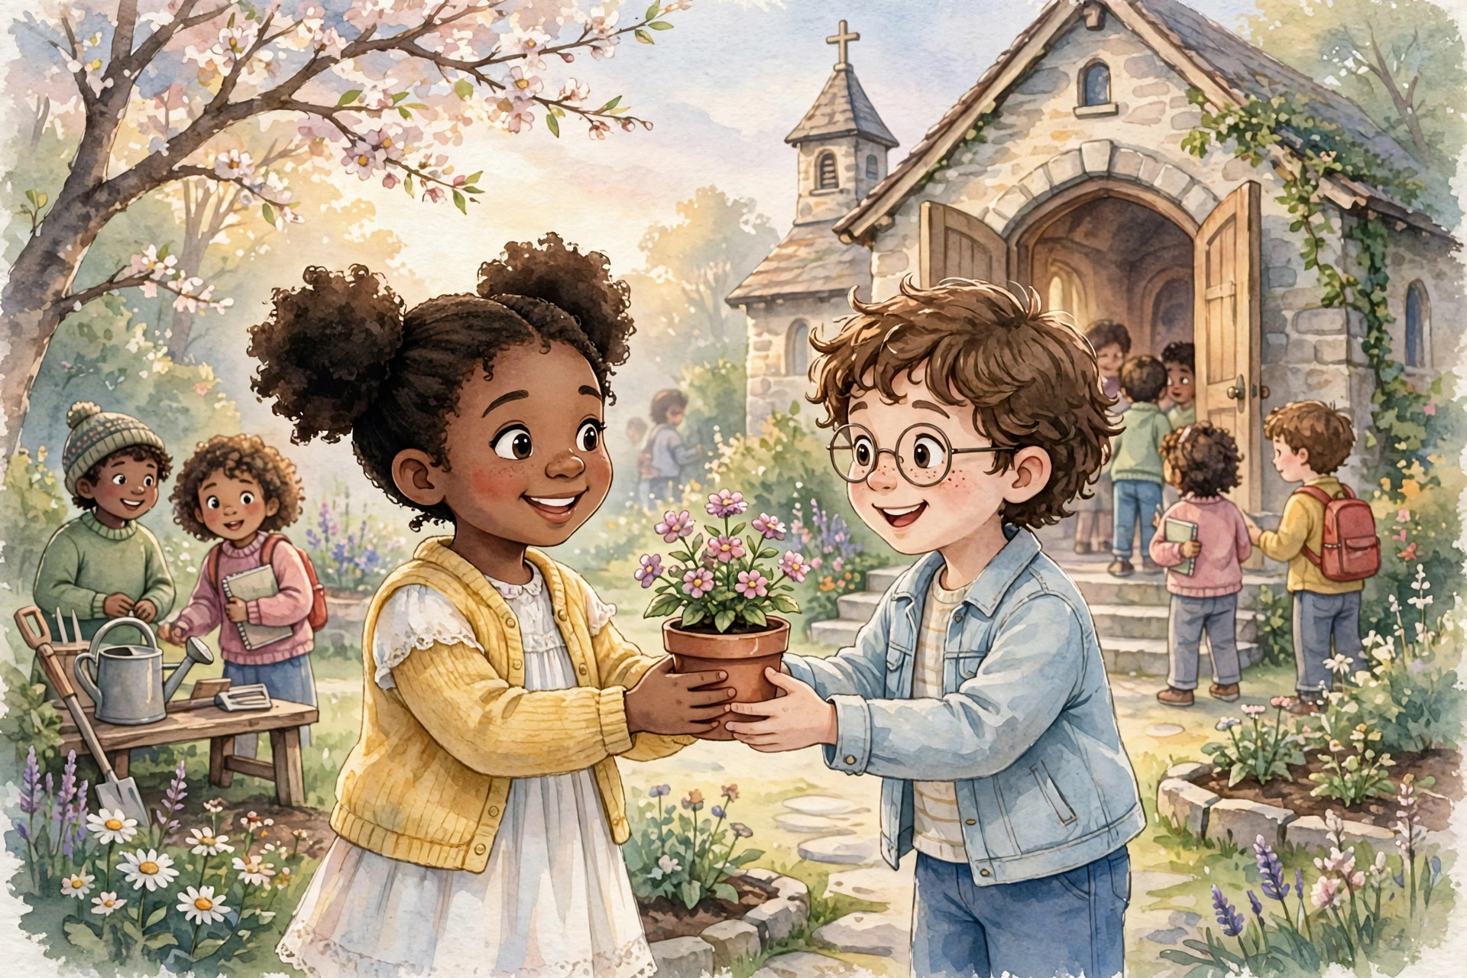
Chapter 10
When a baby is born, nobody says, “Well, that’s done!” A birth is a beginning. The baby grows — a little at a time, day by day, fed and loved and taught.
Receiving Jesus is like that. It is a beginning — the best beginning in the world. The Bible says:
“Therefore if any man be in Christ, he is a new creature: old things are passed away; behold, all things are become new” (2 Corinthians 5:17, KJV).
A new creature — a new person, with a new heart, a new Father, a new family, and a new forever. The old things — the guilt, the separation, the hiding — pass away. New things begin.
So what does the new life look like for a child? Like this:
Read the Bible. God’s Word is food for your new life. Start with the Gospel of John, and learn more and more about Jesus. Read a little every day, with your family when you can.
Pray every day. You can talk to God about anything — your joys, your fears, your mistakes, your friends. He is alive, He is your Father now, and He loves to hear you. Thank Him. Confess to Him. Ask Him. He hears every word.
Go to church and grow with God’s people. Christians are a family, and families gather. At church you will sing, learn, and be encouraged by other people who love Jesus — and one day, you will encourage them.
Tell a trusted grown-up, and keep talking. If you have received Jesus, tell your parents, your pastor, a teacher who loves the Lord. Ask your questions — all of them. Growing Christians ask lots of questions.
Follow Jesus every day. Learn what He taught and do what He says — love God, love people, tell the truth, forgive, share, obey. You will not do it perfectly. When you sin, run to God, not away: confess it, and He forgives (remember 1 John 1:9). Growing is not about never falling. It is about always getting up and holding your Father’s hand again.
And tell others. Good news is for sharing. One day, you may get to tell a friend the very things in this book: that God loves them, that Jesus died and rose for them, and that the gift is free. Imagine that — Mia, sharing her gold-painted stone story. You, sharing the story of how Jesus saved you.
That is the whole book, and here it is in one breath: We have all sinned. God loves us. Jesus came, died on the cross for our sins, and rose again — Jesus is alive! Salvation is God’s gift of grace, received through faith. And any child who admits, believes, receives, and turns can be saved — and can know it.
Now turn the page. Your special invitation is waiting — and a prayer to pray with a grown-up you trust, when your heart is ready to trust Jesus for yourself.
Remember this: Salvation is the beginning of a new life with God — reading, praying, gathering, growing, and telling others. It starts with a gift, and it goes on forever.

A Special Invitation: Give Your Life to Jesus
Grown-ups: please read this page together with your child, and talk about it. It may be the most important conversation in this whole book.
God loves you.
No matter what you have done, or what anyone has said about you, you can come to God through Jesus Christ.
The Bible teaches us that every one of us has sinned — we have all done wrong things — and we all need God’s forgiveness. But God loves us so much that He sent His Son, Jesus Christ, to die on the cross for our sins and to rise again, so that we can be forgiven and live forever with God when we put our faith in Jesus.
What does the Bible say? (Here it is in my own words, so young readers can understand:)
- Romans 3:23 — Everyone has sinned, and everyone falls short of God’s perfect goodness.
- Romans 6:23 — Sin leads to death, but God gives the free gift of living forever through Jesus Christ.
- Romans 10:9–10 — If you say with your mouth that Jesus is Lord, and believe in your heart that God raised Him from the dead, you will be saved.
- Ephesians 2:8–9 — We are saved by God’s grace — His loving gift — when we put our faith in Jesus. We cannot earn it by being good enough.
If you want to turn away from sin and put your faith in Jesus Christ, you can pray this prayer. Read it with a parent, a guardian, a pastor, or another trusted grown-up — and talk with them about what it means:
The Sinner’s Prayer
Dear Heavenly Father,
I come to You today knowing that I am a sinner, and that I need Your forgiveness.
I believe that Jesus Christ is Your Son, that He died on the cross for my sins, and that You raised Him from the dead.
Lord Jesus, I am sorry for my sins, and I turn away from them and turn to You. Please forgive me, cleanse my heart, and make me new.
I receive You as my Lord and Savior. Help me follow You, trust Your Word, and live the way You want me to live.
Thank You for Your love, Your mercy, and the gift of living forever with You.
In Jesus’ name, Amen.
What Comes Next?
If you truly put your faith in Jesus Christ, here is how you can begin growing in your friendship with Him:
- Read the Bible. Start with the Gospel of John to learn more about Jesus.
- Pray every day. Talk to God honestly about your life, your struggles, your hopes, and the things you are thankful for.
- Find a Bible-believing church. Grow alongside other Christians who can encourage you and teach you.
- Talk with a parent, guardian, pastor, or another trusted Christian grown-up. Ask questions, and let them help you as you grow in faith.
- Follow Jesus every day. Learn what He taught, and seek to live by His Word.
Remember: the prayer itself does not save you. Salvation is God’s gift of grace, received through real faith in Jesus Christ. The prayer is simply how you can tell God, from your heart, that you believe in Him.

MORE FROM KIMANI UPSHUR, M.Ed.
Find more books for children, teens, and grown-ups — Bible stories, faith, and clear thinking for the whole family — at:
https://upshurunlimitedllc.com
Salvation: By Grace, Through Faith is also available in a teen edition (ages 13–18) and an adult edition. Every edition is a free gift, just like the salvation it describes.

About the Author
Kimani Upshur, M.Ed. is an educator, author, and publisher, and the founder of Upshur Unlimited, LLC. He writes short, plain-language books that make big ideas clear for ordinary people — for children, teenagers, and adults alike — about faith, family, and everyday life.
Upshur Unlimited LLC was founded on one principle: deliverance and redemption by Jesus Christ. Man sees the sin — God sees within. Kimani’s own story is one of real redemption: his past was not all that good, but his future is looking wonderful — delivered from, redeemed by, and restored to, all to the glory of God.
Learn more at https://upshurunlimitedllc.com.
All to the glory of God.

