

Up. Time Apache Monitor

Executive Summary
Prerequisites
Installation
Troubleshooting

Doc Rev 2.0 - January 23, 2012
Author: uptime software
Contact: support@uptimesoftware.com

Executive Summary

This document provides a detailed overview of how to get the Apache HTTP Monitor for up.time installed and configured.

The purpose of the monitor is to interact with MOD-STATUS for the Apache Webserver and to return the following metrics:

Metric | Metric Description
Total Accesses | Total number of web based accesses to the server since the last restart of the HTTPD Daemon
Total Kbytes Served | Total number of Kbytes served out to the users of the web server since the last restart of the HTTP daemon.
CPU Load | The amount of load the HTTP Daemon is placing on the server as a percentage of total CPU availability
Uptime | The length of time the server has been active in Seconds (warning on low values would allow you to know when the Daemon has restarted even though the box has stayed up).
Requests Per Second | The number of requests per second the server is receiving
Bytes Per Request | The current average size of each request
Busy Workers | Number of busy Worker Processes active on the server serving active web requests from users
Idle Workers | The number of ready worker threads idling on the server

The document will outline how to enable MOD-STATUS, how to verify it’s operation and how to install, configure, and troubleshoot the up.time Apache HTTP Status Monitor.

NOTE: The purpose of this module is not to provide web analytics for marketing purposes, such as number of site hits, or how long people are spending on particular pages. The type of monitoring just described is best done with web analytics point tools such as Google Analytics. Up.time’s primary concern is about the health of the web tier and the state, and factors leading to poor performance of an Apache webserver over time. This status information can then be rolled into a business services view along with all other applications/hardware and services that comprise a business deliverable to your internal/external stakeholders. If you are unsure of why you would want to do this, please contact your up.time Solutions Architect or Customer Service Engineer for best practice guidance.

Prerequisites
This monitor was tested with Apache 2.2(.21).

The following must be enabled on your Apache Webserver:
- Module: MOD STATUS
- THE EXTENDED STATUS DIRECTIVE

Enabling MOD STATUS

To enable mod status edit your httpd.conf and add the following:

<Location /server-status>
SetHandler server-status
Order Deny,Allow
Deny from all
Allow from all
</Location>

Enabling the extended Status Directive

Only with extended status can you get the time based metrics that were listed in the executive summary.

The directive is enabled by changing the line in the conf file as depicted below to “On”

# ExtendedStatus controls whether Apache will generate "full" status
# information (ExtendedStatus On) or just basic information (ExtendedStatus
# Off) when the "server-status" handler is called. The default is Off.
#
ExtendedStatus On

**Remember to restart the httpd service to enable these features.

Testing MOD STATUS

Navigate to the following URL, substituting your servers domain name and port in the URL below where <www.myserver.com > has been given as an example:

http:// <www.myserver.com>/server-status

When you visit the URL if your MOD STATUS is configured correctly you should see something like the screenshot below. Once you have verified operation of mod status proceed to the installation section.

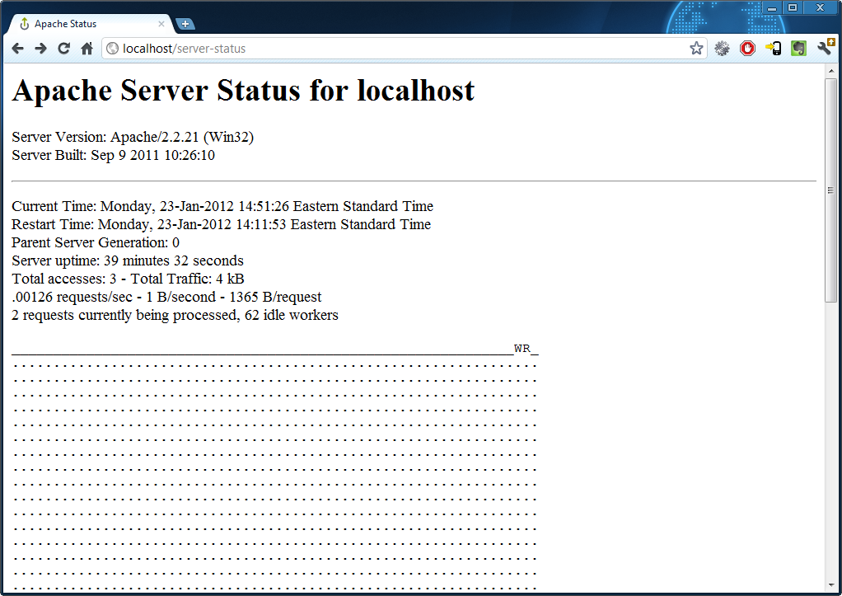

Installation
- Place zip file in uptime base directory

- Run the following command(s) from the uptime directory:

Windows:
> cd
> scripts\loadpluginmonitor

Linux/Solaris:
# cd
# scripts/loadpluginmonitor

That's it!

Configure a new monitor

- Load the up.time web interface
- Goto service instances
- Click “Add New Service Instance”
- Select the Apache Status monitor and click “Continue” on the dialogue window as shown below:
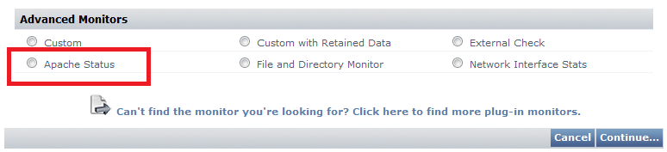

- Configure the URL path to the server-status page.
Example: /server-status

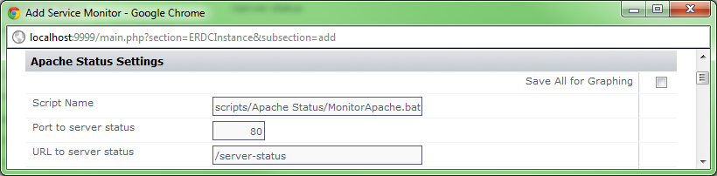

Note: Make sure you DO NOT add “?auto” to the end of the url as this will be added within the script automatically.

- Configure the monitor as usual to capture the metrics you want, perform thresholding and perform graphing.

Note: If you are unsure what this means please immediately contact technical support or solutions engineering for assistance and guidance.

- Save the service monitor, find it on the list of services under “View Service Instances”
- click edit service instance for the new service monitor and click “test service instance”

you should see the following kind of output, notice that it says status: OK.
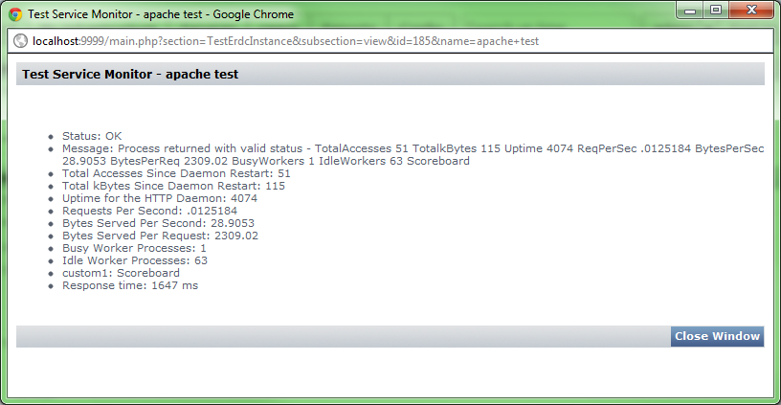

- You have now successfully configured the Apache Monitor for up.time.

Troubleshooting

I get the following error when I test the service instance in up.time:

“ERROR: Monitor could not connect to MOD-STATUS on your apache server. The passed in URL was <something> Please ensure that you have mod-status enabled, the extended status directive enabled, and have given the monitoring station domain permissions to call the directive.”

Steps:

- Go back to page 1 and verify pre-requisites
- Ensure that you have correctly changed the MonitorApache.bat or MonitorApache.sh only for the highlighted areas in the document and nothing else

To be expanded/amended based on client feedback, please send your feedback to solutionsgroup@uptimesoftware.com

