

Up. Time Disk Available Plugin

Executive Summary
Prerequisites
Installation
Troubleshooting

Doc Rev 1.0 - Thursday, October 09, 2008
Author: Kenneth Cheung – Solutions Engineering
ken.cheung@uptimesoftware.com

Executive Summary

There currently needs to be a way to threshold against the actual number of megabytes of disk space available on any given file system.

This plug-in finds the file system with the least available space and alerts based on the thresholds on what is acceptable space remaining on a volume.

The document will outline how to install, configure, and troubleshoot the Datastore Capacity Available Plugin

Prerequisites

There are no pre-requisites. This is a core extension plugin.

Installation
Before you proceed with installation please note the following directory structure for the compressed plugin files that you download :

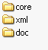

The doc folder contains this document.
The core folder contains the plug-in file.
The xml folder contains the xml definition for the plugin.

Copying Files

- Copy the files MonitorDatastoreCapacityAvailable.jar to the core folder of yoru installation
- Copy the file MonitorDatastoreCapacityAvailable.xml to the xml directory of your up.time install
- Restart the up.time core service

Note: An example default install path is /usr/local/uptime (for POSIX)
An example default install path is /usr/local/uptime (for Windows)

Initializing the plugin/database

Now execute the following command from the console of your respective server directly from the scripts directory:

erdcloader -x xml\MonitorDatastoreCapacityAvailable.xml

Once the command has run move onto the next step.

Note: the up.time core does not necessarily give a verbose response, once the command has finished executing you will be returned to the command prompt/shell prompt.

Configure a new monitor

- Load the up.time web interface
- Goto service instances
- Click “add new service instance”
- Select the “Datastore Capacity Available Monitoring” monitor and click “Continue” on the dialogue window as shown below:

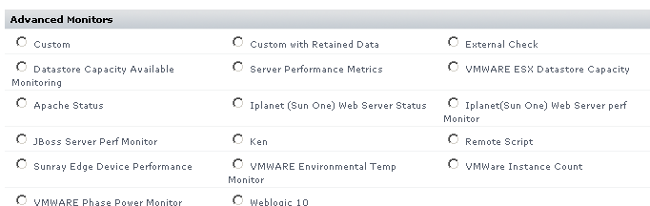

- Configure the monitor as usual to capture the metrics you want, perform thresholding and perform graphing.

Note: If you are unsure what this means please immediately contact technical support or solutions engineering for assistance and guidance.
- Save the service monitor, find it on the list of services under “View Service Instances”
- click edit service instance for the new service monitor and click “test service instance”

you should see the following kind of output, notice that it says status: OK.

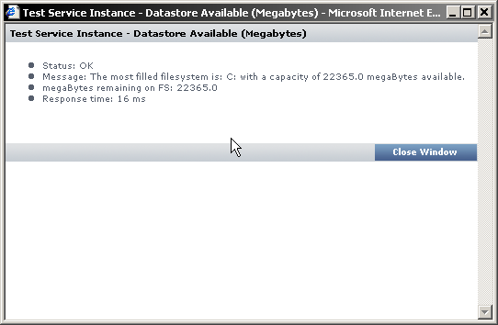

- You have now successfully configured the Sunray “Datastore Capacity Available Monitoring” Monitor for up.time.

Troubleshooting

Steps:

- If you are unable to load the monitor go back to step 1, ensure file copy is completed as described, then restart the core services.

To be expanded/amended based on client feedback, please send your feedback to ken.cheung@uptimesoftware.com

Doc Revision History

Revision/Date | Author | Description
1.0 / 10.09.2008 | Ken Cheung | Document creation and review

