# DATA STRUCTURES PRACTICAL

Examination roll no:- 21020570059

Semester:- 3

Date:- 16/12/2022

**Ques-1:-**Write a program to reverse elements of a stack using additional stock. Implement the stack using linked list.

**Solution:-**

**a)**

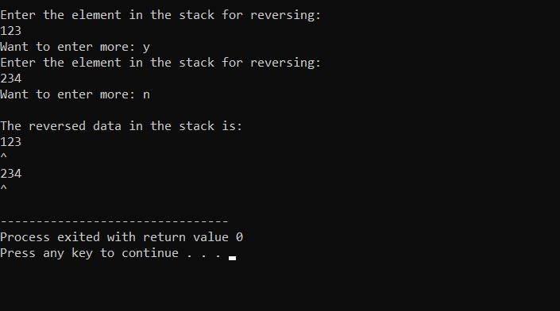

**b)**

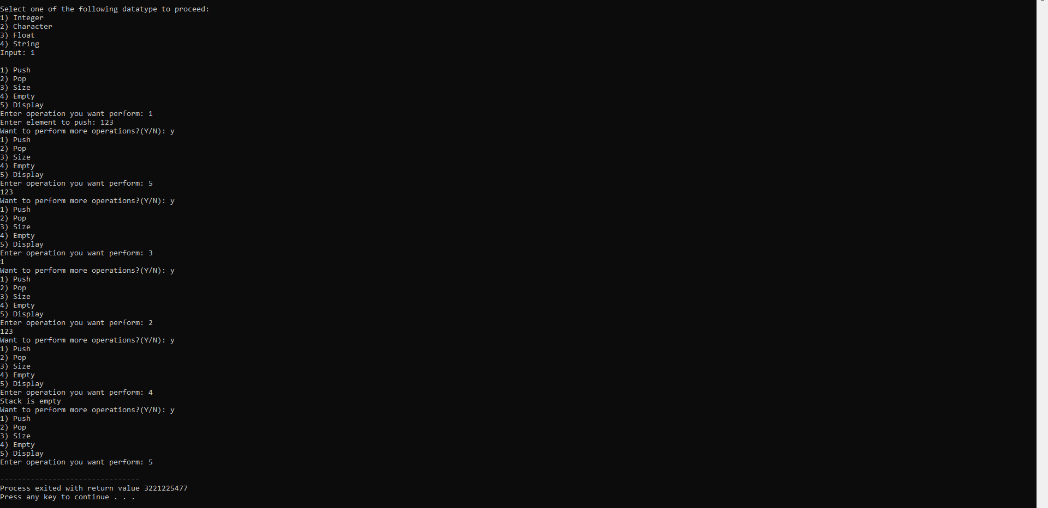

**Ques-2:-**Write a menu driven program to implement following operations in binary search tree:

1. Insertion
2. Display the contents in inorder transversal using recursion.
3. Display the height of the tree.
4. Deletion by copying.

**Solution:-**