CH2 data

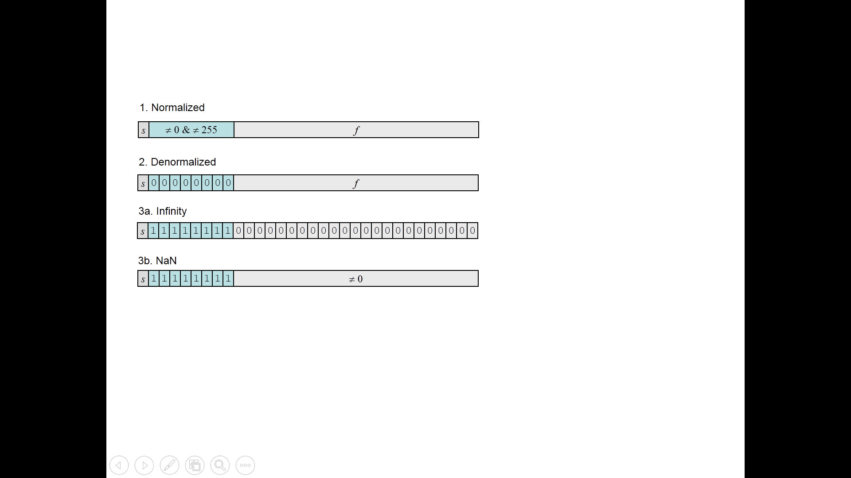 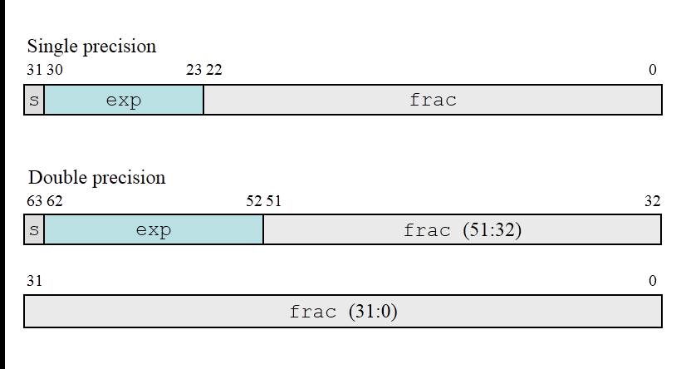

Normalized: 2 k−1 − 1(127 for single precision and 1023 for double). This yields

exponent ranges from −126 to +127 for single precision and −1022 to +1023 for

double precision.

CH3 asm

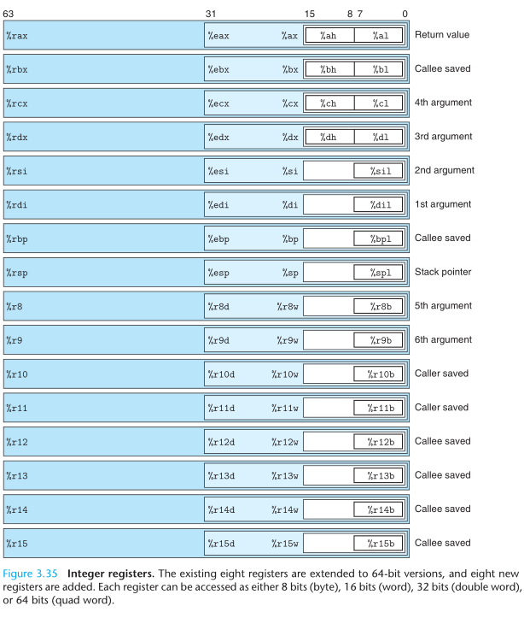

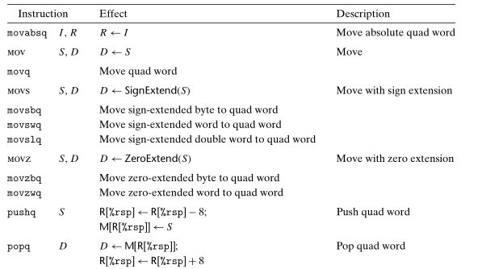

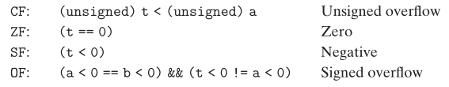

CH6 cache

