编译原理课程实验报告
实验1：词法分析
姓名 | 李一鸣 |  | 院系 |  | 计算机科学与技术学院 |  |  | 学号 |  |  | 1160300625
任课教师 |  | 辛明影 |  |  |  | 指导教师 | 辛明影
实验地点 |  | 格物楼 208 |  |  |  | 实验时间 | 2019.4.12 15:45 – 15:30
实验课表现 |  | 出勤、表现得分 |  |  |  | 实验报告  得分 |  |  | 实验总分
 |  | 操作结果得分
一、需求分析 |  |  |  |  |  |  |  |  |  | 得分
要求：阐述词法分析系统所要完成的功能
- 输入：通过文件导入测试用例，测试用例要涵盖文法设计中列出的各类单词，并且包含各种单词拼写错误。
- 输出：分为两部分
  - 打印输出词法分析器的符号表
  - 打印输出源程序对应的 token 序列
例：
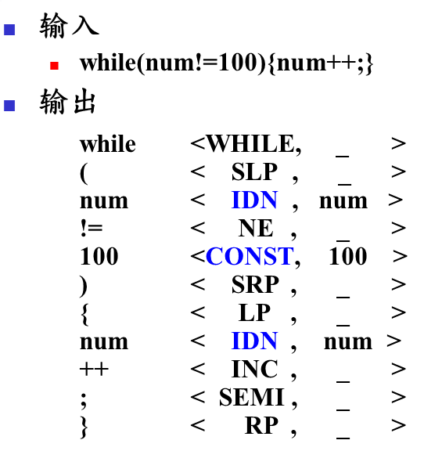
二、文法设计 |  |  |  |  |  |  |  |  |  | 得分
要求：对如下内容展开描述
- 给出各类单词的词法规则描述（正则文法或正则表达式）
- 各类单词的转换图
语法规则描述
单词类型 | 说明 | 正则表达式
标识符 | 由大小写字母、数字以及下划线组成，但必须以字母或者下划线开头 | digit → 0|1|2|…|9  letter_ → A|B|…|Z|a|b|…|z|_  id → letter_(letter_|digit)*
关键字 | - 类型关键字  - 分支结构关键字  - 循环结构关键字 | type → int|float |bool|struct|char|void  branch → if|else|switch|case  loop → do|while|while  keyword → type|branch|loop
运算符 | - 算术运算符  - 关系运算符  - 逻辑运算符  - 位运算符 | arithmetic → +|-|*|/|%|++|--  relational → ==|!=|>|<|>=|<=  logical → &&| || | ! |  bitwise → & | | | ^ | ~ | >> | <<  operator → arithmetic | relational | logical | bitwise
界符 | - 赋值语句  - 句子结尾  - 括号 | delimiter → = | ; | { | } | ( | ) | [ | ]
常数 | - 无符号整数  - 有符号整数  - 浮点数  - 字符常数  - 字符串常数 | digit → 0|1|2|…|9  digits → digit digit*  integer → (+|-|ε)digits  fraction → .digits  optionalExponent → (E integer)| ε  float → digits fraction optionalExponent  character → 所有可能的字符  char → ‘character’  string → “character*”
注释 | - /* … */ 形式 | character → 所有可能的字符  comment → /* (character)* */
符号表格式
单词名称 | 记号 | 种别码（类别编码） | 单词值
标识符 | IDN | 1 | 内部字符串值
整数 | VAR_INT | 2 | 整数值
浮点数 | VAR_FLOAT | 3 | 数值
布尔常数 | VAR_BOOL | 4 | 0 或 1
字符常数 | VAR_CHAR | 5 | 内部字符
字符串常数 | VAR_STR | 6 | 内部字符串
int | INT | 7 | -
float | FLOAT | 8 | -
bool | BOOL | 9 | -
struct | STRUCT | 10 | -
char | CHAR | 11 | -
void | VOID | 12 | -
if | IF | 13 | -
else | ELSE | 14 | -
switch | SWITCH | 15 | -
case | CASE | 16 | -
do | DO | 17 | -
while | WHILE | 18 | -
goto | GOTO | 19 | -
+ | ADD | 20 | -
- | MINUS | 21 | -
* | MUL | 22 | -
/ | DIV | 23 | -
% | MOD | 24 | -
++ | INC | 25 | -
-- | DEC | 26 | -
== | EQL | 27 | -
!= | NEQ | 28 | -
> | GT | 29 | -
< | LT | 30 | -
>= | GE | 31 | -
<= | LE | 32 | -
&& | LAND | 33 | -
|| | LOR | 34 | -
! | LNOT | 35 | -
& | BAND | 36 | -
| | BOR | 37 | -
^ | BXOR | 38 | -
~ | BNOT | 39 | -
>> | BRSFT | 40 | -
<< | BLSFT | 41 | -
注释 | CMT | 42 | -
= | ASS | 43 | -
; | SIMI | 44 | -
{ | LBAC | 45 | -
} | RBAC | 46 | -
( | LPAR | 47 | -
) | RPAR | 48 | -
[ | LBRA | 49 | -
] | RBRA | 50 | -

状态转换图
由于状态转换图用电脑软件绘制比较耗时，难以修改，所以使用了手工绘制+拍照的形式，如下图所示。
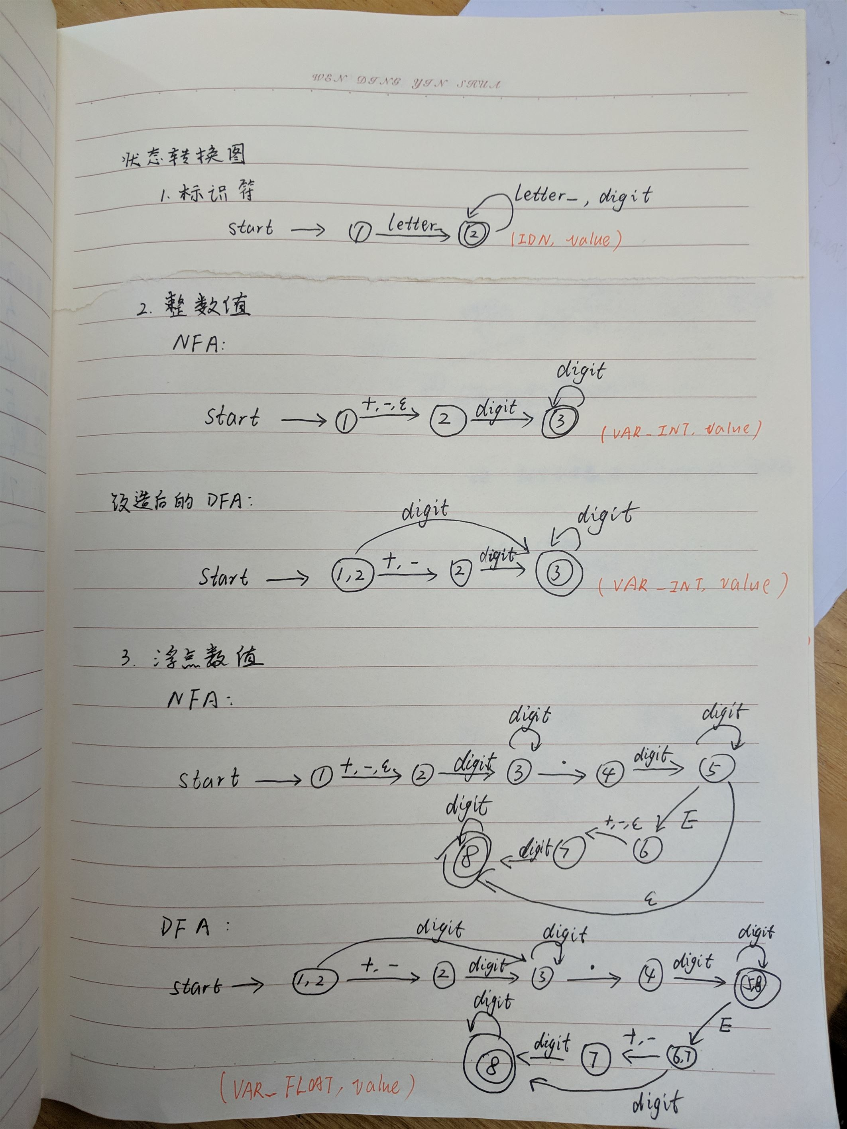
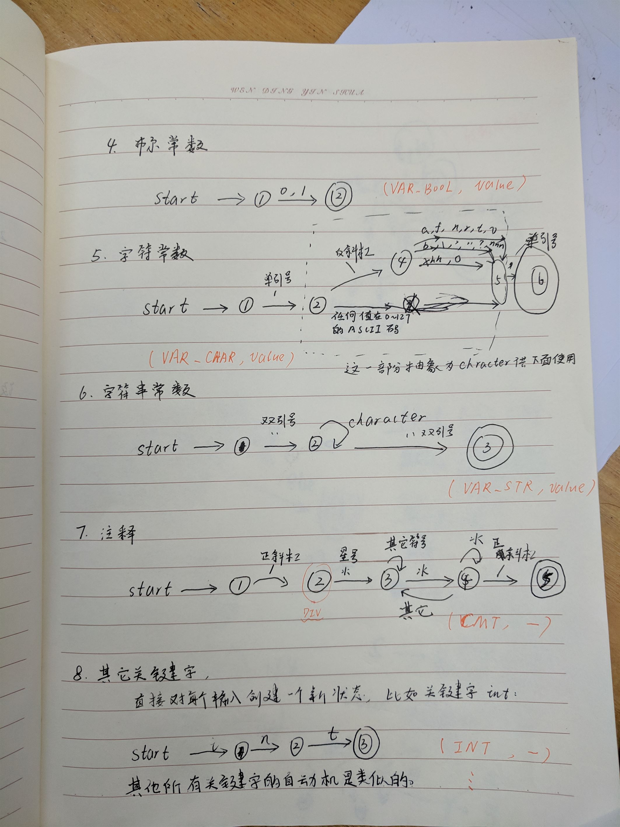
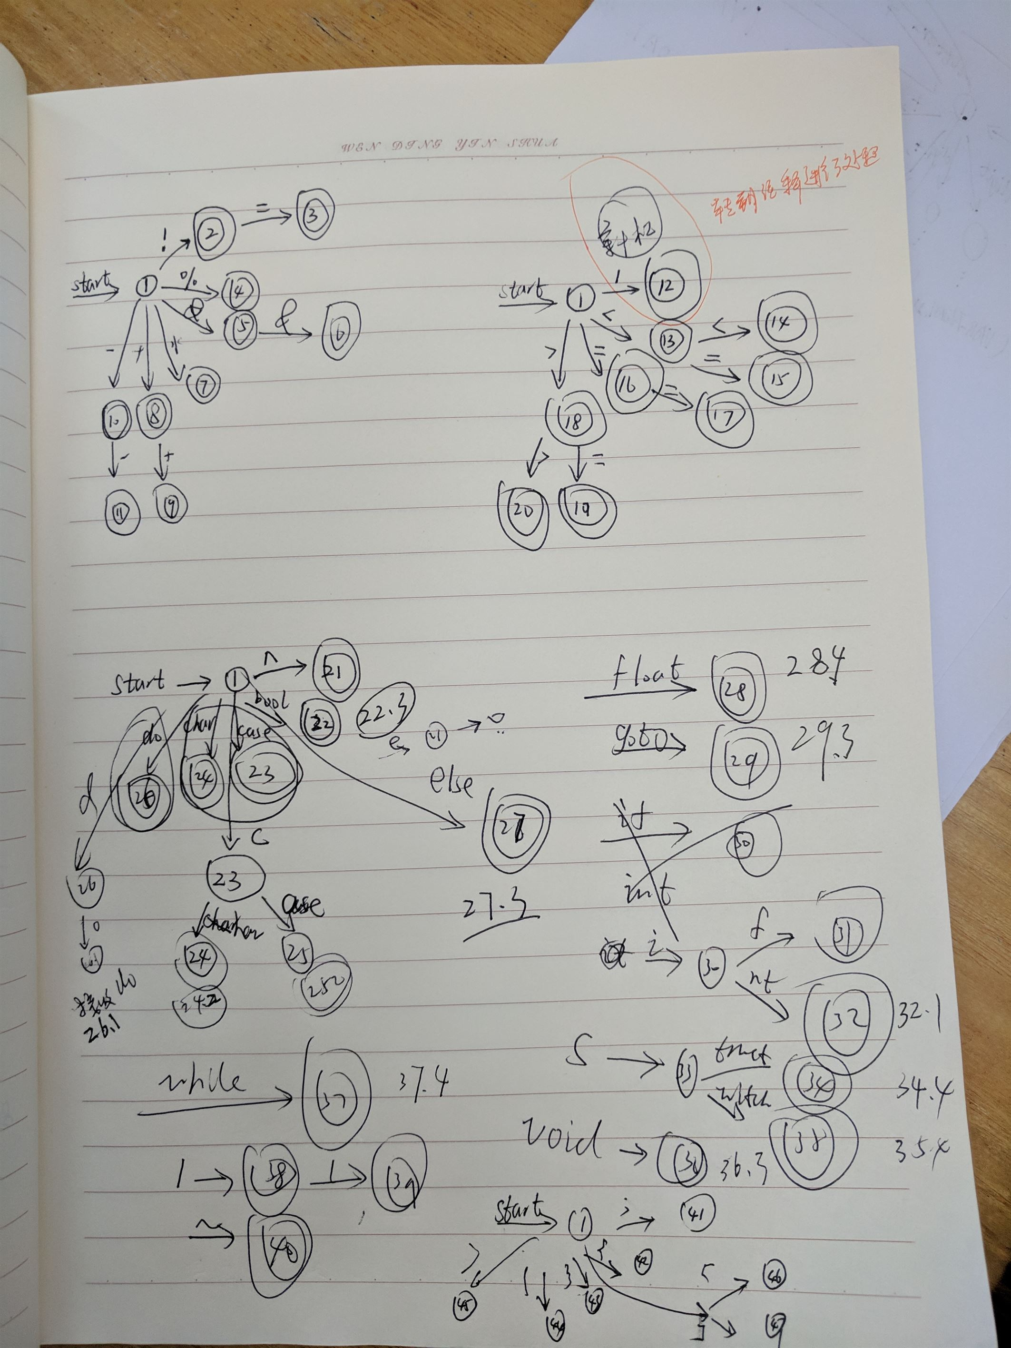
构造最终的 DFA
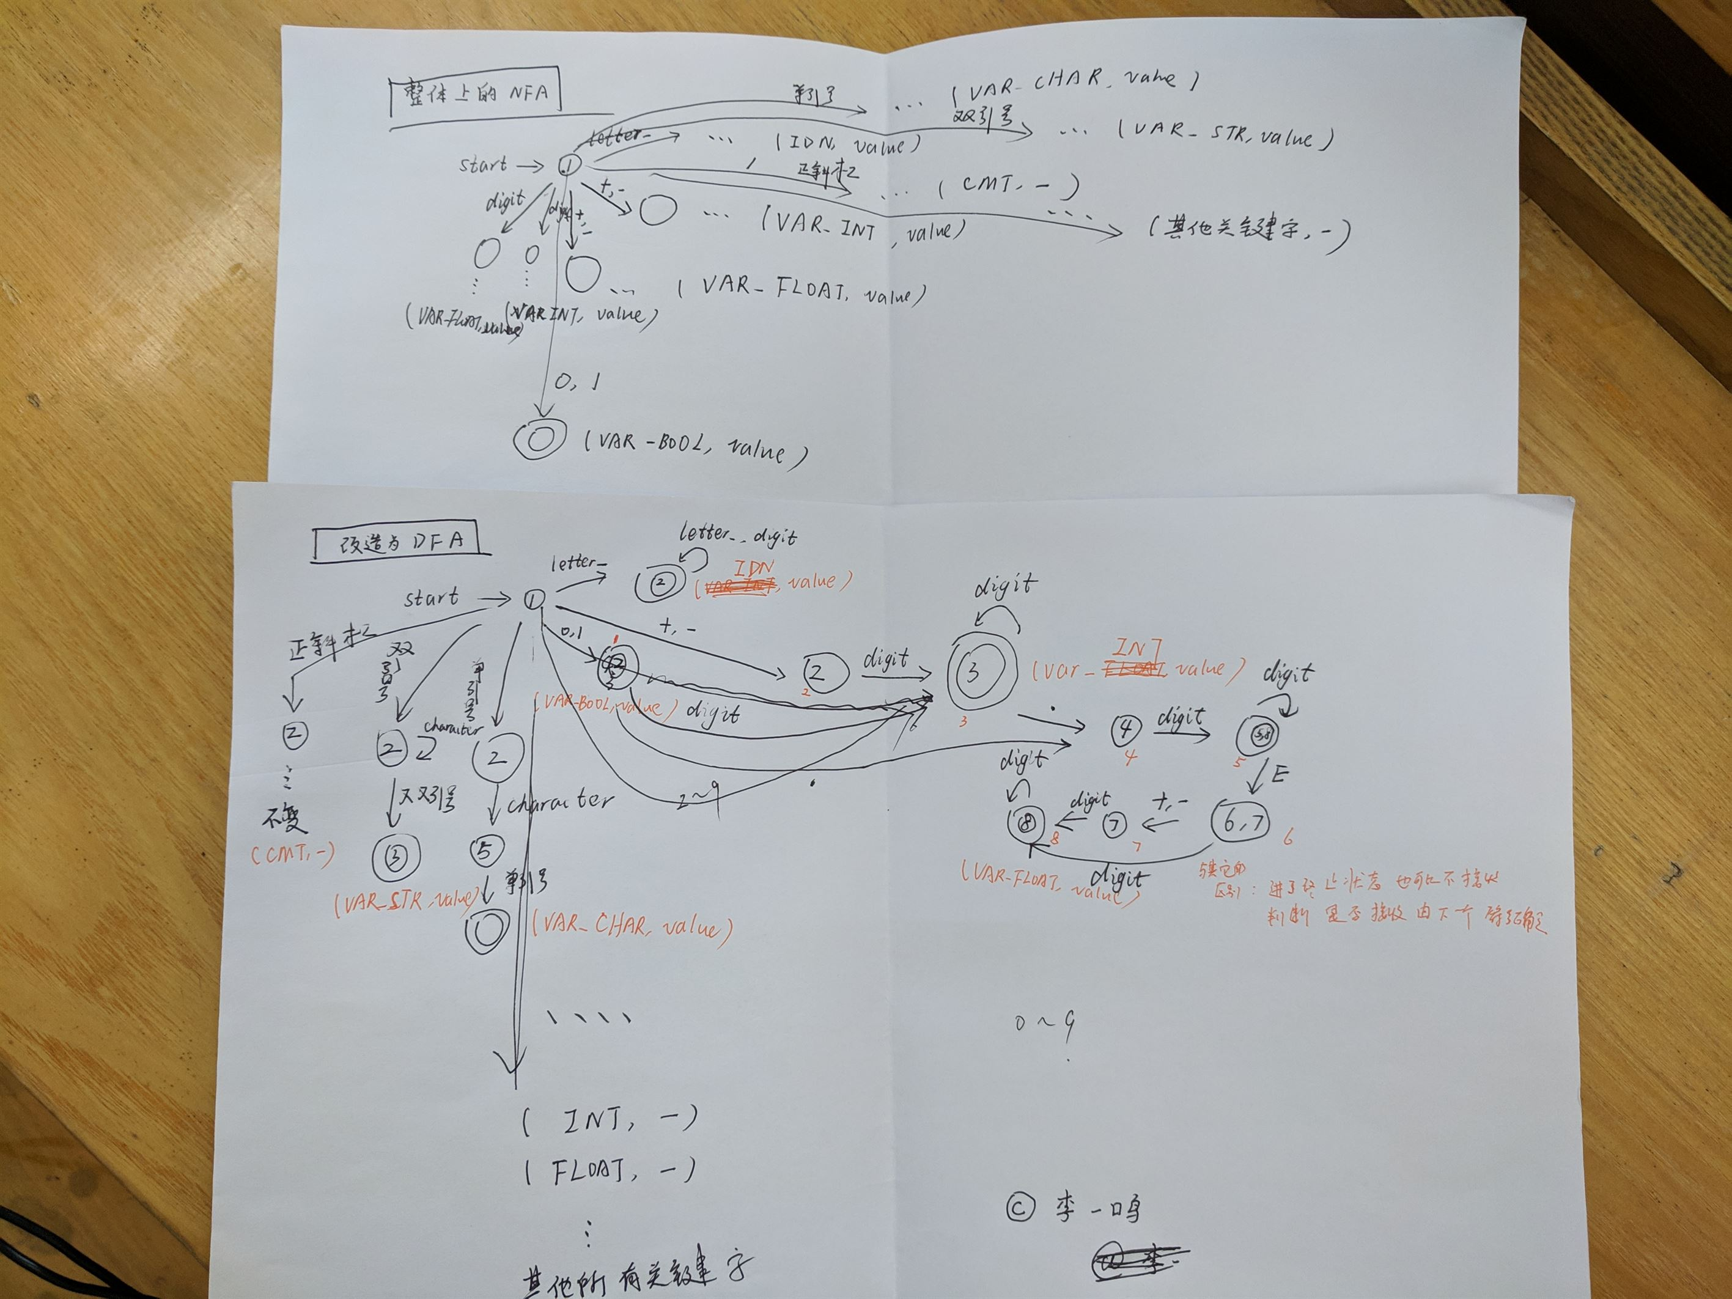
三、系统设计 |  |  |  |  |  |  |  |  |  | 得分
要求：分为系统概要设计和系统详细设计。
- 系统概要设计：给出必要的系统宏观层面设计图，如系统框架图、数据流图、功能模块图等以及相应的文字说明。
程序的流程图如下
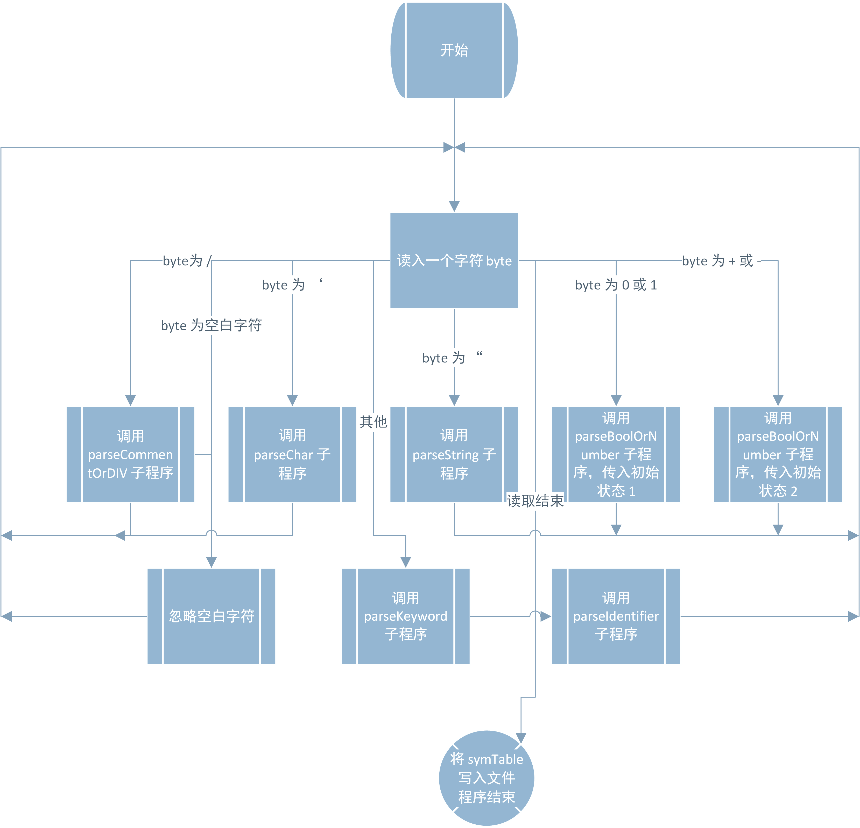
每个 parse 子程序具有类似的结构，都是内部有一个 DFA 自动机，不断读取源代码中的字符，进行状态转移，当发现到达接收状态并且下一个字符无法让自动机进入新的状态时就会将相应的解析结果输出成 token 序列，并在符号表中做相应的记录。如果因为向前看了一个字符而终止，此时要把这个字符返回给调用函数，由调用函数继续处理。
（2）系统详细设计：对如下工作进行展开描述
- 核心数据结构的设计
- 主要功能函数说明
- 程序核心部分的程序流程图
核心数据结构有 symTable（符号表）（参见实验结果部分）、每个 parse 子函数内部的 getNextState 函数，就相当于一个 map，每给一个当前状态和输入字符，就返回一个后记状态，使用 node.js 的 function 和 switch 语句进行实现。
项目结构如下：
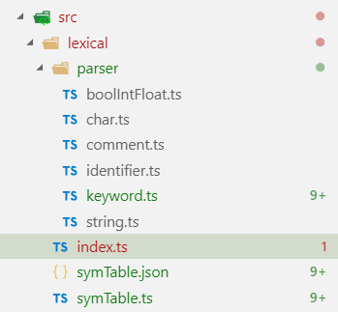
其中symTable.json 包含了初始状态下的符号表，由symTable.js 生成。在 parser 文件夹下，每一个 ts 文件对应一个解析器，负责解析相应类型的词法。由 index 进行总控驱动。
在 test 文件夹下使用 mocha 进行测试，生成的结果如下：
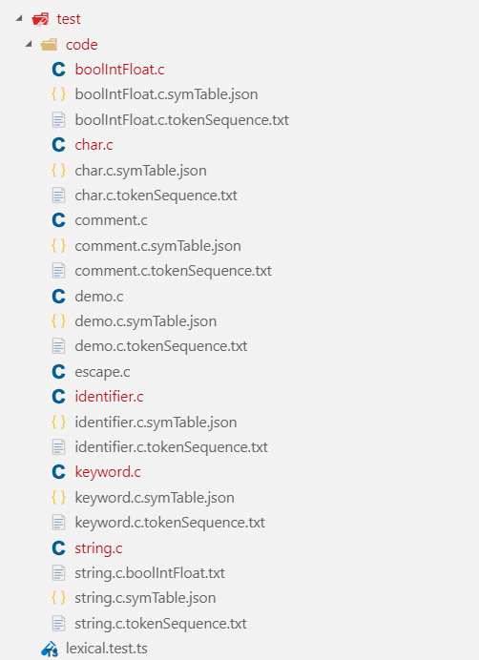
它们的名字都是自解释的，包括源代码、生成的符号表、以及token 序列。具体内容请参见附件。
四、系统实现及结果分析 |  |  |  |  |  |  |  |  |  | 得分
要求：对如下内容展开描述。
- 系统实现过程中遇到的问题；
- 针对某测试程序输出其词法分析结果；
- 输出针对此测试程序对应的词法错误报告；
- 对实验结果进行分析。
注：其中的测试样例自行产生。
问题
- 除号的开始与注释的开始相同，把它们归为一个自动机的两个不同终止状态进行处理。
- 发现代码有很多是可以复用的，目前所有 parse… 函数都有相同的结构，使用 interface 进行规范会更好，代码重构很有必要。
- 当当前的parse…子程序无法再继续识别时，一定要将已经从文件描述符中读出的符号返回给调用函数，不然会出现丢失字符的情况。
- 自动机的状态很多，需要细心处理，不出任何差错。由于使用测试优先的开发方式，错误的定位提升了很大的效率。
实验结果分析
注释的识别
对于下面的源代码：
/* This is a comment */
输出的 token 序列如下：
/* This is a comment */
<CMT, null>
运行日志如下
[INFO]: comment state: 2, byte read: *, new state: 3
[INFO]: comment state: 3, byte read: , new state: 3
[INFO]: comment state: 3, byte read: T, new state: 3
[INFO]: comment state: 3, byte read: h, new state: 3
[INFO]: comment state: 3, byte read: i, new state: 3
[INFO]: comment state: 3, byte read: s, new state: 3
[INFO]: comment state: 3, byte read: , new state: 3
[INFO]: comment state: 3, byte read: i, new state: 3
[INFO]: comment state: 3, byte read: s, new state: 3
[INFO]: comment state: 3, byte read: , new state: 3
[INFO]: comment state: 3, byte read: a, new state: 3
[INFO]: comment state: 3, byte read: , new state: 3
[INFO]: comment state: 3, byte read: c, new state: 3
[INFO]: comment state: 3, byte read: o, new state: 3
[INFO]: comment state: 3, byte read: m, new state: 3
[INFO]: comment state: 3, byte read: m, new state: 3
[INFO]: comment state: 3, byte read: e, new state: 3
[INFO]: comment state: 3, byte read: n, new state: 3
[INFO]: comment state: 3, byte read: t, new state: 3
[INFO]: comment state: 3, byte read: , new state: 3
[INFO]: comment state: 3, byte read: *, new state: 4
[INFO]: comment state: 4, byte read: /, new state: 5
[SUCCESS]: Accepted a comment
字符常量的识别：
对于下面的源代码：
'a''c''\r'
生成的token序列如下：
'a'
<VAR_CHAR, a>
'c'
<VAR_CHAR, c>
'\r'
<VAR_CHAR, \r>
运行日志如下：
[INFO]: top level byte read: '
[INFO]: character state: 2, byte read: a, new state: 5
[SUCCESS]: Accepted a character
[INFO]: VAR_CHAR state: 3, byte read: ', new state: 4
[SUCCESS]: Accepted a VAR_CHAR
[INFO]: top level byte read: '
[INFO]: character state: 2, byte read: c, new state: 5
[SUCCESS]: Accepted a character
[INFO]: VAR_CHAR state: 3, byte read: ', new state: 4
[SUCCESS]: Accepted a VAR_CHAR
[INFO]: top level byte read: '
[INFO]: character state: 2, byte read: \, new state: 4
[INFO]: character state: 4, byte read: r, new state: 5
[SUCCESS]: Accepted a character
[INFO]: VAR_CHAR state: 3, byte read: ', new state: 4
[SUCCESS]: Accepted a VAR_CHAR
得到的符号表为：
{
"IDN": [],
"VAR_INT": [],
"VAR_FLOAT": [],
"VAR_BOOL": [],
"VAR_CHAR": [
"a",
"c",
"\\r"
],
"VAR_STR": [],
"INT": null,
"FLOAT": null,
"BOOL": null,
"STRUCT": null,
"CHAR": null,
"VOID": null,
"IF": null,
"ELSE": null,
"SWITCH": null,
"CASE": null,
"DO": null,
"WHILE": null,
"GOTO": null,
"ADD": null,
"MINUS": null,
"MUL": null,
"DIV": null,
"MOD": null,
"INC": null,
"DEC": null,
"EQL": null,
"NEQ": null,
"GT": null,
"LT": null,
"GE": null,
"LE": null,
"LAND": null,
"LOR": null,
"LNOT": null,
"BAND": null,
"BOR": null,
"BXOR": null,
"BNOT": null,
"BRSFT": null,
"BLSFT": null,
"CMT": null,
"ASS": null,
"SIMI": null,
"LBAC": null,
"RBAC": null,
"LPAR": null,
"RPAR": null,
"LBRA": null,
"RBRA": null
}

字符串的识别
对于下面的源代码：
"aaa'""bbb""\a\r\n"
生成的 token 如下：
"aaa'"
<VAR_STR, aaa'>
"bbb"
<VAR_STR, bbb>
"\a\r\n"
<VAR_STR, \a\r\n>
运行日志如下：
[INFO]: top level byte read: "
[INFO]: character state: 2, byte read: a, new state: 5
[SUCCESS]: Accepted a character
[INFO]: character state: 2, byte read: a, new state: 5
[SUCCESS]: Accepted a character
[INFO]: character state: 2, byte read: a, new state: 5
[SUCCESS]: Accepted a character
[INFO]: character state: 2, byte read: ', new state: 5
[SUCCESS]: Accepted a character
[INFO]: character state: 2, byte read: ", new state: 5
[SUCCESS]: Accepted a character
[SUCCESS]: Accepted a VAR_STR
[INFO]: top level byte read: "
[INFO]: character state: 2, byte read: b, new state: 5
[SUCCESS]: Accepted a character
[INFO]: character state: 2, byte read: b, new state: 5
[SUCCESS]: Accepted a character
[INFO]: character state: 2, byte read: b, new state: 5
[SUCCESS]: Accepted a character
[INFO]: character state: 2, byte read: ", new state: 5
[SUCCESS]: Accepted a character
[SUCCESS]: Accepted a VAR_STR
[INFO]: top level byte read: "
[INFO]: character state: 2, byte read: \, new state: 4
[INFO]: character state: 4, byte read: a, new state: 5
[SUCCESS]: Accepted a character
[INFO]: character state: 2, byte read: \, new state: 4
[INFO]: character state: 4, byte read: r, new state: 5
[SUCCESS]: Accepted a character
[INFO]: character state: 2, byte read: \, new state: 4
[INFO]: character state: 4, byte read: n, new state: 5
[SUCCESS]: Accepted a character
[INFO]: character state: 2, byte read: ", new state: 5
[SUCCESS]: Accepted a character
[SUCCESS]: Accepted a VAR_STR
得到的符号表为：
{
"IDN": [],
"VAR_INT": [],
"VAR_FLOAT": [],
"VAR_BOOL": [],
"VAR_CHAR": [
"a",
"c",
"\\r"
],
"VAR_STR": [
"aaa'",
"bbb",
"\\a\\r\\n"
],
"INT": null,
"FLOAT": null,
"BOOL": null,
"STRUCT": null,
"CHAR": null,
"VOID": null,
"IF": null,
"ELSE": null,
"SWITCH": null,
"CASE": null,
"DO": null,
"WHILE": null,
"GOTO": null,
"ADD": null,
"MINUS": null,
"MUL": null,
"DIV": null,
"MOD": null,
"INC": null,
"DEC": null,
"EQL": null,
"NEQ": null,
"GT": null,
"LT": null,
"GE": null,
"LE": null,
"LAND": null,
"LOR": null,
"LNOT": null,
"BAND": null,
"BOR": null,
"BXOR": null,
"BNOT": null,
"BRSFT": null,
"BLSFT": null,
"CMT": null,
"ASS": null,
"SIMI": null,
"LBAC": null,
"RBAC": null,
"LPAR": null,
"RPAR": null,
"LBRA": null,
"RBRA": null
}

布尔常数、整数、浮点数的识别
下面的源代码文件：
1.345 1 0 99 34e3 10.0e+35 -35e-25.0
生成的 token 序列如下：
1.345
<VAR_FLOAT, 1.345>
1
<BOOL, 1>
0
<BOOL, 0>
99
<VAR_INT, 99>
34e3
<VAR_FLOAT, 34e3>
10.0e+35
<VAR_FLOAT, 10.0e+35>
-35e-25
<VAR_FLOAT, -35e-25>
运行日志如下：
[INFO]: top level byte read: 1
[INFO]: BOOL/VAR_INT/VAR_FLOAT state: 1, byte read: ., new state: 4
[INFO]: BOOL/VAR_INT/VAR_FLOAT state: 4, byte read: 3, new state: 5
[INFO]: BOOL/VAR_INT/VAR_FLOAT state: 5, byte read: 4, new state: 5
[INFO]: BOOL/VAR_INT/VAR_FLOAT state: 5, byte read: 5, new state: 5
[INFO]: BOOL/VAR_INT/VAR_FLOAT state: 5, byte read: , new state: -1
[SUCCESS]: Accepted a VAR_FLOAT
[INFO]: top level byte read:
[INFO]: Ignored white character (ASCII): 32
[INFO]: top level byte read: 1
[INFO]: BOOL/VAR_INT/VAR_FLOAT state: 1, byte read: , new state: -1
[SUCCESS]: Accepted a BOOL
[INFO]: top level byte read:
[INFO]: Ignored white character (ASCII): 32
[INFO]: top level byte read: 0
[INFO]: BOOL/VAR_INT/VAR_FLOAT state: 1, byte read: , new state: -1
[SUCCESS]: Accepted a BOOL
[INFO]: top level byte read:
[INFO]: Ignored white character (ASCII): 32
[INFO]: top level byte read: 9
[INFO]: BOOL/VAR_INT/VAR_FLOAT state: 3, byte read: 9, new state: 3
[INFO]: BOOL/VAR_INT/VAR_FLOAT state: 3, byte read: , new state: -1
[SUCCESS]: Accepted a VAR_INT
[INFO]: top level byte read:
[INFO]: Ignored white character (ASCII): 32
[INFO]: top level byte read: 3
[INFO]: BOOL/VAR_INT/VAR_FLOAT state: 3, byte read: 4, new state: 3
[INFO]: BOOL/VAR_INT/VAR_FLOAT state: 3, byte read: e, new state: 6
[INFO]: BOOL/VAR_INT/VAR_FLOAT state: 6, byte read: 3, new state: 8
[INFO]: BOOL/VAR_INT/VAR_FLOAT state: 8, byte read: , new state: -1
[SUCCESS]: Accepted a VAR_FLOAT
[INFO]: top level byte read:
[INFO]: Ignored white character (ASCII): 32
[INFO]: top level byte read: 1
[INFO]: BOOL/VAR_INT/VAR_FLOAT state: 1, byte read: 0, new state: 3
[INFO]: BOOL/VAR_INT/VAR_FLOAT state: 3, byte read: ., new state: 4
[INFO]: BOOL/VAR_INT/VAR_FLOAT state: 4, byte read: 0, new state: 5
[INFO]: BOOL/VAR_INT/VAR_FLOAT state: 5, byte read: e, new state: 6
[INFO]: BOOL/VAR_INT/VAR_FLOAT state: 6, byte read: +, new state: 7
[INFO]: BOOL/VAR_INT/VAR_FLOAT state: 7, byte read: 3, new state: 8
[INFO]: BOOL/VAR_INT/VAR_FLOAT state: 8, byte read: 5, new state: 8
[INFO]: BOOL/VAR_INT/VAR_FLOAT state: 8, byte read: , new state: -1
[SUCCESS]: Accepted a VAR_FLOAT
[INFO]: top level byte read:
[INFO]: Ignored white character (ASCII): 32
[INFO]: top level byte read: -
[INFO]: BOOL/VAR_INT/VAR_FLOAT state: 2, byte read: 3, new state: 3
[INFO]: BOOL/VAR_INT/VAR_FLOAT state: 3, byte read: 5, new state: 3
[INFO]: BOOL/VAR_INT/VAR_FLOAT state: 3, byte read: e, new state: 6
[INFO]: BOOL/VAR_INT/VAR_FLOAT state: 6, byte read: -, new state: 7
[INFO]: BOOL/VAR_INT/VAR_FLOAT state: 7, byte read: 2, new state: 8
[INFO]: BOOL/VAR_INT/VAR_FLOAT state: 8, byte read: 5, new state: 8
[SUCCESS]: Accepted a VAR_FLOAT

得到的符号表为：
{
"IDN": [],
"VAR_INT": [
"99"
],
"VAR_FLOAT": [
"1.345",
"34e3",
"10.0e+35",
"-35e-25"
],
"VAR_BOOL": [
"1",
"0"
],
"VAR_CHAR": [],
"VAR_STR": [],
"INT": null,
"FLOAT": null,
"BOOL": null,
"STRUCT": null,
"CHAR": null,
"VOID": null,
"IF": null,
"ELSE": null,
"SWITCH": null,
"CASE": null,
"DO": null,
"WHILE": null,
"GOTO": null,
"ADD": null,
"MINUS": null,
"MUL": null,
"DIV": null,
"MOD": null,
"INC": null,
"DEC": null,
"EQL": null,
"NEQ": null,
"GT": null,
"LT": null,
"GE": null,
"LE": null,
"LAND": null,
"LOR": null,
"LNOT": null,
"BAND": null,
"BOR": null,
"BXOR": null,
"BNOT": null,
"BRSFT": null,
"BLSFT": null,
"CMT": null,
"ASS": null,
"SIMI": null,
"LBAC": null,
"RBAC": null,
"LPAR": null,
"RPAR": null,
"LBRA": null,
"RBRA": null
}

关键字、界符、操作符的识别
对于下面的源代码：
int ^ & bool case void || ~ ) () ; goto
输出的token序列如下：
int
<INT, null>
^
<BXOR, null>
&
<BAND, null>
bool
<BOOL, null>
case
<CASE, null>
void
<VOID, null>
||
<LOR, null>
~
<BNOT, null>
)
<RPAR, undefined>
()
<LPAR, undefined>
)
<RPAR, undefined>
;
<SIMI, undefined>
goto
<GOTO, null>
运行日志如下：
[INFO]: top level byte read: i
[INFO]: current state: 30
[INFO]: Keyword state: 30, byte read: n, new state: 32
[INFO]: Keyword state: 32, byte read: t, new state: 321
[INFO]: Keyword state: 321, byte read: , new state: -1
[SUCCESS]: Accepted a INT
[INFO]: top level byte read:
[INFO]: Ignored white character (ASCII): 32
[INFO]: top level byte read:
[INFO]: Ignored white character (ASCII): 32
[INFO]: top level byte read: ^
[INFO]: current state: 21
[INFO]: Keyword state: 21, byte read: , new state: -1
[SUCCESS]: Accepted a BXOR
[INFO]: top level byte read:
[INFO]: Ignored white character (ASCII): 32
[INFO]: top level byte read: &
[INFO]: current state: 5
[INFO]: Keyword state: 5, byte read: , new state: -1
[SUCCESS]: Accepted a BAND
[INFO]: top level byte read:
[INFO]: Ignored white character (ASCII): 32
[INFO]: top level byte read: b
[INFO]: current state: 22
[INFO]: Keyword state: 22, byte read: o, new state: 221
[INFO]: Keyword state: 221, byte read: o, new state: 222
[INFO]: Keyword state: 222, byte read: l, new state: 223
[INFO]: Keyword state: 223, byte read: , new state: -1
[SUCCESS]: Accepted a BOOL
[INFO]: top level byte read:
[INFO]: Ignored white character (ASCII): 32
[INFO]: top level byte read: c
[INFO]: current state: 23
[INFO]: Keyword state: 23, byte read: a, new state: 25
[INFO]: Keyword state: 25, byte read: s, new state: 251
[INFO]: Keyword state: 251, byte read: e, new state: 252
[INFO]: Keyword state: 252, byte read: , new state: -1
[SUCCESS]: Accepted a CASE
[INFO]: top level byte read:
[INFO]: Ignored white character (ASCII): 32
[INFO]: top level byte read: v
[INFO]: current state: 36
[INFO]: Keyword state: 36, byte read: o, new state: 361
[INFO]: Keyword state: 361, byte read: i, new state: 362
[INFO]: Keyword state: 362, byte read: d, new state: 363
[INFO]: Keyword state: 363, byte read: , new state: -1
[SUCCESS]: Accepted a VOID
[INFO]: top level byte read:
[INFO]: Ignored white character (ASCII): 32
[INFO]: top level byte read: |
[INFO]: current state: 38
[INFO]: Keyword state: 38, byte read: |, new state: 39
[INFO]: Keyword state: 39, byte read: , new state: -1
[SUCCESS]: Accepted a LOR
[INFO]: top level byte read:
[INFO]: Ignored white character (ASCII): 32
[INFO]: top level byte read: ~
[INFO]: current state: 40
[INFO]: Keyword state: 40, byte read: , new state: -1
[SUCCESS]: Accepted a BNOT
[INFO]: top level byte read:
[INFO]: Ignored white character (ASCII): 32
[INFO]: top level byte read: )
[INFO]: current state: 45
[INFO]: Keyword state: 45, byte read: , new state: -1
[SUCCESS]: Accepted a RPAR
[INFO]: top level byte read:
[INFO]: Ignored white character (ASCII): 32
[INFO]: top level byte read: (
[INFO]: current state: 44
[INFO]: Keyword state: 44, byte read: ), new state: -1
[SUCCESS]: Accepted a LPAR
[INFO]: top level byte read: )
[INFO]: current state: 45
[INFO]: Keyword state: 45, byte read: , new state: -1
[SUCCESS]: Accepted a RPAR
[INFO]: top level byte read:
[INFO]: Ignored white character (ASCII): 32
[INFO]: top level byte read: ;
[INFO]: current state: 41
[INFO]: Keyword state: 41, byte read: , new state: -1
[SUCCESS]: Accepted a SIMI
[INFO]: top level byte read:
[INFO]: Ignored white character (ASCII): 32
[INFO]: top level byte read: g
[INFO]: current state: 29
[INFO]: Keyword state: 29, byte read: o, new state: 291
[INFO]: Keyword state: 291, byte read: t, new state: 292
[INFO]: Keyword state: 292, byte read: o, new state: 293
[SUCCESS]: Accepted a GOTO

标识符的识别
对于下面的源代码：
_aac num test ; logs
生成的 token 序列如下：
_aac
<IDN, _aac>
num
<IDN, num>
test
<IDN, test>
;
<SIMI, null>
logs
<IDN, logs>
运行的日志如下：
[INFO]: top level byte read: _
[INFO]: IDN state: 2, byte read: _, new state: 2
[INFO]: IDN state: 2, byte read: a, new state: 2
[INFO]: IDN state: 2, byte read: a, new state: 2
[INFO]: IDN state: 2, byte read: c, new state: 2
[INFO]: IDN state: 2, byte read: , new state: -1
[SUCCESS]: Accepted a IDN
[INFO]: top level byte read:
[INFO]: Ignored white character (ASCII): 32
[INFO]: top level byte read: n
[INFO]: IDN state: 2, byte read: n, new state: 2
[INFO]: IDN state: 2, byte read: u, new state: 2
[INFO]: IDN state: 2, byte read: m, new state: 2
[INFO]: IDN state: 2, byte read: , new state: -1
[SUCCESS]: Accepted a IDN
[INFO]: top level byte read:
[INFO]: Ignored white character (ASCII): 32
[INFO]: top level byte read: t
[INFO]: IDN state: 2, byte read: t, new state: 2
[INFO]: IDN state: 2, byte read: e, new state: 2
[INFO]: IDN state: 2, byte read: s, new state: 2
[INFO]: IDN state: 2, byte read: t, new state: 2
[INFO]: IDN state: 2, byte read: , new state: -1
[SUCCESS]: Accepted a IDN
[INFO]: top level byte read:
[INFO]: Ignored white character (ASCII): 32
[INFO]: top level byte read: ;
[INFO]: current state: 41
[INFO]: Keyword state: 41, byte read: , new state: -1
[SUCCESS]: Accepted a SIMI
[INFO]: Ignored white character (ASCII): 32
[INFO]: top level byte read:
[INFO]: Ignored white character (ASCII): 32
[INFO]: top level byte read: l
[INFO]: IDN state: 2, byte read: l, new state: 2
[INFO]: IDN state: 2, byte read: o, new state: 2
[INFO]: IDN state: 2, byte read: g, new state: 2
[INFO]: IDN state: 2, byte read: s, new state: 2
[SUCCESS]: Accepted a IDN

生产的符号表如下：
{
"IDN": [
"_aac",
"num",
"test",
"logs"
],
"VAR_INT": [],
"VAR_FLOAT": [],
"VAR_BOOL": [],
"VAR_CHAR": [],
"VAR_STR": [],
"INT": null,
"FLOAT": null,
"BOOL": null,
"STRUCT": null,
"CHAR": null,
"VOID": null,
"IF": null,
"ELSE": null,
"SWITCH": null,
"CASE": null,
"DO": null,
"WHILE": null,
"GOTO": null,
"ADD": null,
"MINUS": null,
"MUL": null,
"DIV": null,
"MOD": null,
"INC": null,
"DEC": null,
"EQL": null,
"NEQ": null,
"GT": null,
"LT": null,
"GE": null,
"LE": null,
"LAND": null,
"LOR": null,
"LNOT": null,
"BAND": null,
"BOR": null,
"BXOR": null,
"BNOT": null,
"BRSFT": null,
"BLSFT": null,
"CMT": null,
"ASS": null,
"SIMI": null,
"LBAC": null,
"RBAC": null,
"LPAR": null,
"RPAR": null,
"LBRA": null,
"RBRA": null
}
出现错误的情况
出现语法错误会直接抛出，并且不会写入符号表。最终的测试结果如下。
源文件：
/*
运行日志：
[INFO]: top level byte read: /
[INFO]: CMT/DIV state: 2, byte read: *, new state: 3
1) should parse 语法错误

0 passing (35ms)
1 failing

1) lexical
should parse 语法错误:
Error: CMT/DIV lexical error: unexpected terminal
at Object.parseCommentOrDIV (src\lexical\parser\comment.ts:73:13)
at parse (src\lexical\index.ts:26:19)
at Object.parseFile (src\lexical\index.ts:77:3)
at Context.<anonymous> (test\lexical.test.ts:53:13)

token 序列：
/*
指导教师评语：

日期：

